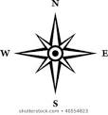
Lot addition – 60-C-207296 - Otter Lake, Rudd Township

