# Towards a Planning Approach for Fisheries Management Zone (FMZ) 16

# 

## A Discussion Paper

### Ministry of Natural Resources and Forestry Southern Region

April 2021

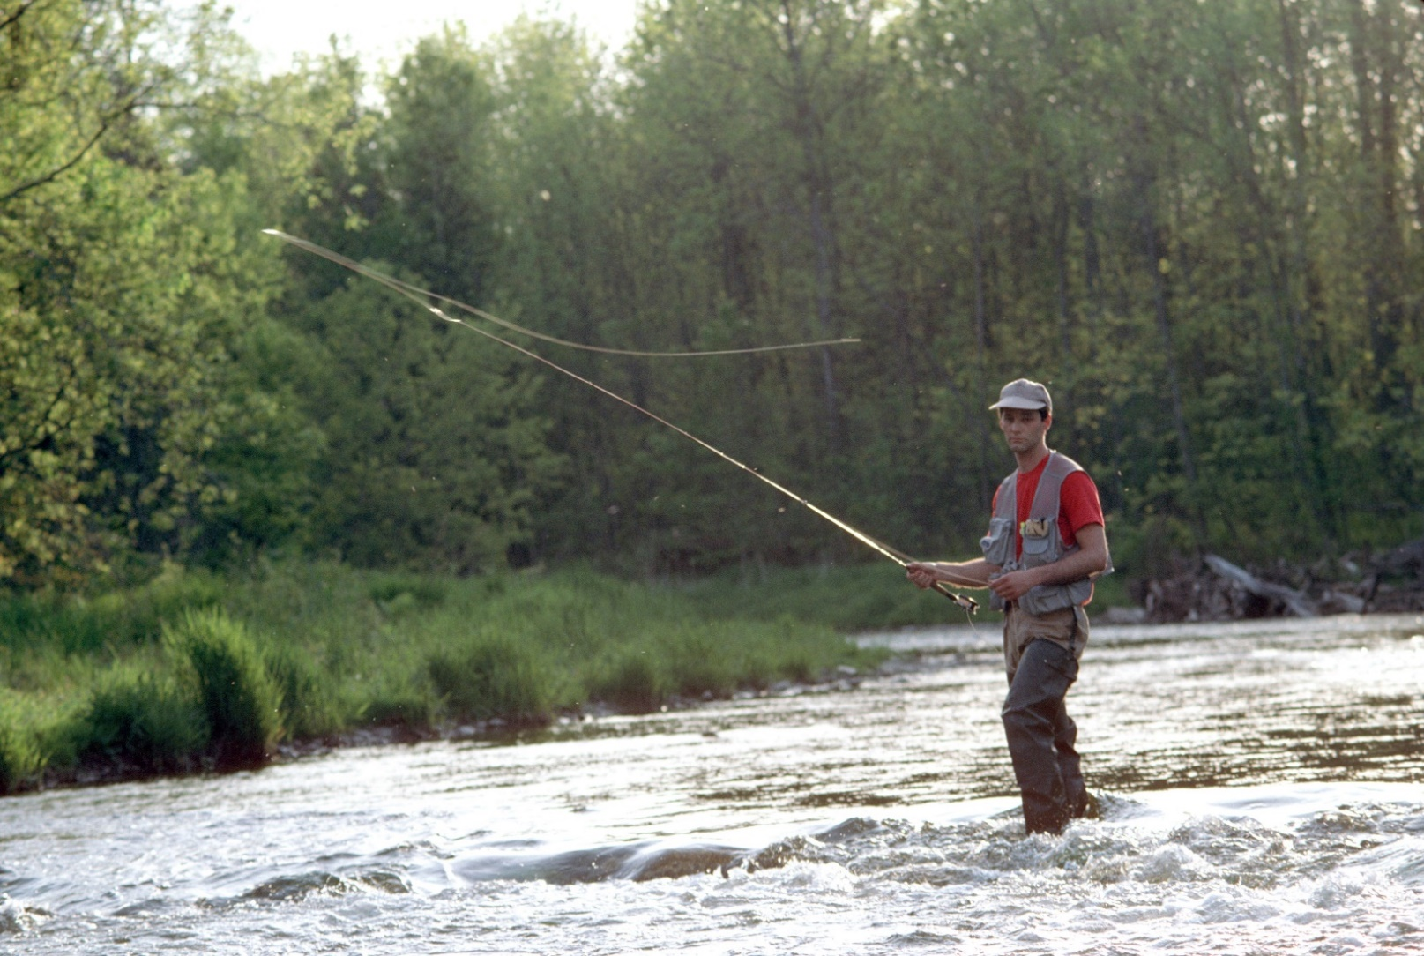

## Table of Contents

Introduction 3

Chapter 1: Fisheries management in Ontario 4

Shared responsibility 4

Indigenous fisheries 5

FMZ planning 5

Chapter 2: Overview 6

Environment 6

Socio-economic 7

Chapter 3: Complexities 8

Chapter 4: Overview of planning approach 10

Typical FMZ planning components 10

FMZ 16 planning approach 11

Chapter 5: Listening session feedback summary 12

Background 12

Listening session feedback 12

Additional information 20

Chapter 6: Towards a planning approach 21

Scale of planning 21

Collaborative approach 24

Chapter 7: How to provide feedback 27

Glossary 29

References 32

## Introduction

Ontario has a large and diverse aquatic resource that makes up 24 per cent of Canada's freshwater, including over 250,000 inland lakes, the Canadian portion of four of the Great Lakes and countless rivers and streams. It supports the largest freshwater recreational fishery in Canada and is among the largest in the world. This fishery, which depends on high quality fish habitat and healthy aquatic ecosystems, is a renewable resource that provides considerable benefits to the province.

The Ontario Ministry of Natural Resources and Forestry (MNRF) is responsible for sustainably managing recreational fisheries in Ontario. The primary unit for fisheries planning, management and monitoring are Fisheries Management Zones (FMZ). Fisheries management planning aims to document the current state of the fisheries as well as the goals, objectives and management actions intended to maintain or move the zone closer to a desired future state.

Located in southwestern Ontario, FMZ 16 is the most urban and industrialized area in Ontario. This, along with a variety of other characteristics, makes FMZ 16 one of the most unique zones for fisheries management in the province.

In the fall of 2017, MNRF hosted a series of Listening Sessions to hear about the diverse interests, concerns and opportunities for recreational fisheries management in FMZ 16 from the public, stakeholders and First Nation and Métis communities. Given the passage of time since the Listening Sessions, MNRF is taking this opportunity to summarize what was heard and seek additional confirmation and/or feedback from interested parties.

The purpose of this Discussion Paper is to summarize feedback received from the Listening Sessions and seek further input that will inform a path forward to manage the diverse fisheries in FMZ 16.

This Discussion Paper:

* provides general information on fisheries management in Ontario (Chapter 1)
* describes some of the unique characteristics associated with FMZ 16 (Chapter 2 and 3)
* describes the approach taken for planning within FMZ 16 to date (Chapter 4)
* summarizes what we heard at the Listening Sessions and poses questions to gather additional feedback on your interests, concerns and opportunities in FMZ 16 (Chapter 5 and 6)

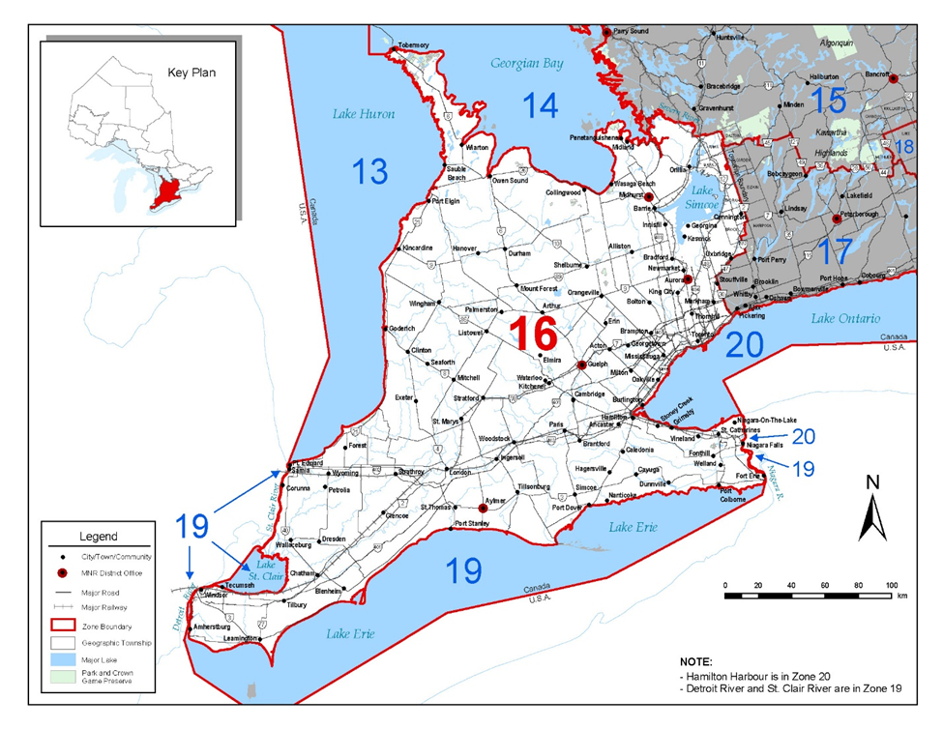

**Figure 1.** Map of FMZ 16

## Chapter 1: Fisheries management in Ontario

### Shared responsibility

The management of fisheries in Ontario is critical to protect biodiversity, support a sustainable resource economy based on self-sustaining fisheries and to provide recreational and social benefits to Ontarians.

MNRF is responsible for sustainably managing the province's diverse natural resources. MNRF has delegated authority from the federal government to sustainably manage the fisheries and administer and enforce the [Ontario Fishery Regulations](http://laws-lois.justice.gc.ca/eng/regulations/SOR-2007-237/page-1.html) under the [*Fisheries Act*](http://laws-lois.justice.gc.ca/eng/acts/f-14/)*.*

MNRF shares responsibility for fisheries management with other agencies. For example, the Department of Fisheries and Oceans Canada manages fisheries at the federal level and is the primary agency responsible for the protection of fish habitat under the federal [*Fisheries Act*](http://laws-lois.justice.gc.ca/eng/acts/f-14/). Other agencies and levels of government also have roles to play in fisheries management, including Ontario's Conservation Authorities and local municipalities.

The management framework for fisheries is guided by [Ontario's Provincial Fish Strategy - Fish for the Future](https://www.ontario.ca/page/ontarios-provincial-fish-strategy). This document sets out a practical and strategic framework for managing Ontario’s fisheries resources.

### Indigenous fisheries

Fish are of central importance to First Nation and Métis peoples in Ontario. Throughout the province, First Nation and Métis peoples have constitutionally protected Aboriginal and treaty rights to fish for food, for social and ceremonial purposes, and in some areas of the province, for commercial purposes that stem from historical practices. [*The Constitution Act*](https://laws-lois.justice.gc.ca/eng/const/) recognizes and affirms Aboriginal and treaty rights of the Aboriginal peoples of Canada.

MNRF is committed to working alongside First Nation and Métis communities to determine the best way forward with respect to balancing and sharing the fishery resource.

### FMZ planning

Across the province, 20 FMZs have been established based on biological, climatic and social considerations (see Figure 2 for a map of Ontario’s FMZs). Planning at the FMZ level enables sustainable management of fisheries in Ontario through a planning process that is responsive to the individual needs and nature of each zone.

Long-term goals for recreational fisheries are typically established at the FMZ level and supported by objectives and management actions for the fisheries within each zone.

FMZ planning is based on a foundation of collaboration. Fisheries management zone plans are developed in consultation with advisory councils.

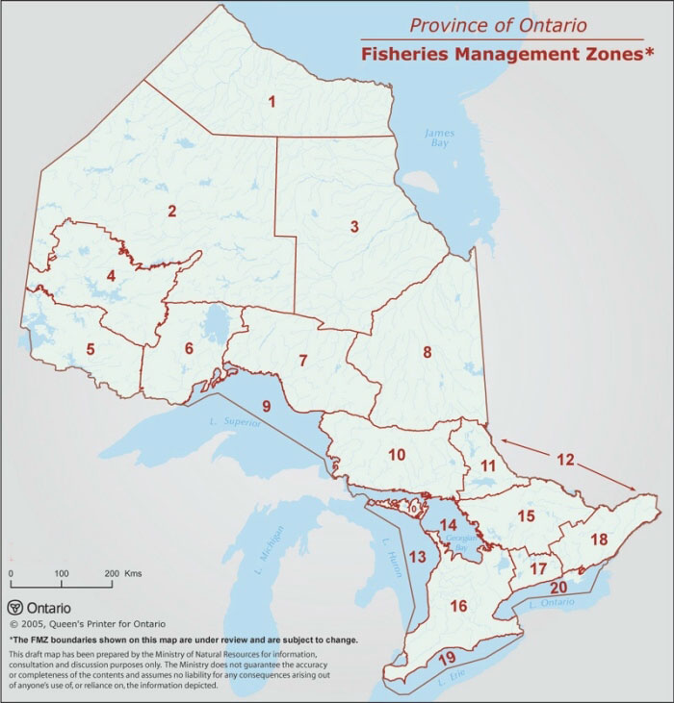

**Figure 2.** Map of Ontario showing its 20 FMZs

## Chapter 2: Overview of FMZ 16

### Environment

FMZ 16 is characterized by flat terrain, interspersed with rolling hills with significant ridges made up of glacier-deposited materials, such as the Oak Ridges Moraine. The Niagara Escarpment crosses FMZ 16 and provides an elevated rugged geography, characterized by steep slopes, fast flowing streams and cascading waterfalls.

FMZ 16 is the largest zone in southern Ontario, comprising an area of nearly 5.3 million hectares (52,671 square kilometers). The aquatic resource within the Zone is generally made up of large river systems, with more than 70,000 km of watercourses (rivers, streams and creeks) and relatively few lakes, reservoirs and wetlands compared to other FMZs.

Approximately 62 per cent of the land cover in FMZ 16 has been converted to agricultural lands, with urban areas making up more than 10 per cent of the Zone[1]. The remaining natural areas in the Zone, including forests, rivers and wetlands, support some of the richest diversity of plants and animals in Canada.

Within the province, the diversity of freshwater fish species is greatest in the south and typically decreases as you move north. Correspondingly, fish communities in FMZ 16 are some of the most diverse in all of Ontario, with 128 native and 17 naturalized fish species. There are currently 23 fish species at risk and 14 invasive fish species in the Zone.

Lake Simcoe is a significant waterbody within FMZ 16, which is also subject to the [*Lake Simcoe Protection Act*](https://www.ontario.ca/laws/statute/08l23) and Lake Simcoe Protection Plan. Discussions regarding FMZ 16 will need to consider how best to address the Lake Simcoe fishery in future planning work.

### Socio-economic

FMZ 16 supports the largest urban population of any zone. The estimate of the permanent population in the Zone is approximately 9.2 million inhabitants[2]. The Greater Toronto Area is the fastest growing region of the province with projections of the population increasing by 2.8 million or 41 per cent by 2041[3].

FMZ 16 offers a range of recreational fishing opportunities for residents and visitors, from world class inland trout fisheries to multispecies urban fisheries, often in close proximity to the largest communities. Consequently, FMZ 16 has the highest proportion of resident anglers of any zone in the province. Angling statistics from 2015 illustrate the extensive use of the sport fishery in FMZ 16, with over 300,000 active anglers reportedly spending almost 2 million days (9.8 million hours) fishing its waters.

The recreational fishery in FMZ 16 provides an important contribution to the regional and provincial economy. In 2015, anglers in FMZ 16 spent $152.7 million on goods such as rods, bait and boats, and on services such as guides and fishing tournaments. Ontario has 1,600 fishing-related tourism operators, generating hundreds of millions of dollars of economic activity annually.

The social and cultural benefits of a well-managed recreational fishery are plentiful. Fishing can improve overall health, wellbeing and prosperity by connecting anglers with family and friends and with nature and the outdoors. Fishing is an activity that builds and strengthens intergenerational relationships, allowing values and skills to be passed on through the shared use and mutual appreciation of the outdoors.

Fish are of central importance to First Nation and Métis peoples in Ontario. Fishing for food, social and ceremonial purposes is a part of a traditional way of life and often provides an essential component of nutrition.

## Chapter 3: Complexities of FMZ 16

The unique characteristics of FMZ 16 also makes fisheries management in the Zone more complicated. With this in mind, MNRF has identified some of the planning challenges in FMZ 16.

### Jurisdiction

FMZ 16 presents a unique planning environment because of the large number of organizations and levels of government with an interest in fisheries management.

* Fisheries of the Great Lakes are managed by provincial, state and tribal agencies, with support from the federal governments of Canada and the United States. It is important that FMZ 16 planning aligns with the existing Great Lakes fish community objectives.
* Within FMZ 16 there are 19 Conservation Authorities (CAs). Some CAs within the Zone have watershed-based fisheries management plans developed in cooperation with MNRF. It is important for MNRF to work collaboratively with CAs to seek integration with existing watershed-based plans where appropriate.
* There are 21 First Nations and Métis communities within FMZ 16, each with its own views of fisheries management.
* There are also 160 lower-tier municipalities located in the Zone, which are engaged in their own municipal planning processes.

### Stakeholders

Due to the large population, FMZ 16 houses a wide range of stakeholder groups with an interest in fisheries management. These groups hold diverse opinions about how FMZ 16 should be managed. For example, as we heard in Listening Sessions, there are different views about stocking native versus non-native/naturalized fish species and whether specific fisheries should be open to harvesting or restricted to catch-and-release.

### Access to the fishery

Accessing the fisheries of FMZ 16 has become increasingly difficult. Because FMZ 16 is predominately a private land base, there is limited ability for the public to access the fishery. In addition, increased shoreline development and competing recreational uses of water, such as boating and jet-skiing, have reduced angling opportunities.

### High angling pressure

Given the large population size and high population density in FMZ 16, waterbodies that have public access to the recreational fishery tend to experience relatively high fishing pressure. According to the 2010 Survey of Recreational Fishing in Canada, several rivers in FMZ 16 (Grand, Thames, Welland and Nottawasaga) are listed in the top 25 most fished waterbodies in Ontario. Ensuring that fish harvest levels in the Zone are sustainable is a priority.

### Land-use change

Watersheds in the Zone have the highest stress index values in the province, suggesting that aquatic habitat loss and degradation is highest in this part of the province[4] [5]. While agriculture dominates much of the land use, the Zone has also experienced significant urban growth with numerous large cities and considerable urban land cover. Both agricultural and urban land use have had impacts to fish and fish habitat in FMZ 16.

### Drainage

The most significant impact of agricultural drainage on aquatic ecosystems has been the direct loss and alteration of wetland and riparian habitats[6]. Ontario’s wetlands are biodiversity hotspots that serve as an important habitat for a variety of fish and other aquatic organisms, including many species at risk. Wetlands also improve aquatic habitats in other parts of their watersheds through sediment control, water quality improvement and water temperature moderation.

### Fragmentation

Increasing development and land use changes in FMZ 16 have resulted in habitat fragmentation for many species.

Dams and other barriers, such as weirs and culverts, are human made structures that alter the natural flow of rivers and streams and can prevent the passage of fish and other aquatic species. There are approximately 1,000 dams and more than 15,000 road crossings within the FMZ 16 watershed[7]. Migratory fish species, which spend part of their lives in the Great Lakes and migrate into rivers to spawn, are especially impacted by dams and other barriers as they can prevent movement to spawning and other critical habitats5.

### Invasive species

Invasive species cause additional stresses on fish communities in the Zone. Ontario has the highest number of invasive species in Canada and is at the greatest risk of new species invasions because of its large and mobile population and its geographic location. This is particularly true for FMZ 16 where over 41 aquatic invasive species have been reported.

### Climate change

Climate plays a fundamental role in the function and form of aquatic ecosystems. As the climate continues to change in Ontario, ecosystems will also be impacted and altered. Aquatic ecosystems are vulnerable to these changes as fish have very specific temperatures in which they can thrive which determines where on the landscape they can live. Increasing water temperatures will have the greatest impact on coldwater and coolwater species as these desired habitats are being reduced across FMZ 16.

### Species at risk

FMZ 16 has the highest number of fish species at risk (currently at 23) of all FMZs in the province. This includes species such as American Eel, Lake Sturgeon and Redside Dace. FMZ planning considers the pressures and risks for fish communities and species.

## Chapter 4: Overview of planning approach for FMZ 16

### Typical FMZ planning components

A chart showing typical FMZ planning components, including Advisory Council, Background Report, FMZ Plan and Consultation.


The current provincial approach to fisheries management at the zone level focuses on developing an FMZ fisheries management plan. Key planning components include the formation of an advisory council, writing of a background report and development of an FMZ plan.

 An advisory council typically consists of 10 to 20 volunteers who represent partners, stakeholder groups and the public with an interest in Ontario's fisheries resources. The council provides advice to MNRF concerning recreational fisheries management in the zone.

A background report is a compilation and analysis of fish data collected in the zone, providing detail on the current state of the fishery, target species of interest and information on the social and economic significance of the fishery. Information in the report is used to support the planning process, consultation with First Nation and Métis communities and informs fisheries management decisions.

The outcome of the typical FMZ planning process is the creation of an FMZ fisheries management plan that outlines the management strategies for fisheries in the zone. The plan reflects the current and desired future state of the fishery. It provides objectives, goals, indicators and benchmarks for fisheries in the zone.

### FMZ 16 planning approach

A modified planning approach may be needed in FMZ 16 in order to address the complex nature of the Zone. Given the diverse range of stakeholders and interests across FMZ 16, MNRF recognizes the importance of providing additional opportunities for the public and stakeholders to provide input into the planning approach. Incorporating information we heard during the fall 2017 Listening Sessions, this Discussion Paper provides an additional opportunity to provide input into an approach to for fisheries management in FMZ 16.

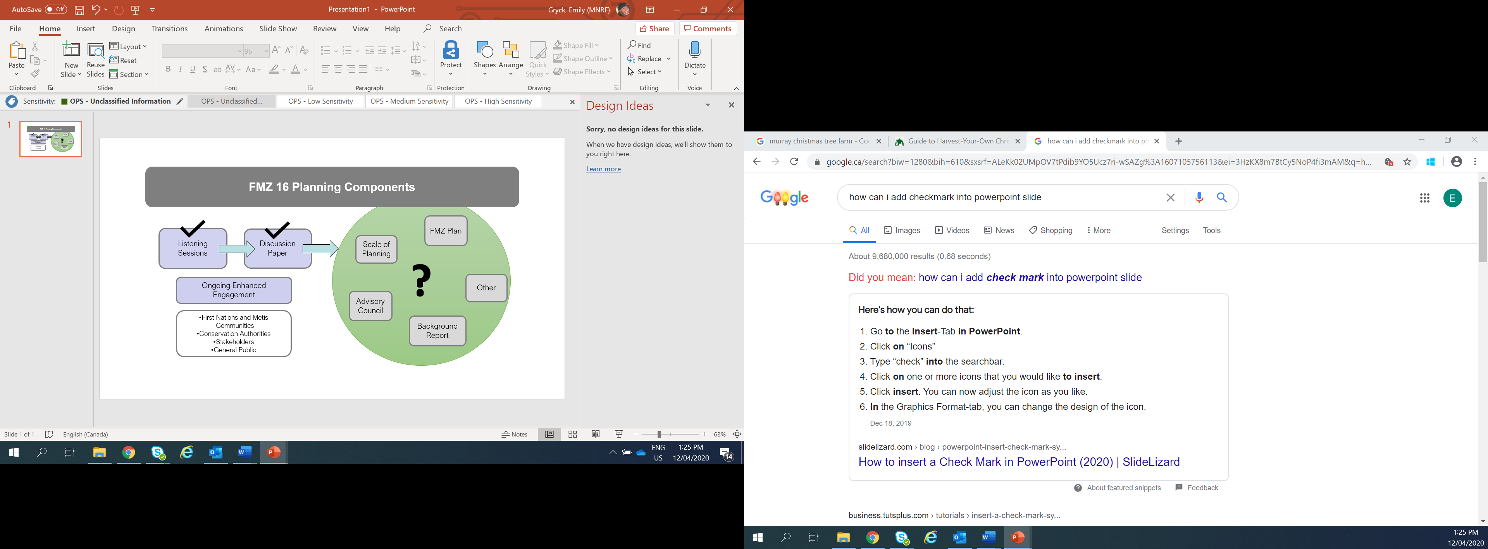

## Chapter 5: Listening session feedback summary

### Background

In the fall of 2017, Listening Sessions were conducted to launch fisheries management planning in FMZ 16. The intent of the sessions was to ask interested parties for advice on what planning for FMZ 16 should include and consider. MNRF invited stakeholders, members of the public and Conservation Authorities to Listening Sessions held across southwestern Ontario. MNRF also held sessions to hear from First Nation and Métis communities on how they would like to be engaged in FMZ 16 planning.

### Listening session feedback

The Listening Sessions resulted in a considerable amount of feedback. The comments received were analyzed and organized into themes and categorized according to whether they are within the scope of fisheries management planning.

Table 1 summarizes feedback that was obtained during the Listening Sessions and how the feedback could be considered and addressed.

### Table 1. Summary of Listening Session feedback

| **Theme** | **Summary of comments received during Listening Sessions** | **How the comments could be addressed and/or considered through fisheries management in FMZ 16** |
| --- | --- | --- |
| Collaboration | * Increase collaboration with First Nation and Métis communities, Conservation Authorities and other partners in fisheries management. * Improve coordination and collaboration with other government agencies (Ministry of Environment, Conservation and Parks, Ministry of Agriculture, Food and Rural Affairs, Department of Fisheries and Oceans Canada, Great Lakes Fishery Commission) to integrate objectives with their plans/policies. | * MNRF recognizes the need for increased collaboration with First Nation and Métis communities in FMZ 16 when it comes to fisheries management. First Nation and Métis communities have been engaged through Listening Sessions and we will continue to engage as fisheries management progresses in the Zone. * Sustainable natural resource management is a shared objective. There are many examples of MNRF and First Nation and Métis communities working cooperatively to achieve this shared objective. MNRF is seeking feedback on opportunities to work together towards this shared objective in this Discussion Paper. * MNRF also recognizes the important leadership role Conservation Authorities play in fish habitat protection, collecting fish community information, delivering aquatic stewardship programs and, in some cases, developing co-operative watershed-based fisheries plans. * MNRF has engaged Conservation Authorities through Listening Sessions, will make use of fisheries data collected by Conservation Authorities to inform decision making where possible and will continue to work with these groups as fisheries management in the Zone progresses. * Fisheries management planning in Ontario is based on collaboration and input from interested parties. * This Discussion Paper is seeking confirmation and additional feedback on how to best manage the fisheries in FMZ 16. |
| Watershed management | * Continued support for the development of watershed-based fisheries management plans. * Improve cooperation with Conservation Authorities with respect to watershed management. | * While MNRF typically manages fisheries at the zone level, there may be circumstances under which more localized planning is required to address a specific issue. * MNRF will continue to engage with Conservation Authorities on fisheries management in FMZ 16 and other related initiatives. * This Discussion Paper is seeking input on the appropriate scale at which fisheries should be managed within FMZ 16. |
| Scale of planning | * Use broad-scale planning to create linkages, focus restoration efforts in key areas and feed into other more localized efforts. * Consider alternative approaches to planning in different areas based on the linkages with watershed plan guidelines. * Consider a smaller scale of planning given that FMZ 16 is too large and complex a geographic area to be managed at the zone scale. * Ensure that broad planning does not hinder or constrain more local scale planning. | * This Discussion Paper is seeking input on the appropriate scale at which fisheries should be managed within FMZ 16. |
| Conservation | * Conserve and restore native species and species at risk to ensure sustainable fisheries management. | * Conservation and restoration of native species is a key component of conserving Ontario’s biodiversity. As such, this will remain a priority for managing the fisheries in FMZ 16. * Since the 2017 Listening Sessions, the provincial responsibility for Species at Risk and the Ontario Endangered Species Act has been transferred to the Ministry of the Environment, Conservation and Parks. |
| Fishing opportunities | * Improve access to fishing opportunities. | * MNRF supports outdoor recreational opportunities including access to fishing. * Access to fishing opportunities will be considered as fisheries management progresses in the Zone. |
| Stocking | * Incorporate ecological considerations, including genetic diversity and species interactions, in the development of stocking strategies. * Weigh the benefits and costs of stocking. * Focus on stocking native species. * Consider additional consultation with regards to stocking non-native species. | * It is anticipated that fish stocking will be an important topic of discussion as fisheries management progresses in the Zone. * MNRF and its partners continue to undertake research to ensure ecological factors are considered in stocking programs. This research will be considered when making fisheries management decisions in FMZ 16. |
| Sustainability | * Manage harvest and fishing activities to support sustainable fisheries and conservation. | * Harvest levels will be an important topic of discussion as fisheries management progresses in the Zone. * Management direction to support sustainable harvest levels is guided by MNRF policies and initiatives. |
| Ecosystem approach | * Recognize the importance of healthy and diverse ecosystems for fisheries and fish communities and ensure a balanced and integrated approach to management at the appropriate scale. | * A balanced approach to fisheries management will be an important topic of discussion as fisheries management progresses in the Zone. |
| Impacts of invasive species | * Manage invasive species and address concerns for the negative impacts of aquatic invasive species. * Promote invasive species awareness. | * MNRF recognizes the need to manage invasive species in FMZ 16 as well as their negative impacts on native species and ecosystems. These issues will be discussed as fisheries management progresses in the Zone. |
| Rights-based fishery | * Need for acknowledgement of rights-based fishery and its importance to First Nation and Métis communities. | * Many First Nation and Métis communities in Ontario hold Aboriginal or treaty rights to fish. Aboriginal and treaty rights are protected in the Canadian Constitution. MNRF is committed to respecting these constitutionally protected rights. * MNRF is responsible for the sustainable management of Ontario’s fish and wildlife resources and is committed to conservation. In doing so, MNRF respects the protection provided for existing Aboriginal and treaty rights as recognized and affirmed by section 35 of the [*Constitution Act*](http://laws-lois.justice.gc.ca/eng/Const/), 1982. * After conservation goals are met, Aboriginal and treaty rights to fish take priority before allocation and management of the resource for other purposes. * Sustainable natural resource management is a shared objective and there are many examples of MNRF and First Nation and Métis communities working cooperatively to achieve this shared objective. |
| Communication and engagement | * Ensure that there is transparent reporting of MNRF decision making and timelines for FMZ 16 planning. * Create more engagement opportunities and dialogue with stakeholders, the public and youth. * Consider engagement through online platforms and social media. | * MNRF has incorporated more opportunities for the public and other stakeholders to comment on the planning approach through Listening Sessions. * To reach a wider audience leading up to the Listening Sessions, MNRF utilized online and social media platforms. * This Discussion Paper also provides an opportunity for interested parties to provide feedback that will inform an approach to fisheries management in FMZ 16. |
| Science and monitoring | * Consider a need for standardized monitoring, baseline fisheries data and long-term monitoring programs in all waterbody types within the Zone. | * Broad-scale monitoring is MNRF’s core monitoring program for in-land fish communities and fish populations in FMZs across Ontario. In addition, MNRF’s Great Lakes Units also have specific monitoring programs for migratory fish species. Fisheries information is also collected by numerous partners, stakeholders and agencies – in particular by Conservation Authorities. * Analysis of fisheries data and information is key to informing fisheries management in any zone. |
| Education and outreach | * Engage youth and new anglers in fisheries and conservation initiatives through education and outreach. * Consider online educational tools and social media. * Increase public awareness/education on safe fish consumption, fish identification, fish handling and release, invasive species, water conservation, human impacts and regulations. | * There are many existing initiatives that aim to engage youth and new anglers. Further opportunities for engagement and outreach aimed at different audiences may be explored as fisheries management in the Zone progresses. * Partner agencies also have existing outreach and education initiatives related to fisheries, conservation and invasive species. |
| Water quality | * Focus on the health of waterways and the direct connection between aquatic ecosystem health and fish community health. * Promote mitigation of the impacts of development/ urbanization, agriculture, pollutants and other stressors on water quality. | * It is recognized that water quality is interconnected with fisheries management. Water quality in Ontario is managed by the Ministry of Environment, Conservation and Parks and other conservation agencies. * MNRF will continue to maintain dialogue with other agencies that have a role in addressing water quality and will engage and work with these agencies as needed. |
| Dams and barriers | * Explore opportunities to enhance fish passage for native species. * Consider options for dam removal and remediation. | * It is recognized that dams and other human-made structures can create barriers to the movement of both native and invasive species with potential impacts to fish habitats and communities. These impacts will be an important topic of discussion as fisheries management progresses in the Zone. |
| Fish and fish habitat conservation and restoration | * Promote and prioritize aquatic habitat rehabilitation and restoration. | * Opportunities to identify habitat restoration priorities will be considered as fisheries management progresses in the Zone. |
| Climate change | * Consider the impacts of climate change during fisheries management planning. | * It is recognized that the potential impacts of climate change on the fisheries resource will be an important consideration moving forward with fisheries management in FMZ 16. |
| Regulations | * Consider pros/cons of changing regulations, fishing seasons, catch limits, slot sizes, special regulations, fish sanctuaries, etc. | * Potential regulatory changes will be explored more thoroughly as fisheries management progresses in FMZ 16. In order to optimize decision making, these items will be considered once data analysis has been conducted. |
| Stewardship | * Explore options to increase stewardship opportunities. | * Stewardship initiatives are important for the protection and restoration of Ontario’s fisheries resource. * MNRF supports on-the-ground efforts in habitat enhancement and ecological restoration through a variety of initiatives. |

### Additional information

Through the Listening Sessions MNRF received feedback on several themes that are outside of what FMZ planning can address. For example, there were several comments related to enforcement, including recommendations for greater enforcement presence and capacity with stronger compliance tools, as well as the need for improved relations with local communities, including First Nation and Métis. Enforcement of natural resource legislation and MNRF’s enforcement program will not be specifically addressed through planning. However, this feedback, as well as any enforcement concerns that arise as fisheries management progresses in FMZ 16, will be shared with MNRF Enforcement Branch.

MNRF also heard feedback related to funding and capacity. It was noted that there may be a need to consider additional funding and resources for fisheries management initiatives including stewardship activities. The allocation of funding and resources is addressed more broadly at the provincial and program level and is not an area that can be specifically addressed during planning.

At the Listening Sessions several comments were received about licensing, with suggestions to improve licensing systems, review license fees and improve angler education with respect to licensing. Licencing for recreational fishing is addressed more broadly at the provincial level, and therefore, will not be specifically addressed through planning. Feedback obtained from the Listening Sessions will be shared with MNRF Licensing and Client Services Section.

Finally, the importance of information sharing was brought up in the Listening Sessions. Specifically, it was noted that there should be consideration for increased public access to MNRF research and data and greater accessibility in general to information online. The accessibility of information to the public occurs at a higher level than fisheries management zone planning and as a result will not be specifically addressed through planning.

## Chapter 6: Towards a planning approach for FMZ 16

Now that you have had the opportunity to read through the background information and the listening sessions feedback summary, MNRF is seeking feedback from you on proposals related to:

* the best scale for fisheries management planning in FMZ 16
* the best way to ensure stakeholders, Indigenous communities, conservation organizations and other relevant agencies can continue to participate in fisheries management planning

MNRF is bringing forward several concepts that build on the feedback received through the Listening Sessions. The concepts are described below, to stimulate discussion and solicit feedback that will help inform government direction toward developing a planning approach for FMZ 16.

MNRF acknowledges that the scale of planning and methods of engagement are linked and will influence one another. Based on the feedback MNRF receives, consideration will be given to ensure the scale of planning and method of engagement align.

### Scale of planning

Typically, throughout the planning process, goals, objectives, strategies and actions are developed at a zone-wide level. In most FMZs across Ontario, this approach has been effective. However, in FMZ 16, there are several unique complexities, outlined in Chapter 3. During the Listening Sessions, MNRF heard various ideas on how fisheries management planning could be adapted in FMZ 16 to address the many complexities in this Zone.

MNRF is seeking input on a scale of planning that best suits the needs of the Zone. Three scales of planning concepts have been developed for your consideration:

* Concept one – Planning at the zone level
* Concept two – Planning at the Great Lakes Watershed level
* Concept three – Planning at a scale reflective of the management issue

MNRF is not limited by the three concepts outlined below and will consider feedback obtained through this Discussion Paper.

### Table 2: Concept one – Planning at the zone level

| **Description** | **Opportunities** |
| --- | --- |
| Fisheries management would focus on issues that impact the Zone as a whole and management actions (e.g., regulations) would apply across the Zone.  Figure 1: Map of FMZ 16 boundary  Figure 1: Map of FMZ 16 boundary | * + Consistent with the approach found within guiding policies (e.g., Ontario’s Provincial Fish Strategy).   + Consistent with the planning approach used for all other inland FMZs across the province to date.   + May enable planning to occur in a more streamlined fashion, given that fisheries management will be addressed at a Zone level (i.e., will not address issues specific to individual watersheds). |

### Table 3: Concept two – Planning at the Great Lakes watershed level

| **Description** | **Opportunities** |
| --- | --- |
| Fisheries management would focus on addressing issues that impact each Great Lake watershed separately. This includes Lake Ontario, Lake Erie and Lake Huron watersheds in FMZ 16.  Figure 2: Map of Great Lakes watershed boundaries  Figure 2: Map of Great Lakes watershed boundaries | * + Aligns with feedback from Listening Sessions indicating a desire that FMZ 16 be managed on a smaller geographic scale.   + Reflects known differences in the fisheries across the landscape (e.g. Atlantic Salmon is unique to a select few Lake Ontario tributaries in FMZ 16).   + A smaller geographic scale allows more integration. Stakeholders and agencies could adopt relevant FMZ 16 priorities.   + Management at this scale may better align with Great Lakes fish community objectives. |

### Table 4: Concept three – Planning at a scale reflective of the management issue

| **Description** | **Opportunities** |
| --- | --- |
| Fisheries management would focus on addressing issues using a combination of zone-wide and sub-zone (i.e., Great Lakes watershed) scales.  The determination of the appropriate geographic scale of planning (e.g., zone, Great Lakes, etc.) would depend on the nature of the issue.  For example, issues related to regulations could be addressed at a zone-wide scale, whereas stocking could be addressed at a sub-zone level.  See Figure 1 for map of zone boundary, Figure 2 for map of Great Lakes watershed boundaries and Figure 3 for tertiary watershed boundaries.  Figure 3: Map of tertiary watershed boundaries  Figure 3: Map of tertiary watershed boundaries | * + Aligns with feedback from Listening Sessions indicating a desire that FMZ 16 be managed on a smaller geographic scale.   + Provides flexibility to choose the appropriate scale as issues are brought forward.   + Allows for consideration and integration of Conservation Authority cooperative watershed-based plans. * Stakeholders and agencies could adopt or align with relevant FMZ 16 priorities. |

### Collaborative approach

Management of recreational fisheries is intended to be an inclusive effort that enables collaboration between parties who have a shared interest in the stewardship of the fishery. In typical FMZ planning across the province, collaboration occurs through an advisory council to increase involvement of the public in recreational fisheries management decision making.

MNRF is committed to working alongside First Nation and Métis communities to determine the best way forward with respect to balancing and sharing the fishery resource.

MNRF is seeking your input on determining an effective method through which to engage and collaborate with interested parties that suits the complex needs of FMZ 16 and best aligns at the scale with which fisheries management planning in the Zone will be undertaken. Two concepts have been developed, which include:

* Concept one – Collaborative advisory stakeholder and partner committee
* Concept two – Inter-agency committee (in addition to stakeholder and partner committee)

MNRF is considering the following concepts to meet the needs of the Zone. MNRF is not limited by the concepts outlined below and will consider all feedback received as a result of this Discussion Paper.

### Table 5: Concept one – Collaborative advisory committee

| **Description** | **Membership** | **Details** | **Opportunities** |
| --- | --- | --- | --- |
| The collaborative advisory committee works together to provide advice that is considered by MNRF in FMZ planning and decision making. | The committee could be made up of partners and stakeholders that have an interest in the FMZ 16 fishery, including (but not limited to) First Nation and Métis representatives, stakeholders, academics, angling groups, non-consumptive user groups, conservation organizations and tourism representatives. | * + This type of committee is a planning approach used for all other inland FMZs across the province to date. In other FMZs this group is called the Advisory Council.   + Typically, the Advisory Council’s primary role is to provide advice and recommendations to develop a fisheries management plan and to inform plan implementation. | * + Supports an inclusive and collaborative approach to managing recreational fisheries in FMZ 16.   + Contributes to ensuring MNRF has a more fulsome understanding of the varying perspectives on issues related to the fisheries in FMZ 16. |

### Table 6: Concept two – Inter-agency committee (in addition to a collaborative advisory committee)

| **Description** | **Membership** | **Details** | **Opportunities** |
| --- | --- | --- | --- |
| The Inter-agency Committee would provide a forum for engagement of other agencies with roles and responsibilities that intersect with fisheries management in FMZ 16.  This committee would inform and be informed by the FMZ 16 planning team and collaborative advisory committee. | In addition to MNRF, the Inter-Agency Committee could be made up of Conservation Authorities, relevant provincial and federal government agencies (e.g., Ministry of Environment Conservation and Parks, Ontario Ministry of Agriculture, Food and Rural Affairs, Department of Fisheries and Oceans) and relevant associations (e.g., Association of Municipalities Ontario). | * + An Inter-Agency Committee could provide a forum to discuss fisheries management issues that overlap across agencies. Agencies could bring forward issues and discuss potential goals, objectives, strategies and actions that could contribute to sustainable fisheries management. | * + Supports increased inter-agency collaboration and an opportunity to strengthen relationships.   + Enables all agencies to bring forward relevant issues and discuss potential goals, objectives, strategies and actions that could contribute to the sustainable management of fisheries in the Zone. |

## Chapter 7: How to provide feedback

This discussion paper is intended to seek input on proposed concepts that may help inform fisheries management in FMZ 16.

Your feedback is important and valuable. Please provide your comments and suggestions via the Environmental Bill of Rights Environmental Registry posting by visiting [Environmental Registry of Ontario](https://ero.ontario.ca/) and entering posting number 019-3564.

All comments are welcome, and we ask that you consider the following questions:

1. **Do you feel that this Discussion Paper captures the key themes or priority areas for consideration with respect to fisheries management in FMZ 16?** 
   1. Yes or no
   2. If not, why? Do you have any other suggestions to improve Fisheries Management in FMZ 16?

1. **Of the themes identified in Table 1 (Summary of Listening Session Feedback), which themes in your opinion are most important for consideration with respect to fisheries management in FMZ 16?** Please list your top three choices.

Are there any other important themes that should be considered? If yes, please list the concept and explain why it is important.

1. **In this discussion paper, MNRF has presented concepts to address the feedback received with respect to the appropriate scale for fisheries management in FMZ 16:**
   1. **Planning at a zone level**
   2. **Planning at a Great Lakes watershed level**
   3. **Planning at a scale reflective of the management issue**

Which concept do you think is best suited for fisheries management in FMZ 16?

Are there other concepts that could also be considered? What are some of the opportunities of these other concepts?

1. **In this discussion paper, MNRF has also presented concepts to address the feedback received to help establish an effective method to engage and collaborate with interested parties in FMZ 16:**
   1. **Collaborative advisory committee**
   2. **Inter-agency Committee**

Which concept do you think is best suited for fisheries management in FMZ 16?

Are there alternative concepts that could also be considered? What are some of the opportunities of these other concepts?

## 

## Glossary

**Aboriginal peoples:** Use of the term Aboriginal in this Discussion Paper is intended to be consistent with the definition provided in the Constitution Act, 1982. “Aboriginal peoples of Canada” includes the Indian, Inuit and Métis peoples of Canada.

**Allocation:** Assignment of aquatic resources for fish production and other water uses. This includes providing for sufficient numbers of fish to escape harvest in order to perpetuate the fishery as well as assigning a portion of the annual allowable yield to a group or individual.

**Benchmark:** A reference value used to assess progress towards achieving fisheries management targets and objectives.

**Biodiversity:** The natural variety and variability among all living organisms from all sources, including among terrestrial, marine and other aquatic ecosystems, the ecological complexes in which they naturally occur and the ways in which they interact with the physical environment. Biodiversity includes the diversity of genes, populations and species and communities and ecosystems.

**Climate change:** Any change in climate over time due to natural variability or as a result of human activity.

**Collaboration:** Involves partners working together to reach an identified and shared goal. Collaboration exists where (1) partners share mutual interests, goals and objectives, (2) partners each invest knowledge, skills and resources to achieve jointly identified outcomes and (3) success and achieving planned results brings benefits to each party. Collaboration does not imply legislative authority, jurisdiction or devolution of responsibility.

**Conservation:** The management of the human use of natural resources so they may yield the greatest sustainable benefit to current generations, while maintaining the potential to meet the needs of future generations. Thus, conservation is positive, embracing preservation, maintenance, sustainable utilization, restoration and enhancement of the natural environment.

**Ecosystem(s):** A dynamic complex of plant, animal and microorganism communities and their physical environment functioning as an ecological unit.

**Ecosystem health:** The ability of an ecosystem, through its structure and functions, to sustain biological diversity, biotic integrity and biological processes over time.

**First Nation and Métis communities:** First Nation and Métiscommunities with Aboriginal and treaty rights within FMZ 16.

**Fish:** Includes parts of fish, shellfish, crustaceans, marine animals and any parts of shellfish, crustaceans or marine animals and the eggs, sperm, spawn, larvae, spat and juvenile stages of fish, shellfish, crustaceans and marine animals (as defined in *Canada’s Fisheries Act*).

**Fish community objectives:** In the context of Great Lakes fisheries management, they provide a common framework for agencies to develop and implement complementary fishery management programs.

**Fish habitat:** Spawning grounds and any other areas, including nursery, rearing, food supply and migration areas, on which fish depend directly or indirectly in order to carry out their life processes (as defined in *Canada’s Fisheries Act*).

**Fishery/fisheries:** A term that is usually used to describe the human use of fish and includes catching, releasing, preparing and selling fish.

**Fisheries Management Zone (FMZ):** The province’s 20 FMZs are the primary units for planning, management and monitoring most fisheries in Ontario and were determined using a combination of ecological factors and angler use patterns.

**Fisheries resource(s):** Ontario’s fisheries resources include fish species, fish communities, commercial, recreational and Aboriginal fisheries and the aquatic ecosystems that support them. In the interests of brevity, this Discussion Paper refers to “Ontario’s fisheries resources” to reflect this broader meaning.

**Genetic diversity:** The variety of genetic information contained within individuals of a particular species in an area. It generally improves the ability of a species to adapt to environmental stresses such as climate change.

**Goals (FMZ plan):** Are overarching statements made about a desired state of the fishery.

**Habitat fragmentation**: The process where large areas of habitat are divided into smaller and more isolated areas.

**Habitat protection:** The prescribing of guidelines and conditions and enforcement of laws, for the purpose of preventing the harmful alteration, destruction or disruption of fish habitat.

**Indicator(s):** Variables that are measured to track progress toward fisheries objectives. For example, the measured natural mortality rate of a fish population.

**Invasive species:** Alien species whose introduction or spread threatens the environment, economy and/or society, including human health (e.g., Rusty Crayfish).

**Issue:** A concern that impedes achievement of a goal.

**Lake:** A standing body of water; including a pond.

**Management actions (FMZ plan):** The specific tasks that must be done to implement strategies, address specific issues and to meet management objectives.

**Migratory fishes:** Species that undergo periodical migrations (e.g., American Eels spawn in tributaries off the St. Lawrence River and Lake Ontario and migrate to the ocean for breeding).

**Mitigation:** Actions taken during the planning, design, construction and operation of works and undertakings to alleviate potential adverse effects on the productive capacity of fish habitats.

**Native species:** Species that occur naturally or which have migrated into a region and become established through natural mechanisms. Native species do not include species that have been transported by humans or have been able to establish themselves because of human alterations of the region’s environment.

**Naturalized species:** Alien species (species introduced beyond their natural past distribution) that have established stable self-sustaining populations (e.g., Alewife).

**Objectives (FMZ plan):** Describe what is wanted to achieve in the future or the “desired end result”. Objectives need to contribute to the broad and specific fisheries management goals for the zone, be consistent with strategic direction and guiding principles and must be measurable. Objectives can reflect biological or social considerations. In most cases, objectives are identified that benefit both the sustainability of the resource and to provide quality fisheries.

**Recreational fisheries:** Fish caught under the authority of a license for personal benefit (e.g., food, enjoyment).

**Rehabilitation:** The return of a species, population or ecosystem to a healthy, functioning state.

**Restoration:** The return of a species, a population or an ecosystem to the state in which it existed prior to a disturbance.

**River:** A flowing body of water; including creeks, streams or brooks.

**Science:** Research (i.e., the development and synthesis of fact-based knowledge derived through rigorous scientific methods) and related activities such as monitoring and assessing resources, transferring science knowledge and providing scientific advice. Both natural and social science are included in this definition.

**Socio-economic factors:** The social and economic aspects of fisheries resources use and management, including considerations such as demographic patterns and trends, economic activity (spending) and cultural norms and preferences.

**Species at risk:** Any wild species threatened by or vulnerable to extirpation or extinction. Under Ontario legislation, species at risk are assigned a designation to represent the degree of imperilment (i.e., special concern, threatened, endangered or extirpated).

**Stakeholder:** A person or organization with an interest or stake in fisheries and the aquatic ecosystems that support them.

**Stewardship:** An ethic that embodies cooperative planning and management of environmental resources in which individuals, organizations, communities and other groups actively engage in the prevention of habitat loss, or the facilitation of resources recovery and/or rehabilitation (including education and outreach), usually with a focus on long-term sustainability.

**Strategies (FMZ plan):** General approaches or decision-making processes that must be taken on an ongoing basis.

**Stress/stressor:** A stimulus or succession of stimuli which, if of sufficient magnitude, will tend to disrupt the stability of a system.

**Sustainable:** The potential for long-term maintenance of well-being, which has biological, environmental, economic and social dimensions.

**Watershed:** The area of land that drains into a river, lake or other water body.

## 

## References

1. Agriculture and Agri-Food Canada (AAFC) -Annual Crop Inventory 2017, Satellite Imagery. Retrieved from <http://www.agr.gc.ca/eng/home/?id=1395690825741>
2. Statistics Canada. (2016). Population and Dwelling Counts, 2016 Census. Retrieved from <https://www12.statcan.gc.ca/census-recensement/2016/dp-pd/hlt-fst/pd-pl/comprehensive.cfm>
3. Ontario Ministry of Finance. (2018). Ontario Population Projections Update, 2017-2041. Based on the 2011 Census. Queen’s Printer for Ontario.
4. Chu, C., C.K. Minns, N.P. Lester, and N.E. Mandrak. (2015). An updated assessment of human activities, the environment, and freshwater fish biodiversity in Canada. *Canadian Journal of Fisheries and Aquatic Sciences*, 72,135-148.
5. Ontario Biodiversity Council. (2015). State of Ontario's Biodiversity. Ontario Biodiversity Council, Peterborough, Ontario. Retrieved from <http://ontariobiodiversitycouncil.ca/sobr>
6. Blann, K.L., J.L. Anderson, G.R. Sands, and B. Vondracek, B. (2009). Effects of agricultural drainage on aquatic ecosystems: A review. *Critical Reviews in* *Environmental Science and Technology*, 39, 909-1001.
7. Wisconsin Institutes for Discovery. (2018) Fishwerks. Retrieved from <https://greatlakesconnectivity.org/>