Project Summary

**K+S Windsor Salt Ltd. Mining Rights Only Leases (#106466/107254) - Renewal**

The Ministry of Energy, Northern Development and Mines (ENDM) will be renewing two existing mining leases and is considering whether to apply new terms and conditions to the leases in connection with this renewal.

The Ojibway Mine located in Windsor, Ontario has been in operation since 1955 and employs over 225 people. On an annual basis, the Ojibway Mine produces up to 3 million metric tons of salt.

K+S Windsor Salt Ltd. (the “Company”) has a comprehensive network of salt production sites throughout Canada designed to produce and package salt for consumer and industrial uses. The Company is engaged in the recovery, processing and sale of salt, and provides over 200 evaporated and rock salt products under its well-known Windsor and Safe-T-Salt brand names. Products made from evaporated salt (recovered from brine) are used in household and food products, as well as for agricultural, water softening and industrial purposes. Mined rock salt is sold to household and industrial markets for ice control.

The Company holds three mining leases issued under the *Mining Act* which allow for rock salt extraction beneath the Detroit River in southern Ontario, two of which are up for renewal. The mining leases are for lands that were not subject to the mining claim registration process, due to the unique nature of salt extraction and the location of the lands.

The two leases up for renewal each contain renewal provisions for at least one additional term of 21 years if mine production is expected to last longer than the current term. The conditions to this renewal have been satisfied so the company is entitled to renewed leases; however, it is open to the Province to impose new terms and conditions on the leases, if determined expedient. The existing terms and conditions in the leases that confirm the leases are subject to applicable environmental legislation, as well as the terms and conditions that protect water quality, natural water flow, navigation of the waters, and fishing rights, are proposed to be retained. To view copies of the leases, as well as the proposed new draft terms for the renewed leases, navigate to the posting for this item on the Environmental Registry of Ontario at <https://ero.ontario.ca/>.

These two leases are essential for the continued operations of the underground salt mine. They form an integral part of the overall mining operation as they provide travel and escape ways to the mine including critical sub-surface equipment such as the main conveyor belt and air exhaust systems.

The mining area is progressing south beneath the Detroit river and away from the mine shaft and surface infrastructure.

There are no new environmental impacts anticipated as a consequence of the proposal, as most of the mine’s activities are underground and such activities are regulated by other environmental legislation and regulations, not through the terms and conditions of the lease.

Location Map:

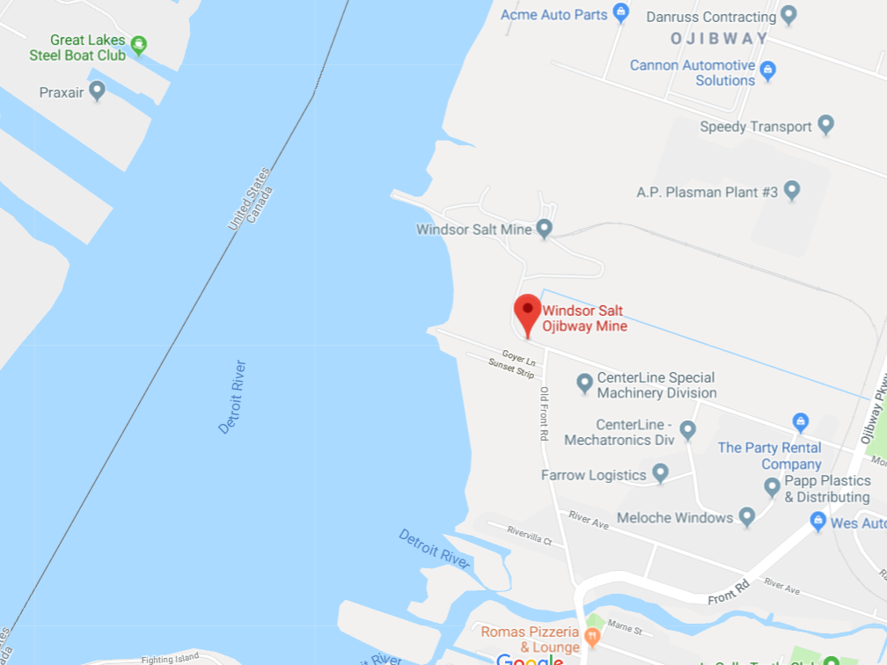

Source: <https://maps.google.com>

Location of Mining Leases:

