**Ministry of Mines**

**Assessment Work – Allocating Credits, Applying Credits and Making Payment in Place**



Mining Lands Section

Policy Updated: July 2022

Table of Contents

Purpose 3

Background 3

Limit on the Amount of Assessment Work Credits a Claim Can Receive 4

Limit on the Amount of Assessment Work Credits that Can Be Allocated from Mining Lands 4

Ownership and Assessment Work Manager 5

Contiguity of Mining Claims 5

Contiguity of Mining Lands 7

Example of Complex Contiguity 12

Payment in Place of Assessment Work 12

Contact Mining Lands Section 13

Authority Detail 14

Mining Act R.S.O. 1990 M. 14 14

Work on mining lands 14

Ontario Regulation 65/18: Assessment Work 14

System of assessment work credits 14

How system works 14

Distribution of assessment work credit 15

Assessment work manager 16

Limits on distribution of credits 16

## Purpose

The purpose of this policy is to provide direction to claim holders and decision makers with respect to their options for meeting their assessment work requirements pursuant to the Mining Act, R.S.O. 1990 M.14 (the Act) and Ontario Regulation 65/18 (the Regulation). Claim holders may **allocate credits**, **apply credits,** or make **payment in place.** [1]

## Background

Claim holders must satisfy their required annual units of assessment work to keep their claims in good standing. They must perform assessment work and submit an assessment work report that complies with the Technical Standards for Reporting Assessment Work through the Mining Lands Administration System (MLAS). The Minister reviews the report and assigns assessment work credits as set out in the Regulation. The assessment work credits are then placed in the reserve of the mining lands on which the work was performed.

Assessment work credits in the reserve for mining lands can then be distributed to a mining claim to satisfy the claim’s annual assessment work requirements. There are two types of distribution of assessment work credits:

* Assessment work credits can be ***applied*** from the reserve of a mining claim to satisfy the annual units of assessment work required for that claim; or
* Assessment work credits can be ***allocated*** from the reserve of any mining lands (be the lands a mining claim, or another type of mining land) to satisfy the annual units of assessment work required for a contiguous mining claim.

The MLAS application shall be used to distribute and apply assessment work credits. The Ministry has prepared directives pertaining to distributing and applying assessment work credits. The documents are available through the Ministry’s website: [Distribute Approved Credit](https://www.mndm.gov.on.ca/en/mines-and-minerals/mlas/directive5-7-distribute-approved-credits), [Submit a Pending Distribution](https://www.mndm.gov.on.ca/en/mines-and-minerals/mlas/directive5-4-submit-pending-distribution) and [Revise Pending Distribution](https://www.mndm.gov.on.ca/en/mines-and-minerals/mlas/directive5-4-revise-pending-distribution).

In certain circumstances, a claim holder may make a ***payment in place*** of performing assessment work required for a mining claim. A payment in place shall be made to the Minister on or before the due date of the mining claim. Payments must be submitted via MLAS; claim holders can reference the [Payment in Place](https://www.mndm.gov.on.ca/en/mines-and-minerals/mlas/directive5-6-payment-in-place-for-new-claims) directive available on our website.

## Limit on the Amount of Assessment Work Credits a Claim Can Receive

The amount of assessment work credits that a mining claim can receive is the amount required to satisfy the current annual unit of assessment work and the five subsequent annual units.

## Limit on the Amount of Assessment Work Credits that Can Be Allocated from Mining Lands

The maximum amount of assessment work credits that may be allocated from the reserve of any mining lands are set based on the type of tenure involved, and the size of the mining lands.

For mining claims, the maximum amount of assessment work credits that can be allocated from a reserve are as follows:

|  |  |
| --- | --- |
| **Claim Size** | **Maximum Allocation per assessment year** |
| Boundary claim | $50,000 |
| 1 to 2 cells | $50,000 |
| 3 to 5 cells | $100,000 |
| 6 to 25 cells | $150,000 |

For mining lands other than mining claims, such as leases, patents or licenses of occupation (whether exploratory or mining) the maximum amount of assessment work credits that can be distributed from a reserve are as follows:

|  |  |
| --- | --- |
| **Area (ha)** | **Maximum Allocated per calendar year** |
| ≤25 | $50,000 |
| >25 to ≤100 | $100,000 |
| >100 | $150,000 |

## Ownership and Assessment Work Manager

Assessment work credits from the reserve of the mining lands can not be distributed to a contiguous mining claim unless the lands are:

* owned or held by the same person,
* or where the claims or lands are owned or held by a group of persons, have at least one holder or owner in common, or
* have a common assessment work manager appointed.

## Contiguity of Mining Claims

Mining claims are contiguous to one another if the cells on the provincial grid in which the mining claims are located are contiguous to one another as defined in section 17(4) of the Regulation.

For the purposes of allocating assessment work credits from a reserve of a mining claim (provider) to another contiguous mining claim (receiver), contiguity is considered established when the cells on the provincial grid in which the mining claims (including boundary claims) are located are contiguous to one another in any of the following ways:

1. The cells touch one another on at least one side or at least at one corner (Figure 1).

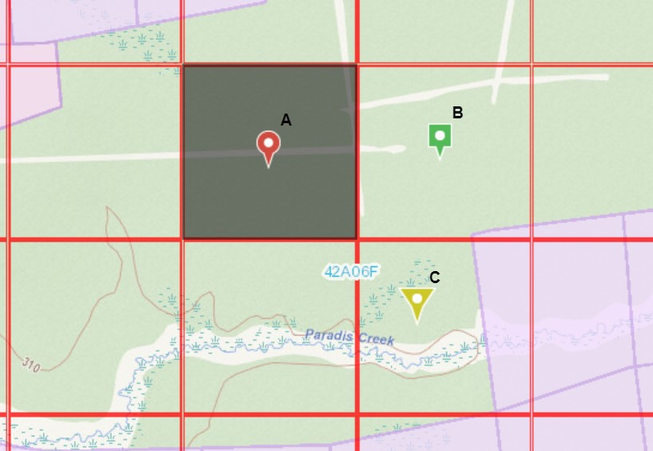

Figure 1: Cell A (provider claim) is contiguous with Cell B (receiver claim) and Cell C (receiver claim). Cell A touches Cell B on one side. Cell A touches Cell C at one corner.

1. A cell is contiguous to another cell even though they do not touch each other but the cells are connected through one or more cells each contiguous with one another by at least one side or at least at one corner (Figure 2)

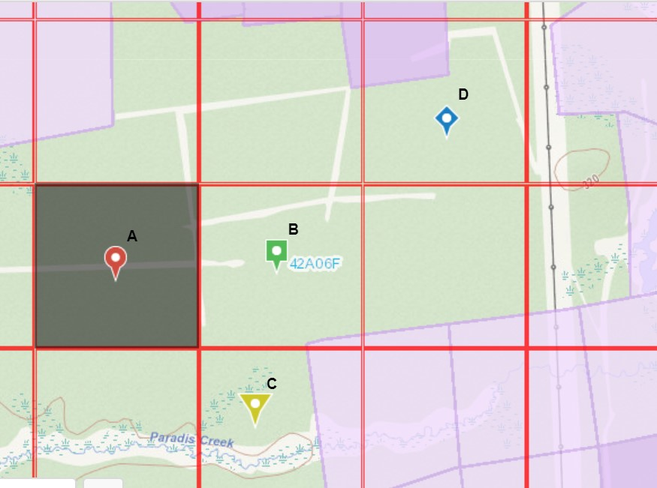

Figure 2: Cell A (provider claim) is contiguous with Cell D (receiver claim). Cell A touches one side of Cell B and Cell B touches one corner of Cell D.

## Contiguity of Mining Lands

Mining lands (including mining claims and mining lands other than mining claims) are contiguous if they meet the rules for contiguity set out in subsections 17(4), (5) and (6) of the Regulation.For the purposes of allocating assessment work credits from a reserve of mining lands other than a mining claim to a contiguous mining claim, contiguity is considered established when:

1. the mining lands are located,
2. in the same cell as the mining claim (Figure 3)

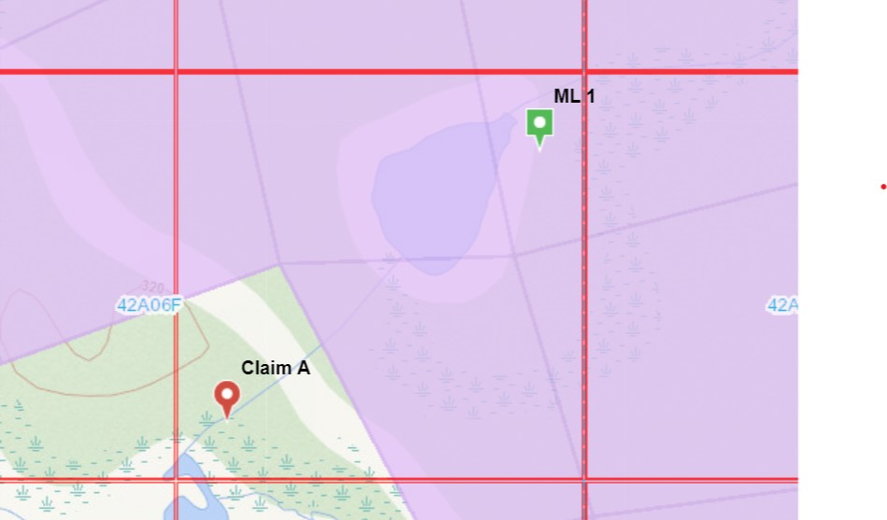

Figure 3: Mining Lands 1 (ML 1 (provider)) is contiguous with Claim A (receiver). ML 1 does not touch Claim A however ML 1 and Claim A and are in the same cell.

1. in the same cell as another mining claim that is contiguous with the receiver claim in question connected through one or more cells each contiguous with one another by at least one side or at least at one corner (Figure 4)

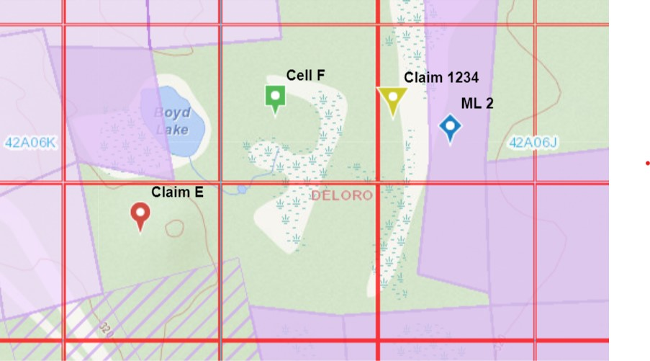

Figure 4: Mining Lands 2 (ML 2 (provider)) is contiguous with Claim E (receiver). ML 2 and Claim 1234 are in the same cell, Claim 1234 has a side that touches Cell F (Claim F) and Cell F has a corner that touches Claim E.

Note: The bottom of the pushpin identifies the location of the mining lands or the mining claim.

1. The boundaries of the mining lands touch the boundaries of other mining lands that are not a mining claim and a part of those other mining lands and are located:
2. the same cell as the mining claim (Figure 5)

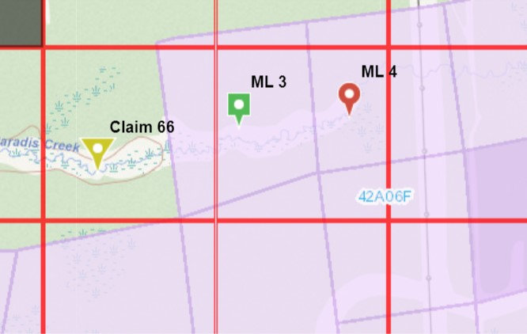

Figure 5: Mining Lands 4 (ML 4 (provider)) is contiguous with Claim 66 (receiver). The boundary of ML 4 touches the boundary of ML 3 and part of ML 3 is in the same cell as Claim 66.

1. in the same cell as another mining claim that is contiguous with the mining claim in question connected through one or more cells each contiguous with one another by at least one side or at least at one corner (Figure 6)

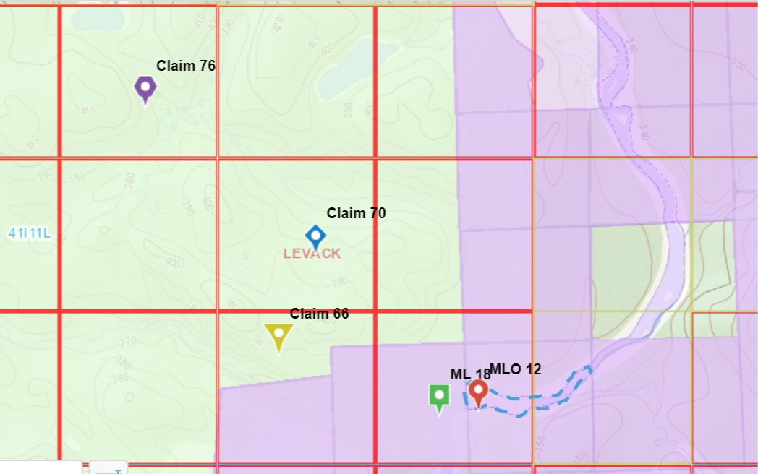

Figure 6: Mining Lands 12 (MLO 12 (provider identified by blue hatched area)) is contiguous with Claim 76. The boundary of MLO 12 touches ML 18 and a part of ML 18 is in the same cell as Claim 66. Claim 66 has a boundary that touches Claim 70 and Claim 70 touches the corner of Claim 76.

Note: The bottom of the pushpin identifies the location of the mining lands.

## Example of Complex Contiguity

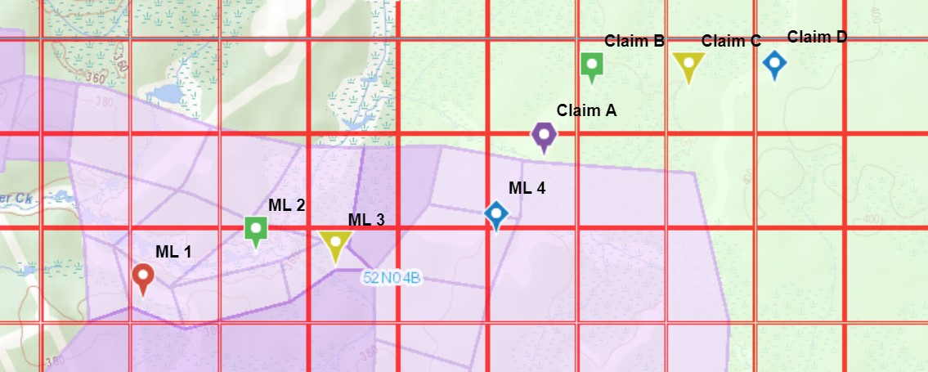

Figure 7: Mining Lands 1 (ML 1 (provider)) is contiguous with Claim D (receiver). ML 2 touches a point on the boundary of ML 1 and touches a boundary of ML 3. ML 3 touches a corner of ML 4. ML 4 is in the same cell as Claim A. Claim A touches a corner of Claim B. Claim B touches a boundary of Claim C. Claim C touches a boundary of Claim D.

Note: The bottom of the pushpin identifies the location of the mining lands.

**Note**: Patented mining lands owned in fee simple must be entered on the mining land tax record before they may be used to establish contiguity. If a property is not entered on the mining land tax record, the owner must provide written notice to the Ministry at least 30 days prior to allocating assessment work credits in MLAS. Please refer to the Mining Land Tax policy for more information.

## Payment in Place of Assessment Work

A claim holder may make a payment in place of assessment work required for a mining claim. The following are the prescribed limitations:

1. Payment in place must be made to the Minister on or before the due date of the mining claim,
2. Payment in place can only be made after the first unit of required assessment work has been fulfilled,
3. A payment in place can only be made for the current assessment year,
4. A payment in place cannot exceed the required amount to keep the mining claim for the current year,
5. A payment cannot be made for two consecutive years on the mining claim.

## Contact Mining Lands Section

For all inquiries about assessment costs please contact:

Ministry of Mines

Mining Lands Section

Land Tenure and Assessment Unit

B-3, 933 Ramsey Lake Road

Willet Green Miller Centre

Sudbury, ON P3E 6B5

Toll Free Telephone: 1-888-415-9845

Email: mlas.ltau@ontario.ca

## Authority Detail

## Mining Act R.S.O. 1990 M. 14

## Work on mining lands

66(3) Assessment work performed on mining lands or payment made in place of assessment work may be allocated to contiguous unpatented mining claims in the prescribed manner.  2009, c. 21, s. 34 (3).

## Ontario Regulation 65/18: Assessment Work

## System of assessment work credits

**8.**(2) The purpose of assessment work credits is to allow a claim holder to use the credits in accordance with this Part to satisfy annual units of assessment work that are required to be performed on the claim under section 65 of the Act.

(4) Under the system of assessment work credits, a claim holder shall be permitted to,

(a) use assessment work credits assigned for assessment work performed on mining lands other than the mining claim to satisfy the annual units of assessment work required for the mining claim, so long as the mining lands are contiguous to the mining claim; and

(b) use assessment work credits assigned for assessment work performed in a given assessment year on the mining claim or on mining lands other than a mining claim to satisfy the annual units of assessment work required for that assessment year and for subsequent assessment years, subject to the limitations set out in section 19.

## How system works

**9.**(1) The Minister shall review all assessment work reports submitted under section 6 and evaluate the assessment work described in the report in order to,

(a) determine in accordance with section 12 whether the work is eligible for assessment work credits; and

(b) determine in accordance with section 13 the amount of assessment work credits to be assigned to the work.

(2) The Minister shall transfer the amount of assessment work credits into a reserve for the mining claim established under section 16.

(3) The claim holder may distribute assessment work credit from a reserve to the mining claim in accordance with sections 17 and 19 in an amount that is sufficient to satisfy the annual units of assessment work that the claim holder is required to perform on the claim under section 65 of the Act,

(a) for the assessment year in which the assessment work is performed;

(b) for assessment years subsequent to the assessment year in which the assessment work is performed, subject to the limitations in section 19; or

(c) for both types of assessment years described in clauses (a) and (b).

## Distribution of assessment work credit

**17(4)** For the purposes of allocating assessment work credits from a reserve for a mining claim to another contiguous mining claim under clause (3) (b), mining claims are considered to be contiguous to one another if the cells on the provincial grid in which the mining claims are located are contiguous to one another in any of the following ways:

1. A cell is contiguous with another cell if the two cells touch one another on at least one side or at least one corner.

2. A cell is contiguous to another cell even though they do not touch each other as described in paragraph 1 if the cells are connected through one or more cells each contiguous with one another in the manner described in paragraph 1.

**17(5)** For the purposes of allocating assessment work credits from a reserve of mining lands other than a mining claim to a contiguous mining claim under clause (3) (b), the mining lands are considered to be contiguous to a mining claim if,

1. The mining lands are located,
2. in the same cell as the mining claim, or
3. in the same cell as another mining claim that is contiguous with the mining claim in question in accordance with subsection (4); or
4. The boundaries of the mining lands touch the boundaries of other mining lands that are not a mining claim and a part of those other mining lands are located,
5. in the same cell as the mining claim, or
6. in the same cell as another mining claim that is contiguous with the mining claim in question in accordance with subsection (4).

**17(6)** The holder or owner of mining lands shall not allocate assessment work credits from the reserve of the mining lands to a contiguous mining claim unless the mining lands and the mining claim, and any mining claims or mining lands that connect them in accordance with the rules on contiguity described in subsections (4) and (5),

1. are held or owned by the same person;
2. if any of the mining claims or mining lands are owned or held by a group of persons, have at least one holder or owner in common; or
3. have the same assessment work manager appointed in accordance with section 18.

## Assessment work manager

**18.**(1) The holder or owner of mining lands may appoint an assessment work manager to distribute assessment work credits in the reserves for the mining lands in the place of the holder or owner in accordance with this Regulation.

## Limits on distribution of credits

**19.**The amount of assessment work credits that may be distributed from a reserve for a mining claim or for other mining lands to a mining claim at any given time is subject to the following limitations:

1. The amount of assessment work credits distributed to a mining claim shall not exceed the amount required to satisfy the annual units of assessment work required for the assessment year in which the distribution is made and the five subsequent assessment years.

2. The maximum amount of assessment work credits that may be allocated from the reserve for a mining claim to one or more contiguous mining claims in any assessment year is,

i. $50,000.00, in the case of an allocation from the reserve for a boundary claim or a cell claim comprised of one or two cells,

ii. $100,000.00, in the case of an allocation from the reserve for a multi-cell claim comprised on three to five cells, or

iii. $150,000.00, in the case of an allocation from the reserve for a multi-cell claim comprised of six to 25 cells.

3. The maximum amount of assessment work credits that may be allocated from the reserve for mining lands other than a mining claim to one or more contiguous mining claims in any calendar year is,

i. $50,000.00, in the case of mining lands that are no larger than 25 hectares

ii. $100,000.00, in the case of mining lands that are larger than 25 hectares but no larger than 100 hectares, or

iii. $150,000.00, in the case of mining lands that are larger than 100 hectares.

1. All statements regarding legislative and regulatory requirements are accurate as of the publication date of this Policy. However, legislation and regulations may change from time to time. Up-to-date copies of the *Mining Act* and O. Reg 65/18 are available at the following links:

   *Mining Act*: <https://www.ontario.ca/laws/statute/90m14>

   O. Reg. 65/18: Assessment Work: <https://www.ontario.ca/laws/regulation/180065>