Certificate of Property Use
Issued under the authority of the Environmental Protection Act, R.S.O. 1990, c. E.19, sections 168.6 (CPU) and 197 (Order)

Certificate of Property use number: 4020-CNKS6U
Risk Assessment number: 4777-C5AKX2

Owner: Veterinary Wholesale Company Inc.
485 Queen Street West
St. Marys, Ontario
N4X 1B7

Site: 509 Queen Street in the Town of St. Marys, Ontario

with a legal description as follows:

Part Lot 19, Concession Thames Blanshard, being Part 2 on Reference Plan 44R-5860, in the Town of St. Marys, County of Perth, being all of the PIN 53239-0007

The conditions of this Certificate of Property Use address the Risk Management Measures in the Risk Assessment noted above and described in detail in Part 1 below. In the event of a conflict between the CPU and the Risk Assessment, the conditions of the CPU take precedence.

Part 1: Interpretation
In the CPU the following terms shall have the meanings described below:

“Adverse Effect” has the same meaning as in the Act; namely,
- impairment of the quality of the natural environment for any use that can be made of it,
- injury or damage to property or to plant or animal life,
- harm or material discomfort to any person,
- an adverse effect on the health of any person,
- impairment of the safety of any person,
- rendering any property or plant or animal life unfit for human use,
- loss of enjoyment of normal use of property, and,
- interference with the normal conduct of business.

“Act” means the Environmental Protection Act, R.S.O. 1990, c. E.19.

“Applicable Site Condition Standards” means the soil and groundwater criteria for medium-fine textured soils on industrial/commercial/community property use in in Table 2: Full Depth Generic Site Condition Standards in a Potable Groundwater Condition of the “Soil, Ground Water and Sediment Standards for Use under Part XV.1 of the Environmental Protection Act” published by the Ministry and dated April 15, 2011.

“Building” means an enclosed structure occupying an area greater than ten square metres consisting of a wall or walls, roof and floor.
“Building Code” means the Ontario Regulation 332/12: Building Code, made under the Building Code Act, 1992, S.O. 1992, c.23.

“Competent Person” has the same meaning as set out in the Occupational Health and Safety Act, R.S.O. 1990, c. O.1.

“Contaminant” has the same meaning as in the Act; namely any solid, liquid, gas, odour, heat, sound, vibration, radiation or combination of any of them, resulting directly or indirectly from human activities that causes or may cause an Adverse Effect.

“Contaminants of Concern” has the meaning as set out in section 3.2 of the CPU.

“CPU” means this Certificate of Property Use as may be altered from time to time and bearing the document number 4020-CNKS6U.

"Director" means the undersigned Director or any other person appointed as a Director for the purpose of issuing a certificate of property use.

“EBR” means the Environmental Bill of Rights, 1993, S.O. 1993, c. 28.

“First Storey” has the same meaning as in the Building Code.
“Grade” has the same meaning as in the Building Code.
“Licensed Professional Engineer” means a person who holds a licence, limited licence or temporary licence under the Professional Engineers Act, R.S.O. 1990, c. P.28 and who has obtained the appropriate education and training and has demonstrated experience and expertise in the areas related to the work required to be carried out in this CPU.
“Ministry” means the ministry of the government of Ontario responsible for the administration of the Act, currently named the Ministry of the Environment, Conservation and Parks.
“O. Reg. 153/04” means Ontario Regulation 153/04, “Record of Site Condition – Part XV.1 of the Act”, made under the Act.

“OHSA” means the Occupational Health and Safety Act, R.S.O. 1990, c. O.1.

“Owner” means the owner(s) of the Property, beginning with the person(s) to whom the CPU is issued, described in the “Owner” section on Page 1 above, and any subsequent owner(s) of the Property.

"OWRA" means the Ontario Water Resources Act, R.S.O. 1990, c.O.40, as amended.

“Property” means the property that is the subject of the CPU and described in the “Site” section on page 1 above.

“Property Specific Standards” or “PSS’ means the property specific standards established for the Contaminants of Concern set out in the Risk Assessment and in section 3.2 of the CPU and are the same standards specified in the Risk Assessment.

"Provincial Officer" means a person who is designated as a provincial officer for the purposes of the Act.

“Qualified Person” means a person who meets the qualifications prescribed in subsection 5 (2) of O. Reg. 153/04, namely a person who:
- Holds a licence, limited licence or temporary licence under the Professional Engineer Act, or
- Holds a certificate of registration under the Professional Geoscientists Act, 2000, and is a practising member, temporary member, or limited member of the Association of Professional Geoscientists of Ontario.

“Reg. 347” means Revised Regulations of Ontario 1990, Regulation 347: (General - Waste Management), made under the Act.

"Risk Assessment" and “RA” means the Risk Assessment number 4777-C5AKX2 accepted by the Director on February 9, 2023, and set out in the following documents:
• Risk Assessment 509 Queen Street West, St. Marys, Ontario, report prepared by GHD Limited, dated January 7, 2022
• Risk Assessment 509 Queen Street West, St. Marys, Ontario, report prepared by GHD Limited, dated June 27, 2022
• Risk Assessment 509 Queen Street West, St. Marys, Ontario, report prepared by GHD Limited, dated October 26, 2022.
“Risk Management Measures" and “RMMs” means the risk management measures specific to the Property described in the Risk Assessment and Part 4 of the CPU. In the event of a conflict between the requirements in Part 4 of the CPU and the Risk Assessment, the conditions of the CPU take precedence.

“Tribunal” has the same meaning as in the Act; namely, the Ontario Land Tribunal.

“Vapour Barrier” means a geo-synthetic barrier (including but not limited to geomembrane or spray applied equivalent) meeting the appropriate gas permeability and chemical resistance specifications to be considered impermeable and resistant to the Contaminants of Concern as well as waterproof as per Risk Assessment and is considered appropriate by the Licenced Professional Engineer and Qualified Person for its application.
“Venting Components” means a network of drainage panels embedded in granular materials of sufficient permeability or other venting products with continuous formed void space that conveys vapours passively above Grade to the atmosphere and is protected from water infiltration.

Part 2: Legal Authority
2.1 Section 19 of the Act states that a certificate of property use is binding on the executor, administrator, administrator with the will annexed, guardian of property or attorney for property of the person to whom it was directed, and on any other successor or assignee of the person to whom it was directed.

2.2 Subsection 132(1.1) of the Act states that the Director may include in a certificate of property use a requirement that the person to whom the certificate is issued provide financial assurance to the Crown in right of Ontario for any one or more of,
- the performance of any action specified in the certificate of property use;
- the provision of alternate water supplies to replace those that the Director has reasonable and probable grounds to believe are or are likely to be contaminated or otherwise interfered with by a contaminant on, in or under the property to which the certificate of property use relates; and
- measures appropriate to prevent adverse effects in respect of the property to which the certificate of property use relates.

2.3 Section 168.6 (1) of the Act states that if a risk assessment related to the property has been accepted under clause 168.5 (1) (a), the Director may issue a certificate of property use to the owner of the property, requiring the owner to do any of the following things:
- Take any action that is specified in the certificate and that, in the Director’s opinion, is necessary to prevent, eliminate or ameliorate any adverse effect that has been identified in the risk assessment, including installing any equipment, monitoring any contaminant or recording or reporting information for that purpose.
- Refrain from using the property for any use specified in the certificate or from constructing any building specified in the certificate on the property.

2.4 Subsection 168.6(2) of the Act states that a certificate of property use shall not require an owner of property to take any action that would have the effect of reducing the concentration of a contaminant on, in or under the property to a level below the level that is required to meet the standards specified for the contaminant in the risk assessment.

2.5 Subsection 168.6(3) of the Act states that the Director may, on his or her own initiative or on application by the owner of the property in respect of which a certificate has been issued under subsection 168.6(1),
- alter any terms and conditions in the certificate or impose new terms and conditions; or
- revoke the certificate.

2.6 Subsection 168.6(4) of the Act states that if a certificate of property use contains a provision requiring the owner of property to refrain from using the property for a specified use or from constructing a specified building on the property,
- the owner of the property shall ensure that a copy of the provision is given to every occupant of the property;
- the provision applies, with necessary modifications, to every occupant of the property who receives a copy of the provision; and
- the owner of the property shall ensure that every occupant of the property complies with the provision.

2.7 Subsection 197(1) of the Act states that a person who has authority under the Act to make an order or decision affecting real property also has authority to make an order requiring any person with an interest in the property, before dealing with the property in any way, to give a copy of the order or decision affecting the property to every person who will acquire an interest in the property as a result of the dealing.

2.8 Subsection 197(2) of the Act states that a certificate setting out a requirement imposed under subsection 197(1) may be registered in the proper land registry office on the title of the real property to which the requirement relates, if the certificate is in a form approved by the Minister, is signed or authorized by a person who has authority to make orders imposing requirements under subsection 197(1) and is accompanied by a registrable description of the property.

2.9 Subsection 197(3) of the Act states that a requirement, imposed under subsection 197(1) that is set out in a certificate registered under subsection 197(2) is, from the time of registration, deemed to be directed to each person who subsequently acquires an interest in the real property.

2.10 Subsection 197(4) of the Act states that a dealing with real property by a person who is subject to a requirement imposed under subsection 197(1) or 197(3) is voidable at the instance of a person who was not given the copy of the order or decision in accordance with the requirement.

Part 3: Background
3.1 The Risk Assessment was undertaken for the Property on behalf of the Owner to assess the human health risks and ecological risks associated with the presence or discharge of Contaminants on, in or under the Property and to identify appropriate Risk Management Measures to be implemented to ensure that the Property is suitable for the intended use: “commercial/industrial/community”, as defined in O. Reg. 153/04.

3.2 The Contaminants on, in or under the Property that are present above the industrial/commercial/community property use in in Table 2: Full Depth Generic Site Condition Standards in a Potable Groundwater Condition of the “Soil, Ground Water and Sediment Standards for Use under Part XV.1 of the Environmental Protection Act” published by the Ministry and dated April 15, 2011, for medium-fine textured soils or for which there are no such standards are defined as the Contaminants of Concern. The Property Specific Standards for the Contaminants of Concern are set out in Schedule ‘A’ attached to and forming part of the CPU with the following figures as set out in Schedule C: Figure 1: Plan of Survey, Figure 2: Typical Soil Cap Details and Figure 3: Typical Soil Vapour Mitigation System.

  - I am of the opinion, for the reasons set out in the Risk Assessment that the Risk Management Measures described therein and outlined in Part 4 of the CPU are necessary to prevent, eliminate or ameliorate an Adverse Effect on the Property.

  - The Risk Assessment indicates the presence of Contaminants of Concern in soil and groundwater which require on-going restriction of land use and pathway elimination. As such, it is necessary to restrict the use of the Property and implement Risk Management Measures as set out in the Risk Assessment and in Part 4 of the CPU.

Part 4: Director Requirements

Pursuant to the authority vested in me under subsection 168.6(1) and section 197 of the Act, I hereby require the Owner to do or cause to be done the following:

Risk Management Measures
- Implement, and thereafter maintain or cause to be maintained, the Risk Management Measures.

- Without restricting the generality of the foregoing in Item 4.1, carry out or cause to be carried out the following key elements of the Risk Management Measures:

Hard cap and fill cap barriers:

- Hard Cap Barrier or Fill Cap Barrier Risk Management Measure:

- The property shall be covered by a barrier to site soils designed, installed and maintained in accordance with the Risk Assessment, including section 7 and Appendix J of the RA, so as to prevent exposure to the Contaminants of Concern. The barrier to site soils shall consist of a hard cap, fill/soil cap and/or fence as specified below:

  - Hard caps on the Property shall consist of asphalt or concrete underlain by granular fill to a minimum depth of 225 mm.
  - Fill caps on the Property shall consist of aggregate or soil meeting the industrial/commercial/community property use in in Table 2: Full Depth Generic Site Condition Standards in a Potable Groundwater Condition of the “Soil, Ground Water and Sediment Standards for Use under Part XV.1 of the Environmental Protection Act” published by the Ministry and dated April 15, 2011, for medium-fine textured soils to a minimum depth of 0.5 m (as illustrated by Figure 2 of the CPU). If new shrubs or trees are to be planted in the area of the fill cap then the fill cap shall have a minimum depth of 1.0 m.
  - For portion(s) of the Property, where intrusive work is being undertaken that may disturb the hard cap or fill cap barriers, these areas shall have a fence barrier to prevent the general public from accessing the area of disruption to the hard cap or fill cap barriers and a dust control plan shall be implemented to prevent surface soil from impacting the adjacent properties.

- An inspection and maintenance program shall be prepared and implemented, as detailed in section 7.5.2 of the RA, to ensure the continuing integrity of the barriers to site soils risk management measures and any fence barriers as long as the Contaminants of Concern are present on the Property. The inspection program shall include, at a minimum, semi-annual (every six months) inspections of the barrier to site soils integrity. Any barrier to site soils deficiencies shall be repaired forthwith. Inspection, deficiencies and repairs shall be recorded in a log book maintained by the Owner and made available upon request by a Provincial Officer.

- The Owner shall retain a copy of the site plan prepared and signed by a Qualified Person which will describe the Property, placement and quality of all the barriers to site soils. The site plan shall include a plan and cross section drawings specifying the vertical and lateral extent of the barriers to site soils. This site plan shall be retained by the Owner for inspection upon request by a Provincial Officer. The site plan shall be revised following the completion of any alteration to the extent of the barriers to site soils.

Soil and Groundwater Management Plan:

- A Property-specific soil and groundwater management plan (the “Soil and Groundwater Management Plan”) shall be developed for the Property and implemented during all intrusive activities potentially in contact with or exposing COCs in soil or groundwater that exceed the Applicable Site Conditions Standards on the Property. A copy of the Soil and Groundwater Management Plan shall be maintained on the Property for the duration of all planned intrusive activities. Any short term intrusive activities required for the purposes of emergency repairs (i.e. for repairs to underground utilities etc.) will not require the submission of the Soil and Groundwater Management Plan to the Director prior to undertaking the short term emergency repairs. For planned intrusive activities, this Soil and Groundwater Management Plan shall be submitted to the Director by the Owner at least 14 calendar days prior to any such intrusive activities being undertaken and shall be consistent with the measures specified in the RMP. The Soil and Groundwater Management Plan shall include, but not be limited to, the following key components as deemed necessary by a Qualified Person:
      - oversight by a Qualified Person;

      - include dust control measures and prevention of soils tracking by vehicles and personnel from the Property;

      - management of excavated soils including cleaning equipment, placement of materials for stockpiling on designated areas lined and covered with polyethylene sheeting, bermed and fenced to prevent access, runoff control to minimize contact and provisions for discharge to sanitary sewers or other approved treatment;

(iv) storm water management measures to control the potential transport of COCs off-site during on-site construction/redevelopment activities. This shall include, but to not be limited to, silt fences and filter socks on catch-basins and utility covers as necessary;
      - characterization of excavated excess soils to determine if the excavated excess soils exceed the Property Specific Standards and/or the Applicable Site Condition Standards and require off-site disposal in accordance with the provisions of Ontario Regulation 347, as amended, made under the Act;

      - record keeping, which shall include, but not be limited to, dates and duration of work, weather and site conditions, location and depth of excavation activities/dewatering activities, dust control measures, stockpile management and drainage, all soil characterization results obtained as part of the Soil and Groundwater Management Plan, names of the Qualified Persons, contractors, haulers and receiving sites for any excavated excess soils removed from the Property and any complaints received relating to Property activities; and,

- A copy of the Soil and Groundwater Management Plan and any amendments and the records kept thereunder shall be made available for review by a Provincial Officer upon request.

Health and Safety Plan:

- A Property-specific health and safety plan (the “Health and Safety Plan”) shall be developed for the Property and implemented during all planned intrusive activities undertaken potentially in contact with COCs in soil and groundwater that have been identified in the RA at concentrations that exceed the Applicable Site Condition Standard as detailed in the RA and a copy shall be maintained on the Property for the duration of all intrusive activities. The Owner shall ensure that the Health and Safety Plan takes into account the presence of the COCs and is implemented prior to any intrusive activities being undertaken on the Property or portion (s) of the Property in order to protect workers from exposure to the COCs. The Health and Safety Plan shall be prepared in accordance with applicable Ministry of Labour health and safety regulations, along with all potential risks identified in the RA and RMP and include, but not limited to, occupational hygiene requirements, personal protective equipment, contingency plans and contact information. Prior to initiation of any Project (on the Property or portion (s) of the Property), the local Ministry of Labour office shall be notified, where so prescribed under the OHSA, of the proposed activities and that COCs have been identified in soil and groundwater on the Property. The Health and Safety Plan shall be overseen by a Competent Person to review the provisions of the plan with respect to the proposed work and conduct daily inspections. The Owner shall retain a copy of the Health and Safety Plan to be made available for review by a Provincial Officer upon request.

Building Elements to Mitigate Vapour Intrusion:

- Refrain from constructing any enclosed buildings or structures on, in or under the Property unless the Building includes a Passive Soil Vapour Intrusion Mitigation System and the Passive Soil Vapour Intrusion Mitigation System meets the following requirements:

DESIGN, INSTALL AND OPERATE
- Designing, installing and operating a Passive SVIMS for the Building, designed by a Licenced Professional Engineer in consultation with a Qualified Person and installed by a person acceptable to and under the supervision of a Licenced Professional Engineer, so as to remove soil vapour from below the Building and prevent soil vapour containing the Property Specific Contaminants of Concern from entering the Building air, including the following requirements and components for the Passive SVIMS:

SYSTEM REQUIREMENTS
- the Passive SVIMS is to:
  - be designed, installed and operated with the objective of achieving during all seasons a lower air pressure differential below the foundation floor slab, relative to the indoor air pressure within the Building, across at least 90% of the Building Area;
  - be able to be readily converted to operation as an Active SVIMS, if necessary, to ensure soil vapour is being sufficiently removed from below the Building, including making provision to readily allow installation and operation of an electrical powered fan on each vent riser, with the objective of achieving during all seasons at least a 6 Pascal lower air pressure differential below the foundation floor slab, relative to the indoor air pressure within the Building, across at least 90% of the Building Area, and making provision for an automated monitoring system of electrical fan operation which remotely detects and indicates system malfunctions; and
  - have in place or be able to have readily put in place, measures, as appropriate based on an assessment carried out in accordance with ASTM E1998, to prevent potential depressurization induced back drafting and spillage of combustion products from vented combustion appliances that may be in the Building, in the event conversion to operation as an Active SVIMS is necessary;

SUB-SLAB FOUNDATION LAYER
- throughout the Building Area below the foundation floor slab, a sub-slab foundation layer, above soil containing the Property Specific Contaminants of Concern, designed by a Licenced Professional Engineer for the Building constructor in consultation with the Licenced Professional Engineer for the Passive SVIMS;
SOIL VAPOUR VENTING LAYER
- throughout the Building Area below the foundation floor slab and above the sub-slab foundation layer, a soil vapour venting layer designed for collection and venting of soil vapour from below the floor slab to vent risers for venting to the outdoor air, with the soil vapour venting layer consisting of:
  - perforated collection pipes or geocomposite strips of sufficient size or diameter, frequency and locations to promote efficient collection and venting, embedded in granular materials of sufficient air permeability and depth;
or,
other soil vapour collection and venting products used to construct a soil vapour venting layer with continuous open void space, such as an aerated sub-floor below the floor slab and around the exterior walls, which provides similar or greater air permeability and collection and venting efficiency;
and,
  - for a Building with isolated soil vapour venting layer areas caused by interior grade beams or areas of thickened slabs, ventilation pipes to connect the isolated areas or a soil vapour venting layer that extends below these elements of the Building foundation; and
  - clean-outs, drains or openings to ensure drainage and removal of condensate or water, including any entrained dust, that may enter collection pipes, geocomposite strips or vent risers, and, if required, to ensure drainage or dewatering of the soil vapour venting layer in Property areas with a shallow ground water table;

SOIL VAPOUR BARRIER MEMBRANE
- throughout the Building Area, a continuous leak free soil vapour barrier membrane, such as a sheet geomembrane or spray applied membrane, below the foundation floor slab and above the soil vapour venting layer, and below and along the walls of any subsurface structures such as a sump, and which:

- is of appropriate thickness and meets the appropriate gas permeability and chemical resistance specifications to be considered substantially impermeable to the soil vapour, in accordance with the appropriate ASTM standards such as D412, D543 and F739, if applicable; and
- has a suitable protective geotextile, or other suitable protective material, such as a sand layer, immediately below or above the soil vapour barrier membrane, as considered appropriate by the Licenced Professional Engineer;
VENT RISERS
- vent risers of sufficient size or diameter, frequency and locations to promote efficient venting, that terminate above the roof elevation of the Building, to convey the soil vapour from the soil vapour venting layer to the outdoor air above the roof elevation of the Building, and that are at an appropriate distance from Building air intakes, and openable windows, doors and other openings through which exhausted vapours could be entrained in the Building air, including:

- at least one vent riser per isolated section of the soil vapour venting layer caused by interior grade beams or thickened slabs, unless analysis or testing indicates a lesser number of vent risers is required;
- vent pipe riser diameter that is greater than the collection pipe diameter, to promote efficient venting;
- vent risers located within the Building, where possible, to promote temperature induced, convective, venting during colder weather; and
- a wind turbine or solar powered wind turbine on each vent riser;

MONITORING DEVICES

- monitoring devices installed below the foundation floor slab across the Building Area for measurement of the (lower) air pressure differential, relative to the indoor air pressure within the Building, being achieved by the soil vapour venting layer, with the number and locations of the monitoring devices installed being as considered appropriate by the Licenced Professional Engineer in consultation with the Qualified Person, taking into account factors such as the Building Area and the design and configuration of the Building foundation;

LABELING OF EQUIPMENT
- labeling of equipment for the Passive SVIMS, including information such as the installer’s name, date of installation and identification of all visible piping, consistent with the labeling provisions in ASTM E1465 but modified as appropriate for the characteristics of the soil vapour; and
UTILITY SEALING
- where utilities or subsurface Building penetrations are a potential conduit for soil vapour migration,
  - utility trench dams, consisting of a soil-bentonite mixture, sand-cement slurry or other appropriate material, installed as a precautionary measure to reduce the potential for soil vapour to migrate beneath the Building through relatively permeable trench backfill; and
  - conduit seals constructed of closed cell polyurethane foam, or other inert gas-impermeable material at the termination of all utility conduits and at subsurface Building penetrations, such as sumps, to reduce the potential for vapour migration along the conduit to the interior of the Building;
QUALITY ASSURANCE / QUALITY CONTROL
- Preparing and implementing a quality assurance and quality control program, prepared by a Licenced Professional Engineer and to be retained by the Owner, and which is available for inspection upon request by a Provincial Officer, so as to ensure that the Passive SVIMS is being, and has been, properly installed and the installation documented, including inspections, verification testing and documenting of the installation as it is carried out, including at a minimum:
- the procedures and timing for implementing the program, by a person acceptable to and under the supervision of a Licenced Professional Engineer;
- daily inspections of the installation of the Passive SVIMS, including of the quality assurance and quality control measures and procedures undertaken by the installer;

- undertaking, at a minimum, the following quality control measures and verification testing of the soil vapour barrier membrane:
  - daily inspection reports noting any deficiencies and corrective actions taken;
  - smoke testing of the soil vapour barrier membrane, or equivalent alternative testing method that provides comparable results;
  - verification of the type and thickness of the soil vapour barrier membrane through testing of representative samples of materials used, including destructive testing and repair of portions of the membranes to be conducted in a manner and at a frequency that meets or exceeds manufacturer’s recommendations;
  - verification of field seams of sheet geomembranes as being continuous and leak free through vacuum or pressure testing, geophysical testing or other appropriate means; and
  - verification that appropriate measures to prevent post-construction damage or degradation to the soil vapour barrier membrane have been taken, including at a minimum, appropriate preparation of the sub-slab foundation layer, placement of a protective geotextile, or other suitable protective material, below or above the soil vapour barrier membrane, if included in the design, and work practices to prevent post-construction damage;
- the noting of any deficiencies in the materials or installation of the Passive SVIMS;
- ensuring the prompt repair of any deficiencies, to the design specifications;
- preparing a written report of all inspections, quality control measures and verification testing undertaken, and any deficiencies and repairs, prepared by the Licenced Professional Engineer and to be retained by the Owner, and which is available for inspection upon request by a Provincial Officer;
and which is,

- delivered to the Owner at least 30 days before installation of the Passive SVIMS begins; and
- updated and delivered to the Owner within 30 days of making any alteration to the program;
AS CONSTRUCTED PLANS
- Preparing as constructed plans of the Passive SVIMS, prepared by a Licenced Professional Engineer and to be retained by the Owner, and which are available for inspection upon request by a Provincial Officer, showing the location of the Building and the location and specifications of the installed Passive SVIMS, including cross-sectional drawings specifying the design and the vertical and lateral extent of the Passive SVIMS relative to the Building and the ground surface, and which is:
- delivered to the Owner at least 30 days before use of all or any part of the Property begins, or within 90 days following completion of installation of the Passive SVIMS, whichever is earlier; and
- updated, and delivered to the Owner within 30 days following making any alteration to the Passive SVIMS, or other relevant feature shown on the plans;
INSPECTION AND MAINTENANCE
- Preparing and implementing a written inspection and maintenance program, prepared by a Licenced Professional Engineer and to be retained by the Owner, and which is available for inspection upon request by a Provincial Officer, to ensure the continued integrity and effectiveness of the Passive SVIMS, including, at a minimum:
- the procedures and timing for implementing the program, by a person meeting the qualifications as set out in the program ;

- maintenance and calibration of operational, monitoring and other equipment, as appropriate;

- at a minimum, semi-annual inspections, in winter and summer, of the Passive SVIMS, including, at a minimum, inspections of:

  - the visible areas of the foundation floor slab or subsurface walls in contact with soil to identify any cracks, breaches or other deficiencies that may allow soil vapour to enter the Building;
  - the visible components of the Passive SVIMS to identify any cracks, breaches or other deficiencies that may hinder the collection or venting of soil vapour from below the Building; and
  - the wind turbine(s) or solar powered wind turbine(s), to determine whether they turn freely and, during winter and on a more frequent basis as appropriate, to identify any significant accumulation of snow or ice requiring removal;
- the noting of any deficiencies or concerns with the floor slab and Passive SVIMS identified during any inspection, or at any other time;
- the prompt repair of any deficiencies, including under the supervision of a Licenced Professional Engineer for a deficiency referred to in part iii. (b) above;
- factors and considerations for determining if additional inspections or monitoring should be undertaken;
- a contingency plan to be implemented in the event the deficiencies cannot be repaired promptly, including factors and considerations for determining if the Passive SVIMS needs to be converted to operation as an Active SVIMS, and including notification of the Ministry if such deficiencies, along with operational monitoring results and all additional lines of evidence, if any, suggest that soil vapour intrusion into the Building may occur, as determined by a Licenced Professional Engineer; and
- preparing a written report of all inspections, deficiencies, repairs and maintenance, and of implementation of the contingency plan if necessary, prepared by a Licenced Professional Engineer and to be retained by the Owner, and which is available for inspection upon request by a Provincial Officer;
and which is,

- delivered to the Owner at least 30 days before use of all or any part of the Property begins, or within 90 days following completion of installation of the Passive SVIMS, whichever is earlier; and
- updated and delivered to the Owner within 30 days following making any alteration to the program; and

OPERATIONAL MONITORING
- Preparing and implementing a written program for monitoring of the operation of the Passive SVIMS, prepared by a Licenced Professional Engineer in consultation with a Qualified Person and to be retained by the Owner, and which is available for inspection upon request by a Provincial Officer, to ensure the continued integrity and effectiveness of the Passive SVIMS, including, at a minimum:
- the procedures and timing for implementing the program, by a person meeting the qualifications as set out in the program;

- the locations and description of the devices and equipment used, or tested, for each monitoring event;

- the procedures for undertaking the testing, measurement and evaluation during a monitoring event, including calibration of operational, monitoring and other equipment, as appropriate;

- undertaking operational monitoring, including the recording of the monitoring results, at the frequency and in accordance with, at a minimum, the following:
  - at least once prior to occupancy and as considered appropriate by the Licenced Professional Engineer after occupancy has commenced, vacuum testing of the soil vapour venting system, including with respect to the soil vapour venting layer being able to achieve, in the event conversion to operation as an Active SVIMS is necessary, a 6 Pascal lower air pressure differential objective below the foundation floor slab across the Building Area, relative to the indoor air pressure within the Building; and
  - at least once prior to occupancy, and at least quarterly for at least the first two years and then at least semi-annually thereafter after occupancy has commenced, measurement of the (lower) air pressure differential below the foundation floor slab across the Building Area, relative to the indoor air pressure within the Building, being achieved by the soil vapour venting layer, using all of the monitoring devices;

- for each year, undertaking an assessment and preparation of a written monitoring report, by a Licenced Professional Engineer in consultation with a Qualified Person and to be retained by the Owner, and which is available for inspection upon request by a Provincial Officer, on the operational monitoring undertaken and its results and findings with respect to the integrity and effectiveness of the installed Passive SVIMS, including taking into account previous monitoring undertaken, and with recommendations and any follow-up actions to be taken, such as:
  - the need to repeat or undertake additional or follow-up operational monitoring, and assessment, or additional inspections;
  - changes to the frequency or nature of the monitoring;
  - the need to make repairs or changes to the design or operation of the Passive SVIMS;
  - and, if necessary, implementation of the contingency plan, including if the Passive SVIMS needs to be converted to operation as an Active SVIMS, in the event needed repairs or changes to the Passive SVIMS cannot be made promptly, including notification of the Ministry if the operational monitoring results, inspections and all additional lines of evidence, if any, suggest that soil vapour intrusion into the Building may occur, as determined by a Licenced Professional Engineer;
and which is,

- delivered to the Owner at least 30 days before use of all or any part of the Property begins, or within 90 days following completion of installation of the Passive SVIMS, whichever is earlier; and
- updated and delivered to the Owner within 30 days of following making any alteration to the program;

INDOOR AIR MONITORING PROGRAM
- During the first two years after occupancy has commenced, conduct an indoor air program as specified and developed by a Qualified Person. The indoor air monitoring program should be conducted a minimum of twice to assess seasonal variability and be designed to confirm that the SVIMS is adequately maintaining the indoor air concentration of COCs below the target HBIAC as shown in Schedule A of this CPU.

INTRUSIVE ACTIVITIES CAUTION
- Preparing and implementing written procedures, prepared by a Qualified Person and to be retained by the Owner, and which is available for inspection upon request by a Provincial Officer, for written and oral communication to all persons who may be involved in Intrusive Activities at the Property that may disturb an installed Passive SVIMS, so as to ensure the persons are made aware of the presence and significance of the Passive SVIMS and the Property Specific Contaminants of Concern in that area of the Property and the precautions to be taken to ensure the continued integrity of the Passive SVIMS when undertaking the Intrusive Activities, and if damaged, to ensure the Passive SVIMS is repaired promptly to the original design specifications, or if it cannot be repaired promptly the contingency measures are implemented, and records kept, as specified in the inspection and maintenance program;
and which are,
- delivered to the Owner at least 30 days before any Intrusive Activities are undertaken at the Property; and

- updated and delivered to the Owner within 30 days following making any alteration to the procedures; and

BUILDING CODE
- The Building complies with all applicable requirements of the Building Code, such as the provisions governing the following:
    - soil gas control as set out in Division B, subsection 9.13.4 (Soil Gas Control);
    - protection against depressurization as set out in Division B, Article 9.32.3.8 (Protection Against Depressurization); and
    - separation of air intakes and exhaust outlet openings and protection against contamination of the ventilation air by the exhaust air as set out in Division B, Article 9.32.3.12. (Outdoor Intake and Exhaust Openings).
Annual Report:
- The Owner shall prepare, by March 31 each year, an annual report documenting activities relating to the Risk Management Measures undertaken during the previous calendar year. A copy of this report shall be maintained on file by the Owner and shall be made available upon request by a Provincial Officer. The report shall include, but not be limited to, the following minimum information requirements:
- a copy of all records related to the inspection and maintenance program for any soil vapour intrusion control systems installed on the property;
- a copy of all records related to the soil and groundwater management plans, and the health and safety plan on the Property;
- a copy of all records for the operational monitoring of the Passive SVIMS and the indoor air monitoring program; and
- a copy of all signed site plans and cross-sectional diagrams including any alterations.

Property Use Restriction:
- Refrain from using the Property for any of the following use(s): ‘agricultural land use’,’ residential/parkland/institutional use’, as defined in O. Reg. 153/04

Prohibition of Potable Groundwater Wells:
4.3 The Owner shall,
  - refrain from using groundwater in or under the Property as a source of water; and

  - except, as may be required for continued use as a monitoring well, as defined in the OWRA:

(i) properly abandon on the Property any wells, as described or defined in the OWRA, according to the requirements set out in Regulation 903 of the Revised Regulations of Ontario 1990: (Wells), made under the OWRA; and,
(ii) refrain from constructing on the Property any wells as described or defined in the OWRA.

Site Changes
- In the event of a change in the physical site conditions or receptor characteristics at the Property that may affect the Risk Management Measures and/or any underlying basis for the Risk Management Measures, the Owner shall forthwith notify the Director of such changes and the steps taken, to implement, maintain and operate any further Risk Management Measures as are necessary to prevent, eliminate or ameliorate any Adverse Effect that will result from the presence on, in or under the Property or the discharge of any Contaminant of Concern into the natural environment from the Property. In support of this work, a new risk assessment may need to be completed in accordance with O. Reg. 153/04 and submitted to the Ministry for acceptance. An amendment to the CPU will be issued to address the changes set out in any notice received and any future changes that the Director considers necessary in the circumstances.

Reports
- The Owner shall retain a copy of any reports required under the CPU for a period of seven (7) years from the date the report is created and within ten (10) days of the Director or a Provincial Officer making a request for a report, provide a copy to the requesting Director or Provincial Officer.

Property Requirement

- For the reasons set out in the CPU and pursuant to the authority vested in me under subsection 197(1) of the Act, I hereby order you and any other person with an interest in the Property, before dealing with the Property in any way, to give a copy of the CPU, including any amendments thereto, to every person who will acquire an interest in the Property, as a result of the dealing.

Certificate of Requirement

- Within fifteen (15) days from the date of receipt of a certificate of requirement issued under subsection 197(2) of the Act, completed as outlined in Schedule “B”, register the certificate of requirement on title to the Property, in the appropriate land registry office.

- Within five (5) days after registering the certificate of requirement provide to the Director a copy of the registered certificate and of the parcel register(s) for the Property confirming that registration has been completed.

Owner / Occupant Change
- While the CPU is in effect, the Owner shall, forthwith report in writing to the Director any changes of ownership of the Property except that while the Property is registered under the Condominium Act, 1998, S.O.1998 c.19 no notice shall be given of changes in the ownership of individual condominium units or any appurtenant common elements on the Property.

Financial Assurance
- The Director has not included in the CPU a requirement that the Owner provide financial assurance to the Crown in right of Ontario.

Part 5: General

- The requirements of the CPU are severable. If any requirement of the CPU or the application of any requirement to any circumstance is held invalid, the application of such requirement to other circumstances and the remainder of the CPU are not affected.
- An application under subsection 168.6(3) of the Act to alter any terms and conditions in the CPU, or impose new terms and conditions, or revoke the CPU, shall be made in writing to the Director, with reasons for the request.

- The Director may amend the CPU under subsections 132(2) or (3) of the Act to change a requirement as to financial assurance, including that the financial assurance may be increased or provided, reduced or released in stages. The total financial assurance required may be reduced from time to time or released by an order issued by the Director under section 134 of the Act upon request and submission of such supporting documentation as required by the Director.

- Subsection 186(3) of the Act provides that failure to comply with the requirements of the CPU constitutes an offence.

- The requirements of the CPU are minimum requirements only and do not relieve the Owner from, complying with any other applicable order, statute, regulation, municipal, provincial or federal law, or obtaining any approvals or consents not specified in the CPU.

- Notwithstanding the issuance of the CPU, further requirements may be imposed in accordance with legislation as circumstances require.

- In the event that any person is, in the opinion of the Director, rendered unable to comply with any requirements in the CPU because of,

  - natural phenomena of an inevitable or irresistible nature, or insurrections,
  - strikes, lockouts or other labour disturbances,
  - inability to obtain materials or equipment for reasons beyond your control, or
  - any other cause whether similar to or different from the foregoing beyond your control,

the requirements shall be adjusted in a manner defined by the Director. To obtain such an adjustment, the Director must be notified immediately of any of the above occurrences, providing details that demonstrate that no practical alternatives are feasible in order to meet the requirements in question.

- Failure to comply with a requirement of the CPU by the date specified does not relieve the Owner(s) from compliance with the requirement. The obligation to complete the requirement shall continue each day thereafter.

- In the event that the Owner complies with the provisions of Items 4.7 and 4.8 of the CPU regarding the registration of the certificate of requirement on title to the Property, and then creates a condominium corporation by the registration of a declaration and description with respect to the Property pursuant to the Condominium Act, 1998, S.O. 1998, c.19 and then transfers ownership of the Property to various condominium unit owners, the ongoing obligations of the Owner under this CPU can be carried out by the condominium corporation on behalf of the new Owners of the Property.

Part 6: Information regarding a Hearing before the Ontario Land Tribunal
With respect to those provisions relating to my authority in issuing a certificate of property use under section 168.6 and an order under section 197 of the Act:
6.1 Pursuant to section 139 of the Act, you may require a hearing before the Ontario Land Tribunal (the “Tribunal”), if within fifteen (15) days after service on you of a copy of the CPU, you serve written notice upon the Director and the Tribunal.
6.2 Pursuant to section 142 of the Act, the notice requiring the hearing must include a statement of the portions of the CPU and the grounds on which you intend to rely at the hearing. Except by leave of the Tribunal, you are not entitled to appeal a portion of the CPU, or to rely on a ground, that is not stated in the notice requiring the hearing.
6.3 Service of a notice requiring a hearing must be carried out in a manner set out in section 182 of the Act and Ontario Regulation 227/07: Service of Documents, made under the Act. The contact information for the Director and the Tribunal is the following:
Registrar
Ontario Land Tribunal
655 Bay Street, Suite 1500
Toronto, ON, M5G 1E5
Email: OLT.Registrar@ontario.ca
and
Director, section 168.6 of the Act
Ministry of the Environment, Conservation and Parks
733 Exeter Road
London, ON, N6E 1L3
Fax: (519) 873-5020
Email: Environment.London@ontario.ca

The contact information of the Ontario Land Tribunal and further information regarding its appeal requirements can be obtained directly from the Tribunal at: Tel: (416) 212-6349 or Toll Free 1 (866) 448-2248 or www.olt.gov.on.ca
Further information regarding service can be obtained from e-Laws at www.ontario.ca/laws. Please note where service is made by mail, it is deemed to be made on the fifth day after the date of mailing and choosing service by mail does not extend any timelines.
6.4 Unless stayed by the Tribunal under section 143 of the Act, the CPU is effective from the date of issue.
6.5 If you commence an appeal before the Tribunal, under section 47 of the Environmental Bill of Rights, 1993 (the “EBR”), you must give notice to the public in the Environmental Registry of Ontario. The notice must include a brief description of the CPU (sufficient to identify it) and a brief description of the grounds of appeal.
The notice must be delivered to the Minister of the Environment, Conservation and Parks who will place it on the Environmental Registry of Ontario. The notice must be delivered to the Minister of the Ministry of the Environment, Conservation and Parks, College Park 5th Flr, 777 Bay St, Toronto, ON M7A 2J3 by the earlier of:
(a) two (2) days after the day on which the appeal before the Tribunal was commenced; and
b) fifteen (15) days after service on you of a copy of the CPU.
6.6 Pursuant to subsection 47(7) of the EBR, the Tribunal may permit any person to participate in the appeal, as a party or otherwise, in order to provide fair and adequate representation of the private and public interests, including governmental interests, involved in the appeal.
6.7 Pursuant to section 38 of the EBR, any person resident in Ontario with an interest in the CPU may seek leave to appeal the CPU. Pursuant to section 40 of the EBR, the application for leave to appeal must be made to the Tribunal by the earlier of:
(a) fifteen (15) days after the day on which notice of the decision to issue the CPU is given in the Environmental Registry of Ontario; and
(b) if you appeal, fifteen (15) days after the day on which your notice of appeal is given in the Environmental Registry of Ontario.
6.8 The procedures and other information provided in this Part 6 are intended as a guide. The legislation should be consultant for additional details and accurate reference. Further information can be obtained from e-Laws at www.ontario.ca/laws

Issued on this day of , 2023.

Director, section 168.6 of the Act

Schedule ‘A’
Property Specific Standards (Soil and Groundwater) for each Contaminant of Concern

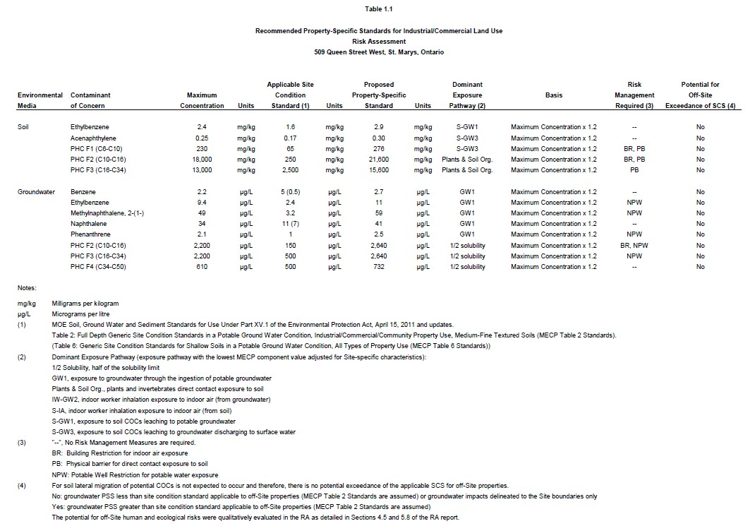

Health-Based Indoor Air Criteria for Contaminants of Concern

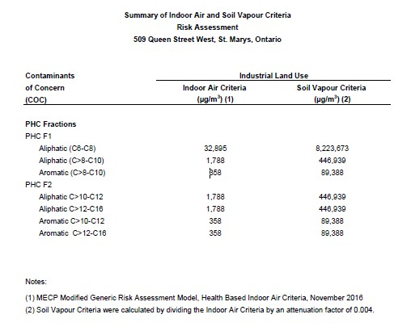

Schedule ‘B’
CERTIFICATE OF REQUIREMENT
s.197(2)
Environmental Protection Act
This is to certify that pursuant to Item 4.6 of Certificate of Property Use number 4020-CNKS6U issued by Pierre Adrien, Director of the Ministry of the Environment, Conservation and Parks, under sections 168.6 and 197 of the Environmental Protection Act, on XXXXXX , 2023, being a Certificate of Property Use and order under subsection 197(1) of the Environmental Protection Act relating to the property municipally known as 509 Queen Street, in the Town of St. Marys, Ontario, and with a legal description of Part Lot 19, Concession Thames Blanshard, being Part 2 on Reference Plan 44R-5860, in the Town of St. Marys, County of Perth, being all of the PIN 53239-0007 (the ”Property”) with respect to a Risk Assessment and certain Risk Management Measures and other preventive measure requirements on the Property
Veterinary Wholesale Company Inc.
and any other persons having an interest in the Property, are required before dealing with the Property in any way, to give a copy of the Certificate of Property Use, including any amendments thereto, to every person who will acquire an interest in the Property.
Under subsection 197(3) of the Environmental Protection Act, the requirement applies to each person who, subsequent to the registration of this certificate, acquires an interest in the Property.

Schedule ‘C’ – Figures and Plans
Figure 1: Plan of Survey
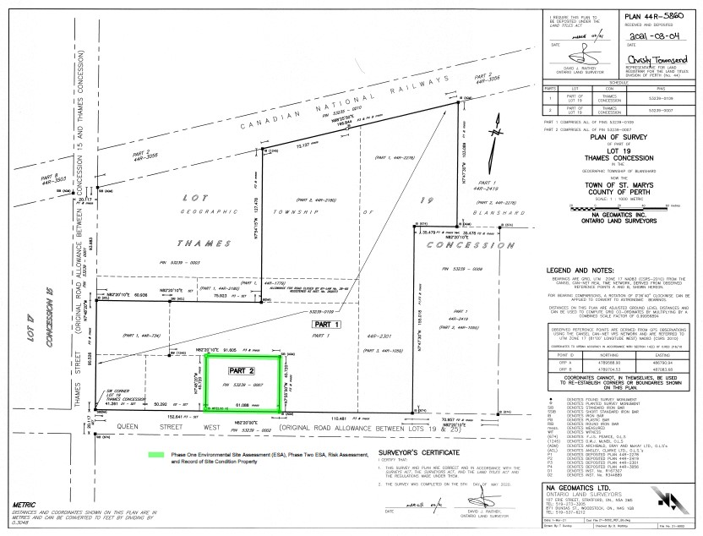

Figure 2: Typical Soil Cap Detail

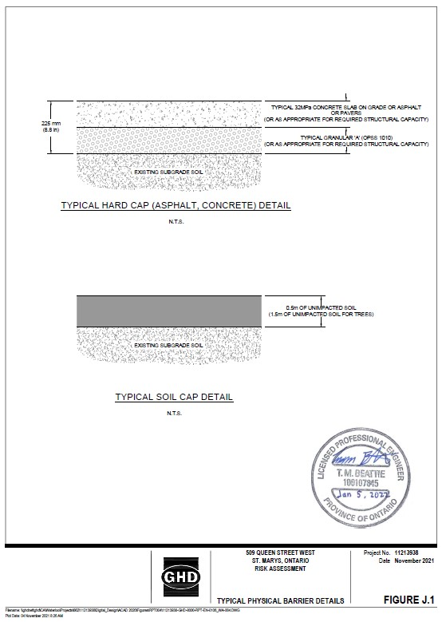

Figure 3: Typical Soil Vapour Mitigation System

