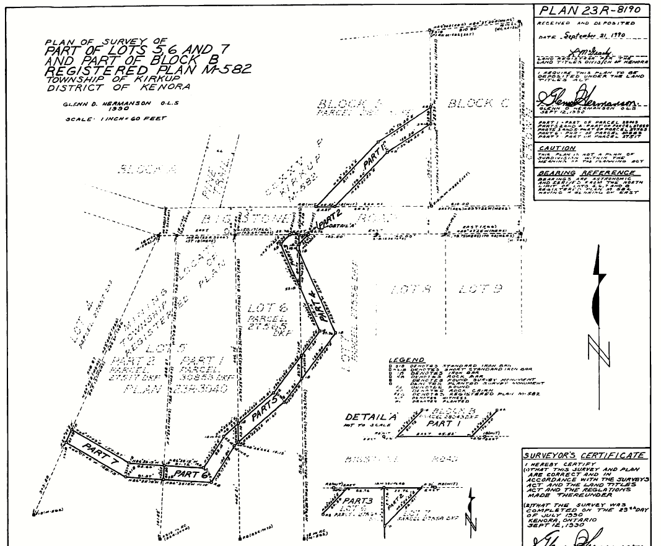
NEW PIN TBD
60-C-216411
Whitta
W Pt of Part 7 Severed Lot

PIN 42125-0911
PT 2 of 23R3040
60-C-216411
Whitta
E Pt of Part 7
Retained Lot
PIN 42125-0156
PT 1 of 23R3040
60-C-232137 (#4)
Balciunas
Part 6
PIN 42125-0157
Lot 6
60-C-232179 (#3)
Maddar
Parts 3 and 5
PIN 42125-0158
Lot 7
60-C-232158 (#2)
James
Parts 2 and 4
PIN 42125-0161
Block B
60-C-232864 (#1)
DeGagne
Part 1 of 23R-8190
