Certificate of Property Use
Issued under the authority of the Environmental Protection Act, R.S.O. 1990, c. E.19, sections 168.6 (CPU) and 197 (Order)

Certificate of Property use number: 7806-DAZQ2D
Risk Assessment number: 5805-CB9L6T

Owners: Imperial Oil Limited on behalf of beneficial owners (Registered Owner)
Imperial Oil, a partnership of
Imperial Oil Limited and Imperial Oil Resources Limited
505 Quarry Park Boulevard, SE
Calgary, Alberta T2C 5N1

Site: 201-215 Talbot Street, St. Thomas, Ontario (Property)

with a legal description as follows:

PT LT 3 N/S Talbot Street and W/S New Street PL 15
St. Thomas; PT LT 4 N/S Talbot Street
And W/S New Street PL 15 St. Thomas
As in E108786, STH52459, STH47141, STH 52634
Except Easement Therein Re: E108786;
St. Thomas Being the whole of PIN 35170-0460 (LT).

The conditions of this Certificate of Property Use address the Risk Management Measures in the Risk Assessment noted above and described in detail in Part 1 below.

Part 1: Interpretation
In the CPU the following capitalized terms shall have the meanings described below:

“Adverse Effect” has the same meaning as in the Act; namely,
- impairment of the quality of the natural environment for any use that can be made of it,
- injury or damage to property or to plant or animal life,
- harm or material discomfort to any person,
- an adverse effect on the health of any person,
- impairment of the safety of any person,
- rendering any property or plant or animal life unfit for human use,
- loss of enjoyment of normal use of property, and,
- interference with the normal conduct of business.

“Act” means the Environmental Protection Act, R.S.O. 1990, c. E.19.

“Applicable Site Condition Standards” means the soil and groundwater criteria for course textured soils on industrial/commercial property use in Table 2: Full Depth Generic Site Condition Standards in a Potable Groundwater Condition of the “Soil, Ground Water and Sediment Standards for Use under Part XV.1 of the Environmental Protection Act” published by the Ministry and dated April 15, 2011.

“Building” means an enclosed structure occupying an area greater than ten square metres consisting of a wall or walls, roof and floor.
“Building Code” means the Ontario Regulation 332/12: Building Code, made under the Building Code Act, 1992, S.O. 1992, c.23.

“Competent Person” has the same meaning as set out in OHSA.

“Contaminant” has the same meaning as in the Act; namely any solid, liquid, gas, odour, heat, sound, vibration, radiation or combination of any of them, resulting directly or indirectly from human activities that causes or may cause an Adverse Effect.

“Contaminants of Concern” or “COCs” has the meaning as set out in section 3.2 of the CPU.

“CPU” means this Certificate of Property Use as may be altered from time to time and bearing the document number 8784-D5RQ35.

"Director" means the undersigned Director or any other person appointed as a Director for the purpose of issuing a certificate of property use.

“EBR” means the Environmental Bill of Rights, 1993, S.O. 1993, c. 28.
“Grade” has the same meaning as in the Building Code.
“Health and Safety Plan” means the Property-specific plan specified in Section 4.2(f).
“Intrusive Activities” means any activity undertaken at the Property, such as excavating or drilling into soil or ground water, which may disturb or expose Contaminants of Concern at the Property.
“Licensed Professional Engineer” means a person who holds a license, limited license or temporary license under the Professional Engineers Act, R.S.O. 1990, c. P.28 and who has obtained the appropriate education and training and has demonstrated experience and expertise in the areas related to the work required to be carried out in this CPU.
“Ministry” means the ministry of the government of Ontario responsible for the administration of the Act, currently named the Ministry of the Environment, Conservation and Parks.
“O. Reg. 153/04” means Ontario Regulation 153/04, “Record of Site Condition – Part XV.1 of the Act”, made under the Act.

“O. Reg. 406/19” means Ontario Regulation 406/19, “On-Site and Excess Soil Management”, made under the Act.

“OHSA” means the Occupational Health and Safety Act, R.S.O. 1990, c. O.1.

“Owner” means the owner(s) of the Property, described in the “Owner” section on page 1 above, and any subsequent registered or beneficial owner of the Property.

"OWRA" means the Ontario Water Resources Act, R.S.O. 1990, c.O.40.

“Property” means the property that is the subject of the CPU and described in the “Site” section on page 1 above.

“Property Specific Standards” or “PSS’ means the property specific standards established for the Contaminants of Concern set out in the Risk Assessment and in section 3.2 of the CPU and are the same standards specified in the Risk Assessment.

"Provincial Officer" means a person who is designated as a provincial officer for the purposes of the Act.

“Qualified Person” means a person who meets the qualifications prescribed in subsection 5 (2) of O. Reg. 153/04, namely a person who:
- Holds a licence, limited licence or temporary licence under the Professional Engineer Act, or
- Holds a certificate of registration under the Professional Geoscientists Act, 2000, and is a practising member, temporary member, or limited member of the Association of Professional Geoscientists of Ontario.

"Risk Assessment" and “RA” means the Risk Assessment number 5805-CB9L6T accepted by the Director on November 6, 2024 and set out in the following documents:
- Risk Assessment 201 to 215 Talbot Street, St. Thomas, Ontario, report prepared by Golder Associates Ltd., dated December 15, 2022

- Risk Assessment Version 2 for 201 to 215 Talbot Street, St. Thomas, Ontario, report prepared by WSP Canada Inc., dated November 17, 2023

- Risk Assessment Submission #3 for 201 to 215 Talbot Street, St. Thomas, Ontario, report prepared by WSP Canada Inc., dated June 5, 2024

- “RE: Request for Additional Information - Risk Assessment for RA2027-22c; 201-215 Talbot Street, St. Thomas, Ontario; IDS#5805-CB9L6T”, email from Christopher Ng, WSP Canada Inc., received by TASDB on October 19, 2024, with the following document attached:

  - 209 Talbot St_St Thomas ON_MECP Additional Info Request-Response to Comments_28Oct2024.pdf

“Risk Management Measures" and “RMMs” means the risk management measures specific to the Property described in the Risk Assessment and/or Part 4 of the CPU.

“SGM Plan” means the Property-specific soil and groundwater management plan specified in Section 4.2(d).

“Tribunal” has the same meaning as in the Act; namely, the Ontario Land Tribunal.

Part 2: Legal Authority
2.1 Section 19 of the Act states that a certificate of property use is binding on the executor, administrator, administrator with the will annexed, guardian of property or attorney for property of the person to whom it was directed, and on any other successor or assignee of the person to whom it was directed.

2.2 Subsection 132(1.1) of the Act states that the Director may include in a certificate of property use a requirement that the person to whom the certificate is issued provide financial assurance to the Crown in right of Ontario for any one or more of:
- the performance of any action specified in the certificate of property use;
- the provision of alternate water supplies to replace those that the Director has reasonable and probable grounds to believe are or are likely to be contaminated or otherwise interfered with by a contaminant on, in or under the property to which the certificate of property use relates; and
- measures appropriate to prevent adverse effects in respect of the property to which the certificate of property use relates.

2.3 Section 168.6 (1) of the Act states that if a risk assessment related to the property has been accepted under clause 168.5 (1) (a), the Director may issue a certificate of property use to the owner of the property, requiring the owner to do any of the following things:
- Take any action that is specified in the certificate and that, in the Director’s opinion, is necessary to prevent, eliminate or ameliorate any adverse effect that has been identified in the risk assessment, including installing any equipment, monitoring any contaminant or recording or reporting information for that purpose.
- Refrain from using the property for any use specified in the certificate or from constructing any building specified in the certificate on the property.

2.4 Subsection 168.6(2) of the Act states that a certificate of property use shall not require an owner of property to take any action that would have the effect of reducing the concentration of a contaminant on, in or under the property to a level below the level that is required to meet the standards specified for the contaminant in the risk assessment.

2.5 Subsection 168.6(3) of the Act states that the Director may, on his or her own initiative or on application by the owner of the property in respect of which a certificate has been issued under subsection 168.6(1),
- alter any terms and conditions in the certificate or impose new terms and conditions; or
- revoke the certificate.

2.6 Subsection 168.6(4) of the Act states that if a certificate of property use contains a provision requiring the owner of property to refrain from using the property for a specified use or from constructing a specified building on the property,
- the owner of the property shall ensure that a copy of the provision is given to every occupant of the property;
- the provision applies, with necessary modifications, to every occupant of the property who receives a copy of the provision; and
- the owner of the property shall ensure that every occupant of the property complies with the provision.

2.7 Subsection 197(1) of the Act states that a person who has authority under the Act to make an order or decision affecting real property also has authority to make an order requiring any person with an interest in the property, before dealing with the property in any way, to give a copy of the order or decision affecting the property to every person who will acquire an interest in the property as a result of the dealing.

2.8 Subsection 197(2) of the Act states that a certificate setting out a requirement imposed under subsection 197(1) may be registered in the proper land registry office on the title of the real property to which the requirement relates, if the certificate is in a form approved by the Minister, is signed or authorized by a person who has authority to make orders imposing requirements under subsection 197(1) and is accompanied by a registrable description of the property.

2.9 Subsection 197(3) of the Act states that a requirement, imposed under subsection 197(1) that is set out in a certificate registered under subsection 197(2) is, from the time of registration, deemed to be directed to each person who subsequently acquires an interest in the real property.

2.10 Subsection 197(4) of the Act states that a dealing with real property by a person who is subject to a requirement imposed under subsection 197(1) or 197(3) is voidable at the instance of a person who was not given the copy of the order or decision in accordance with the requirement.

Part 3: Background
3.1 The Risk Assessment was undertaken for the Property on behalf of the Owner to assess the human health risks and ecological risks associated with the presence or discharge of Contaminants on, in or under the Property and to identify appropriate Risk Management Measures to be implemented to ensure that the Property is suitable for the intended use: “residential” and/or “commercial”, as defined in O. Reg. 153/04.

3.2 The Contaminants on, in or under the Property that are present above Table 3: Full Depth Generic Site Condition Standards (SCS) in a Non-Potable Ground Water Condition intended for Residential/Parkland/Institutional Property, with coarse soil, for Use under Part XV.1 of the Environmental Protection Act published by the Ministry and dated April 15, 2011 are set out in the Risk Assessment and in Table 1 of Schedule A (Contaminants of Concern). The Property Specific Standards for the Contaminants of Concern are set out in Schedule A attached to and forming part of the CPU with the following Figure 1: Plan of Survey as set out in Schedule C.

  - I am of the opinion, for the reasons set out in the Risk Assessment that the Risk Management Measures described therein and outlined in Part 4 of the CPU are necessary to prevent, eliminate or ameliorate an Adverse Effect on the Property.

  - The Risk Assessment indicates the presence of Contaminants of Concern in soil and groundwater which require on-going restriction of land use and pathway elimination. As such, I believe it is necessary to restrict the use of the Property and implement Risk Management Measures as set out in the Risk Assessment and in Part 4 of the CPU.

  - I believe for the reasons set out in the RA that it is also advisable to require the disclosure of this CPU and the registration of notice of the CPU on title to the Property as set out in section 197 order requirement in Section 4.6, Section 4.7, and Section 4.8 of this CPU.

Part 4: Director Requirements

Pursuant to the authority vested in me under subsection 168.6(1) and section 197 of the Act, I hereby require the Owner to do or cause to be done the following:

Risk Management Measures
- Implement, and thereafter maintain or cause to be maintained, the Risk Management Measures.

- Without restricting the generality of the foregoing in Item 4.1, carry out or cause to be carried out the following key elements of the Risk Management Measures:

Hard Cap Barrier and Fill Cap Barrier

- The Hard Cap and/or Fill Cap barriers are required to be installed over any area where soil exceeds the Applicable Site Condition Standards so as to prevent exposure to the Contaminants of Concern identified on the Property and shall be maintained for as long as the COCs are present on the Property at concentrations that exceed the Applicable Site Condition Standards. The Hard Cap and Fill Cap barriers shall be installed across the entire Property in accordance with Section 1.2.1 of the Risk Management Plan (RMP) in Appendix J of the RA. Details of Conceptual Design of Engineered Barriers are shown on Figures 2-4 of Schedule C, which are attached to and forms part of this CPU.

- The Hard Cap barrier(s) shall consist of at least 150 millimeters (mm) of Granular "A" or equivalent material overlain by at least 75 mm of hot mix asphalt, concrete, compacted granular aggregate, cobbles, paving stones, armour stones, rubberized surfaces or equivalent or a combination thereof with a minimum combined thickness of 225 mm, as detailed in Figure 2.

- The Fill Cap barrier (s) shall consist of either:

  - a minimum of 500 mm thick cover of soil that is demonstrated to meet the Applicable Site Condition Standards immediately on top of a geotextile material for landscaped areas with no deep rooting vegetation as detailed in Figure 3; or

  - a minimum of 1500 mm thick cover or two times the root ball diameter of soil that is demonstrated to meet the Applicable Site Condition Standards for landscaped areas with deep rooting vegetation, as shown in Figure 4.

- Before commencing development of any part of the Site, install fencing and implement dust control measures for any part of the Property requiring covering as to restrict access and to prevent exposure to the COCs until the covering of that part is completed.

- Within 90 calendar days of completion of the installation of any new hard cap and/or fill cap barriers on the Property or portion of the Property, the Owner shall submit to the Director written confirmation signed by a qualified Licensed Professional Engineer that the barriers have been installed in accordance with Section 1.2.1 of the RMP and Section 4.2 (a) of this CPU along with final design specifications/drawings and or as-built drawings along with a site plan that clearly identifies the final location of each of the different barriers.

- In relation to Section 4.2 (a) of this CPU, areas of the Property that are not in use or not under development or redevelopment, hard cap and fill cap barriers are not required as long as exposure to the COCs is prevented by a fence barrier that restricts access to those areas of the Property and a dust control plan is implemented.

- An inspection and maintenance program shall be implemented to ensure the continuing integrity of the hard cap and fill cap barriers as long as the COCs are present on the Property at concentrations that exceed the Applicable Site Condition Standards. The inspection program shall include semi-annual inspections of the barrier's integrity in accordance with the inspection and maintenance program as detailed in Sections 1.2.1 and 1.4.1 of the RMP. Any barrier deficiencies shall be repaired within a reasonable period of time in accordance with Section 1.4.1 of the RMP. If cracks, breeches or any loss of integrity in the barriers cannot be repaired or addressed in a timely manner, contingency measures, one example is fencing, shall be implemented to ensure that no exposure to the COCs that have been observed on the Property at concentrations that exceed the Applicable Site Condition Standards occurs.

- For the restoration of any damaged portions of the barriers, restoration shall meet the original design specifications, at minimum, as detailed in Section 1.4.1 of the RMP and Section 4.2 (a) of this CPU and as shown on Figures 2-3. For significant breeches that are identified to potentially expose the COCs that are present on the Property at concentrations that exceed the Applicable Site Condition Standards, the Owner shall submit to the Director written confirmation prepared and signed by a qualified Licensed Professional Engineer, in consultation with a Qualified Person, that the barriers have been repaired in accordance with the applicable requirements of this CPU. The written confirmation shall also include a description of any contingency measures put in place and shall be submitted to the Director within 30 calendar days of the completion of any barrier repairs and/or restorations. The Owner shall keep records of the inspections and maintenance and make them available for review by the Ministry upon request.

Health and Safety Plan:

- A Property-specific health and safety plan shall be developed for the Property and implemented during all planned intrusive activities undertaken potentially in contact with COCs in soil and groundwater that have been identified in the RA at concentrations that exceed the Applicable Site Condition Standard as detailed in the RA and a copy shall be maintained on the Property for the duration of all intrusive activities. The Owner shall ensure that the Health and Safety Plan considers the presence of the COCs and is implemented prior to any intrusive activities being undertaken on the Property or portion (s) of the Property in order to protect workers from exposure to the COCs. The Health and Safety Plan shall be prepared in accordance with applicable Ministry of Labour health and safety regulations, along with all potential risks identified in the RA and RMP and include, but not limited to, occupational hygiene requirements, personal protective equipment, contingency plans and contact information. Prior to initiation of any Project (on the Property or portion (s) of the Property), the local Ministry of Labour office shall be notified, where so prescribed under the OHSA, of the proposed activities and that COCs have been identified in soil and groundwater on the Property. The Health and Safety Plan shall be consulted and overseen by a Qualified Person to review the provisions of the plan with respect to the proposed work and conduct daily inspections. The Owner shall retain a copy of the Health and Safety Plan to be made available for review by a Provincial Officer upon request.

Soil and Groundwater Management Plan:

- A Property-specific soil and groundwater management (SGM) Plan shall be developed for the Property and implemented during all intrusive activities potentially in contact with or exposing COCs in soil and groundwater that exceed the Applicable Site Condition Standards as listed in Table 1 of Schedule A. A copy of the SGM Plan shall be maintained on the Property for the duration of all planned intrusive activities. Any short-term intrusive activities required for the purposes of emergency repairs (i.e. for repairs to underground utilities etc.) will not require the submission of the SGM Plan prior to undertaking the short term emergency repairs. For planned intrusive activities, this SGM Plan shall be submitted to the Director by the Owner at least 14 calendar days prior to any such intrusive activities being undertaken and shall be consistent with the measures specified in the Risk Management Plan. The SGM Plan shall include, but not be limited to, the following key components as deemed necessary by a Qualified Person:

- oversight by a Qualified Person;

- dust control measures and prevention of soils tracking by vehicles and personnel from the Property;

- odour control and prevention measures;

- management of excavated materials including cleaning equipment, placement of materials for stockpiling on designated areas lined and covered, bermed and fenced to prevent access, runoff control to minimize contact and provisions for discharge to sanitary sewers or other approved treatment as required;

- storm water management measures to control the potential transport of COCs off-site during on-site construction/redevelopment activities. This shall include appropriate soil erosion and sediment control measures, as necessary;

- characterization of excavated soils to determine if soils exceed the Property Specific Standards shall follow the soil sampling strategy in the Risk Assessment. Excavated soils and materials requiring off-site disposal as a waste shall be disposed of in accordance with the provisions of Ontario Reg. 406/19;

- soils brought to the Property shall follow the soil sampling strategy in the Risk Assessment and only soils meeting the Residential Property Use Standards within the Table 3 of the Soil, Ground Water and Sediment Standards for Use under Part XV.1 of the Act for coarse soils published by the Ministry and dated April 15, 2011 is to be placed on, in or under the Property; and

- record keeping is to include, but not to be limited to, dates and duration of work, weather and site conditions, location and depth of excavation activities and dewatering activities, dust control measures, odour control measures, stockpile management and drainage, all soil and groundwater characterization results obtained as part of the soil and groundwater management plan, names of the Qualified Person, contractors, haulers and receiving sites for any excavated excess soils and/or groundwater removed from the property and any complaints received relating to site activities potentially coming in contact with or exposing site soils and ground water.

- A copy of the SGM Plan and any amendments and the records kept thereunder shall be made available for review by a Provincial Officer upon request.

Annual Report:
- The Owner shall prepare, by March 31 each year, an annual report documenting activities relating to the Risk Management Measures undertaken during the previous calendar year. A copy of this report shall be maintained on file by the Owner and shall be made available upon request by a Provincial Officer. The report shall include, but not be limited to, the following minimum information requirements:
- a copy of all records related to the soil and groundwater management plans; and
- a copy of all signed site plans and cross-sectional diagrams in case of any alterations.

Restriction on Community Gardens:
- The Owner shall refrain from planting fruit and vegetables for consumption on the Property unless planted in above ground containers such that the plants are isolated from the subsurface conditions. The planting of fruit and vegetables for consumption on the Property is prohibited for as long as the COCs in soil and groundwater remain present.

Restriction on Planting Deep-Rooted Plants/Trees:
- The Owner shall refrain from planting new deep-rooted plants/trees on the Property as long as the COCs in soil and groundwater remain present; except

- those species with rooting depths less than 0.5 m (e.g., grasses) wherein a typical hard/fill cap barrier is placed as per Section 4.2 (a) of this CPU; or
- those species with rooting depths greater than 0.5 m wherein a clean fill cap barrier is of sufficient depth to capture the rooting zone of these species, as shown in Figure 4 of the CPU.

Property Use Restriction:
- The owner shall refrain from using the Property for any use more sensitive than the following use(s): ‘residential use' and ‘community use’, as defined in O. Reg. 153/04.

Prohibition of Potable Groundwater Wells:
4.3 Upon issuance of the CPU, the Owner shall take all actions necessary or advisable to prevent any use of ground water in or under the Property as a potable water source. The Owner shall,
  - refrain from using groundwater in or under the Property as a potable source of water; and
  - except, as may be required for continued use as a monitoring well, as defined in the OWRA:
(i) properly abandon on the Property any wells, as described or defined in the OWRA, according to the requirements set out in Regulation 903 of the Revised Regulations of Ontario 1990: (Wells), made under the OWRA; and,
(ii) refrain from constructing on the Property any wells as described or defined in the OWRA.

Site Changes
- In the event of a change in the physical site conditions or receptor characteristics at the Property that may affect the Risk Management Measures and/or any underlying basis for the Risk Management Measures, the Owner shall forthwith notify the Director of such changes and the steps taken, to implement, maintain and operate any further Risk Management Measures as are necessary to prevent, eliminate or ameliorate any Adverse Effect that will result from the presence on, in or under the Property or the discharge of any Contaminant of Concern into the natural environment from the Property. In support of this work, a new risk assessment may need to be completed in accordance with O. Reg. 153/04 and submitted to the Ministry for acceptance. An amendment to the CPU will be issued to address the changes set out in any notice received and any future changes that the Director considers necessary in the circumstances.

Reports
- The Owner shall retain a copy of any reports required under the CPU for a period of seven (7) years from the date the report is created and within ten (10) days of the Director or a Provincial Officer making a request for a report, provide a copy to the requesting Director or Provincial Officer.

Property Requirement
- For the reasons set out in the CPU and pursuant to the authority vested in me under subsection 197(1) of the Act, I hereby order you and any other person with an interest in the Property, before dealing with the Property in any way, to give a copy of the CPU, including any amendments thereto, to every person who will acquire an interest in the Property, as a result of the dealing.

Certificate of Requirement
- Within fifteen (15) days from the date of receipt of a certificate of requirement issued under subsection 197(2) of the Act, completed as outlined in Schedule B, register the certificate of requirement on title to the Property, in the appropriate land registry office.
- Within five (5) days after registering the certificate of requirement provide to the Director a copy of the registered certificate and of the parcel register(s) for the Property confirming that registration has been completed.

Owner / Occupant Change
- While the CPU is in effect, the Owner shall, forthwith report in writing to the Director any changes of ownership of the Property except that while the Property is registered under the Condominium Act, 1998, S.O.1998 c.19 no notice shall be given of changes in the ownership of individual condominium units or any appurtenant common elements on the Property.

Financial Assurance
- The Director has not included in the CPU a requirement that the Owner provide financial assurance to the Crown in right of Ontario.

Part 5: General

- The requirements of the CPU are severable. If any requirement of the CPU or the application of any requirement to any circumstance is held invalid, such finding does not invalidate or render unenforceable the requirement in other circumstances nor does it invalidate or render unenforceable the other requirements of the CPU.
- An application under subsection 168.6(3) of the Act to alter any terms and conditions in the CPU, or impose new terms and conditions, or revoke the CPU, shall be made in writing to the Director, with reasons for the request.

- Subsection 186(3) of the Act provides that failure to comply with the requirements of the CPU constitutes an offence.

- The Director may amend the CPU under subsections 132(2) or (3) of the Act to change a requirement as to financial assurance, including that the financial assurance may be increased or provided, reduced or released in stages. The total financial assurance required may be reduced from time to time or released by an order issued by the Director under section 134 of the Act upon request and submission of such supporting documentation as required by the Director.

- The requirements of the CPU are minimum requirements only and do not relieve the Owner from, complying with any other applicable order, statute, regulation, municipal, provincial or federal law, or obtaining any approvals or consents not specified in the CPU.

- Notwithstanding the issuance of the CPU, further requirements may be imposed in accordance with legislation as circumstances require.

- In the event that any person is, in the opinion of the Director, rendered unable to comply with any requirements in the CPU because of,

  - natural phenomena of an inevitable or irresistible nature, or insurrections,
  - strikes, lockouts or other labour disturbances,
  - inability to obtain materials or equipment for reasons beyond your control, or
  - any other cause whether similar to or different from the foregoing beyond your control,

the requirements shall be adjusted in a manner defined by the Director. To obtain such an adjustment, the Director must be notified immediately of any of the above occurrences, providing details that demonstrate that no practical alternatives are feasible in order to meet the requirements in question.

- Failure to comply with a requirement of the CPU by the date specified does not relieve the Owner(s) from compliance with the requirement. The obligation to complete the requirement shall continue each day thereafter.

- The provisions of the CPU shall take precedence in the event of a conflict between the provisions of the CPU and the Risk Assessment.

- In the event that the Owner complies with the provisions of Items 4.7 and 4.8 of the CPU regarding the registration of the certificate of requirement on title to the Property, and then creates a condominium corporation by the registration of a declaration and description with respect to the Property pursuant to the Condominium Act, 1998, S.O. 1998, c.19 and then transfers ownership of the Property to various condominium unit owners, the ongoing obligations of the Owner under this CPU can be carried out by the condominium corporation on behalf of the new Owners of the Property.

- Where there is more than one Owner each person is jointly and severally liable to comply with any requirements of the CPU unless otherwise indicated.

- The Risk Management Measures identified in the Risk Assessment and also in Part 4 of the CPU and all the other requirements in the CPU shall commence upon the issuance of the CPU and continue in full force and effect in accordance with the terms and conditions of the CPU until such time as the Director alters or revokes the CPU.

Part 6: Information regarding a Hearing before the Ontario Land Tribunal
With respect to those provisions relating to my authority in issuing a certificate of property use under section 168.6 and an order under section 197 of the Act:
6.1 Pursuant to section 139 of the Act, you may require a hearing before the Ontario Land Tribunal, if within fifteen (15) days after service on you of a copy of the CPU, you serve written notice upon the Director and the Tribunal.
6.2 Pursuant to section 142 of the Act, the notice requiring the hearing must include a statement of the portions of the CPU and the grounds on which you intend to rely at the hearing. Except by leave of the Tribunal, you are not entitled to appeal a portion of the CPU, or to rely on a ground, that is not stated in the notice requiring the hearing.
6.3 Service of a notice requiring a hearing must be carried out in a manner set out in section 182 of the Act and Ontario Regulation 227/07: Service of Documents, made under the Act. The contact information for the Director and the Tribunal is the following:
Registrar
Ontario Land Tribunal
655 Bay Street, Suite 1500
Toronto, ON, M5G 1E5
Email: OLT.Registrar@ontario.ca

and
Pierre Adrien, London District Manager
Director, section 168.6 of the Act
Ministry of the Environment, Conservation and Parks
733 Exeter Road
London, ON, N6E 1L3
Fax: (519) 873-5020
Email: Environment.London@ontario.ca

The contact information of the Ontario Land Tribunal and further information regarding its appeal requirements can be obtained directly from the Tribunal at: Tel: (416) 212-6349 or Toll Free 1 (866) 448-2248 or www.olt.gov.on.ca
Further information regarding service can be obtained from e-Laws at www.ontario.ca/laws. Please note where service is made by mail, it is deemed to be made on the fifth day after the date of mailing and choosing service by mail does not extend any timelines.
6.4 Unless stayed by the Tribunal under section 143 of the Act, the CPU is effective from the date of issue.
6.5 If you commence an appeal before the Tribunal, under section 47 of the Environmental Bill of Rights, 1993 (the “EBR”), you must give notice to the public in the Environmental Registry of Ontario. The notice must include a brief description of the CPU (sufficient to identify it) and a brief description of the grounds of appeal.
The notice must be delivered to the Minister of the Environment, Conservation and Parks who will place it on the Environmental Registry of Ontario. The notice must be delivered to the Minister of the Ministry of the Environment, Conservation and Parks, College Park 5th Flr, 777 Bay St, Toronto, ON M7A 2J3 by the earlier of:
(a) two (2) days after the day on which the appeal before the Tribunal was commenced; and
(b) fifteen (15) days after service on you of a copy of the CPU.
6.6 Pursuant to subsection 47(7) of the EBR, the Tribunal may permit any person to participate in the appeal, as a party or otherwise, in order to provide fair and adequate representation of the private and public interests, including governmental interests, involved in the appeal.
6.7 Pursuant to section 38 of the EBR, any person resident in Ontario with an interest in the CPU may seek leave to appeal the CPU. Pursuant to section 40 of the EBR, the application for leave to appeal must be made to the Tribunal by the earlier of:
(a) fifteen (15) days after the day on which notice of the decision to issue the CPU is given in the Environmental Registry of Ontario; and
(b) if you appeal, fifteen (15) days after the day on which your notice of appeal is given in the Environmental Registry of Ontario.
6.8 The procedures and other information provided in this Part 6 are intended as a guide. The legislation should be consultant for additional details and accurate reference. Further information can be obtained from e-Laws at www.ontario.ca/laws.

Issued on this xx^{th} day of April 2025.

DRAFT
_____________________________________
Pierre Adrien
Director, section 168.6 of the Act

Schedule A

Table 1. Property Specific Standards (Soil and Groundwater) for each Contaminant of Concern for implementation of Risk Management Measures.
Environment | Contaminant of Concern (COC) | Overall PSS
Soil (µg/g) | Metals and Organics
Soil (µg/g) | Cadmium | 2.6
Soil (µg/g) | Copper | 336
Soil (µg/g) | Lead | 624
Soil (µg/g) | Zinc | 1320
Soil (µg/g) | Petroleum Hydrocarbons
Soil (µg/g) | PHC F1 | 2640
Soil (µg/g) | PHC F2 | 720
Soil (µg/g) | PHC F4 | 3600
Soil (µg/g) | Benzene | 0.49
Soil (µg/g) | Ethylbenzene | 6.6
Soil (µg/g) | Xylenes Total | 11.5
Soil (µg/g) | Polycyclic Aromatic Hydrocarbons
Soil (µg/g) | Acenaphthylene | 0.50
Soil (µg/g) | Anthracene | 1.4
Soil (µg/g) | Benz[a]anthracene | 2.9
Soil (µg/g) | Benzo[a]pyrene | 2.9
Soil (µg/g) | Benzo[b]fluoranthene | 4.3
Soil (µg/g) | Benzo[k]fluoranthene | 1.6
Soil (µg/g) | Dibenz[a h]anthracene | 0.56
Soil (µg/g) | Fluoranthene | 6.4
Soil (µg/g) | Indeno[123 -cd]pyrene | 2.3
Soil (µg/g) | Methylnaphthalene 2-(1-) | 5.9
Soil (µg/g) | Naphthalene | 5.9
Groundwater (µg/L) | Petroleum Hydrocarbon
Groundwater (µg/L) | Benzene | 3.0

Schedule B
CERTIFICATE OF REQUIREMENT
s.197(2)
Environmental Protection Act, R.S.O. 1990, c. E.19
This is to certify that pursuant to Item 4.6 of Certificate of Property Use number 7806-DAZQ2D issued by Pierre Adrien, Director of the Ministry of the Environment, Conservation and Parks, under sections 168.6 and 197 of the Environmental Protection Act, on April XX, 2025, being a Certificate of Property Use and Order relating to the property municipally known as 201-215 Talbot Street, St. Thomas, Ontario which is legally described as PT LT 3 N/S Talbot Street and W/S New Street PL 15 St. Thomas; PT LT 4 N/S Talbot Street and W/S New Street PL 15 St. Thomas; As in E108786, STH52459, STH47141, STH 52634 Except Easement Therein Re: E108786; St. Thomas and Being the whole of PIN: 35170-0460 (LT) (the “Property”) with respect to a Risk Assessment and certain Risk Management Measures and other preventive measure requirements on the Property
Imperial Oil Limited on behalf of beneficial owners
and
Imperial Oil, a partnership of
Imperial Oil Limited and Imperial Oil Resources Limited
and any other persons having an interest in the Property, are required before dealing with the Property in any way, to give a copy of the Certificate of Property Use, including any amendments thereto, to every person who will acquire an interest in the Property as a result of the dealing.
Under subsection 197(3) of the Environmental Protection Act, the requirement applies to each person who, subsequent to the registration of this certificate, acquires an interest in the Property.

Schedule C – Figures and Plans

Figure 1: Plan of Survey (not to scale).

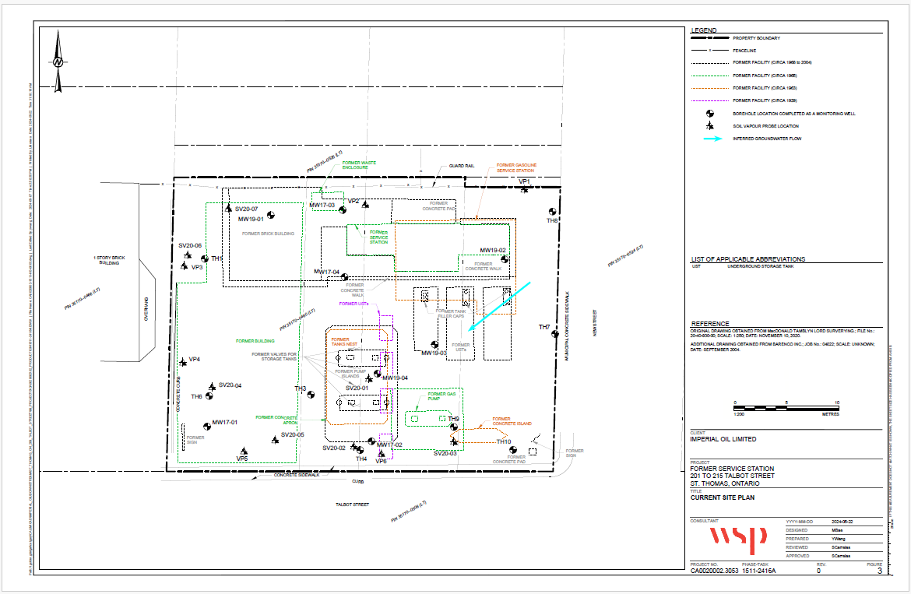

Figure 2: Conceptual Design of a Typical Hard Cap Barrier.

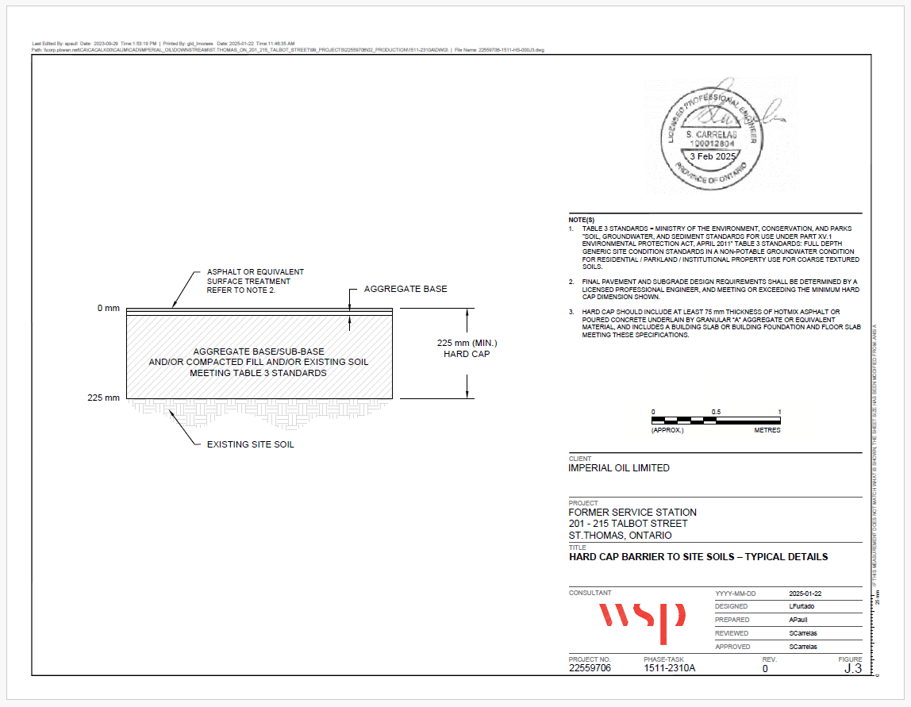

Figure 3: Conceptual Design of Typical Fill Cap Barriers.

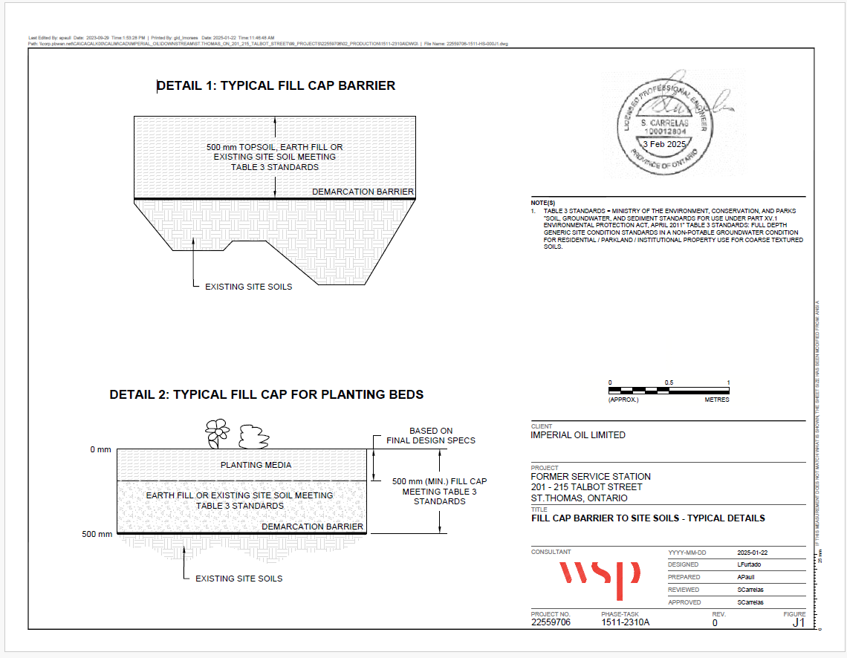

Figure 4: Conceptual Design of a Typical Fill Cap Barrier in Arears of Deep-Rooted Trees.

