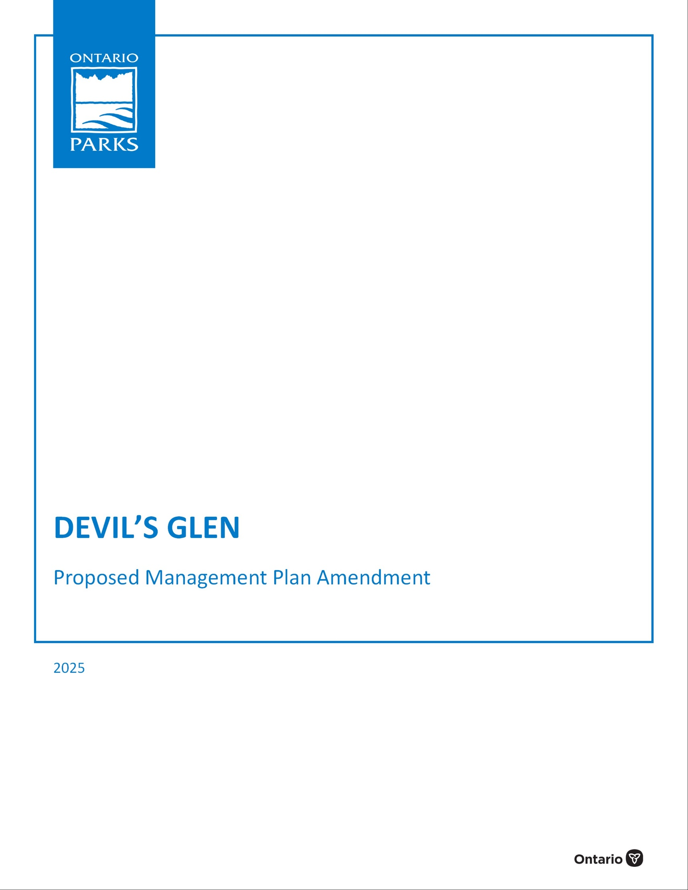

© 2025, King’s Printer for Ontario

Cover photo: Description

Photo taken by: Name

Additional copies of this publication can be obtained from:

Environmental Registry of Ontario

ero.ontario.ca

Ontario.ca website

www.ontario.ca/page/provincial-park-management-direction

and / or

Wasaga Beach Provincial Park

11-22nd Street N

Wasaga Beach, Ontario L9Z 2V9

Telephone: (705) 429-2516

ISBN 0-0000-0000-0 (PDF)

ISBN 0-0000-0000-0 (html)

**Opportunity to Comment**

**Devil’s Glen Provincial Park Proposed Management Plan Amendment**

The Ministry of the Environment, Conservation and Parks is amending the management plan for Devil’s Glen Provincial Park. After careful consideration of related planning information and review of input received thus far, this proposed amendment outlines proposed changes to site-specific management policies for the park. Administrative updates were made including new values information, current and relevant legislation and policy references and the outcomes of completed park projects. Sections have been reordered and new sections added to align with current park management plan format and content standards. For ease of review, this document is worded in the style of an approved management plan.

The release of this proposed amendment provides an opportunity for Indigenous communities, members of the public and stakeholders to be involved and provide comment. The Ministry of the Environment, Conservation and Parks will carefully consider all comments received and make changes as appropriate. Any revisions will be reflected in the approved management plan amendment. The approved management plan amendment will guide the management of the provincial park over a 10-year period.

The proposed amendment is available through the Environmental Registry of Ontario at ero.ontario.ca (number 019-8238) for 49 days to allow opportunity to review and provide input. Communities, groups, organizations, and individuals on the project mailing list have been notified.

To assist with our review of your comments, list the topic(s) you wish to discuss and briefly state your reasons for agreeing or disagreeing with the proposed management direction. You may also make suggestions or comments on other topics that are important to you. For further information on the proposed/preliminary management plan amendment or the planning process, please contact:

Ontario Parks, Southwest Zone

659 Exeter Road, 4th Floor, London, ON, N6E 1L3

E-mail address: Ontario.Parks.Southwest.Zone@ontario.ca

Comments should be submitted by **September 19th, 2025** through the Environmental Registry of Ontario at ero.ontario.ca (number 019-8238). Comments can also be sent to the individual identified above.

Thank you for your interest in the management of this provincial park.

Jason Travers,

Director, Ontario Parks Operations

The Ministry of the Environment, Conservation and Parks (MECP) is collecting your personal information and comments under the authority of section 29 of the *Provincial Parks and Conservation Reserves Act, 2006* for the purpose of public consultation on management planning. Your comments (not including personal information) will become part of the record of consultation and may be shared with the general public. Your personal information may be used by MECP to follow-up with you upon request or when required, and to send you information about future initiatives involving this park. Please indicate in your response if you do not wish to be notified of new initiatives. Any personal information you provide will be protected in accordance with the *Freedom of Information and Protection of Privacy Act* and will be handled in accordance with the government of Ontario’s Privacy Statement: www.ontario.ca/page/privacy-statement. If you have questions about the use of your personal information, please contact the individual identified above.

**Regional Director’s Approval Statement**

September 12, 1994

I am pleased to approve the Devil’s Glen Provincial Park Management Plan Amendment.

This document is to be used in conjunction with the 1989 Park Management Plan, as official policy for the development and management of Devil’s Glen Provincial Park.

Inquiries or requests for additional copies of this document should be directed to:

Park Planning Specialist

Midhurst Parks Zone

Ministry of Natural Resources

Midhurst, Ontario

LOL IXO

Telephone: (705) 725-7598

Facsimile: (705) 725-7594

Regional Director

Southern Region

**Regional Director’s Approval Statement**

1989

We are pleased to approve the Devil’s Glen Provincial Park Management Plan, as official policy for the management and development of this park. The plan reflects this Ministry’s Intent to protect the natural features of the park and maintain and develop high quality opportunities for outdoor recreation and heritage appreciation for both residents of Ontario and visitors to the Province.

|  |  |
| --- | --- |
| A. S. Holder  Regional Director, Central Region | N. Richards  Director Parks and Recreational Areas Branch |

# Contents

Contents iv

1 Introduction 1

1.1 Boundary 4

1.2 Indigenous communities 4

1.3 Planning context 4

1.4 Ecological integrity 5

2 Classification 5

3 Purpose and objectives 5

3.1 Purpose 5

3.2 Vision 5

3.3 Objectives 5

3.3.1 Protection 6

3.3.2 Recreation 6

3.3.3 Heritage appreciation 6

3.3.4 Scientific research 6

4 Values 7

5 Summary of pressures 8

6 Zoning 8

6.1 Development zone 8

6.2 Natural environment zone: 9

6.3 Nature reserve zone 9

7 Resource management 11

7.1 Industrial activities 11

7.2 Fish habitat management 11

7.3 Vegetation management 11

7.4 Species at risk 11

7.5 Invasive species 12

7.6 Fire management 12

7.7 Cultural heritage 12

7.8 Land management 12

7.9 Science and research 13

8 Operational policies 13

8.1 Visitor services 13

8.1.1 Information 13

8.1.2 Interpretation 14

8.2 Recreation management 14

8.2.1 Rock climbing 14

8.3 Marketing 14

9 Development policies 14

10 Summary of public consultation 15

11 Plan review and amendment 15

12 Implementation Priorities 16

13 References 17

Appendix I: Summary public consultation (1994) 19

Appendix II: Management planning history 21

Appendix III: Management of rock climbing 22

**Figures**

**Figure 1: Regional context** 2

**Figure 2: Park boundary**  3

**Figure 3: Zoning and proposed development** 10

# Introduction

Devil’s Glen Provincial Park is a 60.19 hectare (ha) recreational class park. It is situated on the Niagara Escarpment, south of Nottawasaga Bay, in the Township of Clearview, County of Simcoe. The park is located approximately 16 km south of Collingwood, and 24 km southwest of Wasaga Beach (see Figure 1).

The park has an upland land base of approximately 5 ha which includes a small day-use picnic area and viewing platform. The adjacent 55 ha primarily consists of a steep-sided valley where the Mad River has cut through the Niagara Escarpment and left Silurian Amabel dolomite rock exposed (see Figure 2). The park’s 2.5 km hiking trail is located in this valley and is part of the Blue Mountain Section of the Bruce Trail. The Ganaraska Hiking Trail joins the Bruce Trail southeast of the park.

Devil's Glen is part of the Niagara Escarpment Parks and Open Space System (NEPOSS) which protects the significant natural and cultural features along the escarpment and provides opportunities for recreation and appreciation of those features. Lands within the NEPOSS are owned and managed by various agencies and public bodies, including the Ministry of the Environment, Conservation and Parks (MECP) who manages provincial parks along the escarpment.

Natural features of the park include cliff faces, crevice caves and outcrop features, talus slopes, bottomlands, wetlands, the Mad River (high quality coldwater fish habitat), forest cover, wildlife and species at risk habitat areas, and viewing vantage points along the rim of the valley.

The park offers day use recreation opportunities such as hiking, nature appreciation and fishing. The Bruce Trail, which goes through Devil’s Glen, is an essential component of the system, linking the park to other public open spaces and scenic attractions along the Escarpment’s 725 km. The 1994 management plan amendment authorized the permanent closure and retirement of a 45-site campground and related facilities (see Appendix 1 for Summary of Public Consultation). No additional camping or picnicking facilities are proposed because the land is too steep and fragile to be suitable for further development. The Niagara Escarpment Commission has recommended a classification change to “Natural Environment” to recognize the significant natural functions of the park.

This management plan will guide the planning, development and management of the park and activities to ensure protection of its natural and cultural values and provide opportunities for compatible outdoor recreation.

**Figure 1: Regional context**

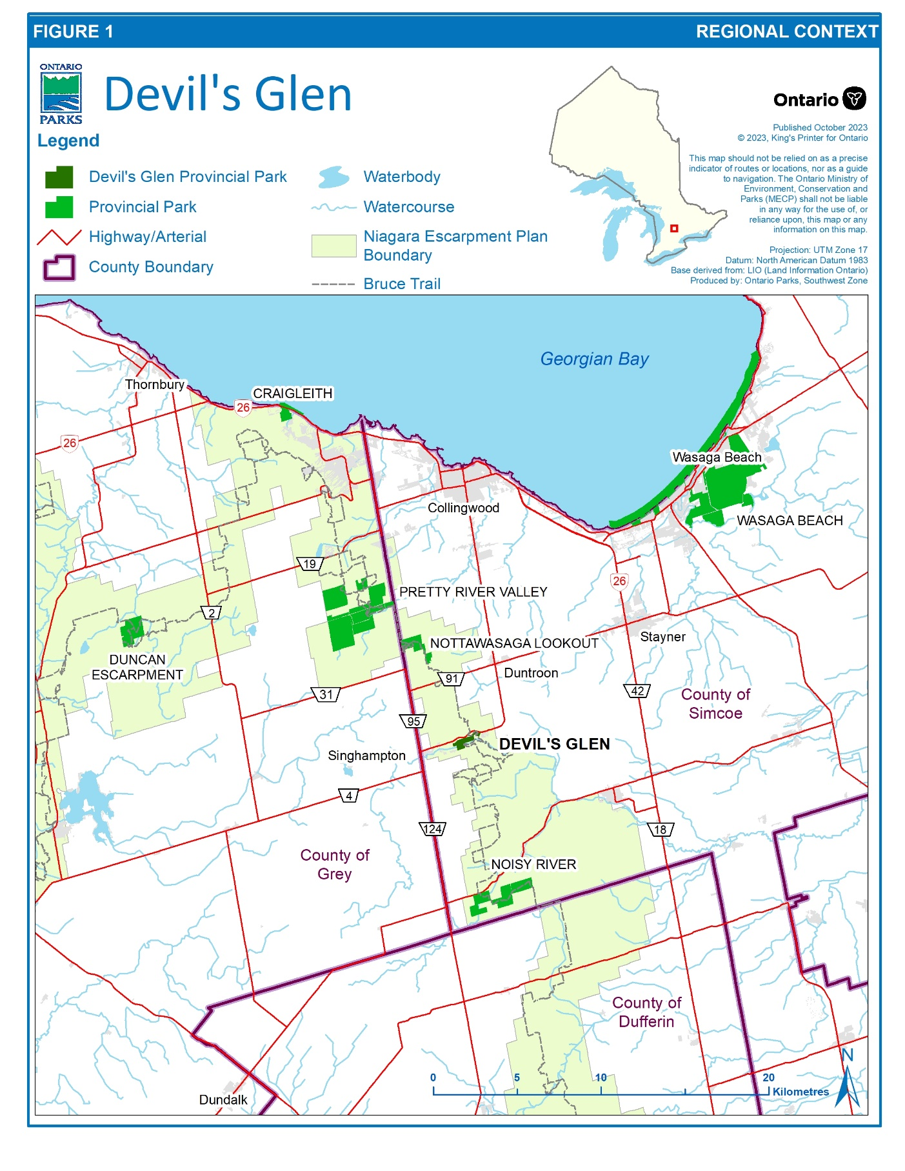

**Figure 2: Park boundary**

## 

## **Boundary**

Devil’s Glen Provincial Park is located in the municipal Township of Clearview in Simcoe County. The park is a continuous 60.19 ha parcel north of Nottawasaga Sideroad 17 and south of Highway 124 (see Figure 2). A boundary amendment is being proposed to regulate the adjacent 18 ha parcel as part of the park (Figure 2).

## Indigenous communities

Devil’s Glen Provincial Park is within the Lake Simcoe-Nottawasaga Treaty Area (Treaty 18) with the Chippewas of Beausoleil First Nation, Chippewas of Mnjikaning (Rama) First Nation, and Chippewas of Georgina Island First Nation. Devil’s Glen Provincial Park is also within the asserted traditional territory of the Saugeen Ojibway Nation.

Indigenous communities have lived and relied upon the lands and waters within their traditional territories and treaty areas long before Devil’s Glen Provincial Park was established. They continue to rely on these lands and waters to exercise their constitutionally protected Aboriginal and treaty rights which includes various practices, customs, and traditions integral to Indigenous communities’ distinctive cultures and ways of life. Some examples of these practices, customs and traditions may include hunting, trapping, fishing, and gathering food for personal, social and ceremonial purposes; traditional teachings; and ceremonial and spiritual activities.

Many Aboriginal and treaty rights are connected to the natural environment and are primarily exercised on Crown lands in Ontario, including within provincial parks and

conservation reserves. MECP is committed to meeting its constitutional obligations to Indigenous communities, including the duty to consult and, where appropriate, accommodate.

Further, Ontario Parks is working to rebuild and renew relationships with Indigenous communities based on trust and respect and to seek opportunities to protect, study, and enjoy provincial parks and conservation reserves together while educating Ontarians and provincial park and conservation reserve visitors.

## Planning context

The *Provincial Parks and Conservation Reserves Act, 2006* (PPCRA) states that management direction must be prepared for each provincial park in Ontario. The preparation of this management plan meets that requirement. Ontario’s Protected Areas Planning Manual and Guidelines: 2014 Edition (MNRF 2014) were used to guide park management planning.

This management plan has been developed consistent with all relevant legislation and provincial policies including the PPCRA and Ontario Provincial Parks: Planning and Management Policies, 1992 Update (MNR 1992).

## Ecological integrity

In the PPCRA, one of the guiding principles for park planning and management is:

* maintenance of ecological integrity shall be the first priority, and restoration of ecological integrity shall be considered.

An ecosystem has ecological integrity when:

* it has all the parts (both living and non-living) that you would expect to find, and
* natural functions and rates of change are happening normally.

This management plan identifies site-specific management policies and actions intended to maintain or, where possible, restore ecological integrity.

# Classification

Devil’s Glen Provincial Park is a recreational class park.

An amendment to O. Reg 316/07 is being proposed to change the park classification to Natural Environment in recognition of the park’s unique life science and earth science features and the recreational values of the park. The current recreational classification of the park is no longer appropriate given the removal of the campgrounds and facilities and its environmental functions.

# Purpose and objectives

## Purpose

The purpose of Devil’s Glen Provincial Park is to permanently protect the park’s natural and cultural heritage values, and to provide a limited variety of compatible forms and levels of outdoor recreation.

## Vision

The vision for Devil’s Glen Provincial Park is a place where visitors can experience the unique life science, earth science, cultural heritage and recreational values of the Niagara Escarpment and Bruce Trail. Recreation and nature appreciation opportunities are promoted in areas of the park where impacts to resources and natural processes are minimized in order to ensure that ecological integrity is maintained.

## Objectives

Devil’s Glen Provincial Park contributes to all four PPCRA objectives which pertain to protection, ecologically sustainable recreation, heritage appreciation and scientific research.

### ****Protection****

The protection objective for the park’s significant natural values continues to be a high priority. The protection objective of Devil’s Glen Provincial Park is:

* to protect provincially rare, provincially uncommon, and regionally uncommon plant and animal species, including species at risk
* to protect the regionally significant incised river valley, as well as ecological features and communities associated with the Niagara Escarpment
* to protect the high-quality cold-water fishery habitat for Brook Trout in the Mad River.

### ****Recreation****

The recreation objective of Devil’s Glen is:

* to offer day use opportunities for hiking, rock climbing, sport fishing, and nature appreciation.
* to serve as a Bruce Trail access point
* to provide visitors with opportunities to discover and experience the natural settings of the Niagara Escarpment, Bruce Trail and surrounding recreational attractions in the Blue Mountain and southern Nottawasaga Bay region.

### ****Heritage appreciation****

The heritage appreciation objective of Devil’s Glen is:

* to provide facilities that will enable park visitors to explore, interpret and appreciate the landscape units and ecological, geological, and cultural heritage of the park and the adjacent portions of the Niagara Escarpment.

### ****Scientific research****

The scientific research objective of Devil’s Glen is:

* to support scientific research in relation to both the natural and cultural heritage resources of the park, including species at risk, other significant species and habitats, significant earth science features, and human history
* research will be used to inform management direction and ensure that ecological integrity is maintained.

# Values

Devil’s Glen is located on the Niagara Escarpment, in the Oak Ridges Ecodistrict, 6E-7. The park is also within the Devil’s Glen Gorge Area of Natural and Scientific Interest (ANSI), which was designated an ANSI in the early 1990s by the Ontario government as part of the Ecological Survey of the Niagara Escarpment Biosphere Reserve (Riley *et al*. 1996). Devil’s Glen supports part ofthe Blue Mountain Section of the Bruce Trail and an associated parking area. A viewing platform at the park provides a scenic view of the Niagara Escarpment.

The park contains a significant portion of the largest incised gorge in ecodistrict 6E-7 (Jalava 2008). This regionally significant river valley cuts through the escarpment by the fast-flowing Mad River, formed as surging glacial meltwaters spilled into the river while the Laurentian ice sheet retreated. The most prominent features of Devil’s Glen are the cliffs and talus slopes of the Niagara Escarpment. Representative earth science features include glacial outwash plain and intermittent bedrock exposures of the Manitoulin, Whirlpool, Queenston, and Cabot Head formations. A life science inventory of the park was completed in 2007 (Jalava 2008). The extensive mantled slopes characteristic of the Niagara Escarpment hosts mixed forests predominantly composed of sugar maple, eastern hemlock, and yellow birch. Upper talus slopes are dominated by fire-successional eastern white cedar and white birch. Lowland areas of the Mad River are dominated by eastern white cedar and secondary species such as white spruce, balsam fir, basswood, trembling aspen, balsam poplar, black ash, basswood, red maple, green ash, yellow birch, and white birch.

The park sustains high ecological diversity relative to its size and has been found to support a variety of identified special features including species at risk and specialized habitats. Twenty-five ecosites have been identified within the park (Jalava 2008). The park features nine provincially significant vegetation community types associated with cliff and talus habitats (Bakowsky 1997); these habitats are considered ecologically sensitive and provide habitat for locally rare species such as the smooth cliff-brake. The cliff and talus areas of the park and two areas of cedar forest located on the Mad River valley slopes have been identified as extremely sensitive to disturbance (MNR 1985). A number of old growth cedar trees were identified in the park as part of the Niagara Escarpment Ancient Tree Atlas Project (2004), located within the sensitive cliff ecosites.

Many species of area sensitive and forest interior birds have been recorded in the park including recent evidence of breeding and roosting activity along the cliff face (Jalava 2008). Small crevice cave features in the park provide roosting sites for a significant number of bats, as well as potential hibernation habitat.

# Summary of pressures

A life science inventory of the park indicated that the primary pressures to the park are invasive species, forest clearing on adjacent properties that results in habitat fragmentation and dumping of litter. Pressures to the Mad River include agricultural run-off, road salt, and unmaintained septic systems on adjacent properties (Jalava, 2008). Human use and increased visitation have also impacted natural values within the park.

# Zoning

Ontario Parks divides parks into zones based on the sensitivity of natural and cultural values, potential for recreational uses, and desired degree of development. Different policies are applied to each type of zone to ensure they are managed appropriately.

All lands within the Devil’s Glen Provincial Park boundary, and in the adjacent parcel which has been proposed to be regulated as provincial park land,have been zoned in recognition of their environmental qualities, required protection and their potential for recreational use within the context of the objectives of the park. The park has three zone types: Development Zone, Natural Environment Zone, and Nature Reserve Zone. These proposed zoning changes are shown on Figure 3 and described below.

Life science inventory recommendations indicate that sensitive habitat areas of the park should receive additional management attention. These areas include seepage zones, Niagara Escarpment cliff, rim and talus communities, riparian wetlands, steep slopes and rich shallow-soiled forests over bedrock, and that the provincially rare smooth cliff-brake open cliff community be protected from recreational impacts (Jalava 2008). Zoning changes have been proposed in order to protect these ecological areas.

## Development zone

**Description:**

This zone (5.3 ha) is located on the tableland in the northeast corner of the park and contains day use parking, and the viewing platform. Further development of this area will be limited to a minor expansion of the parking lot to accommodate increased park visitation. The adjacent parcel of Crown land that has been proposed as an addition to Devil’s Glen has a small development zone that would accommodate a small parking lot.

**Management Intent:**

* to improve the landscape aesthetics and the environmental quality of this zone through planting native species.
* to support recreational opportunities by maintaining and improving upon existing facilities as deemed necessary and provide a level of visitor access that conforms to sustainable use and protection of the park.

## Natural environment zone:

**Description:**

This zone (29.3 ha) contains part of the Mad River Valley as well as small upland level areas. It is anticipated that partof the adjacent parcel of Crown land that has been proposed as an addition to Devil’s Glen Provincial Park would be zoned as Natural Environment upon regulation.

**Management Intent:**

* to protect the significant natural and cultural features from detrimental forms and levels of recreational use.
* to encourage low-intensity recreational use and to provide adequate facilities to accommodate such use while minimizing environmental impact.
* to monitor use to determine its impact on the environment and to take appropriate action if environmental degradation occurs.

## Nature reserve zone

**Description:**

This proposed zone (44.5 ha) contains part of the Mad River Valley including forest communities and seepage zones.

**Management Intent:**

* to protect the significant natural and cultural features from detrimental forms and levels of recreational use.

**Figure 3: Zoning and proposed development**

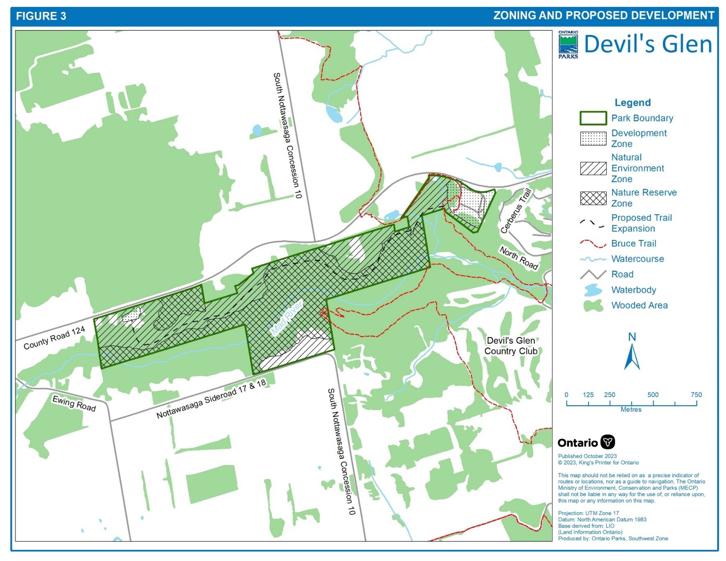

# 

# Resource management

## Industrial activities

Industrial activities are prohibited in Devil’s Glen Provincial Park.

## Fish habitat management

The Mad River is rated as a high-quality cold-water fish habitat and has been identified as a high sensitivity area of the park (MNRF 1985). Management initiatives, endorsed by the MNRF district fish and wildlife section, to maintain and improve fish habitat will be encouraged.

## Vegetation management

The vegetation communities outside the development zone will be allowed to evolve on their own with little or no management. Vegetation management and restoration in the development zone requires additional plantings of native species and maintenance of existing plants.

Grass cutting will be confined to the high use areas of the park such as around picnic areas, parking areas and the viewing platform.

The former campground and areas impacted by off-trail recreational activities may be rehabilitated through the planting of native species that are characteristic of the Niagara Escarpment. This may be addressed as part of a detailed vegetation management strategy for the park, or as a separate vegetation management plan for this area.

Introduced and invasive species, plant pests, and diseases that threaten park values will be controlled where feasible.

## Species at risk

The park will be managed to protect at-risk and rare species. Species at risk and their habitats will be protected in a manner consistent with the Endangered Species Act, 2007 (ESA), regulations and guidelines, and other relevant policy and best practices. The park may undertake management actions for species at risk and rare species, as supported by research and directed through approved recovery strategies and government response statements or other species-specific management plans.

Existing populations may be augmented, and extirpated native species may be reintroduced, if biologically feasible and desirable for perpetuating park values and maintaining or enhancing ecological integrity.

## Invasive species

Invasive species are plants, animals and microorganisms introduced by human actions outside their natural past or present distribution. These species may originate from other continents, countries or provinces, or from other parts of Ontario.

Invasive species are species that are harming, or likely to harm, the natural environment in Ontario. Invasive species will be addressed in a manner consistent with the *Invasive Species Act, 2015*, regulations and guidelines, Ontario’s Invasive Species Strategic Plan, Ontario Parks directive 25.01, and other relevant documents or best practices.

Where possible, Ontario Parks will work to eradicate or control invasive species in Devil’s Glen Provincial Park, with a priority of protecting the park’s most significant and sensitive areas. Invasive species control will aim to reduce or prevent impacts to native species, biodiversity, ecosystem function, and recreational opportunities. Control activities will be adapted based on the best available information.

## Fire management

The Wildland Fire Management Strategy provides strategic direction for the management of wildland fire in Ontario. Fire management in provincial parks is guided by the Fire Management Policy for Provincial Parks and Conservation Reserves (MECP and MNRF 2021) and the associated guideline. The goal of fire management in provincial parks is to promote and encourage the use of fire as a natural ecological process for the maintenance and restoration of ecological integrity.

## Cultural heritage

Cultural heritage values will be identified, assessed, and managed in accordance with existing applicable legislation and policies. If cultural heritage values are discovered, Ontario Parks will follow requirements outlined in relevant cultural heritage policy.

## Land management

In principle, Ontario Parks supports the acquisition of land to enhance protection or park management. Adjacent lands with similar values, would be of highest priority for acquisition. If lands are offered for sale or donation, staff will evaluate how they contribute to park objectives. Suitable properties would only be acquired from willing sellers or donors, and only if there is available funding.

Ontario Parks may carry out recreation inventories, surveys, and monitoring to inform park management decisions.

Actions that may be implemented to address pressures originating from adjacent lands include, but are not limited to:

* Enforcement of unauthorized access and use.
* Fencing or barriers to restrict access or protect sensitive earth and life science values.
* Signage noting access restrictions and/or park values.
* Public communication and/or collaboration.

## Science and research

Any government agency or external party who wishes to carry out research in Devil’s Glen Provincial Park must obtain a research authorization letter from the park superintendent. Researchers must consider the sensitivities of the site, such as the provincially significant earth and life science features and may require additional federal and/or provincial permits (e.g., *Endangered Species Act* permit).

# Operational policies

Ontario Parks may maintain a park operations plan to provide park staff with the necessary information required to operate the park on a day-to-day basis. The park operations plan will include such topics as budget, staffing, and maintenance schedules, enforcement, and emergency services. The provisions of the strategy will be consistent with the approved Ontario Provincial Parks Operating Standards (MNRF 2018) and will be reviewed annually and updated as required.

Day use fees may be introduced to offset costs associated with park operation, development and maintenance.

## Visitor services

As a non-operating park, there are limited visitor services. The park offers three visitor service components: information, interpretation, and recreation, with a stronger emphasis on information and interpretation.

### Information

Information objectives of this component will include the following:

* informing visitors about the park’s policies, and management concerns
* informing visitors about additional recreation and interpretive opportunities in the local area
* informing visitors of the role of the Ministry of Environment, Conservation and Parks
* instilling a sense of respect in visitors for the park’s natural and cultural values providing a means of feedback for visitors to communicate with park management.

The information component of the park’s visitor services program will continue to be achieved through the use of signs, publications and interpretive panels. Personal contact with day users will occur on an informal and infrequent basis.

### Interpretation

Interpretation of the significant earth and life science features will be self-guided on approved trails in conjunction with publications and interpretive signage. A viewing platform provides an excellent view over the gorge and Mad River valley. Interpretive messages will be displayed on signage around the platform.

## Recreation management

The park will be accessible on a year-round basis for day-use activities. Low-intensity recreation activities (i.e., hiking, wildlife viewing, and fishing) will be expanded if feasible. Hunting will not be allowed in the park. Sport fishing is permitted in the Mad River. Cycling and the use of motorized off-road recreational vehicles will not be permitted.

### Rock climbing

Rock climbing may be permitted in areas designated by the park superintendent and demarcated by appropriate signage. Rock climbing use will be secondary to protection of the park’s significant geological and biological features. Ontario Parks may enter into a formal agreement with a climbing club to manage this use. Ontario Parks may restrict, or close, a rock climbing area, or areas, if impacts to the park’s ecological integrity become evident (e.g., impacts to wildlife, vegetation or the geological features of the escarpment). Appendix III provides additional direction respecting this use. Rock climbing in these areas would be done so solely at the risk of the user, and Ontario Parks will not establish, maintain or inspect any rock climbing routes or locations in this Park.

## Marketing

A Marketing Plan may be prepared. The plan will emphasize the park’s value as a place for exploring the Niagara Escarpment in an environmentally responsible manner.

# Development policies

Two specific developments are recommended:

* maintenance of the viewing platform and interpretive plaques,
* expansion and improvement of the park’s trail system in order to avoid sensitive life and earth science features, and any cultural values that may exist, and feature the vistas offered along the rim of the valley.

# Summary of public consultation (1989 plan)

Public consultation during the management planning process of the 1989 Devil’s Glen Provincial Park Management Plan focused on the local area and included the following:

* A news release and advertisement in the Collingwood Enterprise and Bulletin, Blue Mountain Buyers Guide and the Creemore Sun newspapers advised that the draft management plan and the background Information document were available for review at the Park office.
  + copies of the management plan and news release were forwarded to local levels of government for review- (Township of Nottawasaga (now Clearview), Simcoe County, Nottawasaga Valley Conservation Authority, Niagara Escarpment Commission)
  + copies of the management plan and news release were sent to the following interest groups: Blue Mountain Club of the Bruce Trail Association, Devil’s Glen Country Club, Federation of Ontario Naturalists and the Ontario Federation of Anglers and Hunters, Coalition on the Niagara Escarpment
  + where appropriate, contact was made with adjacent landowners by park management, to inform these landowners of the plan and its contents
  + announcements and posters were on display in the park during early 1986 advising park visitors of availability of plan, at the district office, for review.

The summary of public consultation for the 1994 management plan amendment is described in Appendix 1.

# Plan review and amendment

This management plan will be examined in accordance with the provisions of the PPCRA to determine whether it is still relevant, effective and current, or if adjustments are needed. In circumstances where the plan is not providing sufficient direction, or to address specific issues or pressures, it can be examined prior to the next scheduled examination. Minor amendments may be made in the interim as required. Major amendments having broad implications for park management will receive public review.

# Implementation Priorities

The following table summarizes and prioritizes actions identified in the management plan. Implementation of actions may be subject to:

• other applicable legislation

• operational or administrative policy

• evaluation under Ontario Park’s Project Evaluation Policy, which may include public notification or consultation

• the availability of financial and human resources

Table 1: Implementation priorities

| **Actions identified in management plan** | **Section** |
| --- | --- |
| **Short-term priorities** |  |
| * **Invasive species management, especially in areas impacted by increased use** * Enforcement of unauthorized access and use. * Fencing or barriers to restrict access or protect sensitive earth and life science values. * Signage noting access restrictions and/or park values. * **Repair and update interpretive panels** * **Introducing day use fees** | 7.5  7.8  7.8  7.8  8.1.2  8.2 |
| **Medium-term priorities** |  |
| * **Rehabilitation of disturbed areas and former campground** * **Expansion/improvement of the park’s trail system** | 7.3  9.0 |
| **Long-term priorities** |  |
| * **Expansion of the current parking lot and development of a new parking lot in the proposed development zone of the lands to be acquired** | 6.1 |

# References

Bakowsky, W.D. 1997. Vegetation Communities of Southern Ontario. OMNR Natural Heritage Information Centre, Peterborough.

[*Endangered Species Act, 2007, S.O. 2007, c. 6*](https://www.ontario.ca/laws/statute/07e06)

Gould, J. 1984. A Reconnaissance Biological Inventory of Devil ‘s Glen Provincial Park and Park Reserve.

[*Invasive Species Act, 2015, S.O. 2015, c. 22*](https://www.ontario.ca/laws/statute/15i22)

Jalava, J.V. 2008. Life Science Inventory of Devil’s Glen Provincial Park. Ontario Parks, Central Zone, Huntsville, Ontario. v + 109 pp. + 4 pp. check sheet.

Ministry of the Environment, Conservation and Parks. 2023. Project Evaluation Policy. Peterborough: King’s Printer for Ontario.

Ministry of the Environment, Conservation and Parks and Ministry of Natural Resources and Forestry. 2021. Fire Management Policy for Provincial Parks and Conservation Reserves, PAM 7.02.

Ministry of Natural Resources. 1985. Devil’s Glen Provincial Park Management Plan Background Information Document.

Ministry of Natural Resources. 1992. Ontario Provincial Parks: Planning and Management Policies, 1992 Update. Provincial Parks and Natural Heritage Policy Branch. Toronto: Queen’s Printer for Ontario.

Ministry of Natural Resources. 2006. A Technical Guide for Cultural Heritage Resources for Projects Planned Under the Class Environmental Assessment for Ministry of Natural Resources Resource Stewardship and Facility Development Projects and the Class Environmental Assessment for Provincial Parks and Conservation Reserves. Peterborough: Queen’s Printer for Ontario.

Ministry of Natural Resources and Forestry. 2014. Ontario’s Protected Areas Planning Manual and Guidelines: 2014 Ed. Peterborough: Queen’s Printer for Ontario. 33 pp.

Ministry of Natural Resources and Forestry. 2018. Ontario Parks Operating Standards. Peterborough.

[*Ontario Heritage Act, R.S.O. 1990, c. O. 18*](https://www.ontario.ca/laws/statute/90o18)

Ontario Ministry of Natural Resources. ANSI File - Devil’s Glen Upland Forest, 41A/8 610120, Central Region.

Ontario Ministry of Natural Resources. 1985. Devil’s Glen Provincial Park Management Plan, Background Information Document.

Ontario Ministry of Natural Resources. Provincial Parks in the Niagara Escarpment Planning Area: A Future Perspective.

Ontario Ministry of Natural Resources. 1983. A Summary of the Earth Science Areas of Natural and Scientific Interest in Huronia District.

Ontario Ministry of Natural Resources. 1972. Mad River: An Ecological Assessment. OMNR, Parks Branch, Toronto.

Ontario Ministry of Natural Resources and Econometrics Ltd. Economic Impact of Provincial Parks in Ontario: A Summary Report.

Ontario Ministry of Natural Resources. Provincial Park Draft Systems Plan, Central Region, Ontario Ministry of Natural Resources; Central Region Ontario Provincial Parks, Visitor Services Plan.

Ontario Provincial Secretariat for Resources Development. 1984.Niagara Escarpment Plan - Volume 2: Recommended Policies of the Provincial Secretary for Resources Development.

[*Provincial Parks and Conservation Reserves Act, 2006, S.O. 2006, c. 12*](https://www.ontario.ca/laws/statute/06p12)

Riley, J.L., J.V. Jalava and S. Varga. 1996. Ecological Survey of the Niagara Escarpment Biosphere Reserve. Volume I: Significant Natural Areas. Volume II: Technical Appendices. Ontario Ministry of Natural Resources, Southern Region, Aurora, Science and Technology Transfer, Technical Report TR-001. 78pp.

# Appendix I: Summary public consultation (1994)

Public consultation for the 1994 Devil’s Glen Provincial Park Management Plan Amendment was primarily focused on the local area.

The 1994 Ontario Provincial Parks Guide listed Devil’s Glen Provincial Park as ‘day use only’. This listing will be repeated in future editions. A mailing list was prepared consisting of local interest groups, municipalities, government agencies, provincial and federal members of parliament and adjacent landowners. Over 50 copies of the preliminary plan amendment were distributed following March 21, 1994. Additional copies were provided upon request.

A news release was also distributed to local media outlets the week of March 21, 1994. A paid newspaper advertisement was placed in four area newspapers during the first week of April 1994.

On May 3, 1994, over 500 letters were mailed out to Devil’s Glen Provincial Park 1993 camping patrons advising them of the campground closure for the 1994 season.

In early May of 1994, Devil’s Glen was included in an announcement that, as part of its expenditure control plan, MNR would not be reopening eight provincial parks in 1994. The decision was slightly modified for Devil’s Glen to allow normal day use opportunities. This decision was made after the original plan to close the campground.

Notices concerning the proposed plan amendment were posted at both Devil’s Glen and Wasaga Beach Provincial Parks from the Victoria Day weekend through to the Labour Day weekend, 1994.

Staff at Wasaga Beach Provincial Park answered a limited number of (telephone and mail-in) campsite reservation requests for the 1994 season. Campers were advised the campground was closed and were redirected to other campgrounds in the vicinity.

The official due date for responses to the proposed plan amendment was May 27, 1994, however, responses were entertained until Labour Day.

The results of the various consultation-communications efforts included four media interviews, six letters, and six telephone responses. Public comments were summarized and analyzed and incorporated into the final management plan amendment, where appropriate.

Based upon both Ministry of Natural Resources’ staff discussions and external Input, the final Devil’s Glen Provincial Park Management Plan Amendment was approved in early September 1994. Following this, copies were distributed to a revised contact list. Additional copies of this document will be made available upon request.

**Issues Raised (1994)**

A number of local business operators and local residents objected to the closure and retirement of the campground. Some respondents suggested operational alternatives, such as contracting, hiring students, et cetera, as a means of operating the campground more efficiently (measures which the Ministry had previously implemented).

There was support for continued protection of the park’s significant earth and life science features and provision for day use opportunities.

Some concerns were expressed that the level of park maintenance would suffer, and that vandalism would be a problem if the campground were to be dosed.

The Bruce Trail Association had no objection to the plan amendment but did support retention of an overnight camping facility for hikers.

The Niagara Escarpment Commission had no objection to the plan amendment but did propose a change in park classification from “recreation” to “natural environment”.

Park patrons did not express concern over the campground closure.

# Appendix II: Management planning history

| **Approval Date** | **Type of document and/or type of change** | **Document name** |
| --- | --- | --- |
| 1989 | Original management plan | Devil’s Glen Provincial Park Management Plan |
| Sept 12, 1994 | Amendment to close /remove campgrounds | Devil’s Glen Provincial Park Management Amendment |
| April 3, 2013 | Examination – Outcome: Replacement | Devil’s Glen Provincial Park Examination Confirmation Statement |
| May 29, 2023 | Examination – Outcome: Administrative Update & Amendment | Devil’s Glen Provincial Park Examination Confirmation Statement |
| November 23, 2023 | Administrative Update | Devil’s Glen Provincial Park Management Plan – 2023 Administrative Update |

# Appendix III: Management of Rock Climbing

## Purpose

The purpose of this Rock Climbing plan is to establish a necessary means of managing rock climbing activities at Devil’s Glen Provincial Park in order to protect the natural environment while providing visitors with compatible rock climbing opportunities. Climbing will be secondary to the protection of the cliff’s important geological, biological and cultural heritage. A *leave no trace* ethic will be the guiding principle by which all issues will be addressed. This plan will also support cooperative approaches between Ontario Parks and the climbing community including of sharing information and perspectives, understanding expectations, and providing opportunities for mutually beneficial collaboration.

## Disclaimer

While Ontario Parks will accommodate climbing by providing parking, access trails, trail maps, and signage, visitors climbing at Devil’s Glen Provincial Park fully assume all risks associated with rock climbing, including, but not limited to, injury (including death), loss or damage, to persons, property or otherwise, of any kind resulting from such risks and any associated activities.

Ontario Parks will designate areas within Devil’s Glen Provincial Park in which rock climbing may take place at the sole discretion of the rock climber, where the activity will not harm the environment or wildlife or impede the maintenance of ecological integrity. The areas will be identified through signage. Ontario Parks cannot identify all hazards or guarantee the safety of climbers or other park visitors.

## Authority

O. Reg. 347/07: PROVINCIAL PARKS: GENERAL PROVISIONS

11. (1) No person shall rappel or climb rock faces in a provincial park with or without the aid of ropes, anchors, or similar equipment except in an area designated by the superintendent for that purpose. O. Reg. 347/07, s. 11 (1).

(2) For the purposes of subsection (1), the superintendent may designate an area in which the activity will not harm the environment or wildlife or impede the maintenance of ecological integrity. O. Reg. 347/07, s. 11 (2).

## Objectives

The following are the objectives of the Rock-Climbing Plan:

* Maintain ecological integrity and protect the natural environment, especially sensitive, threatened, or endangered plants, animals, and ecological communities.
* Provide for a diversity of compatible rock climbing experiences across as many levels of difficulty as possible.
* Engage the climbing community in cooperative stewardship of the maintenance of ecological integrity and the climbing experience.
* Initiate a continuing planning process that responds to new data and changes over time.

## Designated Climbing Areas and Route Closures

Recreational access for the purpose of rock climbing may not be appropriate for each cliff ecosystem area within Devil’s Glen Provincial Park. Climbing will be allowed only in areas supported by Ontario Parks and designated by the park superintendent, pursuant to the PPCRA. To be eligible for designation as a climbing area, a location must be within the provincial park boundaries, safely accessible by trail, and be able to sustain climbing activities without impacting park values. Designated Climbing Areas, trails and other access points will be clearly marked on site by Ontario Parks using appropriate signage.

In the event that climbing areas are deemed sensitive to climbing activity, it is understood that any route or routes may be closed. This may be due to information derived from inventories and surveys, or from other sources. Ontario Parks does not permit unauthorized trails or rock climbing in unauthorized areas, and will monitor for heavily impacted zones at the base of climbs and other areas where there is potential for harm to the environment or wildlife, or where the maintenance of ecological integrity may be impeded. The Park Superintendent has the authority to close any area, rock feature, or climbing route to protect wildlife, natural or cultural resources, visitor experiences as well as other park values.

Ontario Parks will be the sole authority in determining if route closure is needed through application of a two-part assessment including 1) are there sensitive, threatened, or endangered species or ecological communities present in relation to the route and 2) are climbing activities known or likely to be causing negative impacts to such values.

Designated climbing areas and any closed routes will be clearly marked on site by Ontario Parks through posted signage. Closures may be permanent or seasonal in nature based on applicable environmental values and concerns. Ontario Parks may consult with the climbing community to determine the extent of existing routes and/or if environmental impact mitigation approaches can be undertaken to reduce instances of route closures.

In some instances, Ontario Parks may be required to close routes to comply with provincial or federal regulations or conservation strategies.

Locations of closed routes or informal access trails may be restored as appropriate, at the sole discretion of Ontario Parks. Ontario Parks may consult the climbing community or other park stakeholders to plan and implement restoration efforts. For closed routes Ontario Parks may also require or support the removal of fixed anchors to promote restoration and deter ongoing use.

## Climbing Activities

### Safety

Using the park is not a risk-free experience, and climbing is an inherently dangerous activity. Ontario Parks cannot guarantee the safety of climbers or other park visitors. Ontario Parks will not establish, monitor or maintain any climbing routes or inspect or maintain associated climbing equipment. Ontario Parks makes no warranty as to the suitability or safety of climbing routes or use of this Park for rock climbing.

Ontario Parks will not assume responsibility for the condition of climbing terrain, routes, or the acts or omissions of climbers. Ontario Parks explicitly disclaims all responsibility for the safety of rock climbing equipment, bolts, or other anchor systems in the park.

### Rescue

Ontario Parks does not preform high angle rescues. Climbers should be prepared to self rescue however, in the event of an incident, the incident commander believes it is in the best interest of the park, safety of park staff and visitors, and/or the injured or stranded party, search and rescue resources may be called upon to facilitate the rescue.

### Climbing Practices

Climbing activities that involve use of safety anchors, ropes, harnesses, and other equipment will be permitted. No free climbing, slack-roping or any form of un-roped climbing is allowed in the park.

### Establishing New Climbing Routes

It is recognized that the Devil’s Glen cliff area is highly saturated with existing climbing routes and the need or capacity to create new route opportunities is generally low. However if opportunities are identified in suitable areas, Ontario Parks has the sole discretion to determine whether a new climbing area is appropriate. Installation of bolts or other fixed anchors and establishment of new climbing areas of any kind will not be allowed without authorization of the Park Superintendent. Any decision to authorize new rock climbing areas will be based on values assessments including ecological information, presence of cultural values, the need or contribution of the climbing experience, and the density of the routes in the area. The Park Superintendent may close climbing areas for any reason.

### Repair and Replacement of Existing Fixed Anchors

Although there are hundreds of fixed anchors on the cliff face at Devil’s Glen, Ontario Park’s preference is to minimize their use. Ontario Parks reserves the right to prohibit new installation efforts on a case-by-case basis.

Ontario Parks is not responsible for the installation, condition, use, inspection, replacement or maintenance of any fixed anchors. Ontario Parks makes no representations or warranties as to any fixed anchor's condition or reliability, and is not responsible for anchor information in guidebooks, Internet websites, etc.

The Park may involve local climbing organizations prior to any climber replacing existing hardware. Ontario Parks will provide information on ecologically sensitive placement of hardware.

Only permanent fixed anchors and top rings shall be left on the cliff face for extended periods. All other temporary equipment applied by individual climbers must be removed after each use. Power drills may be used to install or replaced fixed hardware; the Park Superintendent Authorization may establish additional requirements on when and how a power drill may be used. Park Management may require removal of any hardware at any time.

### Bouldering

Due to constraints related to the limited number of bouldering opportunities, the ecological richness and sensitivity of these areas, as well as safety concerns and other constraints related to the transport and use of mats into this area of the park, the practice of bouldering is not permitted.

### Rappelling

The base of the cliff has been historically accessed mostly via informal trails and a crevice feature. As such, rappelling has not been a common or required practice to facilitate climbing access to the base of the cliff. One or more organized rappelling access locations as appropriate may be identified and considered for authorization by Ontario Parks in future, after sufficient consultation with the climbing community and others, however until this occurs the practice of rappelling will be limited to emergency search and rescue or authorized bolt removal or replacement operations.

### Chalk

Ontario Parks encourages climbers to use the minimum amount of chalk necessary to climb safely. Climbers should clean up chalk and tick marks off the cliff face after each use. Ontario Parks will work with climbers and climbing groups to coordinate chalk clean-ups.

### Route Top-Outs

Ontario Parks requires climbers to continue the environmentally sensitive practice of preventing top-outs by stopping climbing routes below the cliff or boulder rim. This provides a degree of protection for the rim ecosystem. Devil’s Glen Provincial Park climbing areas will adopt a “no top out” for all routes, with retreat from the top of any route occurring via fixed anchor stations that are located below the rock face’s top edge. This is intended to both alleviate adverse impacts to cliff-top areas and to avoid the unsafe use of vegetation for anchors. Where desirable and feasible, centralized belay points should be considered to serve multiple routes.

Exceptions to the no top out policy may be allowed subject to the Park Superintendent’s authorization.

### Vegetation Alteration or Gardening

Vegetation alteration is defined as disturb, cut, kill, remove, or harm any plant, tree or natural object in a provincial park. (O. Reg. 347/07, s. 2 (2)(a).)

* Vegetation alteration is prohibited in all areas of the park, including on access routes, staging areas, and climbing routes.
* The use of trees or other vegetation as natural anchors is prohibited.

### Protection of Wildlife

Ontario Parks will make every effort to keep climbing areas, routes and access points away from known features and species of ecological significance but in some cases wildlife activity may overlap with existing climbing areas.

Under O. Reg. 347/07, s. 2 (2)(b) no person shall, disturb, kill, remove, harass or harm any animal except in accordance with the *Fish and Wildlife Conservation Act, 1997*, any bird except in accordance with the *Migratory Birds Convention Act, 1994*(Canada);

* Any animal that is incidentally or otherwise encountered during access to climbing areas and routes or climbing activities must be avoided, including instances of breeding or roosting birds, or mammals, herptiles and invertebrates that may be present on the cliff face or approach areas.
* Particular caution and avoidance of bird nesting ledges and bat roosting or hibernation cavities on or around the cliff face is required.

### Rock / Rock Face Alteration

Rock alteration is prohibited and includes any removal of rock from its natural position, chipping, or gluing, cementing, or installing artificial holds is prohibited. O. Reg. 347/07, s. 2 (1).

### Introduction of Invasive Species

It is very important that all park users including climbers avoid the instruction and spread of invasive species into Devil’s Glen from other sites. O. Reg. 347/07, s. 7 states, “no person shall introduce into a provincial park, or possess in a provincial park, any plant, animal or other living thing, or any object, material or other substance, that may carry non-native or invasive pests or species, as determined by the Ministry.”

The escarpment cliff and talus represent one of the most significant and fragile areas of the park and invasive species can have serious negative impacts to its ecological integrity.

* The introduction of invasive species is prohibited and climbers must ensure all equipment, clothing and footwear is free of invasive species seeds or other materials before entering the park.
* Ontario Parks may coordinate and partner with the climbing community to organize invasive species control efforts in climbing and access areas.

### Gear Caches

Gear cache is defined as any supply of gear left unattended.

* The caching of climbing related equipment is prohibited.
* The caching of climbing related equipment at or near the base of a climb in the event shall be allowed during the climb.

### **Climbing \ Climbers Impact**

All climbers must follow all Ontario Parks rules and regulations and Ontario Parks will promote responsible, ethical, and environmentally sensitive climbing, and will advocate a “Leave No Trace” program.

### Dispose of Waste Properly (Pack It In, Pack It Out)

No person shall deposit or cause to be deposited any litter in a provincial park except in a place designated for that purpose. O. Reg. 347/07, s. 4 (1).

This simple yet effective saying “Pack It In, Pack It Out” motivates park visitors to take their trash home with them. Climbers are required to carry out the extra materials taken there by their group or others. Inspect your climb area, and pack out all trash, leftover food, and litter.

### Trails, Parking, and Access:

Ontario Parks will eliminate duplicate, braided, or unnecessary trails.

Climbers are encouraged to respect private land, private property rights, and the boundary of the provincial park.