Modernizing Ontario’s Framework for Power-Assisted Bicycles (E-Bikes)

The Ministry of Transportation is proposing to create a two-class definition for power-assisted bicycles. The proposal would also clarify that moped/scooter- or motorcycle-style electric motor vehicles would only be permitted on roads if they meet the requirements of an existing motor vehicle class (e.g., motorcycle, limited-speed motorcycle, or motor-assisted bicycle) under the Highway Traffic Act.

Requiring moped/scooter- or motorcycle-style electric motor vehicles to meet existing motor vehicle class standards would enhance safety and support fairness in the marketplace by ensuring that manufacturers of motor vehicle–like products are subject to, and operate under, appropriate motor vehicle regulatory requirements and consistent standards.

A 12-month education and awareness period is proposed to support the public, manufacturers, retailers, and stakeholders in understanding and complying with the updated rules.

Proposed E-bike Class 1 and Class 2: Key Operator, Vehicle and Safety Requirements

 | Class 1 | Class 2
Example Photos | 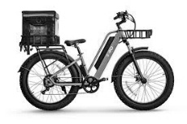  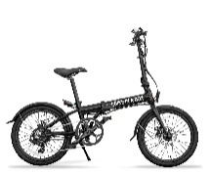 | 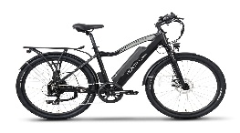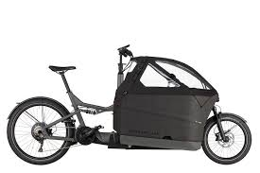  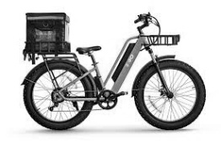
Definition | Required to have an exposed frame, not covered by body panels, and cannot have a footrest or a platform for the operator’s feet
Propulsion Method | Pedal-assist only with exemption to permit a throttle or button for “walk-assist function” up to 6km/h | May be throttle, button or pedal assist
Pedals | Must be equipped at all times with functional hand cranks or foot pedals that are capable of propelling the bicycle by muscular power and are usable during normal operation of the bicycle; however, continuous pedalling is not required.  Pedals are not considered functional if their placement, configuration, or operation renders them impractical, unsafe, or incapable of providing meaningful propulsion during normal riding conditions.
Wheels | Designed to travel on not more than three wheels in contact with the ground
Maximum Unladen Weight  *If passed, the Ministry would explore amending Ontario’s Cargo E-bike Pilot Regulation (O.Reg. 141/21) to update the minimum weight requirement for cargo e-bikes from 55kg to 120kg. | 55 kilograms | 120 kilograms*
Maximum Power-Assisted Speed | 32 kilometres/hour
Seat Requirements | Operator seat height must be adjustable
Maximum Motor Power | Total continuous power output rating, measured at the shaft of each motor, of 500 W or less
Wheel Width | None
Wheel Diameter | Minimum 350 mm (including tire)
Electric Terminals | All electric terminals must be completely insulated and covered
Braking | Must be capable of bringing the bicycle, while being operated at a speed of 30 kilometres per hour on a clean, paved and level surface, to a full stop within nine metres from the point at which the brakes are applied
Lighting/Bell or Horn | Bell or horn required as well as the following lights, reflective tape and reflectors:  - a white light mounted on front  - a red light or reflector on the back  - white reflective tape on the front  - red reflective tape on the rear
Modifications | No modifications permitted
Licence/Insurance/  Registration | No
Minimum Operator Age | 16
Are passengers permitted? | Yes – passengers of any age are permitted, provided a seat is available (either an original equipment seat or a seat designed to be compatible with the vehicle)
Are helmets required? | Compliant bicycle or motorcycle helmet required for all riders
Moped/Scooter and Motorcycle-Style Electric Motor Vehicles

Example Photos:

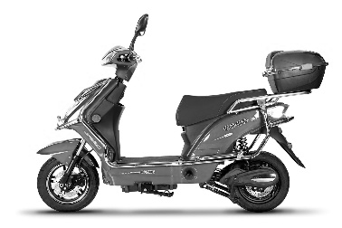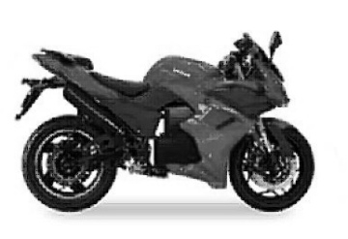

Moped/scooter- and motorcycle-style electric motor vehicles, which are generally heavier, capable of higher speeds, fully throttle-powered, and may have body panels partially or fully covering the frame would only be permitted if they comply with an existing motor vehicle class, as shown in the table below, ensuring that they meet the safety and operational standards appropriate to their design and intended use.

Vehicle Class |  | Motor-Assisted Bicycle (Moped) | Limited-Speed Motorcycle (LSM) | Motorcycle
Vehicle Requirements | Class | Motor Vehicle (may be electric or gas powered)
Vehicle Requirements | Federal Compliance Label | Required to certify the vehicle meets all applicable Canadian Motor Vehicle Safety Standards (CMVSS)
Vehicle Requirements | Maximum Weight | 55 kilograms | No limit
Vehicle Requirements | Maximum Speed | 50 kilometres/hour with motor assistance | 70 kilometres/hour with motor assistance | N/A
Vehicle Requirements | Operable Pedals Required | Yes | No
Operator Requirements | Licence | M or M with condition L |  | M or M with condition M (three wheeled motorcycle)
Operator Requirements | Insurance/ Registration | Yes
Operator Requirements | Helmet | Required for all riders
Operator Requirements | Driver Age | 16+
Operator Requirements | Passengers | No | Yes

