**ERO 013-5101 Discussion Paper: Modernizing Ontario's Environmental Assessment Program**

The Ontario Society of Professional Engineers (OSPE) is pleased to present the following submission concerning the *Discussion Paper: Modernizing Ontario's Environmental Assessment Program*, released on April 25, 2019.

OSPE is the voice of the engineering profession in Ontario. As an organization, we advance the professional and economic interests of our members, many of whom work in the environmental, energy and transportation sectors. OSPE is pleased to respond to this notice for public comments to provide feedback to the Discussion Paper.

While OSPE commends some of the actions outlined in the paper, there are several concerns with some of the proposed recommendations. Therefore, OSPE has respectfully put forward some suggestions as to better modernize the Environmental Assessment Program.

Ontario’s professional engineers are experienced at conducting various aspects of Environmental Assessments (EAs) in almost every sector of Ontario’s economy. Engineers can leverage their knowledge and experience to inform legislation to ensure the safety of the public in Ontario while ensuring economic progress.

OSPE stands ready to work with the government to deliver on its vision of growth, prosperity, and a cleaner environment for the benefit of the people of Ontario.

**Key Recommendations and Questions**

*Ensuring better alignment between the level of assessment and the level of environmental risk associated with a project*

1. **Provide the protocols for determining “low-risk” versus “high-risk” for public review.**

• OSPE supports the government’s plan to exempt low risk activities, however determining what causes “low” impacts versus what causes “high” impacts can vary from aspect-to-aspect (e.g., a proposed activity may have high risk for air emission impacts but low risk for noise impacts) and location-to-location, potentially making a rigorous assessment of “risk” quite site-specific and challenging to formulate.

*Eliminate Duplication between environmental assessments and other planning and approvals processes*

1. **Ensure that the “one-time” assessments are done rigorously.**

• OSPE agrees that there may be duplication in the number of similar assessments conducted for different organizations. However, if assessments are to be collapsed to “one time”, that assessment must be conducted rigorously. We would suggest that assessment protocols be subject to public scrutiny.

* Implementation international best practices (e.g., the International Association of Impact Assessment’s Air Quality Guide) should be considered.
* OSPE believes that the basis for determining whether a comprehensive or a streamlined assessment is required for a particular project must depend on its potential impact, and not solely on its size, scale and/or cost.

1. **Require technical studies to be conducted, signed-off and peer-reviewed by licensed professionals only**

• Licensed professionals, such as professional engineers, are legally required to ensure public safety, as their highest priority, and are accountable for the advice they provide. Given the public safety aspects of EA, OSPE recommends that only licensed professionals, and especially licensed engineers, be allowed to conduct certain aspects of EAs (e.g., air and noise emissions).

* Such a requirement would also initiate practice guides to be developed within professional bodies, and perhaps also stipulations of more specialized requirements (e.g., MSc, or higher) to ensure that EAs in Ontario are rigorous; in the long run this would save the proponent and the Province both time and money.

1. **Decrease the lengthy timeliness of Part II Order Decisions**

* OSPE agrees with the need to reduce the lengthy process regarding Part II Order Decisions.
* OSPE believes that the Minister should only take action if there is a potential for a negative impact on a matter of provincial importance that relates to the natural environment, has cultural heritage value or interest, or regards a constitutionally protected Aboriginal or treaty right.
* OSPE also agrees that only concerns submitted by Ontarians, should be given priority when asking for a higher level of assessment on a project.

*Find efficiencies in the environmental assessment process and related planning, and approvals processes to shorten the timelines from start to finish*

*Can you identify any areas in the environmental assessment process that could be better streamlined with the municipal planning process or with other provincial processes?*

* There should be one assessment covering Land Use Compatibility (PPS s.1.2.6.1 + Planning Act), as well as EA and permit applications under Ontario EPA (e.g., ECAs), when applicable

*Go Digital by permitting online submissions*

* OSPE commends the government in acting to ensure that effective public consultation and participation in the environmental assessment process relies on access to timely, accurate and adequate information.
* Advances in technology and digital platforms require a move towards the use of this medium to better engage and make information available to the general public.
* It is unacceptable that Ontario is the only provincial jurisdiction in Canada that does not accept electronic submissions for environmental assessment documents. OSPE believes that creating an online database will provide Ontarians with a more transparent and accessible system, while improving the delivery of efficient, data-driven decisions.

Sincerely,

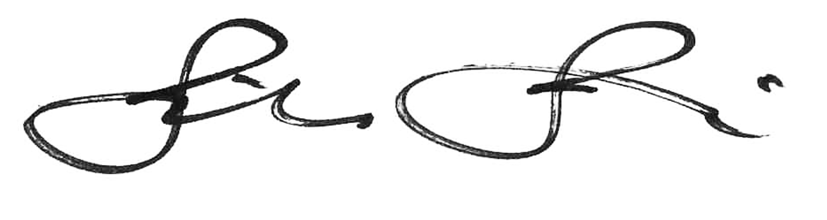 

Dr. Tibor Turi, P.Eng. Sandro Perruzza

President and Chair Chief Executive Officer

Ontario Society of Professional Engineers Ontario Society of Professional Engineers