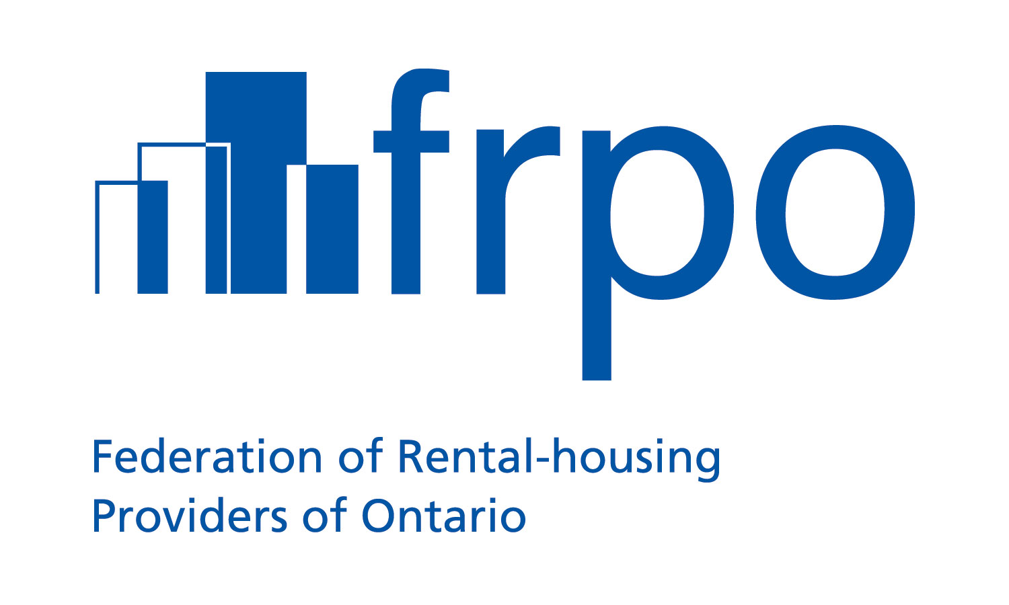
20 Upjohn Rd., Suite 105
Toronto ON M3B 2V9
416-385-1100
1-877-688-1960
www.frpo.org
Tony Irwin
President & CEO

t: (416) 385-1100 ext. 20
e: tirwin@frpo.org

August 21, 2019

John Ballantine, Manager
Municipal Finance Policy Branch
Ministry of Municipal Affairs and Housing
13th Floor, 777 Bay St.
Toronto, ON M5G 2E5

Re: Proposed changes to O. Reg. 82/98 under the Development Charges Act related to Schedule 3 of Bill 108 - More Homes, More Choice Act, 2019 (ERO 019-0184)

About FRPO

The Federation of Rental-housing Providers of Ontario (FRPO) has been the leading voice of the
province’s rental housing industry for over 30 years. We are the largest association in Ontario
representing those who own, manage, build and finance, as well as those who service and supply
residential rental units. We represent more than 2,200 members who own or manage over 350,000 units across the province.

Introduction

On behalf of our members, I am pleased to have the opportunity to provide comments on proposed changes to O.Reg. 82/98 under the Development Charge Act, 1997 related to Schedule 3 of the More Home, More Choice Act, 2019.

First of all, we would like to thank the Ford government for taking strong action on the development charge regime which will undoubtedly assist in making more rental projects feasible and play a role in adding the 90,000 to 100,000 units required to balance the market within the next decade.

Government fees and charges represent a significant and increasing drag on the feasibility of rental projects. In fact, our latest study found that 18 per cent of the total cost for a typical project in the City of Toronto is due to government fees and charges. To make matters worse, these costs are trending upwards with development charges continuing to increase every few years.

In a 2018 study, Altus Group found that development charges have increased between 236% and 878% in six GTA municipalities since 2004.

It is within this context that we appreciate the government’s commitment towards increasing housing supply and specifically taking action to address the rapid increases associated with development charges.

Proclamation of Sections 26.1 and 26.2 of the Development Charges Act

FRPO members support the addition of Section 26.1 of the Development Charges Act which defers the payment of development charges for rental housing (among other types of housing) until the issuance of a permit under the Building Code Act. The deferred development charge is then to be paid over six equal annual installments from that date onwards.

Our members also support the government’s decision to freeze development charges on the date an application is made for a site plan or zoning by-law amendment through the creation of Section 26.2 under the Development Charges Act.

However, these sections have yet to be proclaimed and we understand they may not come into force until January 1, 2020. This poses a major concern as many municipalities have a planned DC rate increase scheduled for this Fall. From example, in the City of Toronto, as of November 1st, 2019, the City’s DC for smaller apartments (bachelor and 1 bedroom) is set to increase by 16% and the DC for larger apartments (2 or more bedrooms) is set to increase by 18%.

The premise of the Ford government’s Housing Supply Action Plan is to create a policy environment so the private sector can get more housing units to the market and at a faster rate. If these sections are not proclaimed before the upcoming DC increases, some planned projects that could have been financially viable may not proceed.

Even the City of Toronto staff recognized this problem. When the current DC by-law went to Council, staff raised this particular issue in a report dated April 3, 2018:

“…it is acknowledged that the City’s proposed increases could jeopardize important rental projects that are coming to fruition, and the increases will add to the already challenging competitive environment”

“Projects currently in the development pipeline present unique issues…these projects could be exposed in the case of large and rapid rate increases…the impact study indicates that the impact on purpose built rental developments is expected to be different, with higher input costs potentially
jeopardizing project financing.”

Accordingly, FRPO members urge the government to proclaim Sections 26.1 and 26.2 of the Development Charges Act into force on September 1st, 2019.

Transition

The proposed regulation sets a sunset date for municipalities to transition to the community benefits regime and subsequently no longer collect development charges for discounted services as of January 1, 2021.

We believe that this is a reasonable timeframe as municipalities need to develop community benefit strategies and then pass community benefit charge (CBC) by-laws.

FRPO members have no objections to this proposal.

Scope of types of development subject to development charges deferral

Section 26.1 of the Development Charges Act lists the types of development where a deferral is permitted. This includes “rental housing development” but it does not define the term.

The Ministry is proposing the following definition in this regulatory package:

“Rental housing development” means construction, erection or placing of one or more buildings or structures for or the making of an addition or alteration to a building or structure for residential purposes with four or more self-contained units that are intended for use as rented residential premises.

There are rental housing projects which technically seek approval as condominiums not purpose-built rental for a number of reasons, but the developer operates the building as a landlord by renting all of the units or sells the building to a rental housing operator.

Therefore, FRPO recommends the definition of “rental housing development” be clarified to ensure that developments that are technically proceeding as condominium applications but will be used as purpose-built rental be permitted as it relates to the DC deferral regime.

To avoid abuse, the government can impose a penalty for proponents who shift away from rental and sell any unit as a condominium within a period a time from occupancy (i.e. 5 years).

Period of time for which the development charge freeze would be in place

Section 26.2 of the Development Charges Act freezes the development charge rate at the time an application is submitted for site plan or zoning by-law amendment (ZBA) for a period of time to be determined through regulation.

This regulatory package sets that time to two years from the date approval is received for either of the previously mentioned applications. Since development charges are payable (usually) when a building permit is received, if the time in between the approval of site plan or ZBA to issuance of the building permit is greater than two years, the freeze is not applicable.

However, FRPO members need clarity on how the freeze intersects with Section 26.1 (DC deferral).

As mentioned earlier, Section 26.1 of the Act enables DC payments to be deferred until the issuance of a permit under the Building Code Act authorizing occupation of the building for certain types of development, including purpose-built rental. In this circumstance, the DC payment would be triggered when a building can be occupied instead of when the building permit for construction is issued.

It may be reasonable to assume that, in most cases, the period of time from approval of application to getting a building permit is usually less than 2 years. However, the period of time from approval of application to occupancy can rarely be less than 2 years.

For clarity, FRPO urges the Ministry to clarify in the regulation that projects which are eligible for the deferred DC payment scheme will not have their DC freeze lifted until they receive an occupancy permit.
Interest rate during the deferral and freeze of development charges

The legislation enabled the Minister to prescribe a maximum interest a municipality can charge on DCs payable during the deferral period under Section 26.1 and during the freeze from when the application is received until the DC is payable under Section 26.2. However, the Minister chose not to prescribe a maximum interest rate.

FRPO members have significant concerns with the proposed approach. We believe that this has the potential of undermining the entire benefit arising from freezing the DC rate at an earlier point or the provision for a deferral. It can essentially make both Sections 26.1 and 26.2 irrelevant if the municipality charges a higher interest rate than the developer can obtain from the market.

In fact, it is possible the proposed approach of not setting a maximum interest rate will make the situation worse for rental housing developments and reduce the number of units that go to market when compared to the pre-Bill 108 environment.

For example, in a hypothetical pre-Bill 108 situation where the DC amount increases 20 per cent from when the application is filed to when the building permit is issued, the developer would simply pay 20 per cent extra during that period of time. Now, in a post-Bill 108 scenario with the same amount of time lapsing between the application and building permit, the municipality can set an interest rate that results in any increase in DC payable they wish (i.e. 30 per cent, 40 per cent, 50 per cent, etc.)

That would be a scenario where the developer is worse off in the post-Bill 108 environment than they were before the changes. This increase in cost means less projects are feasible and less units come onto the market, completely contrary to the government’s intended objective.

Unless the Minister sets a maximum interest rate, municipalities have the ability to “game the rules” and actually make it more difficult and expensive for rental housing development projects to proceed.

Therefore, FRPO strongly urges the government to prescribe a maximum interest rate within the regulation. For optimal impact, the maximum rate should be below the interest rate a developer can reasonable obtain from the market otherwise the deferral does not add much value.

Additional dwelling units

The proposed change allows additional units of the following nature to be created without triggering a development charge:
- Creation of units in an ancillary structure of existing detached, semi-detached, row dwellings and other residential buildings (subject to existing rules/restrictions);
- One additional unit in a new single detached, semi-detached, and row dwelling, including in a structure ancillary to one of these dwellings; or
- Creation of additional units within other existing residential buildings up to 1 per cent of the existing units.

FRPO is encouraged at the direction of these changes as they will allow for more units to be available in the marketplace. The creation of units in ancillary structures will enable laneway housing in areas where there is a market need.
However, we would propose a change to the 1 per cent limit on other existing residential buildings (including purpose-built rental buildings). A 1 per cent restriction would only enable the creation of a unit without a development charge being triggered in a complex with at least 100 units. There may be opportunities to add a handful of rental units within the existing footprint of purpose-built rental buildings by optimizing the usage of space, but the development charge could make the investment prohibitive in some cases.

To make it easier for existing rental housing providers to “squeeze in” a few more units, FRPO proposes the following structure to replace the 1 per cent cap on units added without triggering DCs:

Number of Units in a Building | Units Exempted from DCS
2 to 10 | 1 unit
11 to 50 | 2 units
51 to 100 | 3 units
101 + | 4 units + 1 extra unit for each 50 units over 100

We appreciate the opportunity to share our comments on this set of regulations and would welcome any further discussions on broader implementation aspects relating to the More Homes, More Choice Act.

Please feel free to contact me at tirwin@frpo.ca or (416) 385-1100 x 20 if you have any questions.

Sincerely,

Tony Irwin
President & CEO

CC:
Hon. Steve Clark – Minister of Municipal Affairs & Housing
Alex Earthy, Senior Policy Advisor – Housing, Office of the Minister of Municipal Affairs & Housing
Stephen Hamilton, Senior Policy Advisor – Planning, Office of the Minister of Municipal Affairs & Housing
Kate Manson-Smith – Assistant Deputy Minister, Ministry of Municipal Affairs & Housing

