2019

Draft Ontario Tree Seed Transfer Policy

October 2019

Ministry of Natural Resources and Forestry

Cette publication hautement spécialisée {Ontario Tree Seed Transfer Policy} n'est disponible qu'en anglais conformément au Règlement 671/92, selon lequel il n’est pas obligatoire de la traduire en vertu de la Loi sur les services en français.  Pour obtenir des renseignements en français, veuillez communiquer avec le ministère des Richesses naturelles et des Forêts au {705-943-6572}.

Summary

The Ontario Tree Seed Transfer Policy ensures that seed used to regenerate forests has a reasonable probability of producing trees that are adapted to their growing environment now and in the future. It specifies where seed can be collected and used and the conditions under which seed may be transferred.

Résumé

La politique ontarienne relative au transfert de semences veille à ce que les semences utilisées pour regénérer les forêts aient des possibilités raisonnables de produire des arbres adaptés à leur environnement actuel et futur. Elle spécifie où les semences peuvent être prélevées et utilisées ainsi que les conditions de leur transfert.

ISBN 978-1-4868-3690-1 HTML Proposed Ontario Tree Seed Transfer Policy

ISBN 978-1-4868-3691-8 PDF Proposed Ontario Tree Seed Transfer Policy

Contents

Ontario Tree Seed Transfer Policy 4

Purpose 4

Scope of application 4

How to use this policy 4

Background 4

Principles 5

Objectives 5

Landscape units 5

Climate based-seed transfer 6

Species-specific seed transfer 6

Mixing seed sources 6

Site considerations 6

Seed collection 6

Moving tree seed and planting stock 7

From fixed zones to focal zones for all seed sources 7

Transition of existing seed sources 9

Seed and planting stock sourced from natural stands 9

Seed and planting stock sourced from orchards in existing breeding zones 9

Seed and planting stock sourced from outside Ontario 10

Responsibilities 10

Information and reporting 10

Review and evaluation 11

Appendix 1: Seed transfer implementation direction 12

Seed transfer direction 12

Approval for moving beyond seed transfer areas 12

Species range expansion 13

Appendix 2: Rationale for seed transfer implementation direction 14

Climate similarity analysis 14

Climate projections 14

Risks 15

Tracking by ecodistricts 16

Appendix 3: Technical background 17

History of the seed zones of Ontario 17

Why update the seed zones of Ontario? 17

How was the policy updated? 17

Policy provides flexibility in adapting to a changing climate 17

Climate similarity analysis 18

Data sources 18

Study area considerations 18

Climate variables used in the Seedwhere analysis 18

Climate similarity threshold 19

Ecodistricts as landscape units 19

Appendix 4: Existing Breeding Zones 21

Appendix 5. Glossary 27

Appendix 6: Bibliography 30

Directives/guides 30

Data sources, models, and tools 30

Science to support the development of a climate-based seed transfer system 31

Species-specific science to support the development of a climate-based seed transfer system 33

Glossary references 35

List of Figures

Figure 1. Seed deployment areas are sites where seed may be deployed.

Figure 2. Seed collection areas are sites where seed may be collected.

Figure A1.1. Sample harvest block layout illustrating how seed sources from different ecodistricts might be used to regenerate an area.

Figure A3.1. The former Seed Zones of Ontario (2010)

Figure A3.2. The ecozones, ecoregions, and ecodistricts of Ontario.

Figure A4.1. Black Spruce Northwest Region

Figure A4.2. Jack Pine Northwest Region

Figure A4.3. White Spruce Northwest Region

Figure A4.4. Black Spruce Northeast Region

Figure A4.5. Jack Pine Northeast Region

Figure A4.6. White Pine Southern Region

# Ontario Tree Seed Transfer Policy

Selecting quality *seed* that is adapted to planting site conditions is the foundation of forest renewal efforts under Ontario’s sustainable forest management framework. Seed transfer is the movement of seed from where it is collected, referred to as a collection site, to a growing site. This policy provides guidance for seed transfer in a changing climate.

## Purpose

The Ontario Tree Seed Transfer Policy ensures that seed used to regenerate forests has a reasonable probability of producing trees that are adapted to their growing environment now and in the future. It specifies where seed can be collected and used and the conditions under which seed may be transferred.

|  |
| --- |
| Seed transfer includes the movement of both tree seed and *planting stock*. A *seed transfer area* is a location where seed or planting stock from a specific location can be deployed as defined by an Ontario *ecodistrict* (Crins *et al.* 2009) or a zone from the former S*eed Zones* of Ontario (OMNR 2010). For this policy, planting site refers to a location where seeds are either aerially dispersed or seedlings are planted.  The base land units for the updated seed transfer policy are the Ontario Ecodistricts (Crins *et al.* 2009). *Seed collection* refers to the gathering of seed from one of these units; *seed deployment* refers to seed use in one or more units. |

## Scope of application

**This policy applies to all tree species and *artificial regeneration* materials, including tree seed, planting stock, and *grafted* stock, used to renew Ontario’s *Crown forests*. It also applies to materials established on private lands where the Government of Ontario provides financial support for *afforestation* or *reforestation* activities, or where program guidelines require that the policy is followed (mandatory)**. The policy direction and information provided may also be relevant to other forested land. The Ontario Tree Seed Transfer Policy is an associated policy enabled through the Forest Operations and Silviculture Manual (OMNRF 2017a).

## How to use this policy

This policy replaces the Seed Zones of Ontario (OMNR 2010). The former seed zone unit will be used until the seed collected and stored under the previous policy transitions to seed collected and stored under the current policy. **Bold** text indicates mandatory direction in the policy and appendices; the remaining direction is flexible, allowing for professional interpretation. Direction is included in the appendices to allow for ease of updates to the science and analyses. Terms defined in the glossary (Appendix 5) are in *italics* on first use in text.

## Background

Tree *populations* are genetically adapted to specific local growing environments, so *forest and seed manager*s have traditionally used locally sourced seed for forest renewal activities. However, locally sourced seed may not be the best choice for forest renewal for several reasons. Climate data indicates that Ontario’s environment is, and will continue, changing regardless of current global actions to reduce greenhouse gas emissions. Trees are long lived with limited ability to adapt quickly enough to keep pace with changing local climate. Some populations of a tree *species* may be genetically superior, for example, they may grow faster or be more pest resistant.

Seed transfer can promote forest adaptation and help tree populations keep pace with changing conditions. Transferring seed to areas with a climate similar to what the tree populations are adapted to will increase the chance of producing trees well-adapted to current and future conditions.

Forest managers may develop strategies to adapt to climate change by using a mix of local and non-local seed sources, for example, those that may be more adapted to a future climate. This policy will guide those efforts.

## Principles

The following principles guide the application of the Ontario Tree Seed Transfer Policy:

* Well-adapted planting material is required to conserve *genetic diversity* and implement an effective *regeneration* program.
* Seed transfer areas represent places where forests are likely to be adapted to current and future growing environments.
* Seed transfer is guided by similarity between historic climate at the seed collection area and future climate at the planting area.
* Non-local *seed sources* may be a suitable choice for renewal and therefore seed transfer is permitted beyond *local seed* collection areas.
* When making seed transfer decisions, local forest management objectives need to be considered.
* Using multiple seed sources suitable for a planting site increases the probability that some portion is well adapted to current and future climate
* Collecting seed from multiple high-quality stands increases genetic diversity.
* Seed transfer direction acknowledges the uncertainty associated with the *adaptive capacity* of tree species and the projection of future conditions.
* Seed transfer decisions will include consideration of advances in information and knowledge.
* Seed transfer direction will be revised to keep pace with a changing climate, while avoiding risks, such as frost, associated with current climate. This approach balances the risk of moving seed too far and negatively affecting the survival and fitness of seedlings planted now versus affecting the trees growing under future climate conditions.

## Objectives

The objectives of the Ontario Tree Seed Transfer Policy are to:

1. Contribute to forest sustainability by supporting the adaptation of Ontario’s tree species to a changing environment while promoting forest health and productivity.
2. Contribute to conserving the genetic diversity of native species by using *genecological* information, where available, in guiding movement of seeds and seedlings.
3. Develop a modern approach to guide seed transfer by using advances in science, as available.

## Landscape units

**Forest managers will use Ontario’s ecodistricts for tracking seed (mandatory).** Since ecodistricts comprise relatively homogeneous environmental units, tree populations in them can be assumed to have undergone similar evolutionary processes and possess similar adaptive characteristics. For this reason, ecodistricts were deemed to be suitable base units for the updated seed transfer system; however, to facilitate more precise seed transfer decisions,forest managers are encouraged to record detailed seed collection information (e.g., geographic coordinates of seed collection sites).

## Climate based-seed transfer

**When making seed transfer decisions, forest managers will consider future climate (mandatory)**. Climate-based seed transfer direction is being established across Ontario and identifies where tree seed and planting stock can be moved with low risk of *maladaptation*. Seed transfer is guided by a *climate similarity analysis*, which isused to compare the historical climate of a seed collection site with the future climate of potential deployment sites (Appendix 2). Seed transfer direction is generally from warmer to cooler areas to increase the similarity between past climate at the seed source origin and future climate at the planting site.

Implementation of the direction may require consideration of additional criteria. For details, consult Appendix 1.

## Species-specific seed transfer

Where species-specific climate responses are known, the Ministry of Natural Resources and Forestry may develop species-specific seed transfer direction for use by forest managers.

Species-specific seed transfer direction applies to seed collected from *natural stands* and *seed orchards*. For orchard collected seed, in addition to the seed transfer policy principles and objectives, provincial and local *tree improvement* objectives influence seed deployment decisions.

## Mixing seed sources

Using a mixture of local and non-local seed sources to increase genetic diversity is encouraged as it may improve forest resilience. The best approach for identifying the appropriate ratio of seed sources remains the focus of ongoing research (see Appendix 6). Regardless of the degree to which seed sources are mixed, forest managers are encouraged to maintain seed collection and deployment information, so they can monitor seed source performance.

## Site considerations

Before considering seed sources, select site-appropriate species. For more information:

* Forest Management Guide to Silviculture in the Great Lakes-St. Lawrence and Boreal Forests of Ontario (OMNRF 2015)
* A Silvicultural Guide for Managing Southern Ontario Forests (OMNRF 2014)

## Seed collection

**The forest manager will collect, handle, store, and track tree seed such that quality seed is collected, and its viability is maintained (mandatory)**. Forest managers are encouraged to collect and use high quality tree seed, preferably from trees that are *phenotypically* superior. For information on collecting high quality tree seed:

* A Seed Manual for Ontario (OMNR 1996)
* Seeds of Ontario Trees and Shrubs: Field Manual for Crop Forecasting and Collecting (OMNRF, OTSP 2014).

To encourage greater genetic diversity in regenerated forests, collect seed from multiple stands in a given ecodistrict or species-specific seed zone. Carry out *germination tests* according to current International Seed Testing Association standards (ISTA 2018) for seed intended to be stored and check periodically to ensure seed isn’t deteriorating.

## Moving tree seed and planting stock

### From fixed zones to focal zones for all seed sources

The Ontario Tree Seed Transfer Policy uses a focal zone approach (illustrated in figures 1 and 2).

The Seed Zones of Ontario (2010) followed a fixed zone approach where the zone geographic boundaries defined the limits of seed transfer. The 2010 policy also allowed the development of species-specific seed zones where scientific basis was available. In the focal zone approach, a suitable deployment area is defined for each seed source location or a suitable seed source area is defined for each intended planting site. These are referred to as allowable seed transfer areas.

For example, to choose seed sources for regenerating a site (bounded area in Figure 1), a climate similarity approach is used to identify the best locations to obtain seed (red areas in Figure 1). Seed collected from these areas and from within the ecodistrict may be used for seeding or planting stock. To determine where available seed can be used, the climate similarity approach is applied to identify areas expected to have the most similar near-term future climate. For example, seed can be used in the ecodistrict it was collected from (bounded area in Figure 2) and in areas of highest expected similarity (red areas in Figure 2).

**Movement of tree seed and planting stock within allowable seed transfer areas is unrestricted (mandatory).** Movement beyond allowable seed transfer areas may be necessary to respond to challenges such as seed supply shortages, or desirable where species-specific knowledge is available. **Movement beyond allowable seed transfer areas requires MNRF approval and may involve conditions (mandatory) (Appendix 1).** For example, where transfer is requested to address seed shortages, the requester may be required to commit to developing a seed collection plan to avoid future shortages. See figures 1 and 2 for examples of allowable seed transfer areas; refer to Appendix 1 for seed transfer implementation direction and information about moving seed beyond allowable seed transfer areas.

Figure 2.  Seed deployment areas are sites where seed may be deployed.

A map of southern to northeastern Ontario ecodistricts. Ecodistrict 6E.6 is outlined in blue to show the deployment area. The seed collection area is highlighted in red, where seed may be collected for deployment to ecodistrict 6E.6. The area in red represents the seed transfer area expected to be most climatically suitable.

Figure 1. Seed deployment areas are sites where seed may be deployed. For example, in this map Ecodistrict 6E-6 (bounded by thick line) is one deployment area for seed collected in several ecodistricts or counties highlighted in red, representing the seed transfer area expected to be most climatically suitable for this deployment area.

Figure 1. Seed collection areas are sites where seed may be collected. 

A map of southern to northeastern Ontario ecodistricts. Ecodistrict 6E.6 is outlined in blue to show the seed collection area which, may be deployed to several ecodistricts highlighted in red, representing the seed transfer area expected to be most climatically suitable for this collection area.Figure 2. Seed collection areas are sites where seed may be collected. For example, as shown in this map, seed collected in Ecodistrict 6E-6 (bounded by thick line) may be deployed to several ecodistricts highlighted in red, representing the seed transfer area expected to be most climatically suitable for this collection area.

## Transition of existing seed sources

This policy provides for a transition from the Seed Zones of Ontario (2010) to seed transfer areas to ensure the current seed inventory can be used.

### Seed and planting stock sourced from natural stands

Seed sources defined by the 2010 seed zones will be transitioned to ecodistricts by matching locations using the most geographically precise coordinates available (see Appendix 2). Implementation direction for moving this seed and planting stock is provided in Appendix 1.

**Forest managers may continue to deploy seed previously collected from sites where species-specific seed zones were developed and used under prior forest genetics policies.** **For new seed collections and purchases, forest managers will procure and deploy by ecodistrict according to the new seed transfer policy (mandatory).**

### Seed and planting stock sourced from orchards in existing breeding zones

**Forest managers may continue to use existing fixed *breeding zones* developed and used under prior forest genetics policies (Appendix 4). Any seed movement beyond breeding zones must be approved by MNRF (mandatory)**. Seed collected from tree improvement orchards is genetically improved with the intent of producing healthier trees with higher productivity and wood quality under the growing conditions in the specific breeding zones. This selection results in a narrower genetic base, which means trees may be well adapted and productive in a specific breeding zone but may not do as well if growing conditions change. For this reason, deploying orchard seed outside its breeding zone should be undertaken with caution and in consideration of a changing climate. Forest managers may, however, request movement of orchard seed and associated planting stock; for details, refer to Appendix 1.

### Seed and planting stock sourced from outside Ontario

**For seed sourced from outside Ontario, forest managers will follow federal and provincial sanitary and phytosanitary requirements, as applicable (mandatory).** Allowable seed transfer areas for seed sources from the United States or other provinces are based on climate similarity analysis (Appendix 2) and, where available, genecological information. **At a minimum, forest managers will track seed sources from the United States by county and applicable seed zone(s), and from other provinces by ecodistrict and applicable seed zone(s) (mandatory).** Forest managers should use the most precise location information available, e.g., geographic coordinates, and refer to seed transfer direction in Appendix 1.

## Responsibilities

**Forest managers and those responsible for Crown funded afforestation and reforestation programs will plan for and acquire appropriate high-quality seed to meet their forest renewal obligations (mandatory).**

**MNRF is responsible for decisions on the movement of tree seed and planting stock beyond allowable seed transfer areas (Appendix 1). Deployment of non-native species is automatically considered beyond allowable seed transfer areas and requires approval. Forest managers are responsible for initiating seed movement requests (mandatory).**

## Information and reporting

For tree seed and stock deployed in Crown forests, seed transfer areas are planned for and reported on as part of the renewal support activity in forest management planning, as described in the Forest Management Planning Manual (OMNRF 2017b). Information requirements for monitoring, evaluating, and reporting on the renewal support activity are described in the Forest Information Manual (OMNRF 2017c). Provincially funded private land forestry programs will specify reporting requirements in the program guidelines.

**Forest managers are to maintain records to allow tracking of tree seed and stock deployment and adaptive management (mandatory).** In addition to the information required for reporting, forest managers are encouraged to track the seed lot as a best management practice in maintaining records.

**For existing seed collections, these records include:**

* **Seed zone or breeding zone**
* **Number of seeds by seed zone or breeding zone**
* **Source of seed collected or purchased and used**
* **Deployment destination (seed zone, breeding zone or ecodistrict) of seed or planting stock used in artificial regeneration/afforestation activities**

**For new seed collections, these records include:**

* **Ecodistrict or breeding zone**
* **Number of seeds by ecodistrict or breeding zone**
* **Source of seed collected and used**
* **Deployment destination (ecodistrict or breeding zone) of seed or planting stock used in artificial regeneration/afforestation activities**

**Any new tree seed collections will specify one ecodistrict or breeding zone as part of the information record. Multiple ecodistricts cannot be referenced (mandatory).** For genetically improved (orchard) tree seed and resulting planting stock, seed zone refers to the existing breeding zone. For tree seed previously collected from natural stands, seed zone refers to those identified in the 2010 policy.

Identifying natural stand tree seed and stock using more precise location information, such as geographic coordinates, is preferable to facilitate future management and deployment opportunities.

## Review and evaluation

The Ontario Tree Seed Transfer Policy will be reviewed and revised as needed in response to changes in strategic direction and policy, lessons learned from its implementation and evaluation, and advances in science and technology.

## Appendix 1: Seed transfer implementation direction

### Seed transfer direction

#### Tabular display

Tables are available as interactive pdfs in the attached supporting excel table document.

Results of the climate similarity analysis are presented in the following tables:

* Table 1. For transitional period: Acceptable seed transfer from the 2010 (OMNR 2010) to current seed zones.
* Table 2. Acceptable seed transfer from the 2010 seed zones (OMNR 2010) to ecodistricts.
* Table 3. Acceptable seed transfer among ecodistricts (Crins *et al.* 2009).

#### Visual display

To support seed transfer decisions, the climate similarity analysis used in developing this policy is also available in interactive map format. A variety of maps are available to view to help inform seed collection and deployment decisions, for example:

* Collect seed by ecodistrict or county
* Deploy seed by ecodistrict
* Deploy seed by seed zone
* Detailed map of management unit by seed zone by ecodistrict
* Climate maps to help inform seed transfer decision relating to growing season, precipitation and temperature

To view maps (including instructions), copy and paste the link below into your browser:

<https://public.tableau.com/views/SeedSourceOntario/Intro?:embed=y&:display_count=yes&publish=yes>

### Approval for moving beyond seed transfer areas

Forest managers may make requests for seed movement beyond allowable seed transfer areas in two ways:

1. As part of the development of the forest management plan; or
2. As needed in making seed transfer decisions during the implementation of forest renewal programs.

A seed transfer decision support process has been established to provide advice on the transfer of seed beyond allowable seed transfer areas.   As noted in the policy, forest managers are responsible for initiating seed movement requests to the Senior Program Advisor, Biodiversity in Integration Branch, Regional Operation Division. They provide the lead for further consultation with the other forest genetics advisors including:

* Senior Policy Advisor, Forest Guides and Silviculture Section, Crown Forests and Lands Policy Branch, and
* Forest Research and Development Geneticist, Science and Research Branch.

The regional Forest Genetic Resource Management (FGRM) associations will help by ensuring their partners and clients are aware of the process.  In many cases the FGRM association coordinator will be asked for input on transfer requests that are being reviewed. Other external experts may also be consulted.

In reviewing requests for seed movement beyond allowable seed transfer areas, MNRF will consider:

* whether the proposed transfer involves seed that represents a 0.9 or greater climate similarity to the targeted deployment site
* whether the proposed transfer results in a range expansion for the species, and if this has a scientific or conservation basis
* the conservation status of the affected species, and the effect, if any, of the proposed move on this status
* the available genecological and biological information
* the size and viability of the population, e.g., seed transfer could increase or decrease inbreeding, result in potentially isolated populations, or negatively affect the ecology of the planting site.

### Species range expansion

**Forest managers should deploy seed within the current geographic range of the species (mandatory).** Transfer beyond this range is allowable under certain exceptions as outlined in Approval for Moving Beyond Seed Transfer Areas (above). To determine whether a transfer will result in movement beyond a species’ range, consult Little’s “Atlas of United States tree” (Fryer 2018), the national standard for species ranges. Recognize that range is a generalization of species occurrence that may require local knowledge to refine. Forest managers may want to actively consider planting at the northern edge of a species’ range to help it remain adapted to changing conditions.

## Appendix 2: Rationale for seed transfer implementation direction

### Climate similarity analysis

Seed transfer is guided by a climate similarity analysis that compares the historical climate at a seed collection site to expected future climate at a potential planting site.

The climate similarity analysis is based on data derived from historical and projected climate models developed by the Canadian Forest Service (McKenney *et al.* 2011). Variables selected for the analysis were *mean annual temperature* (MAT), *growing season length* (GSL), and *minimum temperature coldest month* (MinT). These variables have been identified in forest genetics studies as drivers of genetic adaptation. Conspicuous in their absence from this list are precipitation-related variables. While moisture influences tree growth and survival, trees in eastern North America do not show significant among population variation with respect to moisture-related adaptations. This finding may change as science advances.

The climate similarity analysis provides a range of similarity between 0 and 1.0, with zero indicating the least similarity and 1.0 indicating an exact match. A similarity of 0.9 was selected as the threshold for identifying units between which seed transfers are permissible. This threshold was supported by analyses of *provenance* data, which indicated that for several Ontario tree species modest (i.e., <10%) losses in growth and mortality were associated with transfers of this magnitude. Forest managers may choose to obtain seed from locations with the greatest similarity i.e., greater than 0.9 and/or closest to 1.0, to their planting or seeding site. Local seed is also an acceptable choice even though the climate similarity could be less than 0.9. This approach to seed transfer offers forest managers more options and flexibility with a range of what are projected to be climatically similar sites for seed deployment. For some ecodistricts, the most climatically similar seed sources may be found in the United States.

### Climate projections

For the analyses used in this policy, the 2011–2040 period was selected to characterize future climate at a planting site, while the 1961–1990 period was used to summarize recent/historical climate at a seed source. Choosing this relatively near-term future period is intended to increase the likelihood of early plantation survival since trees are most vulnerable as seedlings. Further advances in genecology and climate change science will help inform revisions of the policy.

Seed transfer guidance is based on the *representative concentration pathway* (RCP) 2.6 (Van Vuuren *et al.* 2011). This emissions pathway represents a low *emission scenario*, with reduced effects to societal and environmental interests relative to other scenarios (e.g., RCP4.5 and RCP8.5). Until 2050, the trajectories of the RCP scenarios generally converge. Beyond 2050, the trajectories diverge more significantly, leading to greater risk at longer timescales. At shorter timescales, this risk is reduced, so decisions with a shorter time horizon can be made with more confidence (IPCC 2014).

The use of RCP2.6 is conservative with respect to seed transfer distances (compared to further seed transfer distances projected under RCP8.5), which should promote early tree survival and growth as well as reproductive fitness, when trees are most vulnerable to extreme climate events (Sakai and Larcher 1987). For example, although the climate may be warming on average, risk is ongoing and potentially increasing for false spring events, i.e., early spring warming followed by very cold temperatures. To help address the uncertainty of *climate projections*, forest managers are encouraged to consider planting and tracking multiple, climatically appropriate seed sources to support genetic diversity and future adaptive management decisions. This genetic diversity will increase the likelihood that some of the trees in a renewal program will survive and grow well under a range of possible future climate conditions. This incremental and low emissions scenario approach reduces some of the risks associated with how the climate will change and how species and ecosystems will respond to those changes and recognizes that trees are long lived, adapt slowly, and are generally most vulnerable when they are young.

One example of how to facilitate tracking of seed is to establish seed sources in distinct polygons within a harvest block rather than planting a mix of sources throughout. Figure A1.1 provides an example of a harvest block regenerated with mixed seed sources.

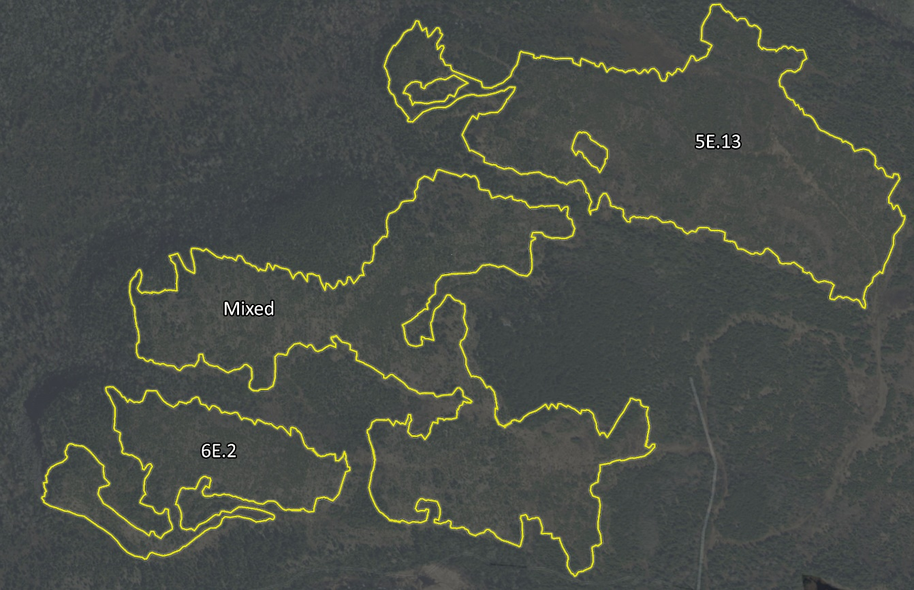

Figure A2.1. Sample harvest block layout illustrating how seed sources from different ecodistricts might be used to regenerate an area. 5E13=seed collected locally; 6E2=seed collected in Ecodistrict 6E2 and planted in 5E13; mixed=mixed planting of seed from 5E13 and 6E2.

### Risks

There are many risks related to uncertainties and imperfect knowledge about climate change to consider when updating policy including:

* How the climate system functions
* The trajectory of the greenhouse gas emission levels over the next century
* How species or ecosystems will respond to climate changes
* How humans will respond to climate or ecosystem changes
* The effectiveness or implementation of policy, regulatory or management actions.

Adaptive management is a valuable approach for when there is significant uncertainty about the outcomes of management policies. It is an iterative process of decision-making, with an aim of reducing uncertainty over time via system monitoring and learning from and being responsive to the outcomes of past programs and policies. While this policy does not dictate an active adaptive management approach, where different approaches are prescribed for different areas, it is expected that the enabling and flexible nature of the policy will result in a patchwork of seed transfer decisions that can accelerate learning. Regular review of the policy, even when it’s performing well, and the use of well-designed pilots throughout the life of the policy to test assumptions related to performance, have been shown to help address emerging issues and trigger important policy adjustments.

Selecting a near-term future time period (2011-2040) and a low emissions scenario (RCP2.6) reduces the risk of near-term maladaptation associated with the uncertainties of how the climate may change, how a species or ecosystem may respond to changing conditions and the effectiveness of policy implementation until advances in science are able to support evidence-based decision-making.

### Tracking by ecodistricts

Using ecodistricts provides greater precision and generally represents less within unit variation in climate and soil conditions. This greater precision reduces the risk of moving a population of trees into an environment to which they are maladapted. However, deployment decisions should also consider soil suitability, which is not incorporated into the climate similarity analysis due to current scientific and modelling limitations. Soil suitability may be considered through information provided within the forest management guides (OMNRF 2014, 2015).

## Appendix 3: Technical background

### History of the seed zones of Ontario

Beginning in 1997, Ontario used the seed zones (Figure A3.1), a generic fixed zone seed transfer system based on the Ontario Climate Model and modified to reflect administrative boundaries of the mid-1990s. The Ontario Climate Model (Mackey *et al.* 1996) provided information about the provincial climate gradients. The 2010 version of the policy enabled the development of species-specific seed zones or seed transfer guidelines given biological information documented in scientific studies. As a result, species-specific fixed zone and dynamic seed transfer systems were developed for some administrative regions and have been used to guide the transfer of seed from natural stands and planting stock during regeneration activities. For some parts of the province, a series of fixed zones were developed to guide the transfer of *improved seed* from orchards.

A picture containing a map of the former Seed Zones of Ontario (2010). The seed zones are drawn across the map of Ontario to the edge of the Area of the Undertaking and labelled by number.

Figure A3.1. The former Seed Zones of Ontario (2010)

### Why update the seed zones of Ontario?

Many jurisdictions are developing seed transfer policies that consider changing climate to ensure the use of well-adapted tree seed and seedlings in regeneration and afforestation activities. Ontario is also enabling forest adaptation in a changing environment by providing forest managers more flexibility in seed transfer options to support a sustainable long-term supply of wood and other forest ecosystem services. Based on an initial review of the 2010 policy, MNRF recommended the seed zones of Ontario be updated to ensure they are:

* Reflective of current operational contexts such as the expanded Area of the Undertaking, changed roles and responsibilities and administrative boundaries
* Reflective of current strategic contexts. Today this includes Ontario’s ongoing climate change efforts under the Made-in-Ontario Environment Plan (OMECP 2018) and the Ministry of Natural Resources and Forestry Natural Resource Climate Adaptation Strategy (2017-2021: Naturally Resilient (OMNRF 2017d)
* Science-based and incorporate advances in tree genetics knowledge
* Responsive by facilitating climate change adaptation
* Effective by updating the spatial direction with higher quality data and technology
* Sustainable by incorporating changing environmental conditions into seed transfer guidance
* Supportive of long-term success of regeneration activities by increasing MNRF’s ability to enforce the policy under the Forest Operations and Silviculture Manual (OMNRF 2017a)’s associated policies

### How was the policy updated?

MNRF conducted a jurisdictional scan and literature review to inform the policy update and contacted practitioners (i.e., those collecting purchasing and deploying seed) to consider their input in developing the best possible direction. Updates were based on climate change and genetic science developed by MNRF’s research scientists as well as collaboration with Natural Resources Canada (NRCan) to customize the climate similarity analysis for Ontario.

### Policy provides flexibility in adapting to a changing climate

This policy offers forest managers flexibility when selecting or collecting seed due to the range of locations projected for seed collection and deployment. Collecting or selecting seed from several locations encourages genetic diversity and resilience to changing conditions, reducing the risk of maladaptation, and it addresses the uncertainty of projecting future growing conditions (McKenney et al. 1999).

### Climate similarity analysis

The MNRF, in collaboration with NRCan, used the Seedwhere program (McKenney et al 1999) to analyze similarity between historic (1961-1990) and future (2011-2040) climate on all pairs of ecodistricts and seed zones. The program employs a Gower metric to measure similarity, such that the climatic difference between any pair of spatial units is expressed as a proportion of the largest climatic difference across the study area; this proportion is then subtracted from 1 to convert it into a similarity. For example, if the largest difference in mean annual temperature across all Ontario ecodistricts was 10°C and the difference between two ecodistricts of interest was 2°C, their similarity would be 0.8 (i.e., 1 – 2/10). When considering more than one climate variable, the program simply averages the similarity estimates across variables. Thus, the Gower metric provides a measure of climate similarity on a scale of 0 to 1, where 1 is an exact match and 0 is the least similar comparison across the study area. For the climate variables used in this analysis (mean annual temperature, growing season length, minimum temperature coldest month), conditions for each ecodistrict were summarized from climate grids by taking an average over the 10-km grid cells that fell within the ecodistrict. To identify potential seed sources for ecodistricts in parts of southern and northwestern Ontario, the analysis was extended into the United States with counties used as spatial units.

### Data sources

Climate data to support this policy were obtained from climate grids generated by NRCan (McKenney *et al.* 2011); historical grids were generated using historical data from North American climate stations (provided by Environment and Climate Change Canada and National Climate Data Center in the U.S.); future grids were generated from General Circulation Model (GCM) outputs.

Provenance data to support this policy was obtained from MNRF trials, NRCan trials, and information published in scientific papers and reports.

### Study area considerations

The study area encompassed all of Ontario and adjacent portions of the United States to include the area in which most seed transfer will occur to support regeneration efforts in Ontario. As described above, the Seedwhere analysis is scaled based on the largest climate difference across the study area, which is affected by study area size. Because of this, it is difficult to ascribe biological meaning to a specific similarity value; for example, a similarity value of 0.8 will vary from one study to the next depending on, among other factors, the size of the study area. Efforts were made to relate the similarity values obtained in the current study to tree growth and survival via provenance data. While the size of the area affects the magnitude of the calculated climate similarity values, it does not affect the relative ordering of climate similarity values across locations. Locations are identified as similar or dissimilar regardless of the size of the area evaluated.

### Climate variables used in the Seedwhere analysis

The selected climate variables were mean annual temperature, growing season length, and minimum temperature coldest month. Each of these variables has been associated with genotypic and phenotypic variation among populations in forest genecology studies. A precipitation-related variable was not chosen for Ontario because evidence does not support the idea that precipitation drives genetic variability in the same way as temperature-related variables. In addition, moisture and temperature are correlated in Ontario (i.e., warmer and wetter versus colder and drier), making it challenging to tease apart their respective effects. Ongoing research suggests that, in Ontario, precipitation is a more important determinant of species presence or absence than population-scale variation.

### Climate similarity threshold

Provenance data for six Canadian tree species was used to generate transfer functions, which can be used to explore the relationship between climatic transfer distance and plantation survival and growth (Pedlar and McKenney 2018). These analyses indicated that moving seeds to planting sites that were up to 3°C cooler than mean annual temperature at seed origin, resulted in minimal (i.e., <10%) reductions in growth and survival relative to planting locally. This critical seed transfer distance of 3°C corresponded with a similarity value of 0.9, such that all transfers between ecodistricts with a similarity value of 0.9 were also within a climatic transfer distance of 3 degrees. In some cases, local seed (e.g., same ecodistrict or seed zone) would not meet the 0.9 threshold. However, it is appropriate to maintain the potential to use a mix of local and non-local seed sources at planting sites, and therefore the use of local seed sources is acceptable.

### Ecodistricts as landscape units

The northern extent of the seed zones was limited to the boundary of the Area of the Undertaking (AOU) in the mid-1990s. The AOU has since been expanded northward and may continue to be adjusted in the future. Using ecodistricts as landscape units is applicable to the whole province.

Ecodistricts were developed to delineate cohesive spatial units based on climate, geology, geomorphology, and landcover/vegetation (Figure A2.1). Ecodistricts generally represent smaller within-zone climate variation than the former seed zones. Thus, ecodistricts strike a balance between allowing finer spatial control over forest genetic resources and being sufficiently large to require reasonable effort related to seed tracking and management.

Figure A2.1. The ecozones, ecoregions, and ecodistricts of Ontario.

A map outlining Ontario's ecozones, ecoregions, and ecodistricts.

Figure A3.2. The ecozones, ecoregions, and ecodistricts of Ontario.

## Appendix 4: Existing Breeding Zones

There are currently six existing breeding zones used in northwest, northeast and southern Ontario regions for black spruce, white spruce, Jack pine and white pine.

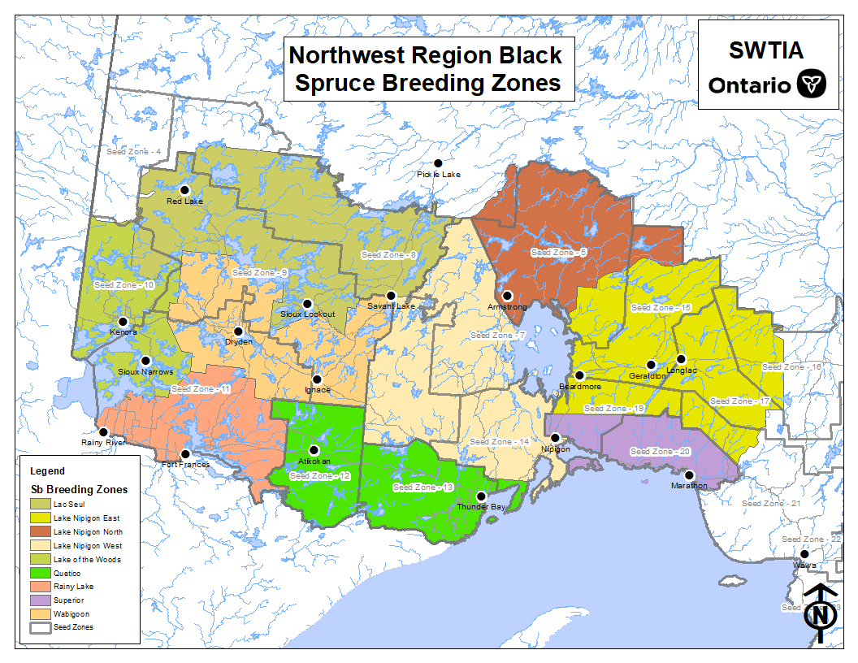

Figure A4.1. Black Spruce Northwest Region

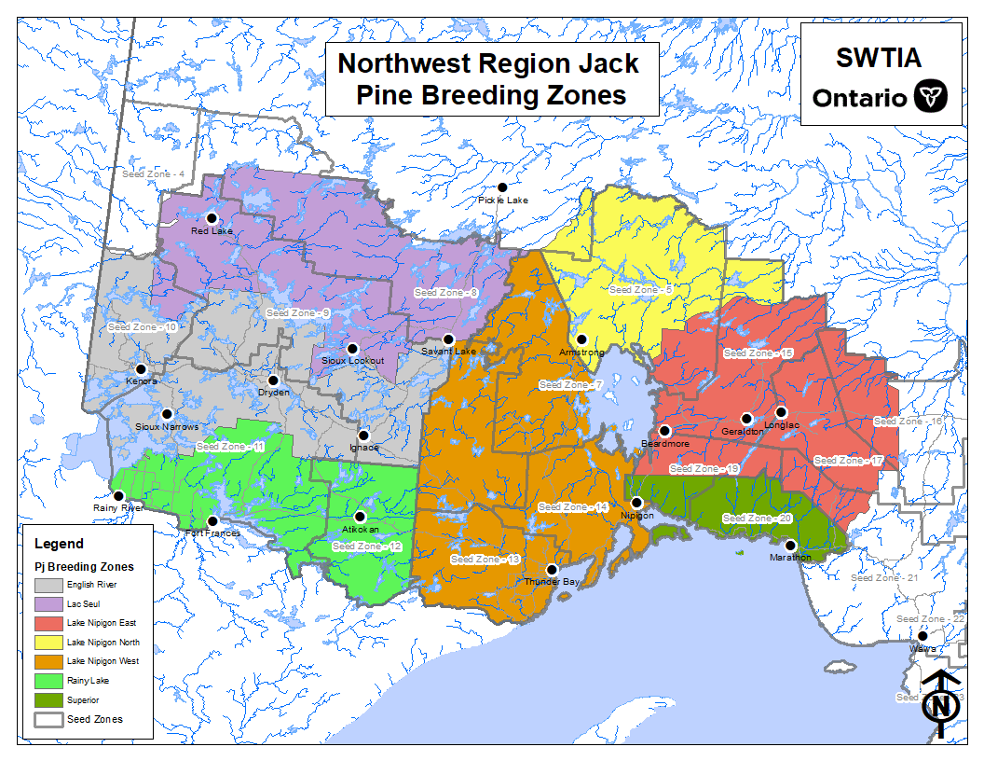

Figure A4.2. Jack Pine Northwest Region

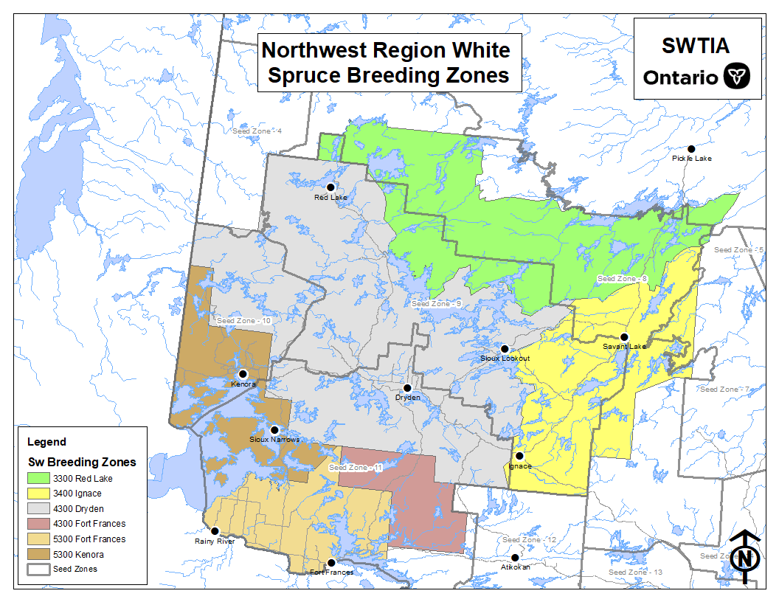Figure A4.3. White Spruce Northwest Region

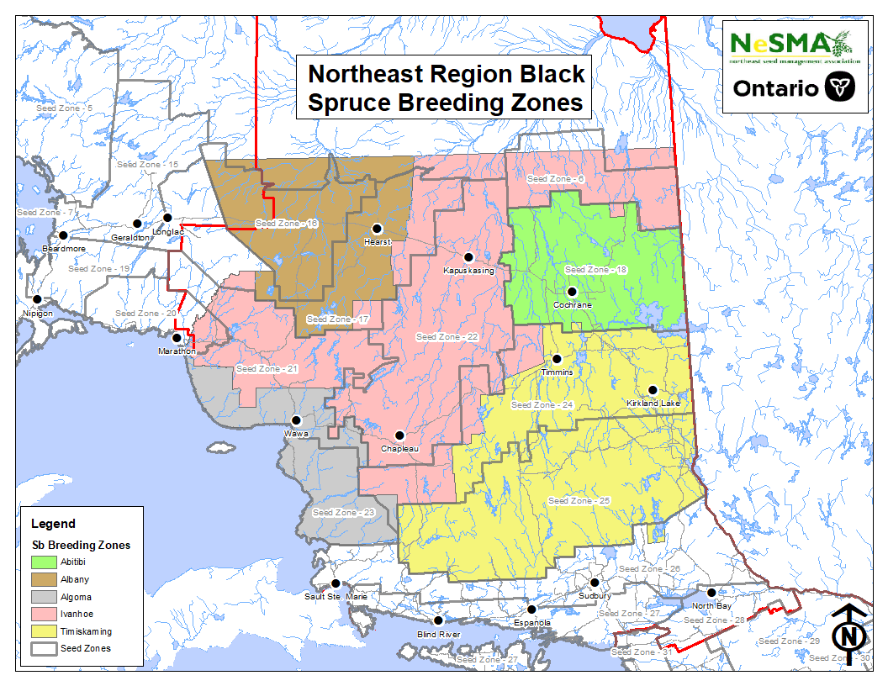

Figure A4.4. Black Spruce Northeast Region

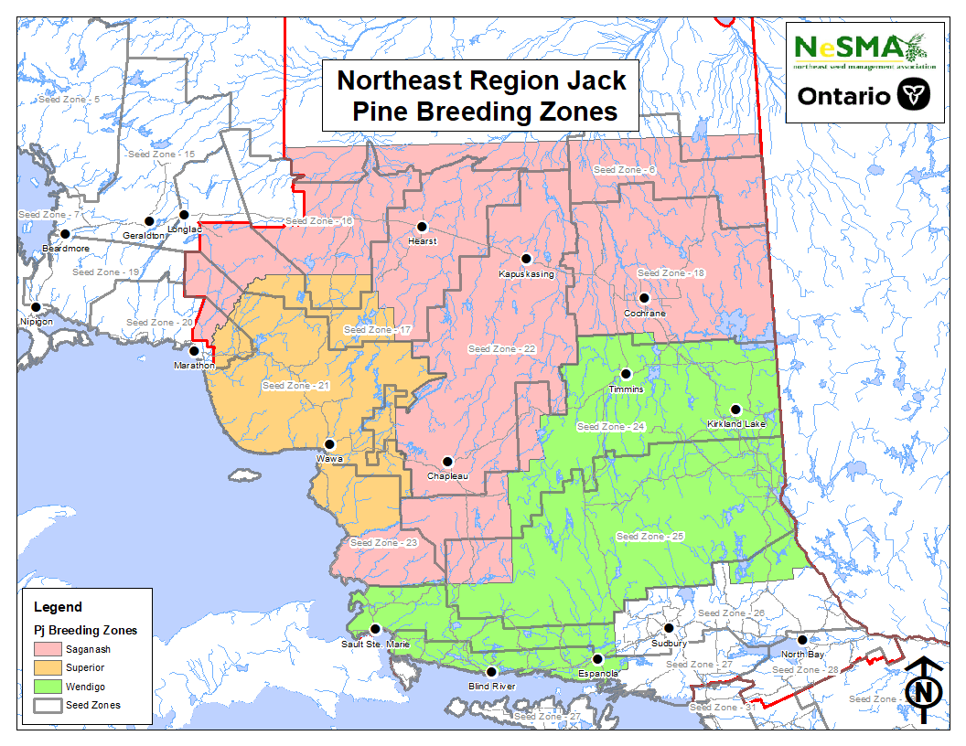

Figure A4.5. Jack Pine Northeast Region

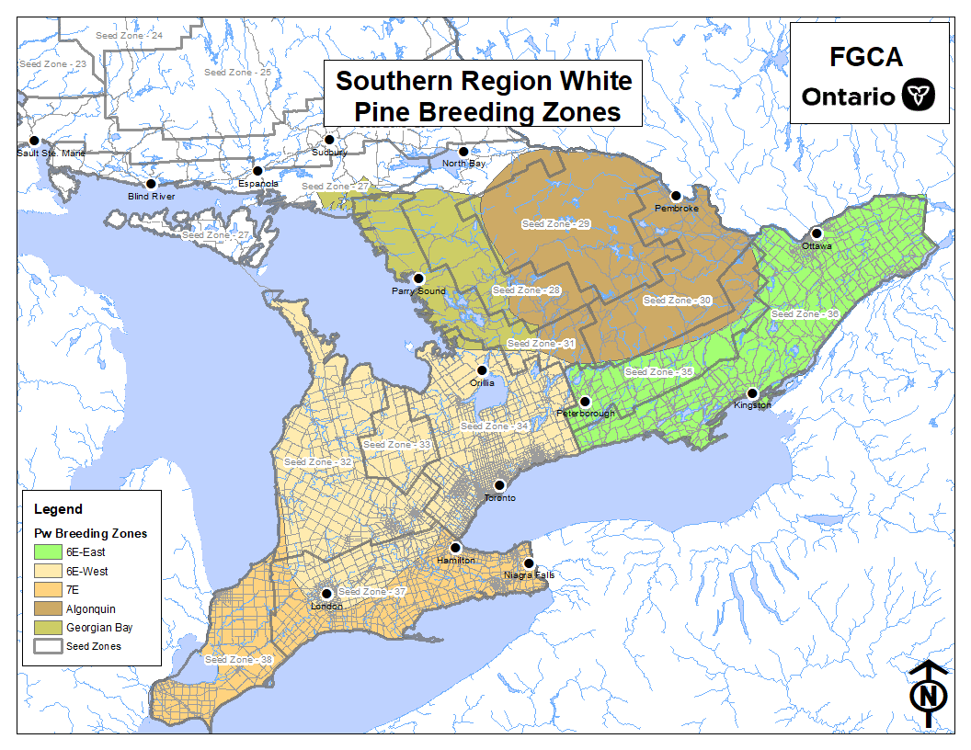

Figure A4.6. White Pine Southern Region

## Appendix 5. Glossary

**Adaptive capacity** is “the ability of a system to adjust to climate change (including climate variability and extremes) to moderate potential damages, to take advantage of opportunities, or to cope with the consequences” (Parry *et al.* 2007).

**Afforestation** refers to “planting of new forests on lands that historically have not contained forests” (IPCC 2013).

**Artificial regeneration** is “the renewal of a forest by seeding or planting seedlings or cuttings” (OMNRF 2017).

**Breeding zone** is a geographic area within which the progeny of selected tree genotypes is well adapted to the soil and climate conditions and perform stably to realize expected *genetic gains* in trait(s) of interest (Pengxin Lu, 2018, OMNRF, personal communication).

**Climate change adaptation** involves modifying practices and behaviours to reduce the vulnerabilities and risks associated with climate change (Edwards and Hirsch 2012). Whereas genetic adaptation involves the genetic change of a tree population where individuals within a population are selected due more successful reproduction by the environment they are in, resulting in future generations with more of the genes of the more fit individuals (Woods 2018).

**Climate projection** is “the simulated response of the climate system to a scenario of future emission … generally derived using climate models” (IPCC 2013).

**Climate similarity analysis uses a Gower Similarity Index to** compare the historical climate at a seed collection site to expected future climate at a potential planting site (see Appendix 2).

**Crown forest** is “a forest ecosystem or part of a forest ecosystem that is on land vested in Her Majesty in right of Ontario an under the management of the Minister of Natural Resources and Forestry. (CFSA)” (OMNRF 2017).

**Ecodistricts** are ecosystem boundaries distinguished by physiographic differences (e.g., geology, geomorphology, patterns of relief, substrate parent material) and microclimate and by the successional trends exhibited by the predominant vegetation type on those physiographic features. In contrast, ecoregions are larger than ecodistricts and are characterized by climate patterns only (Crins *et al.* 2009).

**Emissions scenario** is “a plausible representation of the future development of emissions… (e.g., greenhouse gases) based on a…set of assumptions about driving forces (such as demographic and socioeconomic development, technological change) and their key relationships” (IPCC 2013).

**Forest manager** means the party who has been assigned the obligation to renew the forest after harvesting. It includes a Forest Resource Licensee, the Algonquin Forestry Authority, or the MNRF district office with respect to a management unit where there is no Forest Resource Licensee.

**Genetic diversity** is “the genetic variation present in a population or species” (NRCan 2018a).

**Genetic gain** is the relative increase in quantity or quality of trait(s) of interest through tree improvement. The magnitude of genetic gain is indicative of the effectiveness of tree improvement programs (White *et al.* 2007).

**Genecology** “is the study of patterns of genetic differentiation among populations of a species and how this genetic differentiation is patterned on factors of the environment in which they live” (Woods 2018).

**Germination test** is “a test made to determine the viability of seeds, spores, or pollen grains in a given sample” (NRCan 2018a).

**Grafting** is when “a detached cutting or branch tip (scion) is placed in close cambial contact with a rooted plant (understock) in such a manner that scion and rootstock unite” (NRCan 2018a).

**Growing season length** is “determined using temperature-based rules, starting when the mean daily temperature was greater than or equal to 5 degrees Celsius for 5 consecutive days beginning March 1. The growing season ends when the average minimum temperature is less than -2 degrees Celsius beginning August 1” (NRCan 2018b).

**Improved seed** is derived from tree improvement programs that apply forest genetic principles to develop high yielding, healthy and sustainable plantations (White *et al.* 2007). It has been improved for deployment in a specific geographic area, known as a breeding zone (Pengxin Lu, 2018, OMNRF, personal communication).

**Local seed** is seed collected from the vicinity of a planting site. In this document, local seed refers to seed collected from the seed zone or ecodistrict in which the future planting site is located; non-local seed is that collected from another seed zone or ecodistrict (Pengxin Lu, 2018, OMNRF, personal communication).

**Maladaptation** “occurs when the local environment to which species are adapted begins to change at a rate that is beyond the species’ ability to accommodate. Since trees are long lived organisms and individuals are unable to migrate, the current population of trees will likely become increasingly maladapted as climate change occurs” (Johnston *et al.* 2009).

**Mean annual temperature** is “the mean of all the monthly mean temperatures. Each monthly mean temperature is the mean of that month's maximum and minimum temperature” (NRCan 2018b).

**Minimum temperature coldest month** is the “lowest monthly minimum temperature” (McKenney *et al.* 2011).

**Natural stand seed** refers to seed collected from wild populations of a species, not significantly changed by human activities (Pengxin Lu, 2018, OMNRF, personal communication).

**Phenotype** “is a characteristic of the tree that can be measured or observed; it is the tree that we see and is influenced by both its genetic potential and the environment in which it grows” (White *et al.* 2007).

**Planting stock** “includes seedlings, transplants, cuttings, and occasionally wildlings, for use in planting” (NRCan 2018a).

**Population** “is a group of organisms of the same species living within a prescribed area small enough so that all individuals have the opportunity to mate with all others in the area” (White *et al.* 2007).

**Provenance** “refers to the geographical location of natural forest within the natural range of a species where seed is collected” (White *et al.* 2007).

**Reforestation** refers to establishing “forests on lands that have previously contained forests but that have been converted to some other use” (IPCC 2013).

**Regeneration** is “the renewal of a forest, by natural or artificial means following disturbance. This term may also be used to describe the young forest itself” (OMNRF 2017).

**Representative concentration pathways (RCPs)** are “plausible future scenarios of anthropogenic forcing spanning a range from a low emission scenario characterized by active mitigation (RCP 2.6), through two intermediate scenarios (RCP 4.5), to a high emission scenario (RCP 8.5). Each RCP is associated with plausible combinations of projected population growth, economic activity, energy intensity, and socio-economic development” (NRCan 2018c).

**Seed** “means germplasm derived through sexual reproduction that is used to grow a tree” (Snetsinger 2005).

**Seed collection areas** are sites where seed may be collected (as defined in above policy).

**Seed deployment areas** are sites where seed may be deployed (as defined in above policy).

**Seed lot** means bulk seed collected from an area assigned with an ID for tracking purposes. (Pengxin Lu, 2018, OMNRF, personal communication).

**Seeding** is “a form of artificial regeneration which involves the scattering of seed, more or less evenly, over an area” (OMNRF 2017).

**Seed orchard** is “a well-designed and intensively managed plantation, normally at large spacing, consisting of the very top-ranking elite tree genotypes selected from tree improvement programs for producing seed for use in artificial forest regeneration programs to enhance forest health and productivity” (White *et al.* 2007).

**Seed source** is “the geographic location where seed is collected. Seed source may or may not be the same as provenance, depending on whether the seed collection location is the natural origin or secondary plantations” (Zobel & Talbert).

**Seed transfer area** is a location where seed or planting stock can be deployed as defined by an Ontario *ecodistrict* (Crins *et al.* 2009) or a zone from the former *seed zones* of Ontario (OMNR 2010).

**Seed zone** refers to “areas of similar climatic and elevation conditions, used to specify where tree seed was collected and where trees from such seed are most likely to be successfully grown” (OMNR 2000).

**Species** refers to “a group of closely related organisms that are very similar to each other and are usually capable of interbreeding and producing fertile offspring. The species is the fundamental category of taxonomic classification, ranking below a genus or subgenus” (Editors of the American Heritage Dictionaries 2016)

**Tree improvement** is the application of principles of forest genetics and other disciplines, such as tree biology, silviculture and economics, to the development of genetically improved variety of forest trees (White *et al.* 2007).

## Appendix 6: Bibliography

### Directives/guides

[OMNR] Ontario Ministry of Natural Resources. 1996. A Seed Manual for Ontario. Triumph Graphics and Advertising Limited, Barrie, ON. 226 pp.

[OMNR] Ontario Ministry of Natural Resources. 2010. Seed Zones of Ontario. Ontario Ministry of Natural Resources, Forest Management Directives and Procedures, Forest Health and Silviculture Directive For 06 02 01.

[OMNR, OTSP] Ontario Ministry of Natural Resources, Ontario Tree Seed Plant. 2014. Seeds of Ontario Trees & Shrubs: Field Manual for Crop Forecasting and Collecting. Forest Gene Conservation Association. Ontario. Canada.

[OMNRF] Ontario Ministry of Natural Resources and Forestry. 2017a. Forest Operations and Silviculture Manual. Ontario Ministry of Natural Resources and Forestry, Crown Forests and Lands Policy Branch. Toronto, ON. 48 p.

[OMNRF] Ontario Ministry of Natural Resources and Forestry. 2017b. Forest Management Planning Manual. Toronto. Queen’s Printer for Ontario. 462 pp.

[OMNRF] Ontario Ministry of Natural Resources and Forestry. 2017c. Forest Information Manual. Toronto. Queen’s Printer for Ontario. 93 pp.

[OMNRF] Ontario Ministry of Natural Resources and Forestry. 2017d. Naturally Resilient: MNRF’s Natural Resource Climate Adaptation Strategy (2017-2021). Toronto. Queen’s Printer for Ontario. 32 pp.

[OMNRF] Ontario Ministry of Natural Resources and Forestry. 2015. Forest Management Guide to Silviculture in the Great Lakes-St. Lawrence and Boreal Forests of Ontario. Toronto. Queens Printer for Ontario. 394 pp.

[OMNRF] Ontario Ministry of Natural Resources and Forestry. 2014. A Silvicultural Guide for Managing Southern Ontario Forests. Toronto. Queens Printer for Ontario. 661 pp.

[OMECP] Ontario Ministry of the Environment, Conservation and Parks. 2018. A Made-in-Ontario Environment Plan: Preserving and Protecting our Environment for Future Generations. Toronto. Queen’s Printer for Ontario. 54 pp.

### Data sources, models, and tools

Beaulieu, J. 2009. Optisource: A tool for optimizing seed transfer. Natural Resources Canada, Canadian Forest Service, Laurentian Forestry Centre. Branching Out No. 55. 2 p.

Canadian Centre for Climate Services. 2018. Library of climate resources. Government of Canada, Ottawa, ON. <https://www.canada.ca/en/environment-climate-change/services/climate-change/canadian-centre-climate-services.html>. Accessed Dec 2018.

Crins, W.J., P.A. Gray, P.W.C. Uhlig and M.C. Wester. 2009. The ecosystems of Ontario, Part I: Ecozones and ecoregions. Ontario Ministry of Natural Resources, Peterborough, ON. Inventory, Monitoring and Assessment, SIB TER IMA TR-01. 71 p.

Fryer, Janet L., comp. 2018. Tree species distribution maps from Little's "Atlas of United States trees" series. In: Fire Effects Information System, [Online]. U.S. Department of Agriculture, Forest Service, Rocky Mountain Research Station, Fire Sciences Laboratory (Producer). Available: https://www.fs.fed.us/database/feis/pdfs/Little/aa_SupportingFiles/LittleMaps.html [92602].

Howe, G., B. St. Clair, N. Stevenson-Molnar, B. Ward and D. Bachelet. 2018. Seedlot selection tool. Conservation Biology Institute, Corvallis, OR. <[https://seedlotselectiontool.org/sst/](https://na01.safelinks.protection.outlook.com/?url=https%3A%2F%2Fseedlotselectiontool.org%2Fsst%2F&data=02%7C01%7CNgaire.Roubal%40ontario.ca%7C9f8c38c52e124085a18c08d6596ebabc%7Ccddc1229ac2a4b97b78a0e5cacb5865c%7C0%7C0%7C636794729459521891&sdata=u%2FkPEi9tLOeuNt8ZpduHGZQCS3FE089fcxFWzkQKmdc%3D&reserved=0)>. Accessed Dec 2018.

[ISTA] International Seed Testing Association. 2019. International Rules for Seed Testing. ISTA. Bassersdorf, Switzerland. ISSN [2310-3655](https://www.ingentaconnect.com/content/ista/rules/2019/00002019/00000001). <<http://seedtest.org/en/home.html>> and <<https://www.seedtest.org/en/international-rules-_content---1--1083.html>>. Accessed Jan 2019.

[IPCC] International Panel on Climate Change. 2014. Climate Change 2014: Synthesis Report. Contribution of Working Groups I, II and III to the Fifth Assessment Report of the Intergovernmental Panel on Climate Change [Core Writing Team, R.K. Pachauri and L.A. Meyer (eds.)]. IPCC, Geneva, Switzerland, 151 pp.

McKenney, D.W., M.F. Hutchinson, P. Papadopol, K. Lawrence, J. Pedlar, K. Campbell, E. Milewska, R.F. Hopkinson, D. Price and T. Owen. 2011. Customized spatial climate models for North America. Bulletin of the American Meteorological Society 92(12): 1611–1622.

McKenney, D.W., B.G. Mackey and D. Joyce. 1999. Seedwhere: a computer tool to support seed transfer and ecological restoration decisions. Environmental Modelling Software 14: 589–595.

McKenney, D., J. Pedlar, M. Hutchinson, P. Papadopol, K. Lawrence, K. Campbell, E. Milewska, R.F. Hopkinson and D. Price, 2013. Spatial climate models for Canada’s forestry community. The Forestry Chronicle 89(5): 659–663.

Pedlar, J.P. and D.W. McKenney. 2018. Critical Seed Transfer Distances for Selected Ontario Tree Species. Unpublished report.

Price, D.T., D.W. McKenney, L.A. Joyce, R.M. Siltanen, P. Papadopol and K. Lawrence. 2011. High resolution interpolation of IPCC AR4 GCM climate scenarios for Canada. Natural Resources Canada, Canadian Forest Service, Northern Forestry Centre, Edmonton, AB. Inf. Rep. NOR-X-421.

Van Vuuren, D.P., J. Edmonds, M Kainuma, K. Riahi, A. Thomson, K. Hibbard, G.C. Hurtt, T. Kram, V. Krey, J. Lamarque, T. Masui, M. Meinshausen, N Nakicenovic, S.J. Smith and S.K. Rose. 2011. The representative concentration pathways: an overview. Climatic Change 109(1-2): 5-31.

### Science to support the development of a climate-based seed transfer system

Aitken, S.N. and J.B. Bemmels. 2016. Time to get moving: Assisted gene flow of forest trees. Evolutionary Applications 9(1): 271–290.

Aitken, S.N. and M.C. Whitlock. 2013. Assisted gene flow to facilitate local adaptation to climate change. Annual Review of Ecology, Evolution, and Systematics 44: 367–388.

Aubin, I., L. Boisvert-Marsh, H. Kebli, D. McKenney, J. Pedlar, K. Lawrence, E. H. Hogg, Y. Boulanger, S. Gauthier and C. Ste-Marie. 2018. Tree vulnerability to climate change: improving exposure-based assessments using traits as indicators of sensitivity. Ecosphere 9(2): e02108.

Beardmore, T. and R. Winder. 2011. Review of science-based assessments of species vulnerability: contribution to decision-making for assisted migration. The Forestry Chronicle 87(6): 745–754.

Beaulieu, J. and A. Rainville. 2005. Adaptation to climate change: Genetic variation is both a short and a long-term solution. The Forestry Chronicle 81(5): 704–709.

Cherry, M. 2001. Options for allocating afforestation stock in Ontario with anticipated climate change. Ontario Ministry of Natural Resources, Ontario Forest Research Institute, Sault Ste. Marie, ON. Forest Research Information Paper No. 148.

Cherry, M and W.H. Parker. 2003. Utilization of genetically improved stock to increase carbon sequestration. Ontario Ministry of Natural Resources, Ontario Forest Research Institute, Sault Ste. Marie, ON. Forest Research Report No. 160.

Crowe, K.A. and W.H. Parker. 2008. Using portfolio theory to guide reforestation and restoration under climate change scenarios. Climatic Change 89: 355–370.

Iverson, L.R. and D. McKenzie. 2013. Tree species range shifts in a changing climate: Detecting, modeling, assisting. Landscape Ecology 28: 879–889.

Mackey, B.G., D.W. McKenney, Y.Q. Yang, J.P. McMahon and M.F. Hutchnison. 1996. Site regions revisited: A climatic analysis of Hill’s site regions for the province of Ontario using a parametric method. Canadian Journal of Forest Research 26: 333–354.

Mastrandrea, M.D., C.B. Field, T.F. Stocker, O. Edenhofer, K.L. Ebi, D.J. Frame, H. Held, E. Kriegler, K.J. Mach, P.R. Matschoss, G.-K. Plattner, G.W. Yohe, and F.W. Zwiers, 2010. Guidance Note for Lead Authors of the IPCC Fifth Assessment Report on Consistent Treatment of Uncertainties. Intergovernmental Panel on Climate Change (IPCC). 5pp.

McKenney, D.W., J.H. Pedlar and G.A. O’Neill. 2009. Climate change and forest seed zones: Past trends, future prospects, and challenges to ponder. The Forestry Chronicle 85: 258–265.

McKenney, D.W., J.H. Pedlar, K. Lawrence, P. Papadopol, K. Campbell and M.F. Hutchinson. 2014. Change and evolution in the plant hardiness zones of Canada. BioScience 64: 341–350.

Natural Resources Canada. 2018. Plant hardiness of Canada. Government of Canada, Ottawa, ON. <http://www.planthardiness.gc.ca/>. Accessed Dec 2018

O’Neill, G.A., M. Stoehr and B. Jaquish. 2014. Quantifying safe seed transfer distance and impacts of tree breeding on adaptation. Forest Ecology and Management 328: 122–130.

O’Neill, G., T. Wang, N. Ukrainetz, L. Charleson, L. McAuley, A. Yanchuk and S. Zedel. 2017. A proposed climate-based seed transfer system for British Columbia. Province of British Columbia, Victoria, BC. Technical Report 099.

Parker, W.H. 1992. Focal point seed zones: site specific seed zone delineation using geographic information systems. Canadian Journal of Forest Research 22: 267–271.

Pedlar, J.H. and D. McKenney. 2017. Assessing the anticipated growth response of northern conifer populations to a warming climate. Nature: Scientific Reports 7: 43881.

Rehfeldt, G.E, L.P. Leites, D.G. Joyce and A. Weiskittel. 2017. Role of population genetics in guiding ecological responses to climate. Global Change Biology 24: 858–868.

Sakai, A. and W. Larcher. 1987. Frost Survival of Plants: Responses and Adaptation to Freezing Stress. Springer-Verlag, Berlin, DE. 321 p.

Ying, C.C. and A.D. Yanchuk. 2006. The development of British Columbia’s tree seed transfer guidelines: Purpose, concept, methodology, and implementation. Forest Ecology and Management 227: 1–13.

### Species-specific science to support the development of a climate-based seed transfer system

Bemmels, J.B. and C.W. Dick. 2018. Genomic evidence of a widespread southern distribution during the Last Glacial Maximum for two eastern North American hickory species. Journal of Biogeography 45(8): 1739–1750.

Benowicz, Y. El-Kassaby and R. Guy. 2001. Genetic variation among paper birch (*Betula papyrifera* Marsh.) populations in germination, frost hardiness, gas exchange and growth. Silvae Genetica 50: 7–13.

Bernard, A., F. Lheureux and E. Dirlewanger. 2018. Walnut: Past and future genetic improvement. Tree Genetics and Genomes 14: 1.

Charrier, G., M. Bonhomme, A. Lacointe and T. Amelgio. 2011. Are budburst dates, dormancy and cold acclimation in walnut trees (*Juglans regia* L.) under mainly genotypic or environmental control? International Journal of Biometeorology 55: 763.

Drobyshev, I., M-A. Guitard, H. Asselin, A. Genries and Y. Bergeron. 2014. Environmental controls of the northern distribution limit of yellow birch in eastern Canada. Canadian Journal of Forest Research 44(7): 720–731.

Eschtruth, A.K., R.A. Evans and J.J. Battles. 2013. Patterns and predictors of survival in *Tsuga canadensis* infested by the exotic pest *Adelges tsugae*: 20 years of monitoring. Forest Ecology and Management 305: 195–203.

Joyce, D.G. and G.E. Rehfeldt. 2013. Climatic niche, ecological genetics, and impact of climate change on eastern white pine (*Pinus strobus* L.): Guidelines for land managers. Forest Ecology and Management 295: 173–192.

Joyce, D.G. and G.E. Rehfeldt. 2017. Management strategies for black spruce (*Picea mariana* (Mill.) B.S.P.) in the face of climate change: Climatic niche, clines, climatypes, and seed transfer. Forestry: An International Journal of Forest Research 90(4): 594–610.

Kriebel, H.B. 1993. Intraspecific variation of growth and adaptive traits in North American oak species. Annals of Forest Science 50(1): 153–165.

Lu, P., D.G. Joyce and R.W. Sinclair. 2003. Effect of selection on shoot elongation rhythm of eastern white pine (*Pinus strobus* L.) and its implications to seed transfer in Ontario. Forest Ecology and Management 182: 161–173.

Lu, P., D.G. Joyce and R.W. Sinclair. 2003. Geographic variation in cold hardiness among eastern white pine (*Pinus strobus* L.) provenances in Ontario. Forest Ecology and Management 178: 329–340.

Lu, P., D.G. Joyce and R.W. Sinclair. 2003. Seed source selection of eastern white pine. Ontario Ministry of Natural Resources, Ontario Forest Research Institute, Sault Ste. Marie, ON. Forest Research Note No. 64. 4 p.

Lu, P., W.H. Parker, M. Cherry, S. Colombo, W.C. Parker, R. Man and N. Roubal. 2014. Survival and growth patterns of white spruce (*Picea glauca* [Moench] Voss) range wide provenances and their implications for climate change adaptation. Ecology and Evolution 4(12): 2360–2374.

Marquis, B., M. Vellend, I. Myers-Smith, M. Peros. 2016. The superior distribution limit for sugar maple and yellow birch under climate control: study dendroecological along a gradient of elevation. (climate control on species upper range limit: a dendroecology analysis of two hardwood tree species in southeastern Canada, Québec) Master’s Thesis. Unversite de Sherbrooke, Sherborooke, QC. 66 p.

Parker, W.H. and M.R. Lesser. 2004. Focal point seed zones for white spruce in Ontario. Lakehead University, Thunder Bay, ON. Living Legacy Trust Project 04-012. 82 p.

Parker, W.H. and A. van Niejenhuis. 1996. Regression-based focal point seed zones for *Picea mariana* from northwestern Ontario. Canadian Journal of Botany 74: 1227–1235.

Parker, W.H. and A. van Niejenhuis. 1996. Seed zone delineation for jack pine in the former Northwest Region of Ontario using short-term testing and geographic information systems. Natural Resources Canada, Canadian Forest Service, Great Lakes Forestry Centre, Sault Ste. Marie, ON. Technical Report NODA/NFPTR-35. 34 p.

Parker, W.H., A. van Niejenhuis and P. Charrette. 1994. Adaptive variation in *Picea mariana* from northwestern Ontario determined by short-term common environment test. Canadian Journal of Forest Research 24: 1653–1661.

Potter, K. M., R.M. Jetton, W.S. Dvorak, V.D. Hipkins, R. Rhea and W. A. Whittier. 2012. Widespread inbreeding and unexpected geographic patterns of genetic variation in eastern hemlock (*Tsuga canadensis*), an imperiled North American conifer. Conservation Genetics 13(2): 475–498.

Prud’homme, G.O., M.S. Lamhamedi, L. Benomar, A. Rainville, J. DeBlois, J. Bousquet and J. Beaulieu. 2018. Ecophysiology and growth of white spruce seedlings from various seed sources along a climatic gradient support the need for assisted migration. Frontiers in Plant Science 8: 2214.

Rahi, A.A., C. Bowling and D. Simpson. 2010. A red pine provenance test in northwestern Ontario: 48-year results. The Forestry Chronicle 86(3): 348–353.

Sebastian-Azcona, J., A. Hamann, U.G. Hacke and D. Rweyongeza. 2019. Survival, growth and cold hardiness tradeoffs in white spruce populations: Implications for assisted migration. Forest Ecology and Management 433: 544–552.

St. Clair, J.B. and G.T. Howe. 2007. Genetic maladaptation of coastal Douglas‐fir seedlings to future climates. Global Change Biology 13(7): 1441–1454.

St. Clair, J.B., N.L. Mandel, K.W. Vance-Borland. 2005. Genecology of Douglas Fir in western Oregon and Washington. Annals of Botany 96: 1199–1214.

Thomson, A and W.H. Parker. 2008. Boreal forest provenance tests used to predict optimal growth and response to climate change. 1. Jack pine. Canadian Journal of Forest Research 38(1): 157–170.

Thomson, A.M., C.L. Riddell and W.H. Parker. 2009. Boreal forest provenance tests used to predict optimal growth and response to climate change. 2. Black spruce. Canadian Journal of Forest Research 39: 143–153.

Thomson, A.M., K.A. Crowe and W.H. Parker. 2010. Optimal white spruce breeding zones for Ontario under current and future climates. Canadian Journal of Forest Research 40: 1576–1587.

Wang, B.S.P. and E.K. Morgenstern. 2009. A strategy for seed management with climate change. The Forestry Chronicle 85(1): 39–42.

Weng, Y., P. Charrette and P. Lu. 2018. Re-examining breeding zones of white spruce in northwestern Ontario, Canada. New Forests doi.org/10.1007/s11056-018-9692-y

Yang, J., J.H. Pedlar, D.W. McKenney and A. Weersink. 2015. The development of universal response functions to facilitate climate-smart regeneration of black spruce and white pine in Ontario, Canada. Forest Ecology and Management 339: 34–43.

### Glossary references

Editors of the American Heritage Dictionaries. 2016. American Heritage Dictionary of the English Language, Fifth Edition. Houghton Mifflin Harcourt Publishing Company. 2112 pp.

Crins, W.J., P.A. Gray, P.W.C. Uhlig and M.C. Wester. 2009. The ecosystems of Ontario, Part I: Ecozones and ecoregions. Ontario Ministry of Natural Resources, Inventory, Monitoring and Assessment, Peterborough ON. SIB TER IMA TR-01. 71 p.

Edwards J.E. and K.G. Hirsch. 2012. Adapting sustainable forest management to climate change: Preparing for the future. Canadian Council of Forest Ministers, Ottawa, ON. 32 p.

[IPCC] International Panel on Climate Change. 2013. Annex III: Glossary [Planton, S. (ed.)]. In: Climate Change 2013: The Physical Science Basis. Contribution of Working Group I to the Fifth Assessment Report of the Intergovernmental Panel on Climate Change [Stocker, T.F., D. Qin, G.-K. Plattner, M. Tignor, S.K. Allen, J. Boschung, A. Nauels, Y. Xia, V. Bex and P.M. Midgley (eds.)]. Cambridge University Press, Cambridge, UK/New York, NY.

Johnston, M., M. Campagna, P. Gray, H. Kope, J. Loo, A. Ogden, G.A. O’Neill, D. Price and T. Williamson. 2009. Vulnerability of Canada's tree species to climate change and management options for adaptation: An overview for policy makers and practitioners. Canadian Council of Forest Ministers, Ottawa, ON. 44 p.

McKenney, D.W., M.F. Hutchinson, P. Papadopol, K. Lawrence, J. Pedlar, K. Campbell, E. Milewska, R.F. Hopkinson, D. Price and T. Owen. 2011. Customized spatial climate models for North America. American Meteorological Society 92(12): 1611–1622.

[NRCan] Natural Resources Canada. 2018a. Glossary: Genetic diversity. Government of Canada, Ottawa, ON. <https://cfs.NRCan.gc.ca/terms/category/18>. Accessed Dec 2018.

[NRCan] Natural Resources Canada. 2018b. Regional, national and international climate modeling. Government of Canada, Ottawa, ON. <https://cfs.NRCan.gc.ca/projects/3/8>. Accessed Dec 2018.

[NRCan] Natural Resources Canada. 2018c. Representative concentration pathways. Government of Canada, Ottawa, ON. <http://climate-scenarios.canada.ca/?page=scen-rcp>. Accessed Dec 2018.

[OMNR] Ontario Ministry of Natural Resources. 2000. A Silvicultural Guide to Managing Southern Ontario Forests. Ontario Ministry of Natural Resources, Toronto, ON. 661 p.

[OMNRF] Ontario Ministry of Natural Resources and Forestry. 2017. Forest Management Planning Manual. Toronto. Queen’s Printer for Ontario. 462 pp.

Parry, M.L., O.F. Canziani, J.P. Palutikof, P.J. van der Linden and C.E. Hanson (eds). 2007. Appendix I: Glossary. In Climate change 2007: Impacts, adaptation and vulnerability. Contribution of Working Group II to the Fourth Assessment Report of the Intergovernmental Panel on Climate Change. Cambridge University Press, Cambridge, UK/New York, NY.

Snetsinger, J. 2005. Chief forester’s standards for seed use. BC Ministry of Forests, Vancouver, BC. 43 p. <https://www.for.gov.bc.ca/ftp/hti/external/!publish/Chief_Foresters_Standards_for_Seed_Use/CFstds03Jun2010.pdf>. Accessed Dec 2018.

White, T.L., W.T. Adams and D.B. Neale. 2007. Forest Genetics. CABI Publishing, Wallingford, UK. 682 p.

Woods, J. 2018. Glossary of forest genetics terms. Prepared for Forests Genetics Council of British Columbia. <http://www.fgcouncil.bc.ca/doc-glos.html#anchor5493010>. Accessed Dec 2018.

Zobel, B. and J. Talbert. Applied Forest Tree Improvement. 1984. The Blackburn Press. Caldwell, NJ, USA. 505 p.