29 July, 2020

Dear Sir or Madam,
Introduction
Further to my previous submissions expressing my opposition to a new multi-media Environmental Compliance Approvals (ECA) for 2683517 Ontario Inc. located in the City of Toronto at 633 Coronation Drive, I wish to register the following additional comments.

Traffic Impact Study
The Proponent recently tabled the Traffic Impact Study prepared by JD Northcote. I have concerns about the study which I discuss below.

Limited Study Area
The study is limited to four streets and intersections, namely a small section of Lawrence, Manse, Beechgrove and Coronation. I feel it should be extended to cover all of Lawrence, as well as Morningside and Port Union to the 401, as there are existing traffic delays on these streets, as well as major commercial shopping areas and schools, with many lights, and pedestrian crossings

Allowable Waste Limits
I agree that the allowable waste limit for the organic/biogas plant is 1240 tonnes per day, as is shown on the EBR No. 019-1444 (ECA No. 818-BKDPE7). The limit was initially set at 620 tonnes per day in EBR No. 013-2624 (ECA No. 0608-AWLKA4), along with a wood waste/demolition waste limit set at 880 tonnes per day, for an initial site limit of 1500 tonnes per day. The final site limit was indicated at 2500 tonnes per day (Ref 1. Extract from EBR No. 013 - 2624), presumably to be split evenly between the organic and construction waste operations. The Traffic report only allows for the 1240 tonnes of organic waste being processed at the new biogas plant, thus, as discussed later, it does not appear to allow for the traffic from the existing construction/demolition waste processing plant

Traffic from Proposed Biogas Processing Plant at 633 Coronation
The report estimates the number of trucks serving the new plant based on an organic waste limit of 1240 tonnes per day, as is regulated by EBR No. 019-1444. There will be 24 trucks carrying 5 tonnes each into the plant during the day, and 41 trucks carrying an average of 27 tonnes each during the night for a total of 1227 tonnes coming into the site per day. There will be 27 different trucks each carrying 40 tonnes of digestate out, and 3 trucks each carrying 25 tonnes of inorganic material out of the plant for a total of 1155 tonnes split between day and night.

Existing Traffic Figures
I understand that it was not possible to measure current traffic data because of COVID-19, so historical data from 2014 and 2017 was used. It was extrapolated to 2020, by adding in expected growth, and adding four known new developments. However, no allowance was added for the traffic from the existing Optimum Disposal Services Inc. construction waste processing operation that was approved under ECA 4568-AJTR84 on May 1, 2017 and presumably started operation in 2018.

Traffic from the Construction/Demolition Waste Plant
It seems that the traffic from the existing construction/demolition waste processing plant on the site has not been allowed for in either the existing or projected traffic figures. The plant was not in operation in 2014 and 2017 when the historical traffic data figures were collected. As noted above, it appears that that construction processing operation also has a processing limit of 1240 tonnes per day. Thus, the number of truck trips to and from the site in the current study has probably been underestimated by a factor of two or three, since it is likely that the construction waste trucks will not be as large as those proposed for the food waste and digestate. This deficiency could affect the conclusions drawn in the report.

Provision for Future Increased Traffic
It appears that the traffic analysis only relates to the estimated existing 2020 conditions with the addition of the proposed biogas plant traffic. No consideration appears to have been given to what will happen to the traffic flows in the next 20 years, as densification of the neighbourhoods continues?

Allocation of Traffic to Different Routes
The report assumes that the traffic will be evenly split between Morningside and Port Union, with the Morningside portion being split 60%/40% between Manse and Coronation. I would challenge both these assumptions.

Six alternative routes to the 401 were analyzed in detail as part of the Highland Creek Biosolids Class EA Health Impact Assessment. The two preferred options selected were the Morningside/Manse and the Port Union/Beechgrove routes (Ref. 2 - Highland Creek Biosolids Class EA- Health Impact Assessment - Sections 3.2.4 and 7.1.2).

The route along Coronation west of Manse, which is proposed in the current study, was not selected, probably because, as shown in the photo below, there are limitations on the hours that trucks are allowed in both directions on Coronation between Manse and Morningside, and also on Morningside south of Lawrence; "No Trucks - 7 pm to 7 am."

Coronation Drive looking East from Morningside - No trucks 7pm to 7am

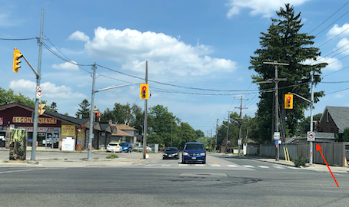

I also question the equal splitting of the traffic between Manse and Beechgrove, as it is most unlikely that will always happen. It would seem more realistic to assume that either route could get up to 75% of the flow depending on the day and time?

As an example, I recently followed a large light green waste truck travelling down Morningside from the 401, and it turned left onto Lawrence but instead of turning down Manse it went on to turn down Beechgrove, and then turned right on Coronation and into the plant at 633. I assume that the driver felt that Beechgrove was a faster route at that time of day! However, it should be noted that Beechgrove allows parking on both sides from 18.00 pm to 7.00 am. This could impede the many large trucks proposed to be delivering waste to the site and returning empty and the large tanker trucks entering the site empty and then transporting the digestate from the site all during the evening and night hours.

Types of Trucks bringing in the Organic Waste
The incoming semi-liquid decaying food waste will be not unlike the dewatered biosolids that are generated at the Wastewater Treatment Plant. As will be seen in the example from the Biosolids Study Truck Route Review Report (Ref. 3. Figure 11), these trucks will be very large and heavy and are loaded from the top. Because of the sticky nature of the waste, these trucks cannot have tightly sealed lids, but rather have a roll-back tarpaulin cover that can release odours.

Figure 11. Typical Haul Truck for Biosolids
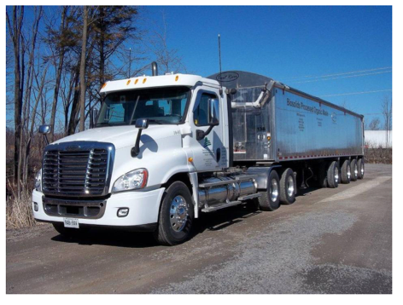
This truck is very similar to the organic waste haulage trucks indicated in the current report.

Proposed 34 tonne capacity trucks for hauling in organic waste.
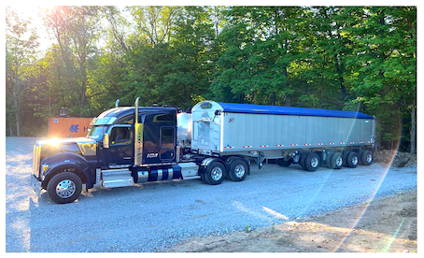

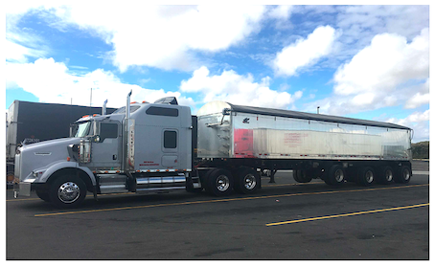

Type of Trucks hauling out the Digestate
In contrast, the processed digestate, which presumably can be pumped, will be hauled off site in sealed tanker trucks as shown below. Each truck will have a capacity of 40 tonnes.
Proposed Digestate Haulage Trucks
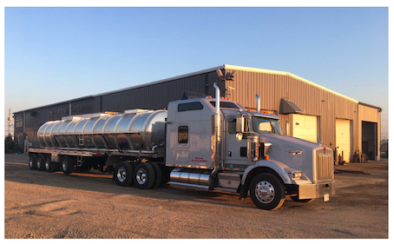
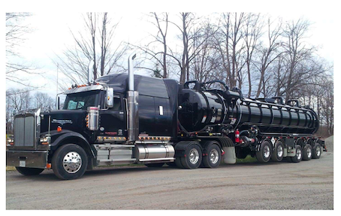

Traffic Safety and Odour Concerns
I would stress that it is important to consider all the potential stops and starts that the trucks may face especially near school crossings, and also at the many entrances and exits from busy shopping centres on Port Union and Morningside. The steep hills leading down from the 401, to Ellesmere on Morningside and Lawson on Port Union, are of particular concern, because the trucks bringing the organic waste to the site do not have tightly sealed lids, and in the worst imaginable scenario, the trucks can spill their load if they have to brake suddenly. This happened in Flat Rock Michigan, when one of the biosolids trucks from Toronto's Ashbridges Bay plant spilled its load of sewage sludge all over the main street, as was reported in the Globe and Mail article below.

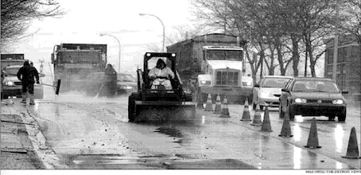
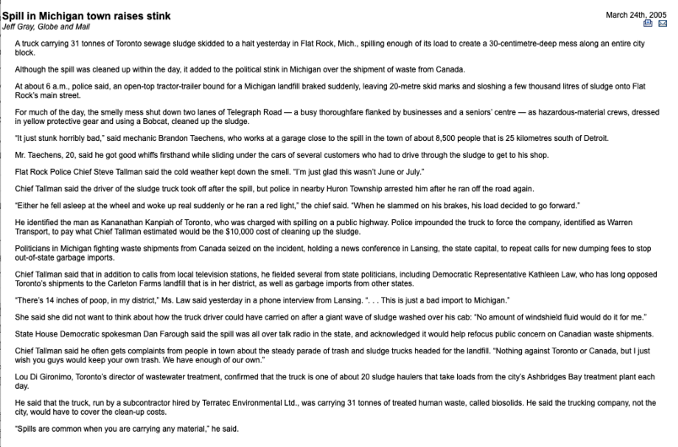
Other Truck Traffic Implications
The current study is only concerned with the efficiency of the traffic flow through the intersections. I think there are many other environmental and health issues that also should be considered, such as air quality, odours, multi-media exposure risk, traffic safety, neighbourhood characteristics, stress-risk perception, climate change and impacts on vulnerable groups. It should be noted that these issues were all considered as part of the Health Impact Assessment undertaken for the Biosolids EA. (Ref. 2)

Impact of the Increased Traffic on the Pavement Condition
The report does not include any discussion on the impact that the large number of very heavy trucks, some as much as 40 tonnes, will have on the existing pavement structures, especially Beechgrove and Manse.

City Staff Review
Given the specialized technical nature of the study, I would suggest that the appropriate City staff be requested to review and comment on the report. I thought that this was going to be done, but I do not think that there has been time for this. It would be interesting to compare the current report with the related reports prepared as part of the Biosolids EA. The Health Impact Assessment (Ref. 2) analyzed and compared the situation on both the likely routes in much more detail, while the earlier Truck Impact Review (Ref. 3) only looked at the Coronation/Manse/Lawrence/Morningside route.

In conclusion, I trust that you will give due consideration to the points listed above in your evaluation.

Thanking you for your assistance and cooperation on this very important issue that will affect the many residents of south eastern Scarborough, both now and in perpetuity.

Your sincerely

A resident of Southeast Scarborough in the City of Toronto

Referenced Documents:
Ref. 1. Extract from ECA No. 0608-AWLKA4

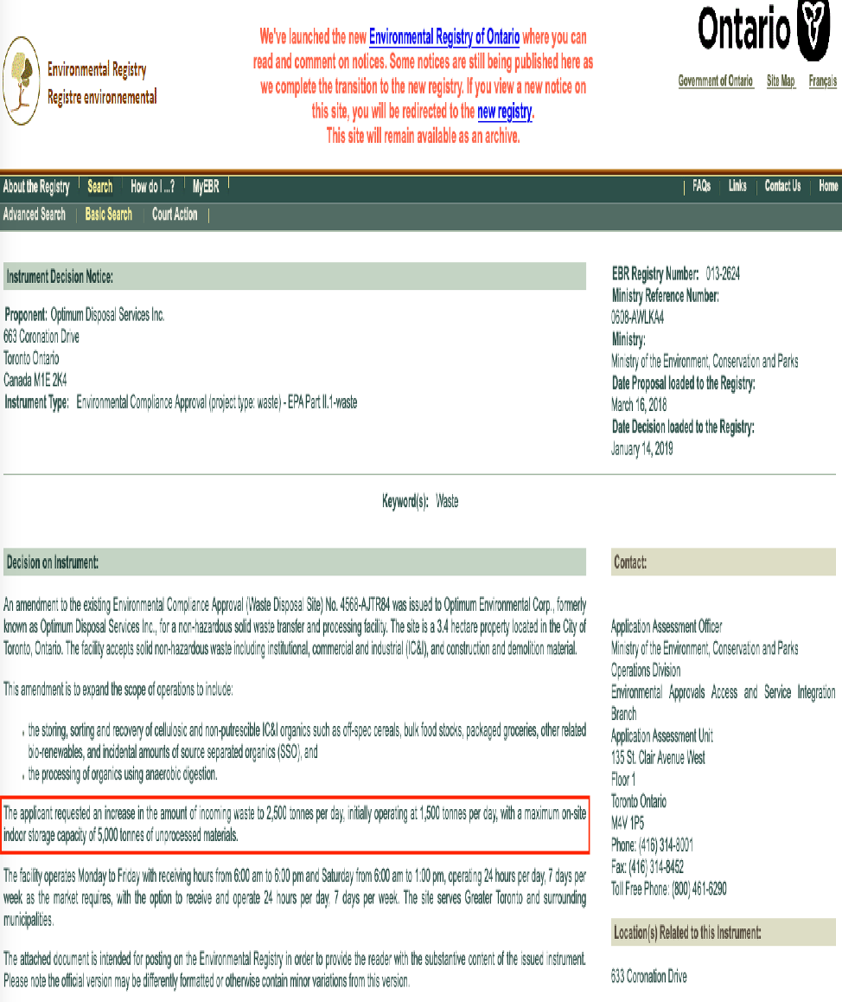

Ref 2. Class Environmental Assessment for Biosolids Management at the Highland Creek Treatment Plant - Health Impact Assessment for Biosolids Management Alternatives - Oct 19, 2015 - See file below:

Section 3.2.4 - pages 11 & 12
Section 7.1.2 - pages 45 to 54

FINAL HCTP HIA - Oct 19 2015.pdf
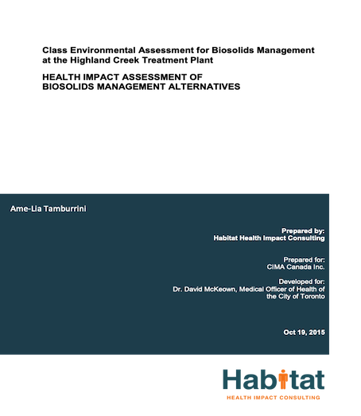
Ref. 3. Truck Route Review for Highland Creek Wastewater Treatment Plant Biosolids Options.
