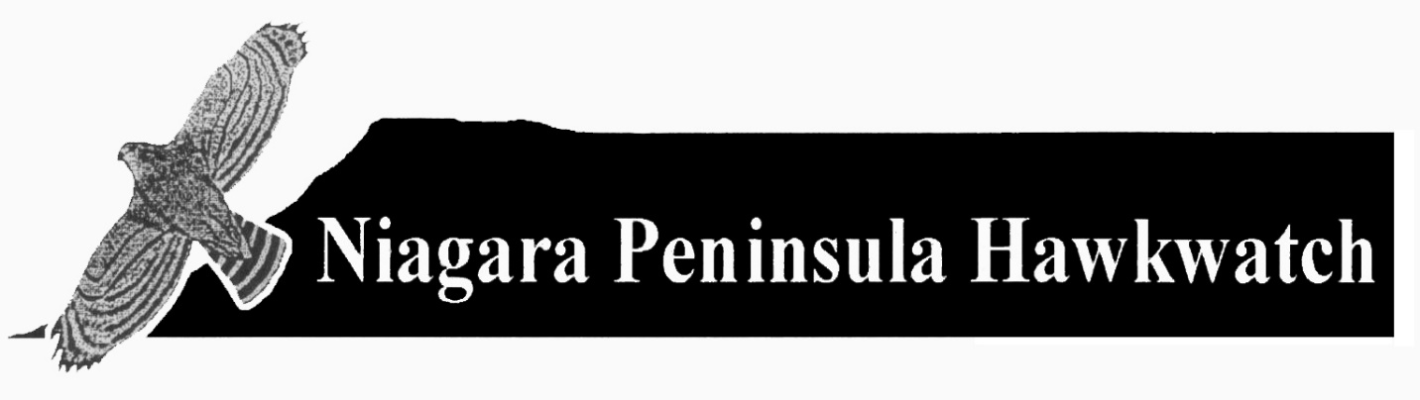**NIAGARA PENINSULA HAWKWATCH**

**Submission to Ontario Ministry of Natural Resources and Forestry**

**Regarding Proposed Changes in Regulations for Falconry**

*Submitted on behalf of the Niagara Peninsula Hawkwatch by:*

*Keith Dieroff, President. (Hamilton,* [*kdieroff@yahoo.ca*](mailto:kdieroff@yahoo.ca)*)*

*Robert Spaul, Research and Reporting (Toronto,* [*spaul.robert@gmail.com*](mailto:spaul.robert@gmail.com)*)*

*Alexander Darling, Count Coordinator and Newsletter Editor (Flamborough,* [*darlina@cogeco.ca*](mailto:darlina@cogeco.ca)*)*

This public comment is made by the Niagara Peninsula Hawkwatch (NPH), which has collected spring raptor migration data from 1975 to 2019. These data have been collected in a standardized manner since 1980, and are the longest continuous dataset on the number of raptors entering Ontario each spring. Derby Hill Bird Observatory in New York State, near the eastern end of Lake Ontario, is the only other comparable count providing similar data on raptors entering Ontario. The most robust set of data on birds exiting Ontario in the fall are those collected at Holiday Beach Migration Observatory (1975-present). Other sites count migrating raptors in Ontario in the fall, but the Holiday Beach counts are clearly of birds leaving the province. Data from hawkwatch sites serve as an *index* of population trends, instead of giving actual population estimates (Farmer et al. 2007). All data from these sites are publicly available and can be found on Hawkcount (www.hakwcount.org), which is maintained by the Hawk Migration Association of North America.

The aims of the Niagara Peninsula Hawkwatch are to:

* Promote the enjoyment of hawkwatching.
* Educate the public about diurnal raptors and their migration.
* Conduct systematic counts of raptors migrating through the Niagara Peninsula and into Ontario.
* Work for the preservation of raptors in Ontario.

**Summary of position, in response to the “Proposal to expand the live capture of wild raptors**

**(birds of prey) by licensed falconers” (ERO 019-1806), proposed by the Ontario Ministry of**

**Natural Resources and Forestry (MNRF), hereafter “The proposal”.**

The position of the Niagara Peninsula Hawkwatch may be summarized as follows:

* The proposal does not provide adequately detailed population information, and there is little evidence that the best available data have been used to formulate the policy.
* It appears that the annual take of raptors could increase significantly from the 25 allocated by the current lottery; based on data given by the Ontario Hawk Club (Gelynase 2019) the take could at least double. In the absence of a quota, the annual take could increase well beyond that if more falconers elect to take a bird annually, as authorized by the proposal, or if falconry simply becomes more popular.
* The data collected by NPH, and corroborated by other raptor migration monitoring sites, suggest that there has been a significant decline in some raptor populations (Figures 1-4). We are particularly opposed to the proposal to add Northern Goshawks (*Accipiter gentilis*) to the list of allowable wild-take raptors, as count data shows population declines for the species (Figure 1). Additionally, we are opposed to the proposed increased wild-take of Sharp-shinned Hawks (*Accipiter striatus*), as their populations are declining substantially across North America, and in Ontario specifically, as is supported by our own data (Figure 2).

In light of these concerns, we ask that:

* There be no change in current provisions until more justification, based on the best available and most transparent data, is presented in a full and open manner to permit more informed public discussion.
* The proposal to add Northern Goshawks to the list of permitted wild-take falconry species be abandoned, or at least deferred, until adequate population assessments and analyses be conducted and presented.
* The proposal to increase the quota of wild-take Sharp-shinned Hawks be abandoned, or at least deferred, until adequate population assessments and analyses be conducted and presented.

**Discussion**

The Niagara Peninsula Hawkwatch (NPH) is confident in the well-intentioned spirit of falconers in Ontario, and has great respect for the tradition of falconry, and its historic role in raptor conservation. However, NPH opposes the proposed changes to the regulation of falconry, the expanded quotas for Sharp-shinned Hawks, and the addition of Northern Goshawks to the list of allowable wild-take species. In the following discussion, we first address the lack of detail and supporting evidence in the proposal, secondly the increased annual take standards, thirdly we provide data that are relevant to the decision, and lastly we propose a series of questions and concerns that further demonstrate the lack of forethought in this policy proposal.

Our opposition rests primarily in the current assessment of populations used to justify the proposed expansion as a sustainable take. While there is evidence demonstrating that modest falconry take, conducted by well-trained, well-regulated, and properly permitted falconers, has a negligible effect on sustainable and well-monitored raptor populations (Millsap and Allen 2006), it must be clarified that not all species are affected equally. Further, past studies emphasize that falconry in already declining populations may serve to exacerbate declines in those species (Millsap and Allen 2006). In this proposal the Ontario MNRF has not demonstrated its understanding of these concepts, as species specific population statuses are not presented or discussed in the proposal. We acknowledge that falconry take quotas have not been adjusted in some time, and that some modification to current quotas, and the lottery system, may be warranted. However, such changes should be done with the **best available science** at hand, and justified in the context of that science, in a transparent manner. As it currently stands, the MNRF has not done its due diligence in providing adequate justification for increased take permits of any of the four currently authorized native falconry species, or the addition of Northern Goshawks, nor has the best available science been presented to the citizens of Ontario transparently. There are many details missing in this proposal, some of which may be put to rest with greater transparency, and others which we feel warrant further research and monitoring, before a sound determination can be made.

**Lack of detail and supporting evidence in the proposal**

The MNRF’s proposal was posted on August 24, 2020 and consists of eight paragraphs. Supporting materials were not posted in a readily-available form, nor were the full rationale or *any* supporting data given for the proposal. We were able to find a document entitled “Wild Raptors in Ontario Falconry: Review and Policy Options”, jointly published on April 5, 2019 by the Ontario Hawking Club (OHC) and the Ontario Federation of Anglers and Hunters (Ontario Hawking Club, 2019), which are jointly representing the falconry community in Ontario. It appears this document is the impetus for the proposal, but that document oversimplifies raptor management issues and presents numerous dubious statistics. Our position is that the MNRF should be evaluating such submissions with more scrutiny, and presenting its findings and rationale for a change in policy more transparently.

**Proposed increase in annual take**

Currently, licensed falconers can participate in a lottery and 25 are selected, each of whom may take one bird. Under the proposed regulation the lottery system would be dissolved, and every licensed falconer would be permitted to take one bird annually. The proposal states that there are approximately 200 licensed falconers Ontario. The OHC document states:

“From 2012 to 2018, 367 applications were received and 175 permits issued, an application success rate of 48%. Based on available data the overall capture or “fill rate” was 59%.”

Based on these data from seven years, if the “fill rate” remains the same, the potential take would at least double; we note that not all authorizations result in a bird being taken. What cannot be measured, however, is whether the absence of a quota and lottery system will encourage more falconers to take a bird each year? We oppose a system like this in which there is no controlled maximum, because it may take further policy changes to course correct in the future.

**Data relevant to the proposal and population trends among raptors**

This public comment letter serves as our organization’s only opportunity to raise these questions and concerns, and to present our own data on the species concerned, collected under standardized protocols and reporting for 40 (1980-2019) uninterrupted spring migration seasons. These data serve as one example of a legacy raptor migration dataset available to inform decisions about raptor management in the province. Comparably long-running and robust data exists for fall migrant raptors leaving Ontario, namely from Holiday Beach Migration Observatory (1975-present). Additionally, standardized migration data are collected annually at other sites, such as Hawk Cliff, High Park and Cranberry Marsh Hawkwatch sites. While these organizations generally do not conduct peer-reviewed analyses of their count data, they do publish annual reports that are publicly available, and share their data with the Hawk Migration Association of North America (HMANA). HMANA conducts peer-reviewed analyses, called the “Raptor Population Index”, using data from numerous migration monitoring sites, from across the entire North American range of most raptor species (Crewe et al. 2016). These analyses are conducted in concert with Birds Canada and other international conservation partners, and are regarded as some of the most robust assessments of historic raptor populations and trends available. These data, supported by our own, show declines in Northern Goshawk populations migrating in and out of Ontario each spring and fall. Additionally, there is significant evidence showing declining Sharp-shinned Hawks, across their northeastern range, and at Ontario count sites.

Data on four species from NPH spring monitoring are shown in Figures 1 – 4, presenting data collected under standardized methodologies (1980-2019). Figure 1 shows a most concerning drop in our counts for Northern Goshawks, so that in recent years we are lucky to observe a few in an entire season (March 1 - May 15). For many years Sharp-shinned Hawks were one of the most numerous raptors counted, and they still are, but Figure 2 shows a steep decline in the species. Recent trends in both Cooper’s Hawks and Red-tailed Hawks are shown in Figures 3 and 4, respectively; while each show recent declines, the trends are less conclusive. We have not shown data for Merlin, because the numbers counted each year are too small for rigorous analysis. Our data clearly show decrease counts over a forty-year time period, and this is most dramatic for Northern Goshawks, though more statistically rigorous for Sharp-shinned Hawks. Data from the other sites named above show similar declines, or non-significant trends, for Northern Goshawks and Sharp-shinned Hawks (Crewe et al. 2016).

**Additional questions and concerns about the proposal**

In addition to the primary concern of declining populations, a number of gaps appear in the regulatory framework of the proposal, that if left unaddressed, serve only to exacerbate these population declines through inadequately regulated falconry take.

1) The proposal states that the Northern Goshawk population statuses in each district will be considered, but does not describe or compare district-specific populations, nor show how monitoring will be conducted after the species is added to the wild-take list. These would be standard considerations for hunting take of any game species, so there is no reason it should be any different for falconry take of birds of prey. How will populations be monitored to determine *if* impacts to local populations are occurring from the proposed take?

While the Ontario Hawking Club cites its own monitoring efforts, from 6 Ontario counties, as justification for falconry take of Northern Goshawks (Gelynase 2019), the methods used to monitor these populations are not disclosed, nor are proper summaries of collected data available. Additionally, these 6 counties represent a very small portion of the range of Northern Goshawks in the province, and there is no evidence showing that populations in each MNRF district are able to withstand take. Understanding the sensitive nature of Northern Goshawk nest locations and nest monitoring efforts, discretion is warranted on the part of the MNRF, but simply stating that Ontario Northern Goshawk populations are “secure” without any scientific evidence is unnaceptable. How has the Ontario Northern Goshawk population been determined to be “secure”? When was the most recent provincial population estimate assessed and why isn’t it presented? What are the protocols and methodology for determining a secure status? What peer-reviewed studies is the MNRF using to support this proposal? Are Breeding Bird Survey data being consulted? Is the Ontario Breeding Bird Atlas being consulted? Are Christmas Bird Count data being consulted? Are eBird data being considered? At the provincial level, none of this is presented at in the proposal, therefore the public can’t really determine whether the best available science has been consulted adequately. In our understanding, none of those datasets suggest stable Northern Goshawk populations, and most show declines.

Given the true breeding population status in some counties (likely less than a few breeding territories), can local populations really tolerate **any** take in these areas? Perhaps the most comprehensive information about breeding Northern Goshawk populations in Ontario results from two Ontario Breeding Bird Atlases, conducted twenty years apart (Cadman 2007). That work reports that:

“Across the province, there was a non-significant decline of 40% in the probability of observation for the Northern Goshawk between atlases, with a significant 54% decline in the Northern Shield.” (p178)

“Based on partial migration data from goshawk invasion years, however, the northern Ontario population was estimated by Duncan and Kirk (1994) at fewer than 5,000 pairs, while Kirk (1995) suggested that the population in central and southern Ontario is possibly in the range 500 – 2,000 pairs.” (p 179)

It should be noted that this commentary is based on surveys conducted over twenty years ago, and migration data shows the populations have continued to decline since then. Preparations are underway for the Third Ontario Breeding Bird Atlas, beginning in 2021.

2) When the anthropogenic effects of nest site disturbance are considered for a notoriously high stress species like the Northern Goshawk, this proposal is particularly concerning. Such disturbance can cause abandonment or reproductive failure for an entire breeding season, and should be considered as a detriment to the conservation of populations. Are falconers allowed to trap on the broader breeding territory, or are they limited to taking nestlings directly from the nest? If so, what is the allowable distance from nests to do so, and what is the allowable season for this to occur? How many nestlings can a falconer take in a single visit, and are multiple falconers allowed to take nestlings from the same nest? Removing a regulated quota system makes avoiding such situations more difficult. If falconers are taking nestlings directly from the nest, is there any guidance to suggest which nestling to take? If there is only one nestling in a nest, are falconers allowed to take that nestling? There is a difference between taking a small nestling, which has a lower chance of natural survival, and taking the largest nestling, which has a higher chance of natural survival. These two scenarios have different implications for populations, and hence should be addressed in the regulations and in this proposal.

**Conclusion**

In light of these collective concerns, the NPH feels strongly that the MNRF must do more to show that they have thoroughly considered all of the potential effects of increased falconry on Northern Goshawks, Sharp-shinned Hawks, Cooper’s Hawks, Merlins, and Red-tailed Hawks, because at the moment they are all being treated with an inadequate evaluation of the data.

Given that the sustainability of raptor populations is in the public trust, sustaining them for all of the citizens of Ontario is paramount to the responsibility of the MNRF. As it currently stands, this policy is crafted only to the benefit of Ontario falconers, and not for the benefit of all who reside in the province. Given that these proposed policy changes are not justified by current and rigorous monitoring programs, we feel it is the MNRF’s responsibility to either publicly present the data and appropriate analyses used to make this decision, or their responsibility to recognize gaps in the current knowledge, and fund and conduct studies to properly assess them, *before* modifications are made to the current policy.

**References**

Cadman, M.D., D.A. Sutherland, G.G. Beck, D. Lepage, and A.R. Couturier (eds). Atlas of Breeding Birds of Ontario, 2001 – 2005. 2007. Bird Studies Canada, Environment Canada, Ontario Field Ornithologists, Ontario Ministry of Natural Resources, and Ontario Nature. Toronto, xxii + 706 pp.

Crewe, T., P. Taylor, D. Lepage, L. Goodrich, J. Brown, and J. Sodergren. 2016. The Raptor Population Index, 2016 Analysis Methods and Trend Results. Available at <http://rpi-project.org/2016/>

Farmer, C.J., D.J. Hussell, and D. Mizrahi. 2007. Detecting population trends in migratory birds of prey. The Auk. 124(3):1047-1062. <https://doi.org/10.1093/auk/124.3.1047>.

Gelynase, M., Ontario Hawking Club, and Ontario Federation of Anglers and Hunters. 2019. Wild raptors in Ontario Falconry: Review and Policy options. Available at

Millsap, B. A. and G. T. Allen. 2006. Effects of falconry harvest on wild raptor populations in the U.S.:

theoretical considerations and likely consequences. Wildlife Society Bulletin. 34:1392-1400.

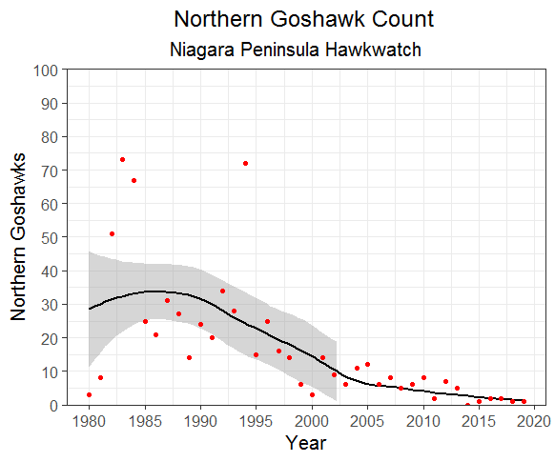

**Figure 1. Northern Goshawk count data from NPH, 1980-2019. Grey shows 95% confidence intervals.**

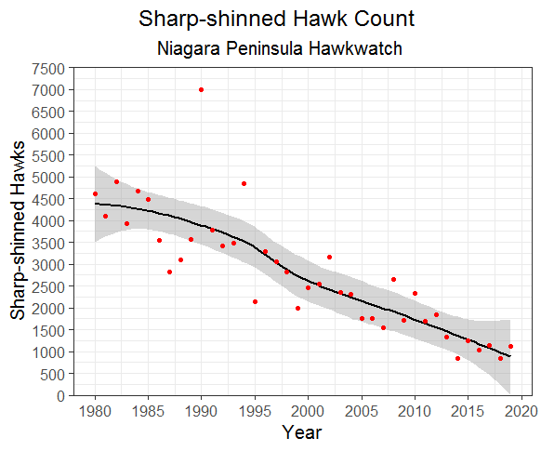

**Figure 2. Sharp-shinned Hawk count data from NPH, 1980-2019. Grey shows 95% confidence intervals.**

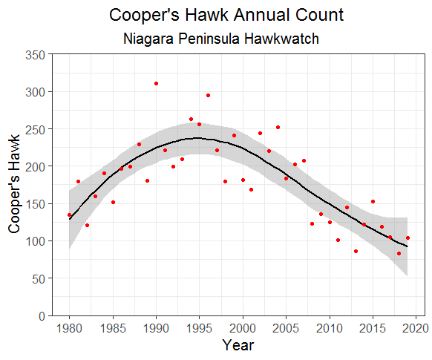

**Figure 3. Cooper’s Hawk count data from NPH, 1980-2019. Grey shows 95% confidence intervals.**

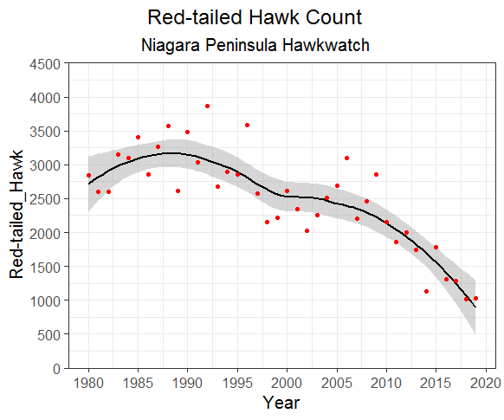

**Figure 4. Red-tailed Hawk count data from NPH, 1980-2019. Grey shows 95% confidence intervals.**