Public Response to No.0058-C82HUU Certificate of Property Use (CPU) ERO #019-4788
Reference CPU 0058-C82HUU Risk assessment number 2141-ATYS6K
With all due respect for the excellent work the MOECP does and as much as we would like to support the completion of this subdivision, we are hesitant with the approval of draft CPU unless we are assured that the mitigation recommendations/site restoration plan are followed and supervised by competent persons.
The property is proposed to be developed into residential from industrial which are considered brown lands. The Risk Assessment completed for the Owner found Contaminants of Concern (CoCs) in the soil requiring Risk Management Measures (RMM’s). The RMM’s are capping the soil with at least 1m of clean soil to approve the application of the CPU.
4.2.1 CAPPING (“Cap”) The Property shall be covered by a physical barrier where there is less than 1.0 m of Unimpacted Soils between the final developed grade and Impacted Soils. In addition, soils located below the final grade and extending to a depth of at least 1.5 m shall have a pH of between 5 and 9.
4.2.1.1 Fill Cap - A clean soil cap shall consist of a minimum of 1.0 m of Unimpacted Soils, all as illustrated in Figure H-1: “Risk Management Measures – Barriers to Site Soils”
Our concerns:
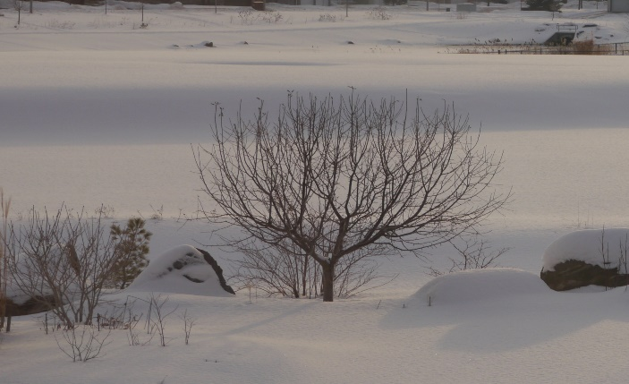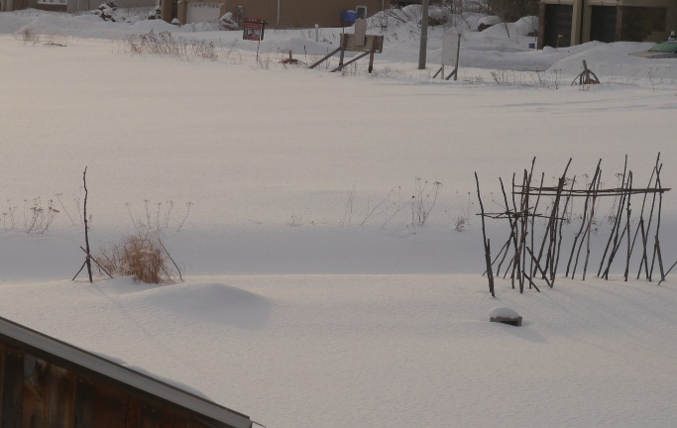
As illustrated, the off-site receptors are already below the grade of the Proposed CPU property. These RMM’s will raise the existing grades even more creating off-site nuisance effects causing adverse drainage effects. This has already happened.
November 2021 soil capping was completed to resolve the pH issue on the site. A swale behind lots 10, 11 and 12 allows water flow away from and toward the storm water retention pond. During the work a pipe with filter cloth was placed at the bottom of the swale 15 cm above it’s soil grade then soil was hilled up in front of the storm water retention pond. As a result of this blockage, rainfall caused water in the swale to rise, back flow and flood onto lot 10 towards lots 11 and 12.
The Town’s Engineering Department was called. The filter cloth was removed, it took hours to pump out the swale. We fear it’s just a matter of time before this happens again.
Furthermore, all vegetation was scraped off the existing lots leaving off site existing homes exposed to wind blown soil and sand. If this is just the beginning it has diminished our confidence in what is to follow and does not instill confidence in the Risk Management measures for off site receptors regarding nuisance effects.

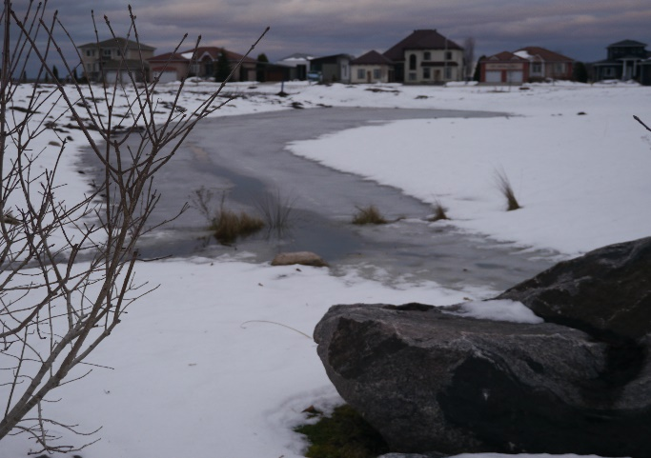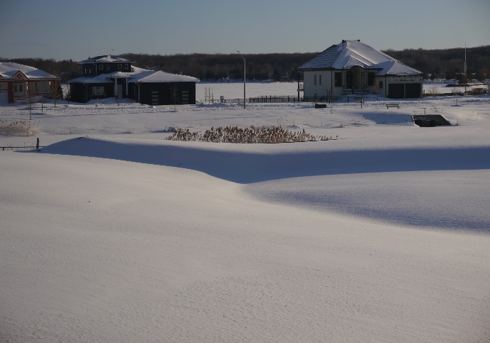

Most off-site receptors back yards are already at least one meter or more below the grade of the proposed remediation area. The required additional 1.0m of soil required to cap impacted soils will increase the grades to a level that may create flooding of adjacent off-site receptors. To avoid flooding their back yards it would be better to remove impacted soils then cap with clean fill to avoid increasing soil grades. Furthermore, the addition of 1.0m of capping on the existing swales behind lots 10,11. 12 and 17 will raise current grade levels higher than the adjacent back yards. Please refer to pictures above.
It is difficult to believe that the 12.23-hectare (30.23-acre) former historic town waste disposal site that is directly across from Taylor Dr lots 1 to 12 of the proposed site, has been confirmed through previous investigations as not having adversely affected this area with CoCs; especially since it is a large hill and there are many underground streams. Refer to SSRA Page 752 #18 section 4.4.6 of the testing report. Direction of ground water flow is to the east towards these lots. Also, note the response in red, especially the words “text that was left in erroneously”. It is difficult to trust erroneous, especially when off site receptors and future residential owners will have to deal with errors.
In the SSRA report there is some ambiguity regarding the waste disposal site. On pages 313, 617 and 844 (Description of Site Land Use) no info on the waste disposal site is mentioned. This becomes a suspected waste disposal site on page 913. Only page 211 lists the waste disposal site as a potential contaminating activity.
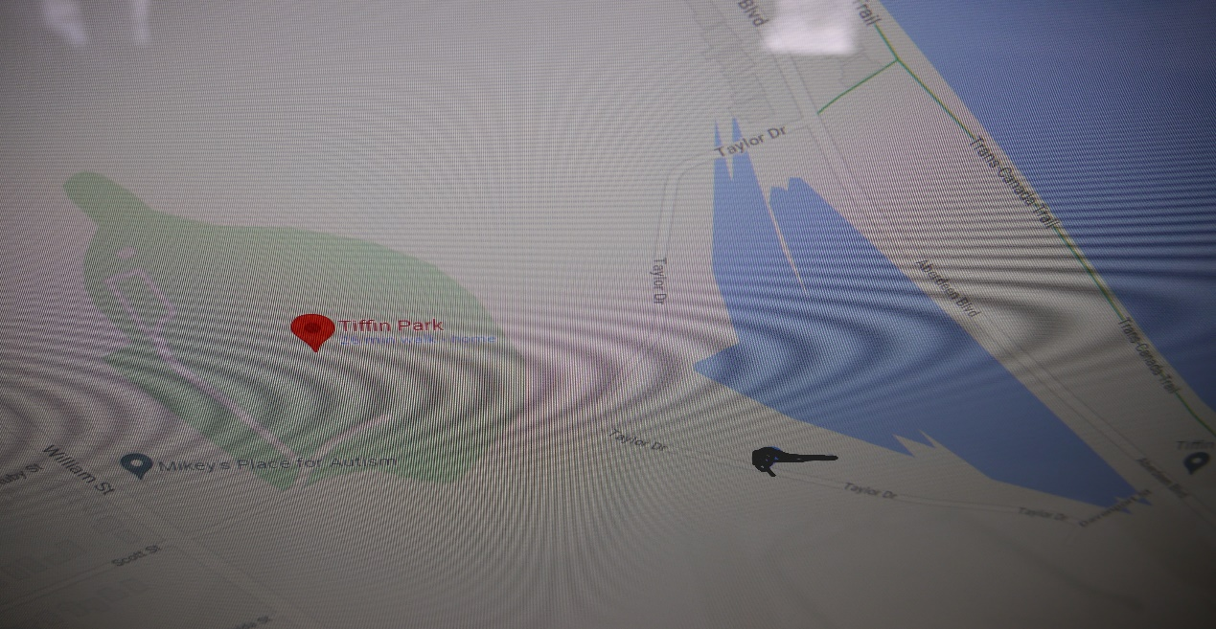
Pg 313, 617 and 844 in the SSRA states:
The property was first developed in 1911 as the Tiffin terminal roundhouse and adjacent rail corridor, which was operated by the Grand Trunk Railway and later by Canadian National Railway. By 1973, the roundhouse appears to have been demolished; however, the rail corridor was in operation until the early 1990s when the Site was decommissioned. The Site is currently vacant with no aboveground or belowground infrastructure remaining.
You can imagine how massive concrete foundations must be to bear the weight of locomotives. These still exist close to the soil surface between Lots 14 to 16 of potential future residences. Yet they are not considered underground structures by the ministry.
The ministry is aware that there may be historic remnants of infrastructure located at the Site in relation to the former property uses, including old foundations, underground wiring, piping, etc., as is typical of any historic demolished industrial property. However, the intent of the description of the Site is to make the ministry aware of any active infrastructure that may be at the site such as sanitary sewers, storm sewers, existing buildings which may have an impact on the assumptions/results of the risk assessment.
It is difficult to understand how these belowground massive foundations, although inactive infrastructure, will not impact constructing house foundations and future homeowners especially if they want to install a back yard garden feature. Although this may be a municipal concern when issuing a building permit, it should also be considered when approving the CPU in the conversion of industrial to residential.

The statements below do not instill trust. page 325 of CPU
The environmental monitoring described herein was conducted in accordance with the terms of reference for this project, agreed upon by soil testing company and Developer. The reported information is believed to provide a reasonable representation of the general environmental conditions at the Site; however, the data was collected at discrete locations and conditions may vary at other locations.
This report has been prepared for the use of the Developer. The soil testing company accepts no liability for claims arising from the use of this report, or from actions taken or decisions made as a result of this report, by parties other than the developer. pg325
In closing, we would like to commend the timely insightful response we received from the Ministry’s contact person.
If or when this CPU is approved we encourage on-going inspections by the MOECP to ensure that the required remedial actions (site restoration plan) are followed without shortcuts furthermore, that the Town ensure that the final grading of the lots and swales do not cause a negative impact on the off site receptors currently on lots 10,11,12 and 18. We trust that the development activities on the site will be remediated/risk managed according to the requirements of the Draft CPU No.0058-C82HUU. We feel it is crucial that the site be given the utmost due diligence and supervision by both the Ministry and the Town.
My daughter asked why I put myself through the agony of reading and responding to these reports because often public responses are ignored or ineffective? I said nothing changes if our concerns are not voiced. So, respectfully take these concerns into consideration.
It all comes down to trust. We hope we can trust this process.

