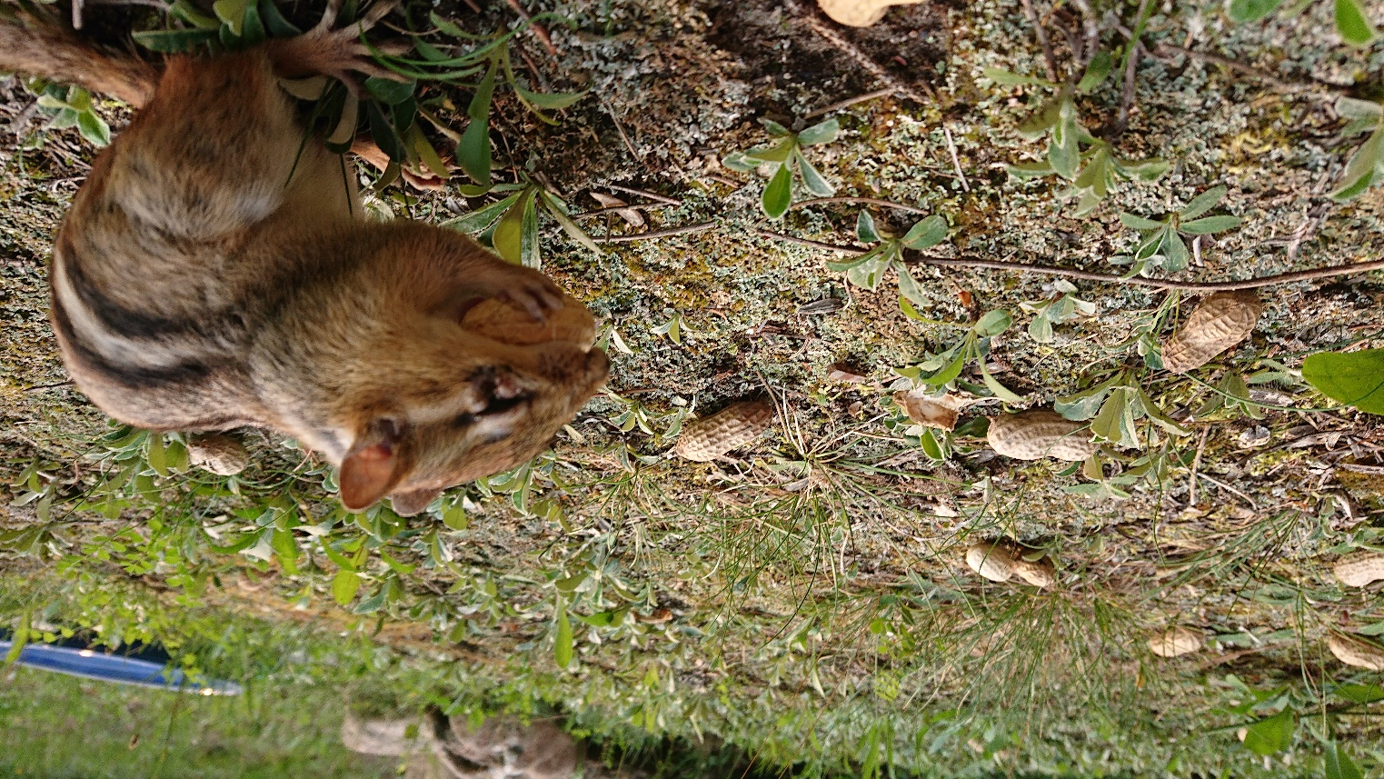
July 2021- after permethrin treatment, den in spray zone

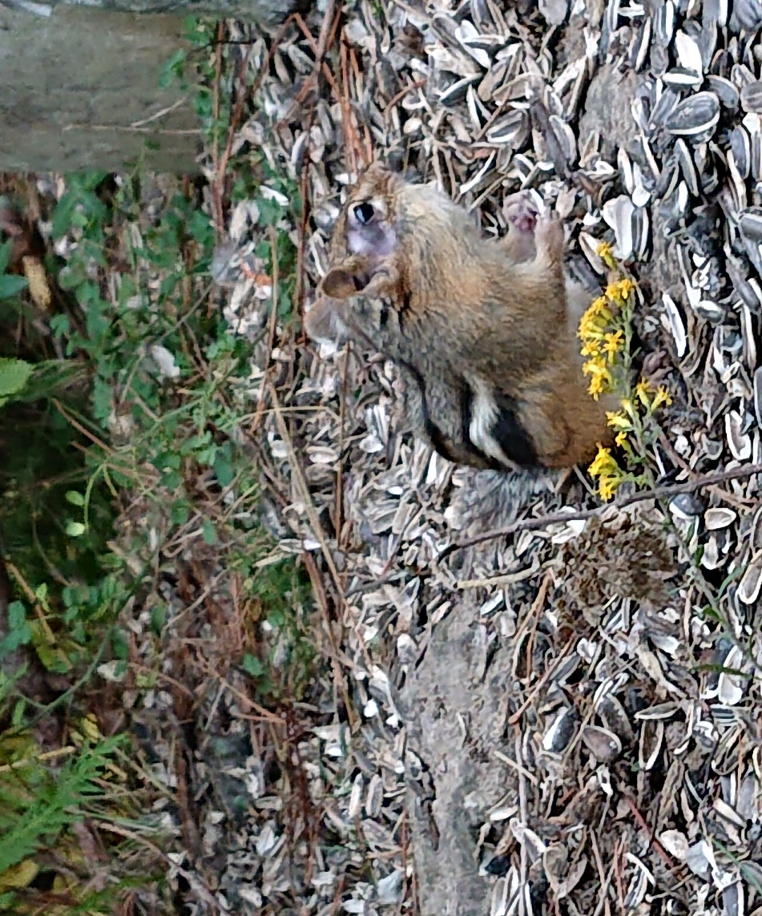
fall 2020
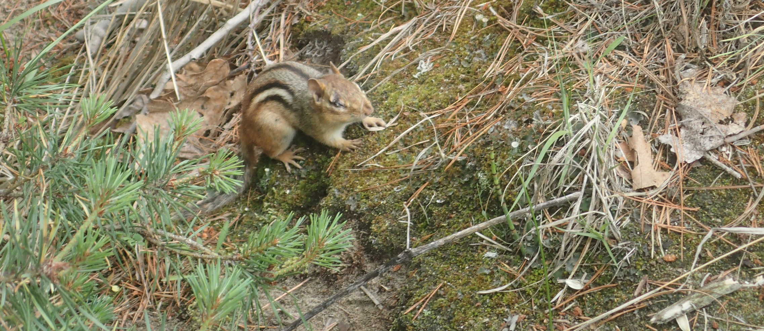
days after permethrin spraying, it kept blinking and squinting, obvious irritation. Den in sprayed zone.

Spring 2021 – same chipmunk based on den site. Eye disorder progressed to blindness in that eye, the eye has turned a pearly colour. Was more susceptible to predation and didn’t live much longer.

