Development of a Clean Energy Credit Registry (ERO number 019-5816)
Response of the Canadian Renewable Energy Association (CanREA)

September 15, 2022

Thank you for the opportunity to provide comment on the proposal to introduce a clean energy credit (CEC) registry and associated processes to support the creation, recognition, tracking and retirement of voluntarily purchased CECs within the province. The Canadian Renewable Energy Association (CanREA) strongly supports maximizing choice for Ontario consumers on electricity supply decisions that align with their personal values or corporate/institutional Environmental, Social and Governance objectives. The proposed CEC framework could be a positive step toward enabling greater consumer choice in this respect.
First and foremost, CanREA would note that Ontario has achieved great success in the decarbonization of its electricity grid over the last two decades. In 2021, Ontario’s electricity supply was 90% non-emitting while continuing to supply customers with reliable service to grow our economy. Looking forward, however, the IESO is projecting a five-fold increase in electricity sector emissions over the coming two decades under current policies, reaching 18.2 million tonnes of CO2-equivalent emissions by 2042 due to increased reliance on natural gas generation. This will undo all progress in electricity sector decarbonization achieved since 2010. In short, the province’s clean electricity advantage over our peer jurisdictions is at risk, and the loss of Ontario’s clean electricity advantage will adversely impact the province’s ability to compete for jobs and investment from a global business community with increasingly stringent Net Zero commitments.

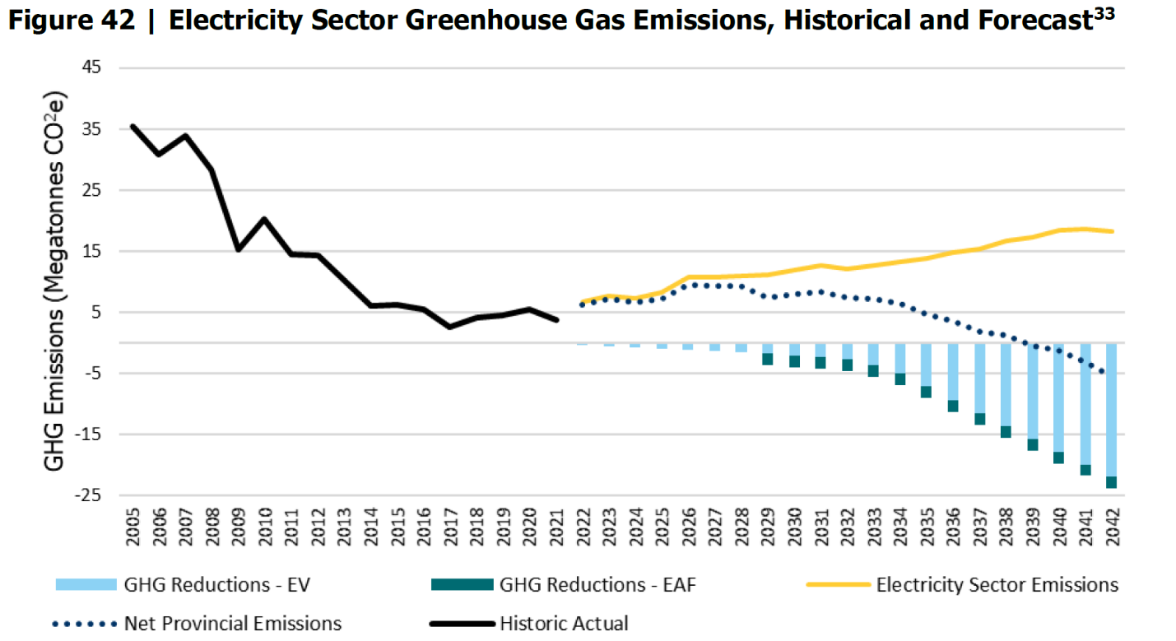
Source: 2021 Annual Planning Outlook, IESO, page 74
In 2019, the RE100 global coalition of businesses committed to 100% renewable electricity reported that their more than 260 members collectively sourced over 120 TWh of renewable electricity either through unbundled purchases of environmental attributes (EAs) (42%), contracts with electricity suppliers (30%), bilateral Power Purchase Agreements (PPAs) (26%), or on-site generation (principally rooftop solar) (2.5%). The Ministry has already taken an important step forward in enabling on-site renewable energy sourcing through the recent amendments to the Net Metering Regulation (O.Reg 541) to enable third-party ownership of net metered generation. Going forward, there could and should be a role for both renewable energy contracts with energy suppliers as well as bilateral PPAs in the Ontario context. Surging global demand for clean electricity represents a valuable opportunity to drive new private sector investment into the province’s generation capacity to help deliver the non-emitting generation capacity the province urgently needs. The Ministry should seize this opportunity to engage directly with prospective buyers of renewable electricity to invest in Ontario’s clean technology economy at this pivotal moment for the province’s electricity system.
In terms of best practice for clean energy sourcing for corporate buyers, RE100 reports that renewable energy PPAs are increasingly seen as the benchmark to meet for corporate renewable energy buyers seeking to maximize the impact of their investment, whereas unbundled EAs are declining in popularity. CanREA concurs with this view and would emphasize that while the establishment of a CEC registry would be a positive step forward, there are many Ontario consumers for whom unbundled EAs are inadequate for meeting their clean electricity requirements, and for whom only bundled PPAs for both energy and environmental attributes would be the only acceptable option.
Regarding the changes to legislative and regulatory powers to support specific design elements, and overall administration of the registry that the Ministry of Energy has proposed, CanREA offers the following recommendations:

Role of the IESO
If the IESO is provided with the authority to establish or designate a CEC registry for Ontario, it would be highly inappropriate for the IESO to also act as a market participant, and to make available the CECs it holds. Independence and transparency of the tracking systems is essential for the integrity of the attribute market. CanREA recommends that the Ministry designate a third party to manage the CEC registry.
EAs from assets currently under contract accrue to the IESO. CanREA would support exploring an arrangement whereby the IESO would offer asset owners the right of first refusal to purchase EAs from their own operating assets, either to meet internal corporate compliance obligations, or to retail at their own discretion. Going forward, EAs from new assets including those sourced through the ongoing and future IESO RFP processes should remain the property of the individual asset owners.

Monetization of Environmental Attributes from regulated assets and IESO procurement contracts
The sale of CECs from existing operating clean and renewable energy assets in Ontario to interested Ontario customers would enable those entities to verify their clean electricity consumption. For some companies, this is an essential requirement for new investment decisions and is therefore one option for Ontario to remain competitive among its peers for those jobs and investment dollars. However, transferring CECs to specific buyers has important implications for remaining customers, in that the emissions profile of the grid for companies and households not purchasing CECs would rise even higher than the current forecast. This could potentially run counter to those customers’ preferences if they are committed to non-emitting resources or have Environmental, Social, and Governance (ESG) targets of their own. For this reason, CanREA recommends that any CEC program be capped so as to maintain the broader Ontario market at 85% non-emitting. In the absence of new non-emitting generation, the proportion of non-emitting generation in Ontario’s supply mix forecasted to decline from approximately 90% to 74% over the coming two decades, EAs from non-emitting generation will become increasingly scarce over the coming years if the Ontario grid is to remain at an acceptable level of emissions intensity for ratepayers who do not opt to purchase CECs.

Another important consideration in terms of scoping the size of the program is to ensure the proper balance of supply and demand: Restricting the volume of unbundled EAs made available for purchase would help to ensure a higher price per EA, while maintaining a low-emission-intensity grid for non-EA-purchasing Ontario consumers.

Tracking and classification of EAs
The CEC registry system envisioned would enable all Ontario-based non-emitting generation facilities to enroll and certify their generation, track ownership of the credit, and retire the CEC so that it can not be claimed by any other party. While most prospective customers would prefer CECs from new-build wind and solar PV facilities rather than from existing renewables or other non-emitting generation, there may be companies that have no such requirements. To ensure fair valuation of different classifications of EAs in terms of different buyers’ specific requirements, CanREA recommends clear classification of EAs by:
  - Resource/fuel Type (e.g. wind, solar, etc.)
  - Serial ID o Generator ID o Generator Name
  - Generator Location o Vintage (date of generation)
  - Issuance Date

Management of revenues

Noting that since January 1, 2021, the Comprehensive Electricity Plan has shifted Global Adjustment (GA) costs for wind, solar and bioenergy under IESO contract from the rate base to the provincial tax base, CanREA would recommend that, in the interests of simplicity, the Minister direct any revenues from CECs created by regulated assets owned by Ontario Power Generation Inc. or assets currently under contract to the IESO to be returned directly to Ontario ratepayers. Going forward, the Ministry should affirm that CECs should remain with the owner of any new generation assets commissioned in Ontario to be used at their discretion, as an incentive to draw investment in urgently-needed new non-emitting generation resources in the province.

Summary of Recommendations
In summary, CanREA respectfully submits the following recommendations to the government in consideration of the creation of a CEC program:
- The registry be managed by an independent third party rather than by the IESO.
- Any CEC program should maintain a minimum threshold on remaining emissions of 85% total generation outside the CEC program.
- The program should be classified into CEC categories based on the fuel type and/or vintage to allow greater customer choice and set appropriate price signals.
- The CEC program should be complementary to other customer options to achieve ESG goals, including corporate PPAs

Contact:

Nicholas Gall
Ontario Director,
Canadian Renewable Energy Association (CanREA)
ngall@renewablesassociation.ca

RE100 2021 Impact Report, Available from: https://www.there100.org/sites/re100/files/2022-01/RE100%202021%20Annual%20Disclosure%20Report.pdf

