Dear Madam/Sir.

In comment to PTTW, ERO number 019-5959, Ministry Reference number 8727-CHUMTY.

Firstly, are these drilled wells or simply sumps? It is confusing, in the Proposal Summary it states that the proposal is to take water from one well but in the Proposal Details it takes water from eight wells.

Secondly, there is no mention of the sump in the southwest corner of the south quarry, which is part of the MNRF EBR registry number 013-1976, which is the proposed new sump that will serve the existing quarry as well as the new quarry that is twice the size of the existing quarry.

If in fact these are drilled wells, then the amount of water they are proposing to take is enormous and that will have an effect of draining my well as well as all the homeowners in the surrounding area which is of unknown size, it could be 500 meters or it could be kilometers.

In a hydrogeological study done in 1991 by GORRELL Consulting, on which the 2012 study by Morrison Herschfield was based. The current application in turn relies on the MH study for background information. The Gorrell study indicates that the property would have to truck in water to sustain operation. The quarry has expanded greatly since 1991 and their water requirements have increased as well. Assuming the drilled wells were insufficient to sustain quarry operation in1991, how does the quarry now obtain sufficient water? The application does not explain this. What has changed since then? We have been told by people in the area that their wells have gone dry in past summers.

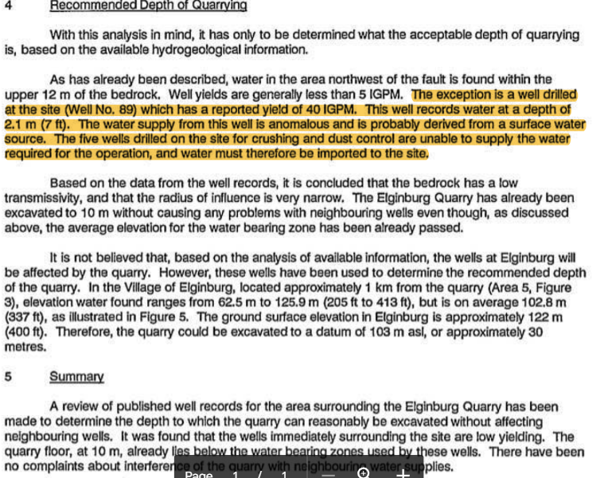

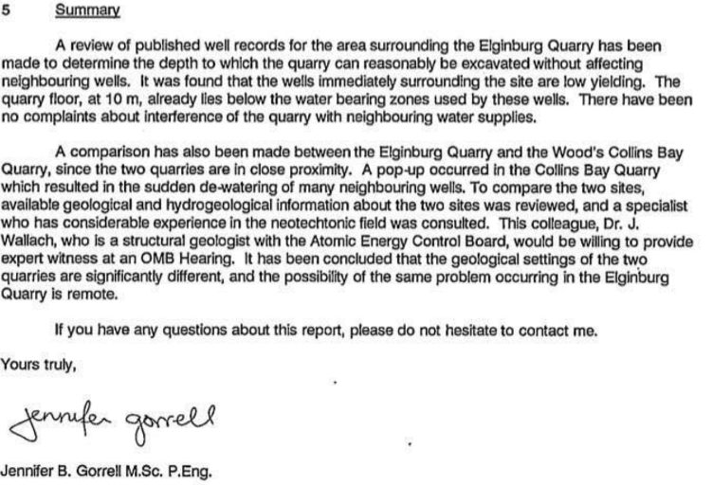

What of the CBM Concrete plant on site, it does not have a PTTW for itself, how is its water use regulated and where does its water come from? And what of its discharge from Ready-mix production and truck washouts, which is potentially laden with toxic chemicals? Does it end up in the discharge of the quarry and eventually into Lake Ontario?

The volumes reported by the company vary greatly in volume and discharge i.e. 2017 sewage ECA.

The tables that the owners supplied do not match.

Who verifies that the data and information submitted by the applicant/quarry owner is correct? It is our understanding that the Ministry of the Environment is short staffed and does not verify the data/information under the PTTW. Their role is limited to confirming that the annual reports are submitted, not to confirm the accuracy of the data itself.

Lastly, with the continuing changes in our climate getting worse each year would it not be prudent to limit the length of time between applications to something less than five years. Ten years is a long time to have a permit in place especially with the earth warming up at an alarming rate, which puts a strain on our wells?