Comment on Bill 23 (submitted by Peter Kirby LL.B., non-practicing, November 23, 2022)

Summary Bill 23 continues Ontario’s neglect of the environment and assault on democracy.
The Bill would prevent cities like Kenora from creating bylaws to enforce climate protection measures, including energy efficiency standards for housing, and eliminate the ability of citizens to challenge zoning amendments.
Despite some good direction in Ontario’s 2018 environmental plan, the Ontario appears to have completely abandoned any pretext of having a credible climate protection plan (see Appendix A).
Bill 23, (Schedule 9, section 11, and Schedule 1, section 2), would remove what little powers local authorities—those closest to the citizens—have to protect land, water, and air and to take responsibility for reducing GHG emissions.
Other provisions of Bill 23 would erode the authority of Conservation Authorities and permit government to override heritage designations.
Bill 23 needs to be scrapped.

The View From Kenora In its former Strategic Plan (2015), the City of Kenora, my home, boasted of being a good environmental steward:
2-11 The City will lead and promote environmental sustainability through conservation, smart building design and, where feasible, retro-fit practices for city-owned facilities
. . . . . . . . . . . . . . . . . . . . . . . . . . . . . . . . . . . . . . . . . . . . . . . . . . . . . . . . . . . . . . . . . . . . . .
2-13 The City will continue to advance our leadership position as "Stewards of the Lake" and "Stewards of the Land" by safeguarding water quality on our lakes and optimizing waste diversion practices that reduce future landfill requirements
This mandate has been overtaken by a Sustainability Plan (2022) It provides the following objectives for the City:
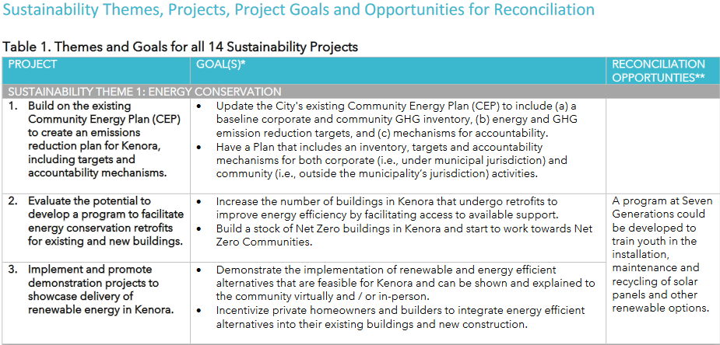
In light of Bill 23, I have little confidence that Kenora will be able to implement the Plan’s goals: emission targets for housing development or net-zero standards for housing developments (including retrofits).

Another Assault on Democracy I note that in developing its Sustainability Plan (and new Strategic Plan) the citizens of Kenora were encouraged to participate in a consultation process. I chose to do so in respect to both Plans.
Now the Ford government is saying that it can ignore my voice and the voice of all those consulted and ignore the will of the people of Kenora as expressed by its City Council when it adopted the Sustainability Plan!

Other Assaults on Democracy I endorse the submission of the Canadian Environmental Law Association, dated November 15, 2022, with respect to the proposed elimination of citizen challenges to planning decisions (p. 4) and its critique of the erosion of the authority of Conservation Authorities—which, much like municipalities, embody knowledge and wisdom of citizens close to the land and decision-making in respect to it (p. 3).
It also appears that the proponents of Bill 23 want to provide a notwithstanding override in the hands of the Minister and Lieutenant-Governor in respect to heritage designation decisions—another brick in the wall shutting out local voices!
According the information provided Bill 23 would permit “the Minister of Citizenship and Multiculturalism to review, confirm and revise, the determination of cultural heritage value or interest by a ministry or prescribed public body respecting a provincial heritage property” and that the “Lieutenant Governor in Council (LGIC) may, by order, provide that the Crown in right of Ontario or a ministry or prescribed public body is not required to comply with some or all” of standards and guidelines “in respect of a particular property.”

Conclusion I am, as is evident from this brief, very unhappy with the Ford government’s feckless record on climate change, environmental protection generally and the protection of democratic processes, rights, and freedoms.
Though there may be some administrative amendments in Bill 23 which have merit, key provisions of the Bill, for reasons stated, should be withdrawn.

Peter Kirby

Appendix A — Carbon Plan? What Carbon Plan?
The key question the Committee must ask the proponents of Bill 23 is:
where is the carbon budget for the additional GHG emissions which will result from eliminating municipal powers to prevent, mitigate and adapt to climate change through imposing energy efficiency standards on housing developments?
Below is an excerpt from a submission made by me and two others to Ontario about the twinning of the Trans-Canada highway between Kenora and the Manitoba border; our comments, however, can be applied to any undertaking, including housing, by any level of government or any builder.

What Is the Carbon Cost? — There Is No Budget
Investing in new fossil fuels infrastructure is moral and economic madness
UN Secretary-General, António Gutteres

We are dismayed that there is no carbon budget for the twinning project to determine how twinning fits into Ontario’s plan to cut (GHG) emissions 30% by 2020—part of Preserving and Protecting our Environment for Future Generations: A Made-in-Ontario Environment Plan (2018) (Plan).
The Plan contains, says Ontario’s Auditor General (AG), no “clear responsibilities and requirements for ministries to track and report on climate change measures” and, nothing embedding addressing climate change “into all government decision making to ensure progress in reducing provincial emissions.”
In addition, though the AG recommended that spending proposals submitted by Ministers to the Treasury Board outline the effect on, inter alia, the environment and climate change, by the fall of 2021, the Board had only gotten as far as making “plans” to create business case templates which would identify GHG and environmental impacts.
. . . . . . . . . . . . . . . . . . . . . . . . . . . . . . . . . . . . . . . . . . . . . . . . . . . . . . . . . . . . . . . . . . . . . . . .
The AG’s trenchant critique of the Plan, and of progress in implementing the Plan is worth stating:
2019 — Our audit found that the Ministry’s projected emissions forecast, and the estimated emissions reductions for all eight areas, are not yet supported by sound evidence. As a result, our analysis found that the initiatives in the Plan have the potential to achieve between 6.3 Mt and 13.0 Mt of the 17.6 Mt emission-reduction target.
2021 — As of October 2021, the Ministry’s internal estimates indicate that “commit-ted policies,” which are discussed in our follow-up on Recommendation 13, could reduce emissions from the business-as-usual forecast by 3.4 Mt in 2030 based on a $50/tonne carbon price. This results in a 13.5 Mt-gap in meeting the updated 2030 target.
We also refer to the AG’s reminder that Ontario’s plan—though published in 2018—remains in draft form, and appears to be continually “updated”, including Ontario’s recent abandonment of emissions reduction through the uptake of Electric Vehicles—an uptake which accounted for 15 per cent of the reductions forecast in the Plan.

Ministry of the Environment, Conservation and Parks, A Made-in-Ontario Environment Plan, https://www.ontario.ca/page/made-in-ontario-environment-plan. Ontario appears to have dropped “Preserving and Protecting our Environment for Future Generations”, from the title of the original 2018 Plan, (https://prod-environmental-registry.s3.amazonaws.com/2018-11/EnvironmentPlan.pdf).
City of Kenora, Strategic Plan: 2016 to 2020 https://www.kenora.ca/en/build-invest/resources/Documents/kenora-vision-2020-strategic-plan-2016-update.pdf.
City of Kenora, Sustainability Action Plan 2022 – 2031, https://www.kenora.ca/en/your-government/resources/Documents/Sustainability%20Action%20Plan.pdf.
City of Kenora, Charting Our Course 2022 to 2027, https://www.kenora.ca/en/your-government/resources/Documents/Strategic%20Plan.pdf.
Environmental Registry of Ontario, Proposal Summary, https://ero.ontario.ca/notice/019-6196
Peter Kirby, Doug Orchard, and Henry Rasmussen, Against the Current, letter submitted to Ontario’s Ministry of Transportation and Ministry of Environment, Conservation and Parks (July 05, 2022).
United Nations, “Secretary-General Warns of Climate Emergency”, Press Release with remarks from Secretary-General, António Gutteres, April 04, 2022, https://www.un.org/press/en/2022/sgsm21228.doc.htm.
Supra note 1. As noted, Ontario appears to have dropped “Preserving and Protecting our Environment for Future Generations,” language contained in the title of the original 2018 Plan.
Auditor General, “Follow-up on Value-for-Money Audit: Climate Change: Ontario’s Plan to Reduce Greenhouse Gas Emissions (Follow-Up on VFM,” Annual Report, Vol. 2, c. 3 2019) 2021, at p. 14, https://www.auditor. on.ca/en/content/annualreports/arreports/en21/ENV_FU_ClimateChange_en21.pdf; “Climate Change: Ontario’s Plan to Reduce Greenhouse Gas Emissions, Annual Report 2019 Vol. 2 c. 3, at p. 12. https://www.auditor.on.ca/en/ content/annualreports/arreports/en19/v2_300en19.pdf. Auditor General, Value-for-Money Audit: Climate Change,
Ibid., at pp. 14 to 15.
Ibid., Auditor General, Annual Report, “Ontario’s Plan to Reduce Greenhouse Gas Emissions,” supra note 10 at p. 122.
Ibid., Auditor General, Value-for-Money at p 7.
Mike Crawley, “Ontario quietly revises its plan for hitting climate change targets”, CBC, April 17, 2022, (referencing Ontario Emissions Scenario as of March 25, 2022, https://prod-environmental-registry.s3.amazonaws.com/2022-04/Ontario%20Emissions%20Scenario%20as%20of%20March%2025_1.pdf); https://www.cbc.ca/news/canada/toronto/ontario-climate-change-carbon-emissions-2030-targets-1.6419671 A Made-in-Ontario Environment Plan, supra note 38.

