1. Map that shows underground infrastructure (water, sewers and Bell lines) within the vicinity of - and in - the Mass Transit Station Area (MTSA) of the Grimsby GO Train Station. This is in further support of our request to merge an additional parcel of land for Greenbelt Removal as noted in ERO # 019-6216 Comment Id 66031.

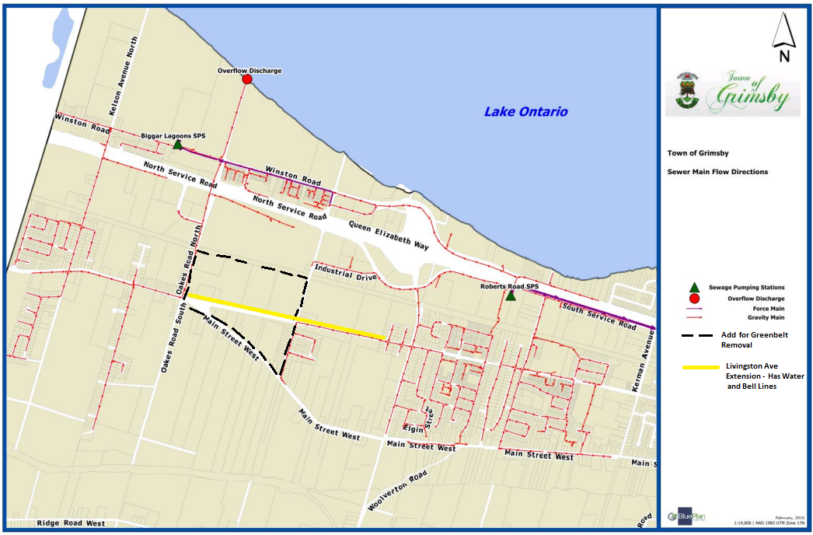

This map shows where the Province, Region and Grimsby have made investment over the years that is being wasted by not removing the parcel from the Greenbelt for inclusion in the urban boundary.  These lands have sanitary sewers that abut to the outlined parcel on the east and west sides as well as having water and Bell lines that actually pass-through underground at Main St. W., the Livingston Avenue Extension and along the train tracks. All within the MTSA of the Grimsby GO Train Station.

1. Also, in Comment Id 66031 the attached MS-Word document requires a correction. On page 5 of the Final-PresentationMPP.doc There was a mistake presented in the number of hectares reported that the Town of Grimsby wanted to swap in their 2016 proposal. On Page 5 it indicated the request was to swap out 100 hectares of Greenbelt land for 150 hectares not in Greenbelt. In fact, the request was to swap out 250 hectares of Greenbelt land for 923 hectares not in Greenbelt. A swap of land at almost a 4 to 1 to increase the Greenbelt size and where *"The provincial decision was to add the 923-hectare parcel into the Greenbelt but to deny removing any lands what-so-ever from within the Greenbelt in Grimsby. The result was Grimsby now has virtually no land available outside the Greenbelt to develop as a result of this decision."*The map below shows the requested land swap:

