**Geographic Areas with Gaps in EV Charging Infrastructure - Rural**

Infrastructure gaps for electric vehicles depend on the type of infrastructure that is being installed, and the size of the gap depends heavily on the demographics of the area. For example, the infrastructure gaps for rural and remote communities will be far different than the infrastructure gaps for urban residents given their different commuting patterns and extreme use cases.

Many other countries and regions have set designated distances between chargers on all major highways. New Zealand has a plan to expand their DC Fast Charging stations to their entire highway network, with fast chargers being deployed every 75 kms[1]. The United States launched the National Electric Vehicle Infrastructure (NEVI) Formula Program, in which 35 states submitted plans to install charging stations according to the proposed standards. This included:

* EV Chargers must be deployed within one mile of an interstate exit or highway intersection, and within 50 miles of the next charging location
* A minimum of four CCS ports capable of charging at 150 kW simultaneously must be installed at each location

New Mexico, Vermont, and Massachusetts (amongst others) have developed their own deployment plans that take into consideration their specific geographies and demographics[2][3]. Massachusetts has added additional provisions that look to add new charging infrastructure to areas with the most unserved demand, with higher priority being given to zones with high percentages of environmental justice communities. Many of these locations that are selected are identified in zones rather than in exact locations, helping to improve range confidence amongst local residents.

With rural residents, they typically live a greater distance away from employment, grocery stores, pharmacies, health care, primary and secondary education, child care, public transit, libraries, and neighbourhood parks[4]. The City of Ottawa’s Equity and Inclusion Lens identifies additional considerations for rural residents, especially as it relates to distances and transportation[5]. The greater distances and more miles travelled by rural residents make electric vehicles an appealing option for their lower operating costs and reduced maintenance, while the additional benefits of lower emissions can have an outsized impact on reducing Ontario’s emissions.

Given that many rural residents could install a home charging station because they typically own their own home and have off-street parking, faster charging stations (50 kW or above) along highways and in prominent locations are likely to be the priority amongst rural residents. The other benefit of these faster charging stations is the potential for increased economic development in rural areas, as those with electric vehicles traveling along these corridors would plan stops accordingly. Since drivers will be parked for an extended period of time while recharging, local businesses that cater to the needs of drivers (stores, restaurants, parks, etc.) can draw regional travelers to these rural communities. These types of stations need high levels of utilization to ensure a positive business case, and locating these stations in attractive areas for travelers can increase the utilization over time.

A series of maps below shows where there is currently fast charging equipment installed, and helps visualize where there is no infrastructure available to enable long-distance travel in an EV in Ontario. These areas typically show up in Northern Ontario, in and around Algonquin Park, stretches of Highway 7 between Carleton Place and Peterborough, and South West/South East Ontario. Given the colder temperatures in winter and the negative effect that cold weather has on the range of electric vehicles, including more charging stations at each site, along with charging sites spaced closer together will be an important part of Ontario’s EV Charger deployment. Many of the charging stations that have been deployed to date feature only two Level 3 chargers per site, which will lead to congestion as the number of EVs on the road in Ontario grows over time.

Some examples of distances between charging stations that are beyond the distances required for US Federal Funding include:

* Orangeville to Parry Sound: 110 kms
* Owen Sound to Tobermory: 106 kms
* Petawawa to Mattawa: 134 kms
* Peterborough to Huntsville: 189 kms
* Carleton Place to Norwood: 190 kms
* Sault St Marie to Wawa: 227 kms
* Hearst to Geraldton: 247 kms
* Renfrew to Huntsville: 253 kms
* Timmins to Hearst: 268 kms
* Sudbury to Timmins: 294 kms
* Timmins to Wawa: 330 kms

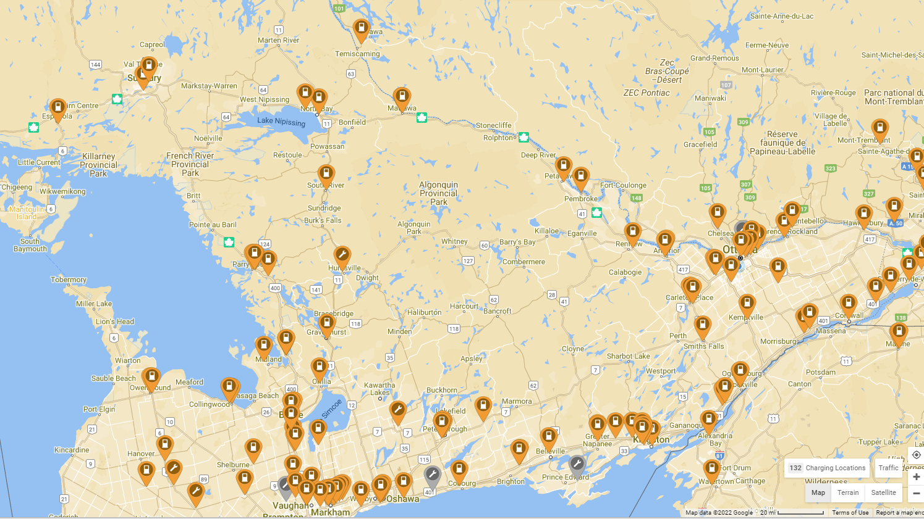

Figure 1 Central/Eastern Ontario Map of Level 3 Charging Stations

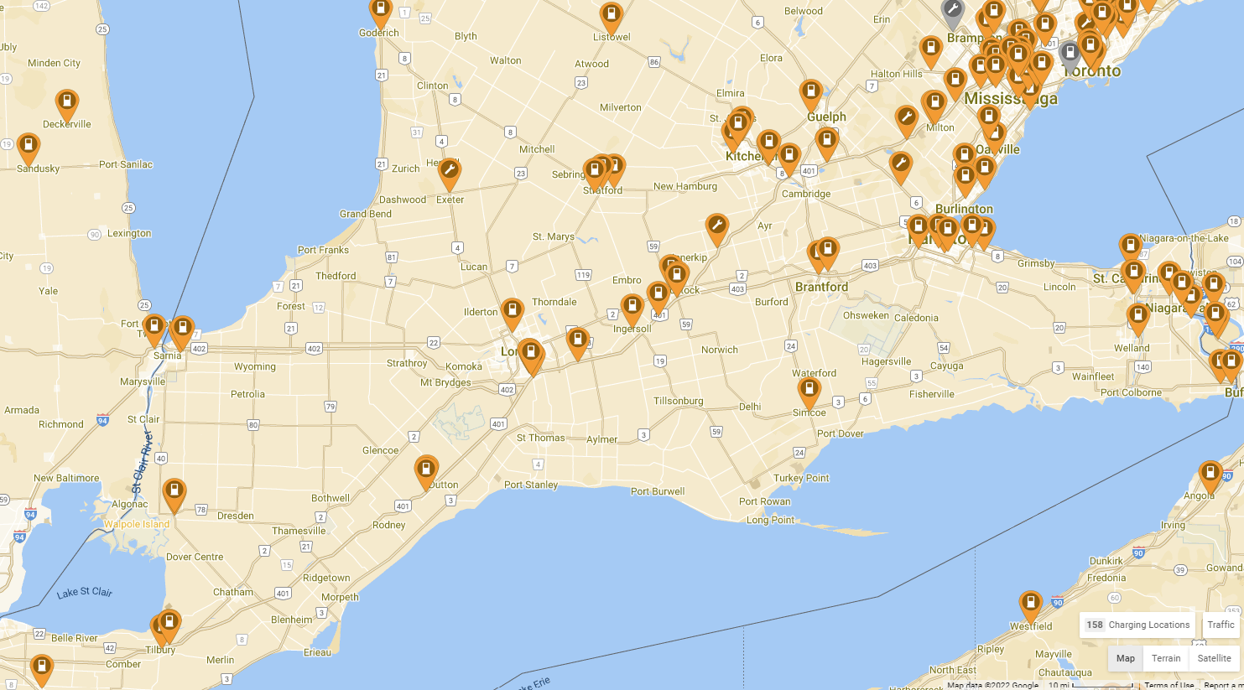

Figure 2 Southern Ontario Map of Level 3 Charging Stations

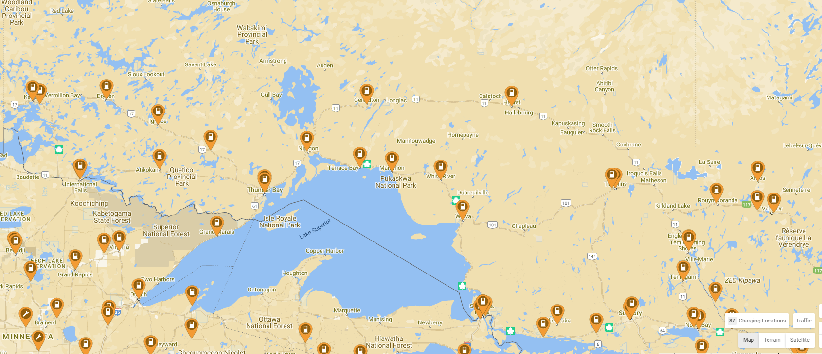

Figure 3 Northern Ontario Level 3 Charging Stations

Slower charging stations (6.6 kW to 9.2 kW) may benefit communities where visitors spend an extended period. This could include regional attractions, recreation facilities like hockey arenas and sporting venues, or provincial parks. With the longer time spent charging, EV charging installations can be installed at a lower cost per charger leading to a greater number of overall chargers being deployed. As these stations do not rely on a large number of visitors per day to generate a positive business case, plans for deploying these stations could focus on the needs of both the local and surrounding community (e.g. regional hockey tournaments, country fairs, holiday parades, festivals, etc.).

**Geographic Areas with Gaps in EV Charging Infrastructure – Urban**

Today’s uptake of electric vehicles has mostly occurred in urban areas with homeowners that own their own home, have off-street parking, and who have an above average household income and level of education[6]. Today’s EV drivers mostly charge overnight at home where charging is most convenient, with smaller percentages of people choosing to use public fast chargers. Meanwhile, the number one barrier to EV adoption remains the non-availability of a home charging station[7].

For prospective urban EV drivers, the provision of public charging stations of multiple charging speeds is a determining factor to support their purchase of an EV. One study of where the greatest need for charging infrastructure is for home charging would represent 93% of the total number of charging ports, while less than 1% of all charging ports will be Public Level 2 and Level 3[8]. Also of note is that costs can be reduced significantly if there is between 6-10 DCFC ports as part of charging site compared to only 2 ports per site, while the deployment of 350 kW chargers instead of 150 kW also leads to significant savings over the long term.

It is generally tougher to produce a business case for Level 3 charging, as the utilization for these stations usually lags behind the installation for a number of years. The study identified that Level 3 stations built today would be built to accommodate the anticipated EV demand five years from the date of construction[9]. Most EV Charging deployment strategies focus on the ideal location of EV charging stations for urban and suburban DCFC hubs. These sites are primarily found “to be near amenities where people tend to spend 15-45 minutes. This includes grocery stores, shopping centers, and food services[10].” Other benefits of EV charging hubs is that they can be located in areas where people naturally gather which can assist with visibility of charging infrastructure[11].

**Challenges with Increasing EV Charging Installations**

The biggest challenges that Municipalities face with installing charging infrastructure is related to accessing funds or financing to support the installation of charging infrastructure. Given the high price for the infrastructure along with the growing demand for EV charging infrastructure, the sooner projects can be funded the sooner municipalities could start to see increased electric vehicle adoption across all demographics. The City of Ottawa is expecting to see around 22% of the vehicles in Ottawa being powered by electricity by 2030, and public electric vehicle charging is an important part of the plan to support increased levels of adoption.

Additionally, the Province of Ontario could provide financial rebates to customers purchasing electric vehicles (similar to leading provinces such as BC and Quebec where battery electric vehicles represent 11.5% and 7.7% of all new vehicle sales respectively)[12]. These rebates have been shown to drive a higher level of EV adoption compared to provinces that do not offer rebates, and has led to additional interest from the private sector to install charging equipment. Ontario has 360 sites that host Level 3 charging equipment with a total of 1,062 charging ports, while Quebec hosts 506 sites with 1,136 Level 3 charging ports[13]. Given that Quebec has nearly half the population of Ontario, this significantly higher number of charging stations correlates to the greater level of investment in EV adoption in Quebec and the higher number of electric vehicles on Quebec’s roads as a result. Stronger levels of EV adoption leads to stronger business cases for charging station operators, as there is a bigger pool of potential users both in the current state as well as future stages of electric vehicle adoption.

In addition to purchase incentives on vehicles, there is an identified need to support retrofits to existing multi-unit residential buildings given the higher capital investment required to provide 100% EV-Ready infrastructure compared to an installation in a private residence. Installations of chargers in multi-unit residential buildings on an incremental basis is expensive, and comprehensive/100% EV-Ready retrofits face challenges related to the significant upfront cost and lack of understanding amongst the different parties to how such a retrofit can be implemented[14]. Meanwhile, is both more convenient and less costly to install charging stations at individual homes than installing charging infrastructure in the public realm. The installation of EV-ready infrastructure for new construction in high rise apartments can be achieved at roughly $2,000 per parking stall, with townhome and mid-rise installations being even cheaper[15]. Retrofits of existing parking spaces in multi-unit residential buildings are generally 2-3 times more costly than new construction, but will be cheaper than installing public level 2 charging infrastructure in areas that may not present a strong current business case for public EV charging. Ensuring that new buildings feature EV charging at the time of construction can also help alleviate the financial barrier to EV charging installation in people’s homes, and updates to the Ontario Building Code to make this a requirement for new construction would be an important part of increasing EV adoption in Ontario.

Another challenge that limits the ability to install public charging is the result of a large number of electric utilities across Ontario that limit the coordination and delivery of a network of charging stations. In British Columbia and Quebec which have the highest levels of EV adoption in Canada, large utilities like Hydro Quebec and BC Hydro lead the delivery of charging infrastructure across the entire province. This centralized delivery agent also benefits from better data collection and analysis, and aligning strategic plans with funding requests, all of which aid in the delivery of evidence-based infrastructure installations. As an example of the deployments that these large utilities have carried out, Hydro Quebec launched a partnership with FLO to install 7,500 public level 2 charging stations between 2022 and 2026 on top of the nearly 700 Level 3 stations that have been deployed to date[16]. Meanwhile, BC Hydro “builds and maintains essential infrastructure to provide electricity to communities across BC … BC Hydro will also provide an alternative to home charging for EV drivers living in homes where there are barriers to charging.[17]” BC Hydro has been working since 2013 to install EV chargers to keep up with the demand for charging across the province, and now operates more than 100 chargers at more than 72 charging sites, and has deployed them in proximity to one another to ensure that even vehicles with the shortest driving range could travel throughout the province (40 to 80 km spacing).

The combination of purchase incentives to increase electric vehicle adoption, which produces a larger user base to utilize public EV charging infrastructure, and generates a stronger business case for EV Charging Infrastructure operators to install more public charging infrastructure. Meanwhile the most convenient place to charge an electric vehicle remains at people’s homes, and local utility companies have the strongest connection to their customers to design programs that meet their needs for home charging. Specific programs developed by utilities could be used to understand where demand for future public charging will be greatest, where grid constraints need to be addressed to support EV adoption at home, and finance the installation of cost effective infrastructure for those that need it the most. This should focus on condos, apartments, and rental properties where residents currently face the greatest barriers (both financial and bureaucratic) towards adoption electric vehicles. Finally, given that design and implementation of EV-ready charging infrastructure is significantly cheaper than retrofitting buildings to feature EV charging after the building has been constructed, updates to the Ontario Building Code to require the allocation of 100% EV-Ready infrastructure at time of construction.

1. Enabling a nationwide network of public EV charging infrastructure: <https://www.nzta.govt.nz/planning-and-investment/planning/transport-planning/planning-for-electric-vehicles/national-guidance-for-public-electric-vehicle-charging-infrastructure/enabling-a-nationwide-network-of-public-charging-infrastructure/>
2. New Mexico EV Infrastructure Deployment Plan, Page 54 <https://realfilef260a66b364d453e91ff9b3fedd494dc.s3.amazonaws.com/b2753484-135f-43d6-bb71-129f3084dc2b?AWSAccessKeyId=AKIAJBKPT2UF7EZ6B7YA&Expires=1666033600&Signature=FYdZoPXZ3j57unzxktjbhdHKIgg%3D&response-content-disposition=inline%3B%20filename%3D%22NM%20NEVI%20Plan%20Final%20-%20revised%207-14-2022.pdf%22&response-content-type=application%2Fpdf>
3. National Electric Vehicle Infrastructure (NEVI) Program – Deployment Plan for Massachusetts: <https://www.mass.gov/doc/massdot-nevi-plan/download>
4. Measuring Proximity to services and amenities: An experimental set of indicators for neighbourhoods and localities https://www150.statcan.gc.ca/n1/pub/18-001-x/18-001-x2020001-eng.htm
5. Equity and Inclusion Lens Snapshot – Rural Residents https://documents.ottawa.ca/sites/documents/files/rural_ss_en.pdf
6. Fuels Institute EV Consumer Behaviour: https://www.fuelsinstitute.org/Research/Reports/EV-Consumer-Behavior/EV-Consumer-Behavior-Report.pdf
7. Ibid.
8. US Passenger Vehicle Electrification Infrastructure Assessment : https://www.fuelsinstitute.org/Research/Reports/EV-Consumer-Behavior/EV-Consumer-Behavior-Report.pdf
9. US Passenger Vehicle Electrification Infrastructure Assessment : https://www.fuelsinstitute.org/Research/Reports/EV-Consumer-Behavior/EV-Consumer-Behavior-Report.pdf
10. Municipal Electric Vehicle Strategy – Halifax: <https://cdn.halifax.ca/sites/default/files/documents/city-hall/standing-committees/211104essc1211.pdf>
11. City of Victoria Electric Vehicle Strategy: <https://pub-victoria.escribemeetings.com/filestream.ashx?DocumentId=67855>
12. New Motor Vehicle Registrations: Quarterly data visualization tool: <https://www150.statcan.gc.ca/n1/pub/71-607-x/71-607-x2021019-eng.htm>
13. Electric Charging and Alternative Fuelling Stations Locator: <https://www.nrcan.gc.ca/energy-efficiency/transportation-alternative-fuels/electric-charging-alternative-fuelling-stationslocator-map/20487#/analyze?country=CA&region=CA-QC&fuel=ELEC&ev_levels=dc_fast>
14. Greater Toronto Hamilton Area EV Ready Residential Parking New Construction Costing Study: <https://cleanairpartnership.org/cac/wp-content/uploads/2021/08/GTHA-EV-Ready-Residential-New-Construction-Costing-Study-AES-Engineering-2021.07.27.pdf>
15. Greater Toronto Hamilton Area EV Ready Residential Parking New Construction Costing Study: https://cleanairpartnership.org/cac/wp-content/uploads/2021/10/2-21-050-GTHA-EV-Ready-Costing-Study-2021.10.14.pdf
16. FLO, Hydro-Quebec to install thousands of new EV chargers, FLO’s biggest order to date: <https://www.newswire.ca/news-releases/flo-hydro-quebec-to-install-thousands-of-new-ev-chargers-flo-s-biggest-order-to-date-827361081.html>
17. BC Hydro’s Electric Vehicle Infrastructure Five-Year Plan – 2025: <https://www.bchydro.com/content/dam/BCHydro/customer-portal/documents/power-smart/electric-vehicles/ev-5-year-ev-fast-charging-network-deployment-plan.pdf>