December 5, 2022

Hon. Steve Clark  
Minister of Municipal Affairs and Housing  
17th Floor, 777 Bay Street  
Toronto, ON M7A 2J3

Dear Minister Clark,

**RE: ERO 019-5937 – City of Toronto Official Plan Amendment (Protected Major Transit Station Areas)**

More Neighbours Toronto is a volunteer-only organization of housing advocates that believe in building more homes of all kinds for those who dream of building their lives in Toronto. We advocate for reforms to increase the ability to build more homes in every neighbourhood. We are a big-tent organization with members across the political spectrum who are nevertheless committed to counterbalancing the anti-housing agenda that dominates Toronto's politics, and has increased costs and environmental burden for a new generation of aspiring residents.

**More Neighbours Toronto believes that Toronto is squandering an opportunity to make progress on the housing crisis with its approach to these 57 Protected Major Transit Station Areas (PMTSAs)**. Both the City and the province have voiced support for transit-oriented development, with mixed income communities supported by inclusionary zoning. However, the land use policies in the delineated areas do not address the urgency of the housing crisis. While we appreciate the complexity of Toronto’s Official Plan, and these 23 PMTSAs are difficult to evaluate in isolation, the delays and promises of more to come in future studies are disappointing. We hope that the Minister views this as an opportunity to increase density and simplify the planning process around these PMTSAs.

Relying on the government’s Housing Affordability Task Force recommendations, More Neighbours Toronto has three suggestions.

1. **Greatly increase density permissions within the delineated areas to encourage affordable unit construction.**

The City of Toronto considers the MTSA delineation to be a conformity exercise where they simply have to demonstrate that they meet the minimum provincial standard or provide an explanation for not meeting it. Zoning changes and secondary plans promise more density later. There is no later for those forced to leave jobs or friends in Toronto due to increasing rents or [the desire to start a family](https://mikepmoffatt.medium.com/ontarians-on-the-move-2022-edition-b8ec483014d). They have to go where their lives can be lived and cannot wait on yet another local area study. The city and province are losing out. This can be seen by the province of [Alberta’s recent efforts to recruit Torontonians](https://toronto.citynews.ca/2022/09/26/alberta-is-calling-campaign-posters-toronto-subway-station/) using housing costs as a major driver.

PMTSAs are meant to have minimum development density defined by Floor Space Index (FSI). However, Toronto has not changed its exclusionary Neighbourhood land use designation in the 57 PMTSAs and instead lowered minimum FSIs to as low as 0.3 in these areas. When it was pointed out that this density could be met by large single family dwellings, the City added an option to consider a 3-unit minimum, but there was no reflection on why poor land use near transit is protected by planning in the first place. In some areas, the City said they had to lower the minimum so that it would not exceed the maximum, which suggests a significant problem with the maximums – not with the PMTSA standard.

One example for the Lawrence West station PTMSA is shown below. Most of the land area has only a minimum and maximum density of 0.5 FSI, with many areas as low as 0.3 FSI. This is an insult to all of the taxpayers who contribute capital and operating funds to public transit but are excluded from living nearby by municipal policies**. The province should greatly expand mixed use area land use designations and greatly increase density permissions in PMTSAs.**

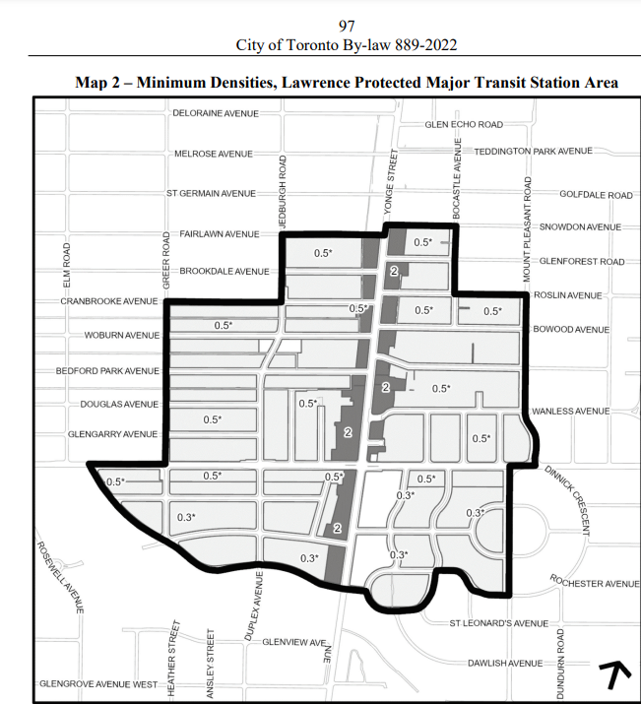

In addition, the province should consider the effects on inclusionary zoning (IZ). Toronto’s IZ policy deviated from many successful policies in other cities by eschewing density bonuses and offsets, relying instead on changes in land value to absorb the cost of new, affordable units. The resulting low affordability percentages disappointed some but aimed to prevent significant reductions in housing completions. With rising interest rates, supply problems and construction costs, this may no longer be feasible; [many projects](https://www.theglobeandmail.com/business/article-developers-expected-to-delay-10000-units-as-slowdown-hits-condo/) - particularly those with affordable units - [risk being cancelled](https://www.ontarioconstructionnews.com/ottawa-council-to-vote-on-spending-plan-for-affordable-housing/).

Furthermore, IZ does not apply to projects with fewer than 100 units, meaning that areas with low FSI will not have to include affordable homes. The most underused land in PMTSAs is in Neighbourhoods, where prices are kept artificially low by exclusionary zoning policies. The province must encourage better land use and zoning in these areas, which will have the added benefit of increasing affordable housing via IZ.

1. **Use this as an opportunity to reduce red tape**

One way to increase affordability is to mandate it for selected units, as described for IZ above. This is a good way to create mixed-income communities, giving people from a range of incomes and backgrounds the opportunity to live near transit. It is not a substitute for reducing red tape and delays in the housing process as a whole. We must do both.

What Toronto has called the “planned density” is a calculation of the people and jobs per hectare that would exist if every property were to construct the maximum density allowed by existing zoning by-laws, local area studies and secondary plans. Equating the plan with hitting the maximum already suggests a problem, but it is also important to note that secondary plans like those found across the City rely heavily on midrise growth that design guidelines and heritage batch listing make infeasible. This means the PMTSA section of the Official Plan contains a series of maps that define the areas but what can or cannot be built is still largely dictated by a complex set of rules contained in overlapping documents that the new PMTSA chapter will now join.

Toronto has both long public consultations for these Official Plan Amendments and secondary plans, as well as hundreds of meetings each year for bespoke spot rezonings that are needed because these plans are too restrictive to accommodate growth. This makes little sense generally and should certainly not be continued during a housing crisis. The PMTSA delineation should be seen as a chance to simplify zoning and/or approvals, as recommended by the Housing Affordability Task Force. **This can be done either by simplifying zoning in the residential and commercial parts of these areas and allowing exceptions to be dealt with at public consultation, and/or by allowing more as-of-right projects that meet clear transparent rules to undergo a streamlined process, including delegated site plan approval and reduced or eliminated consultation. The reduced uncertainty of a simplified process would be particularly beneficial for projects that include affordable housing.**

PMTSAs are a worthwhile initiative to make housing and transit work together and to create thriving, mixed-income communities. The province’s commitment to working with municipalities is admirable, but municipalities have repeatedly demonstrated a satisfaction with the status quo, and even [a worsening of approval times](https://www.cbc.ca/news/canada/toronto/gta-housing-construction-long-approval-times-developer-charges-1.6598176), that will not address the housing crisis. The province must take action to ensure that municipalities will do more than the minimum.

1. **Guarantee infrastructure investment in PMTSAs that are growing; promote growth in areas with available infrastructure.**

Transit and housing are only one part of complete communities. Green space and cultural institutions such as Campbell House and Osgoode Hall play an important role and should be exempt from the minimum density calculations. Another repeated concern raised at public meetings and by City staff is about the infrastructure to accompany growth. Your government has an opportunity for a win-win solution by linking infrastructure funding to prompt approvals that actually result in completed units. This will incentivize cities to do more than the minimum. And, with this concern addressed, delegating the planning of infrastructure to planning staff becomes a feasible option that could reduce or eliminate the need for public consultation, reduce uncertainty and speed up housing construction.

On the other hand, we should not fool ourselves that delaying and failing to build housing in residential zones maintains complete communities. Census data show that many areas with Neighbourhood designations are changing nevertheless, [losing population](https://www.thestar.com/news/gta/2022/02/20/booming-highrises-shrinking-neighbourhoods-4-things-to-know-about-torontos-uneven-growth.html). This results in excess school capacity and underused infrastructure in the same city where young families are leaving, commutes are long, and seniors struggle to find appropriate housing to downsize to.

The province should incentivize the use of existing, underused public infrastructure. One method is to allow municipalities to tax land values, or to shift the education portion of the property tax onto land values and gradually increase it. This encourages the highest and best use of valuable land.

**Closing**

Toronto’s current land use processes are broken. The Official Plan review is an opportunity to rethink them in some of the most important, transit-connected areas of the City. Changing land use designations, simplifying approvals and providing infrastructure funding will encourage responsible growth that reduces sprawl and benefits cities socially, economically and environmentally. We appreciate the opportunity to comment and look forward to an Official Plan for a diverse and welcoming Toronto. More Neighbours Toronto is available should you or your staff wish to discuss these suggestions further.

Sincerely,

Colleen Bailey

Director, More Neighbours Toronto