Project No. 18311
January 26, 2023

Hon. Steve Clark
Minister of Municipal Affairs and Housing
777 Bay Street, 17th Floor
Toronto, Ontario
M7A 2J3

Attn: Erika Ivanic

Dear Minister Clark;

Re: Toronto Official Plan Amendment 540
ERO Number 019-5936
Ministry Reference Number 20-OP-221476

Toronto Official Plan Amendment 540
Modification to Site and Area Specific Policy 620
985 Woodbine Avenue & 2078, 2086, 2100, 2012 and 2106 Danforth Avenue

We are the planning consultants for Choice Properties REIT, owners of the lands municipally known as 985 Woodbine and 2078, 2086, 2100, 2012 and 2106 Danforth Avenue (the “subject site”). The subject site is approximately 6,800 square metres in size, and is located at the northeast corner of Woodbine Avenue and Danforth Avenue, directly adjacent to the Woodbine TTC Subway Station on the Bloor-Danforth Line (i.e. Line 2).

On July 22, 2022, Toronto City Council adopted Official Plan Amendment No. 540 (“OPA 540”), which introduced Site and Area Specific Policies (“SASP’s”) for 23 Protected Major Transit Station Areas (“PMTSA’s”), corresponding with existing and planned transit stations along the Bloor-Danforth corridor. The subject site falls within the City’s delineation of the Woodbine PMTSA as set out in Site and Area Specific Policy (“SASP”) 620. Map 2 of SASP 620 (“Minimum Densities, Woodbine Protected Major Transit Station Area”) specifies a minimum density of 2.0 for the subject site and for the majority of lands along the Danforth Avenue corridor.

With respect to the subject site, in February of 2019, Bousfields Inc. prepared a Planning and Urban Design Rationale report in support of a combined Official Plan and Zoning By-law Amendment application to permit the redevelopment of the subject site with two residential mixed-use buildings, with a proposed density well in excess of 2.0 FSI. The report concluded that, given the existing underutilized nature of the subject site and its proximity to existing higher-order transit services, particulary Woodbine Station, the proposed development would create a transit-supportive development, which optimizes and makes efficient use of land and existing transit infrastructure.

The current vision for Danforth Avenue anticipates mid-rise and some tall building typologies that respond to their site context. As well, the presence of existing higher-order transit infrastructure has resulted in an increase in maximum density limits for large sites along the corridor, particularly to the east of the site at Main Street, where recent approvals are in the order of 11.5 FSI. However, in our view, such consideration has not been given to increasing the required minimum density limits in accordance with the direction set out in the Growth Plan. Rather, through OPA 540, the subject site, and many sites along the Danforth Avenye corridor, have minimum density requirements of 2.0 FSI. As it relates to the site, a density of 2.0 FSI is noticeably lower than the permitted density which has applied to the site for several decades under the former City of Toronto Zoning By-law 438-86, and carried forward to City-wide Zoning By-law 569-2013, which prescribes a density permission of 4.0 FSI.

In our opinion, the minimum densities of 2.0 FSI for lands along the Danforth Avenue, inclusive of the subject site, are artificially low, and are inconsistent with provincial and municipal policy objectives which encourage an integrated approach to transportation and land use planning, promote the development of complete communities, and support the optimization and efficient use of land and infrastructure within the built-up areas. As well, they do not reflect proposed and approved applications along the corridor for mid-rise and tall building forms, particulary between Woodbine Avenue and Main Street which have approved densities generally ranging between 4.6 to 11.5 FSI.

In order to facilitate the intensification of sites along the Danforth Avenue corridor, promote the delivery of new housing supply and support the optimization and efficient use of land and infrastructure within the built-up areas, it is our opinion that a minimum density in the range of 7.0 FSI would be appropriate, consistent with existing and approved densities along the corridor.

Accordingly, we are writing to request that the Ministry of Municipal Affairs and Housing modify OPA 540 as follows:

- Revise SASP 620, Map 2 – “Minimum Densities, Woodbine Protected Major Transit Station”, OPA 540, to increase the minimum density for the subject site to 7.0 FSI, as illustrated in Figure 1.

- As well, we propose the following language be included as new Policy e) to SASP 620, consistent with Policy 5.2.5(1) of the Growth Plan:

e) Minimum Density Targets

The minimum intensification and density targets in this Site and Area Specific Policy, are minimum standards and municipalities are encouraged to go beyond these minimum targets, where appropriate, except where doing so would conflict with any policy of the Growth Plan, the Provincial Policy Statement or any other provincial plan.

In this regard, it is our opinion that a proposed density of 7.0 FSI would be appropriate for the subject site, and would better reflect its immediate adjacency to Woodbine Station, its location along two major streets, its proximity to approved development applications with densities of up to 11.5 FSI, and provincial policy directions which speak to the integration of land use and transportation planning. As well, the density of 2.0 times would result in a low-rise built form typology that is not appropriate or desirable for the subject site from a planning perspective.

In my opinion, the proposed modifications to SASP 620 would support the achievement of provincial and municipal policy objectives which speak to the integration of transportation and land use planning, the prioritization of intensification and higher densities in strategic growth areas, and the achievement of transit-supportive complete communities.

Should you have any questions, I would be pleased to discuss this request at your convenience.

Yours very truly,
Bousfields Inc.


Michael Bissett, MCIP, RPP

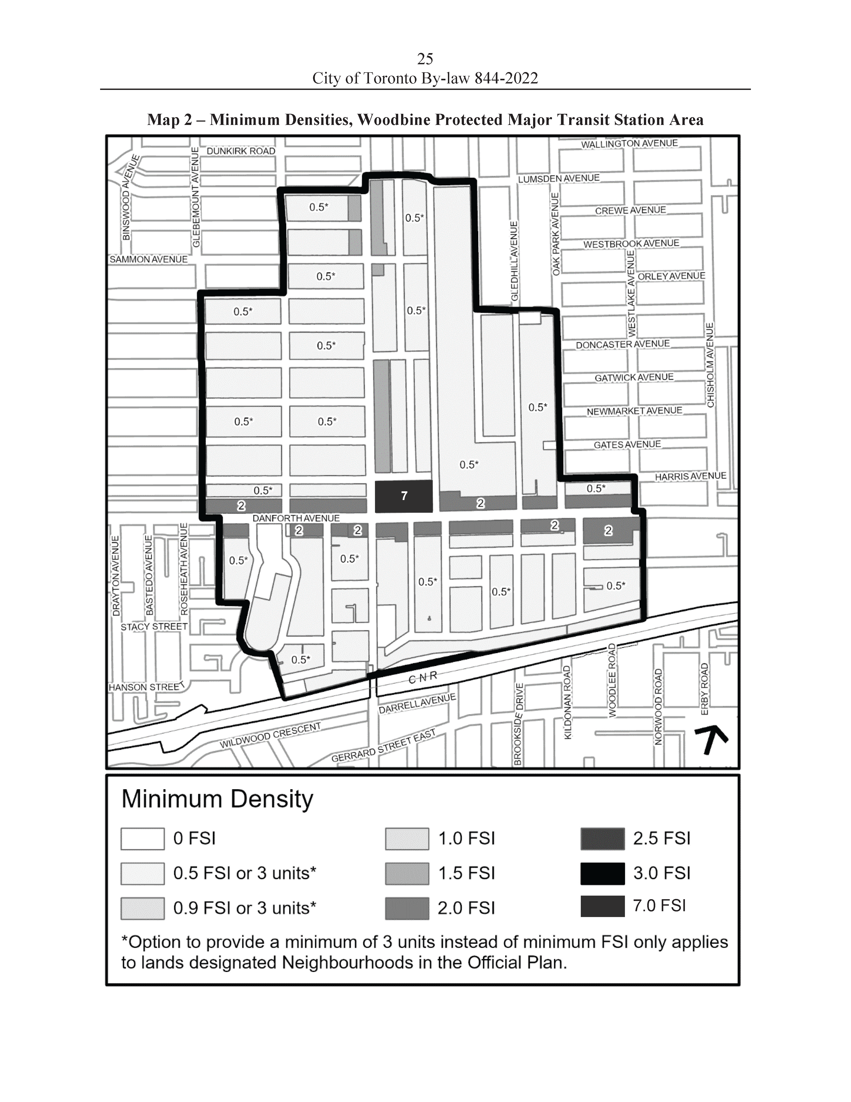
Figure 1

