Project No. 21205
February 9, 2024

Louis Bitonti
Municipal Services Office - Central Ontario
16th floor
777 Bay Street
Toronto, ON, M7A 2J3

Dear Dear Mr. Bitonti:

Re: City of Toronto Official Plan Amendment 653 (By-law 822-2023)
Environmental Registry of Ontario, Number 019-7731
15,17 and 19 Milliken Blvd and 4040 Finch Avenue East
Request for Modifications

We are the planning consultants to Trojan Gate Developments Limited (“Trojan Gate”) with respect to an assembly of its properties located at 15, 17 and 19 Milliken Boulevard and 2901 to 2913 Kennedy Road, 21 Trojan Gate and 4040 Finch Avenue East (the “Subject Properties”). The focus of this letter and related request for modifications will focus on the portion of the Subject Properties identified below located at 4040 Finch Street East and 15 to 18 Milliken Boulevard, referred herein as the “Station Centre Site”, from which lands have already been expropriated for the Station.

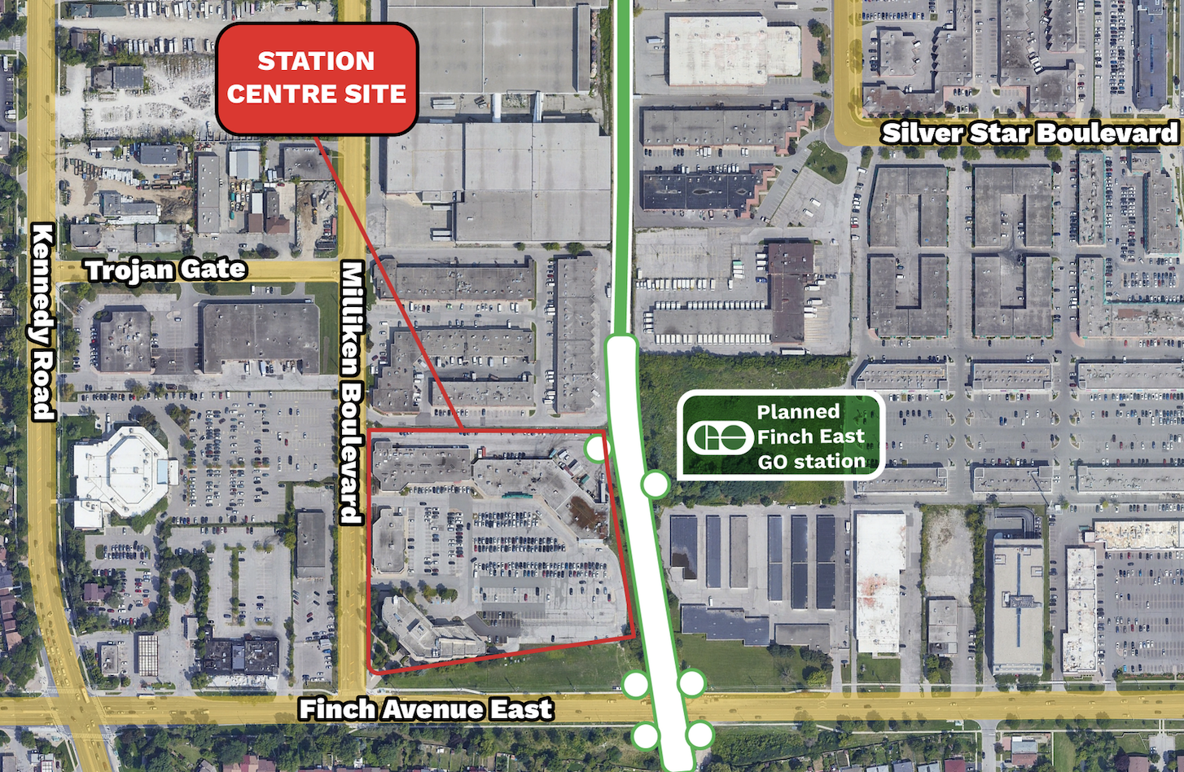
Figure 1 – Aerial of Station Centre Site and Proposed GO Station

Requested Modification to Redesignate Station Centre Site to Mixed Use Area

On behalf of Trojan Gate, we hereby request that the Station Centre Site be redesignated to Mixed Use Areas, with a new Site and Area Specific Policy (SASP) that would require 10,000 square metres of gross floor area providing over 500 jobs (equivalent to the existing non-residential gross floor area) as well as over 1,500 dwelling units, including minimum affordable housing in generally in accordance with the current SASP 853 policies. The requested modifications are attached hereto as Attachment “A”.

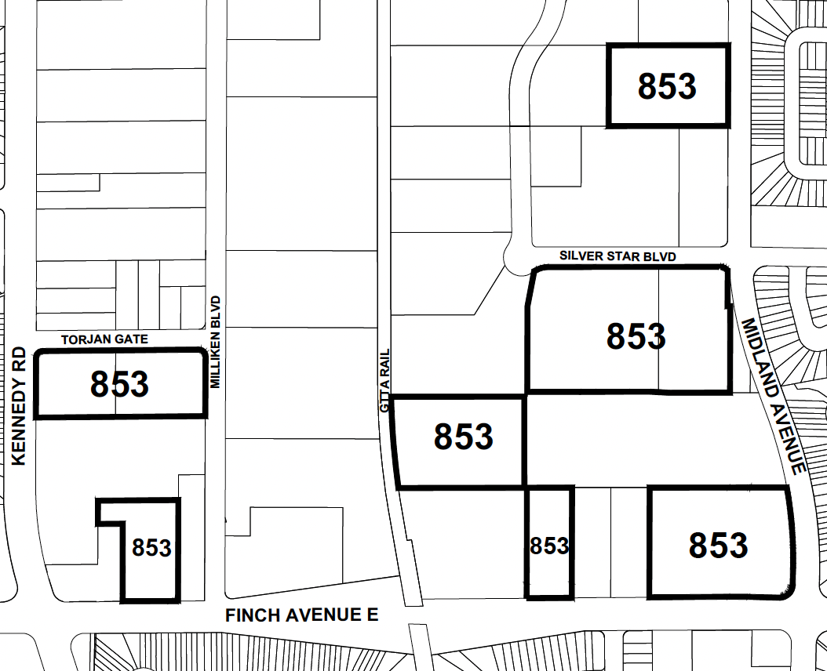
STATION CENTRE SITE
- Redesignate to Mixed Use Areas
- Add new Site and Area Specific Policy
Figure 4 – Modified OPA 653 Mapping

With the Station Centre Site being at the heart of the area, directly adjacent to the planned station, it would be in the public interest to recognize that it would be the most appropriate location for the full spectrum of residential land use permissions in the most expedited fashion. A Mixed Use Areas designation that also maintains the existing non-residential space and provides new affordable housing would provide for immediate ridership and intensification proximate to the station, which would be in the public interest.

Original Conversion Request

On behalf of Trojan Gate, we submitted letters on in July 2021 and May 2022, requesting to convert the Subject Properties from their existing General Employment and Core Employment designations to a Mixed Use Areas designation, or other appropriate designation to include non-employment uses to encourage transit-oriented development. The letters submitted in support of this request are attached hereto as Attachments “B” and “C”. It should also be noted that the July 2021 letter was accompanied by an Economic Analysis prepared by Altus Group.

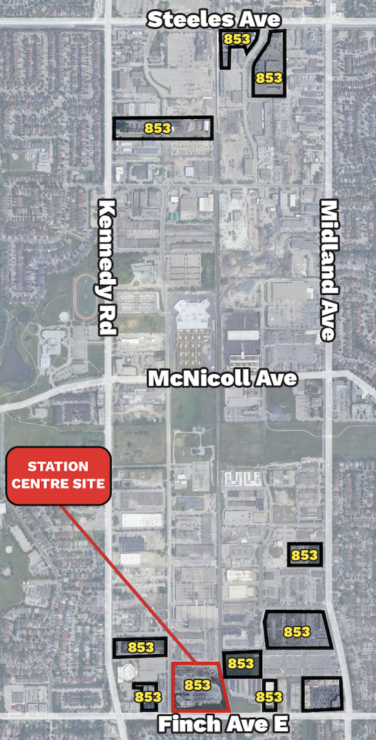
City Council Adoption

On September 6, 2023, City of Toronto Council adopted Official Plan Amendment Number 653 (“OPA 653”), redesignating the Subject Properties, along with several other properties in the general area, to Regeneration Areas, along with a Site and Area Specific Policy 853 (SASP 853). As illustrated in the SASP 853 mapping in Figure 2 the properties included in SASP 853 are not contiguous and extend over a large area generally between Finch Avenue to the south, Steeles Avenue to the north, Kennedy Road to the west and Midland Avenue to the east.

While OPA 653 converted the Subject Properties to allow for non-employment uses, the Regeneration Areas designation and the policies of SASP 853 which require a secondary plan or further site-specific policy process, minimum employment space and affordable housing, will result in constraints and delay. A Regeneration Area study involving the City and many separate landowners over a wide geographic area and with noncontiguous properties will be a complicated and likely time-consuming undertaking that is likely to frustrate or delay the achievement of new housing and jobs. Figure 2 - OPA 653, SASP 853 Map

From a planning perspective, the OPA 653 Regeneration Area designation is especially problematic for the Station Centre Site located at the northeast corner of Milliken and Finch, which is immediately adjacent to the planned Go Transit Station. Such delay in achieving intensification proximate to the planned GO Station is not in the public interest in my opinion.

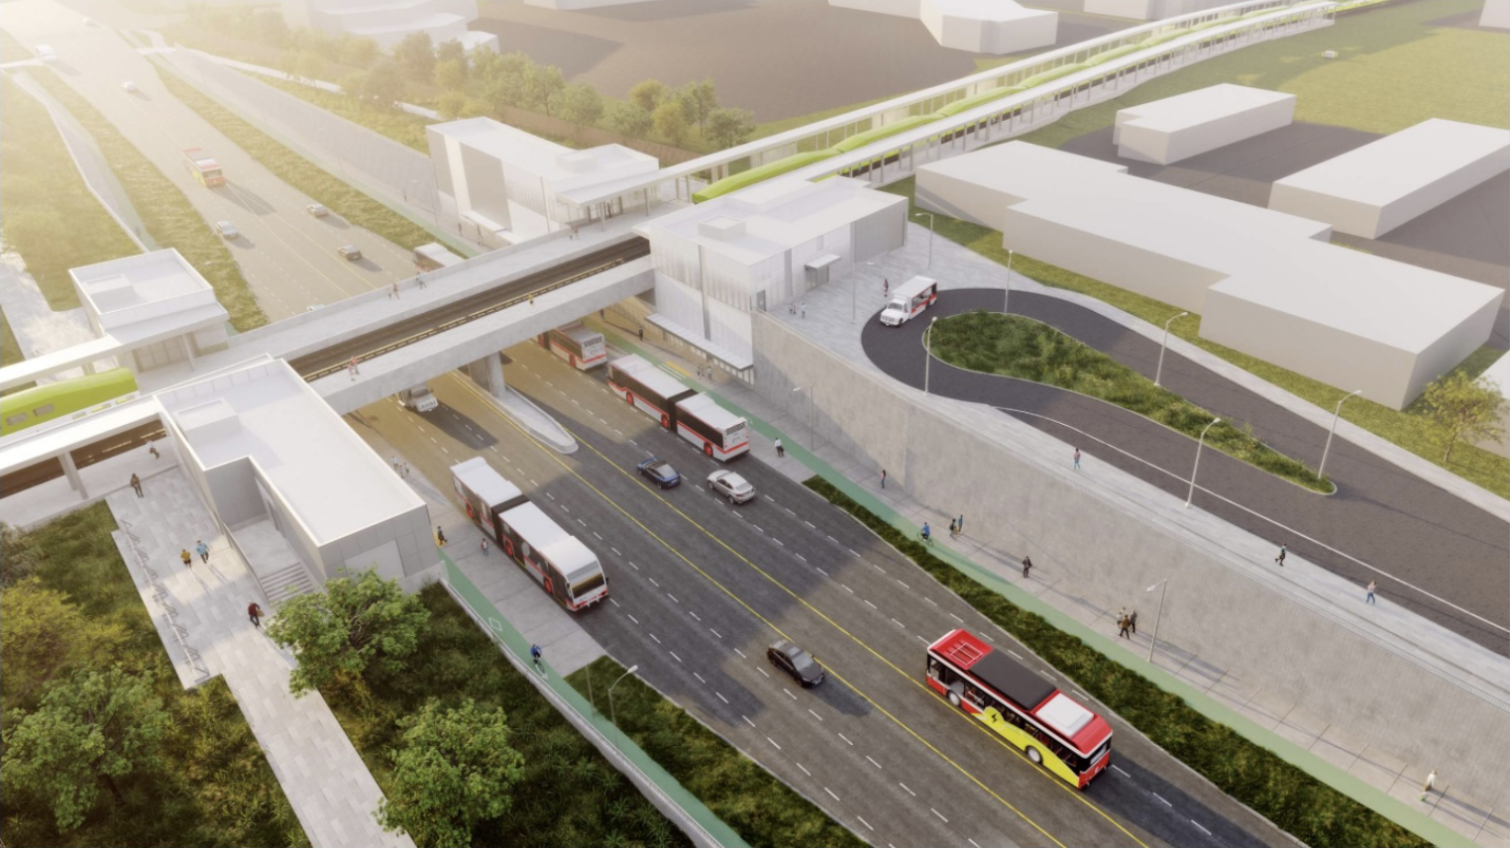
Figure 3 – Conceptual Rendering of planned GO Station

It would be good planning, in our opinion, to modify OPA 653 to designate the Station Centre Site (ie. the lands municipally known as 4040 Finch Avenue East and 15, 17 and 19 Milliken Blvd) as Mixed Use Areas, with an appropriate Site and Area Specific Policy as described in further detail below.

Provincial Growth Plan Conformity

Regarding the criteria for the conversion of employment areas to non-employment uses Policy 2.2.5.9 of the Growth Plan states as follows:

“The conversion of lands within employment areas to non-employment uses may be permitted only through a municipal comprehensive review where it is demonstrated that:

a) there is a need for the conversion;
b) the lands are not required over the horizon of this Plan for the employment
purposes for which they are designated;
c) the municipality will maintain sufficient employment lands to accommodate
forecasted employment growth to the horizon of this Plan;
d) the proposed uses would not adversely affect the overall viability of the
employment area or the achievement of the minimum intensification and density targets in this Plan, as well as the other policies of this Plan; and
e) there are existing or planned infrastructure and public service facilities to
accommodate the proposed uses.”

Policy 2.2.5.10 states that lands may be converted within Major Transit Station Areas subject to satisfying 2.2.5.9 (a), (d) and (e) and maintaining a significant number of jobs through the establishment of development criteria.

With respect to the Policy 2.2.5.9(a) there is a clear direction in the Growth Plan that minimum densities should be achieved in Major Transit Station Areas served by the GO transit rail network. This density is currently not being achieved on the Station Centre Site. Further, the Growth Plan goes on state that land uses and built forms that would adversely affect the achievement of the minimum density target are prohibited (our emphasis). The existing industrial and commercial provisions for the subject properties which limit densities to less than 0.5 times the lot area currently adversely affect the achievement of any form of intensification.

Finally, the Growth Plan then describes the type of development which should be encouraged - which includes planning for a diverse mix of uses, including additional residential units and affordable housing to support existing and planned transit service and prohibiting land uses and built form that would adversely affect the achievement of transit-supportive densities.

Accordingly, it is our opinion that there is a need for the conversion to conform to these policies. A conversion to a Mixed Use Areas designation with site specific requirements for minimum non-residential space and affordable housing would facilitate a more efficient, effective and intensive land use which would better implement the Growth Plan polices as opposed to a Regeneration Area designation, which would present delays and uncertainty with respect to land use permissions proximate to the planned station.

With respect to Policy 2.2.5.9(d), the proposed conversion would not adversely affect the overall viability of the Employment Area or the achievement of the minimum intensification and density targets of the Official Plan.. The Station Centre Site is located on the periphery of the Milliken Employment Area and to the immediate south are residential uses. Today, the nature of the uses on site are primarily retail/restaurant/service commercial and medical offices serving primarily the adjacent residential communities. Apart from an autobody repair shop on Finch Avenue (which has completed an ECA process) the Gradient Study did not identify any industrial uses which would be impacted by the introduction of residential uses. The Gradient land use compatibility and mitigation studies supporting the conversion request are attached hereto as Attachments “D”, “E” and “F”.

The proposed intensification of use on the subject properties would enhance rather than detract from the achievement of the intensification and density targets in the Growth Plan.

With respect to Policy 2.2.5.9(e), there are existing or planned infrastructure and public service facilities to accommodate the proposed uses:

- The subject properties are centrally located in an area well served by community infrastructure.
- The subject properties have convenient access to multiple community
amenities in the L’Amoreaux neighbourhood to the west and the Tam O’Shanter and Agincourt North communities to the south and east. Many of these community facilities are easily accessible and are within walking distance.
- The new GO station planned for Kennedy Road and Finch Avenue will directly service the Station Centre Site. This will be a key piece of infrastructure which will support a higher intensity land use, such as the proposed Mixed Use Areas designation.

In our opinion, given the opportunities provided by a Mixed Use Areas designation and the site specific requirement for maintaining the existing amount of non-residential gross floor area, there would be the potential to accommodate a significant number of jobs. This could be in the form of additional retail, service commercial uses, live-work units or office space in accordance with Policy 2.2.5.10(b).

Furthermore, to the extent that the foregoing request is premised upon the planned Go Station, it is my opinion that having the permissions in place in an expedited manner will allow for the ridership to be present when the GO station is in operation. It would not be in the public interest to have the Go station begin operation and only then consider adding mixed use permissions to facilitate ridership.

If you have any questions or require additional information, please do not hesitate to contact the undersigned.

Yours very truly,
Bousfields Inc.

Michael Bissett, MCIP, RPP

Attachment “A”

PROPOSED MODFICATIONS

- Remove 15,17 and 19 Milliken Blvd and 4040 Finch Avenue East from SASP 853.

- Amend land use Map 19 to designate 15,17 and 19 Milliken Blvd and 4040 Finch Avenue East to “Mixed Use Areas”.

- Amend Chapter 7 to include a new SASP ### and associated map for 15,17 and 19 Milliken Blvd and 4040 Finch Avenue East, which provides as follows:

  - Minimum non-residential gross floor area of 10,000 square metres.

  - No Official Plan Amendment shall be required to permit development in accordance with this Site and Area Specific Policy. A Zoning By-law Amendment application shall be required to determine:

      - building heights and densities across the lands
      - the list of permitted non-residential uses that contribute to the employment gross floor area
      - built form and massing that outlines the location and scale of new development.

  - Prior to the rezoning of the lands the following shall be completed

1. A Compatibility/Mitigation Study will be prepared, in accordance with Policies 2.2.4.5 to 2.2.4.10 of the Official Plan. The Compatibility/Mitigation Study will identify:
    - any uses and Major Facilities on Core and General Employment Areas outside of but near to the Subject Lands that may impact or be impacted by sensitive land uses, including residential uses
    - the Influence Area of any Major Facility outside of but near to the Subject Lands; and
    - potential and/or required mitigation measures for land use designations that permit residential or other sensitive land uses near Core Employment Areas and General Employment Areas outside of the Subject Lands;

2. A Phasing Strategy and Implementation Plan to provide for the sequencing of development, including the provision of infrastructure and services:
A) the Phasing Strategy must set out the amount of non-residential gross floor area to be constructed in each phase, prior to, or concurrent with residential gross floor area to provide a balance of employment and residential growth in all phases of development;

d. A rezoning application will also include a Housing Plan where new development containing residential units on the lands will secure a minimum amount of affordable housing as follows:

- if a condominium development is proposed, a minimum of 7 percent of the total new residential gross floor area shall be secured as affordable ownership housing or a minimum of 5 percent of the total new residential gross floor area shall be secured as affordable rental housing;
- the affordable housing shall be secured at affordable rents or affordable ownership prices for a period of at least 25 years from the date of first residential occupancy of the unit;
- the unit mix of the affordable housing shall reflect the market component of the development, as appropriate, to achieve a balanced mix of unit types and sizes and support the creation of affordable housing suitable for families; and
- if a purpose-built rental development is proposed, there is no minimum requirement for affordable rental housing.

e. The provision of affordable housing required by Policy d) shall be secured through one or more agreements with the City.

f. The use of holding provisions may be used to ensure the required affordable housing is secured. Conditions to be met prior to the removal of a holding ("H") provision on the lands shall include the following:

i) Entering into a Municipal Housing Project Facility Agreement or such other agreement(s) as may be satisfactory to the City Solicitor to secure the provision of affordable housing; and

ii) The submission and acceptance of a Housing Issues Report, to the satisfaction of the Chief Planner and Executive Director, that identifies the unit mix, unit sizes, and how affordable housing requirements will be met.

g. If an Inclusionary Zoning By-law takes effect and becomes applicable to any development on the lands, then the Official Plan Inclusionary Zoning policies and by-law, as may be amended, will prevail and the affordable housing requirements in Policy d) will no longer apply.

h. As part of a complete Zoning By-law Amendment application for the lands:
i) a Rail Safety and Rail Mitigation Report shall be submitted, peer reviewed and implemented to the City's satisfaction, and reviewed by the applicable rail operator; and
ii) a Compatibility/Mitigation Study shall be submitted that will be peer reviewed, at the applicant's expense, and implemented to the City's satisfaction, which may include lifting any holding provisions established through the Secondary Plan or Site and Area Specific Policy, pursuant to Policy d) above.

i. Sensitive land uses, including new residential uses will be located, designed and buffered to mitigate impacts from, be compatible with, and not impede the continuation of and the expansion of existing employment uses, and any new employment uses within the surrounding General and Core Employment Areas.

