Project No. 2305
February 8, 2024

Ministry of Municipal Affairs and Housing
Municipal Services Office – Central Ontario
777 Bay Street, 16th Floor
Toronto, ON M7A 2J3

Attention: Louis Bitonti

Dear Mr. Bitonti:

Re: City of Toronto Official Plan Amendment No. 653
ERO Number 019-7731
Ministry Reference Number 20-OP-238506
Request to Redesignate 4570 and 4630 Sheppard Avenue East to Mixed Use Areas

We are the planning consultants for 2546229 Ontario Ltd., the owner of the property municipally known as 4570 Sheppard Avenue East in the City of Toronto (the “subject site”). The subject site is approximately 2.18 hectares in size, is located on the north side of Sheppard Avenue East, just west of McCowan Road, and is currently vacant.

The subject site is located within an approximate 250 metre radius of the Sheppard & McCowan Subway Station on the 7.8-kilometre Scarborough Subway Extension, which is currently under construction and will result in the extension of the existing TTC Line 2 subway. The Sheppard & McCowan Subway Station will become the easterly terminus station of the extended subway line.

Given the site’s proximity to future higher-order transit, it is our opinion that its current use (vacant), General Employment Areas designation and Employment Industrial (E 0.7) zoning represent a significant underutilization of land and infrastructure. The surrounding area, located north of Highway 401 and south of the CP Rail corridor along McCowan Road, is currently characterized by large format retail uses, smaller multi-unit industrial-commercial plazas and free-standing automotive uses, all of which are conducive to redevelopment and intensification for mixed-use/residential purposes.

The purpose of this letter is to request that the Province modify OPA 653 as it applies to the subject site and the adjacent lands at 4630 Sheppard Avenue East to redesignate the southerly portion of these sites to Mixed Use Areas instead of the Regeneration Areas designation proposed in OPA 653. As outlined below, it is our opinion that the subject site is well-positioned to provide transit-supportive housing as well as to leverage existing and planned infrastructure investments to contribute to the Province’s objective to deliver at least 1.5 million new homes by 2031. The proposed Regeneration Areas designation and associated regeneration area study requirements would needlessly delay approval of new housing supply on the subject site.

Background

As part of the City of Toronto’s municipal comprehensive review process, City Council adopted Official Plan Amendment No. 653 (“OPA 653”) on September 6, 2023 to implement staff recommendations regarding the third round of employment conversion requests. Among other matters, OPA 653 redesignated the southerly portion of the subject site and the property to the immediate east at 4630 Sheppard Avenue East from General Employment Areas to Regeneration Areas (Area “B”), leaving the General Employment Areas designation in place on the northerly portion (Area “A”); as well, it introduced Site and Area Specific Policy 793 (”SASP 793”), which applies to both Area “A” and Area “B” (see Figure 1).

Figure 1 – Site and Area Specific Policy 793

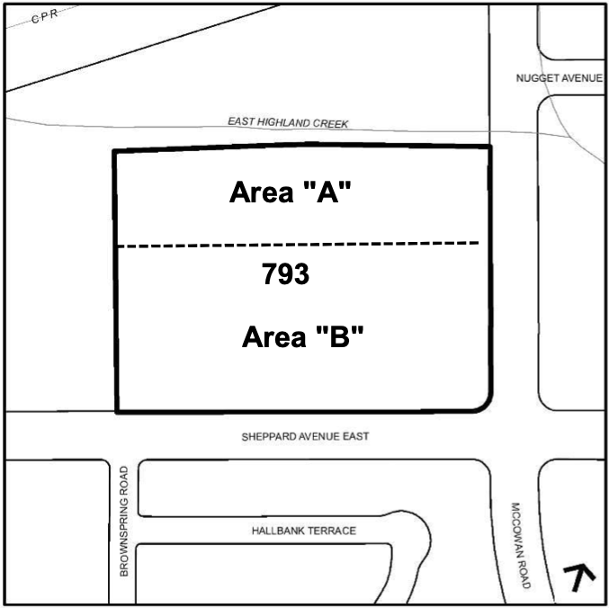

As adopted, SASP 793 would establish a requirement for a regeneration area study leading to the adoption of a Secondary Plan or Site and Area Specific Policy, prior to which “no form of residential uses and/or live-work uses will be permitted” on the site.

In addition to the studies required in Policy 4.7(2) of the Official Plan, SASP 793 would also require the preparation of a land use plan, a phasing strategy and implementation plan, a community services and facilities strategy, a block context plan, a parks and open space plan, urban design guidelines, an infrastructure master plan, a green infrastructure strategy, a transportation analysis, a commercial demand analysis and a housing plan.

Following all of the work required to complete the regeneration area study, it would then be incumbent on the City to adopt a Secondary Plan or Site and Area Specific Policy. Furthermore, SASP 793 provides that sensitive land uses in Area “B” might then still be subject to holding provisions in order to ensure compatibility and mitigation concerns are adequately addressed.

In correspondence and discussions with staff leading up to adoption of OPA 653, we expressed significant concerns regarding the recommended layers of planning approvals, which we believed were unnecessary and would have the potential to significantly delay the development of new housing at this strategic location at the terminus of the subway line. Despite these concerns, staff continued to recommend the Regeneration Areas designation and the associated Site and Area Specific Policy, which recommendations were ultimately adopted by City Council.

Analysis

In our opinion, the proposed use of a Regeneration Areas designation in this circumstance is unnecessary. A redesignation of the lands to Mixed Use Areas would more appropriately achieve Provincial and municipal planning objectives regarding transit-supportive intensification and increased housing supply.

In this regard, the City of Toronto Official Plan provides that Regeneration Areas are areas of the City that are no longer in productive urban use due to shifts in the local or global economies. It also states that Regeneration Areas will need “tailor-made” strategies and frameworks for development, provided through a Secondary Plan. In some cases, such as the Central Waterfront, there will be a need for extensive infrastructure improvements, while in smaller areas the emphasis may be on re-use of existing buildings and compatible infill.

Further, Policy 4.7(2) of the Official Plan states that, for each Regeneration Area, a framework for new development will be set out in a Secondary Plan.

The SASP 793 area is not an expansive area such as the Central Waterfront, nor does it contain multiple ownerships or a heritage building stock that is available for re-use. In such cases, the need for a regeneration area study is more apparent in order to co-ordinate ultimate land use designations, road and block plans and servicing infrastructure across properties.

In contrast, the SASP 793 area consists of two reasonably large and regularly shaped parcels. Accordingly, a redesignation from General Employment Areas to Mixed Use Areas is the preferred approach because it is more straightforward and removes a further unnecessary policy hurdle involving the requirement for a further Official Plan Amendment. In the case of a number of other properties subject to OPA 653, the recommended redesignation is a straightforward redesignation to Mixed Use Areas without the interim step of a regeneration area study (e.g. 20 Brentcliffe Road, 1001 Ellesmere Road and 171 East Liberty Street).

The requested redesignation to Mixed Use Areas would allow the necessary plans and studies to be undertaken by the two landowners as part of the rezoning process, the details of which would be secured through a revised version of SASP 793. Such an approach would eliminate the administrative burden on the City to initiate and undertake the regeneration area study and would allow the landowners to move ahead more quickly on their own to deliver housing on the properties.

In order to implement the requested redesignation to Mixed Use Areas in combination with a reworded version of SASP 793, we are attaching suggested wording for the proposed modification to OPA 653.

Conclusions

For the reasons outlined above, it is our opinion that a Mixed Use Areas designation is preferable to the Regeneration Areas designation proposed in OPA 653 as it would more effectively achieve the Province’s goals to promote the delivery of new housing supply in a timely manner and support the optimization and efficient use of land and infrastructure on lands that are well served by municipal infrastructure, particularly higher-order public transit.

In our opinion, the redesignation of the southerly portion of the subject site and the adjacent lands at 4630 Sheppard Avenue East from General Employment Areas to Mixed Use Areas is appropriate and represents good planning. Intensification of the subject site is encouraged by Provincial policies and the City of Toronto Official Plan given its location within immediate proximity of the new Sheppard & McCowan subway station.

Thank you for your consideration of this requested modification. Should you have any questions or require any clarification, please do not hesitate to contact me or Hailey McWilliam of our office.

Yours very truly,

Bousfields Inc.

Peter F. Smith, MCIP, RPP

