Feedback in this comment requests changes to land use zoning in the Major Transit Station Area (MTSA) for the Grimsby GO Train Station. Changes that will maximize the opportunity for the Region of Niagara, Town of Grimsby and the Province to facilitate the growth as outlined in the Ontario Build More Homes Faster Act, 2022.

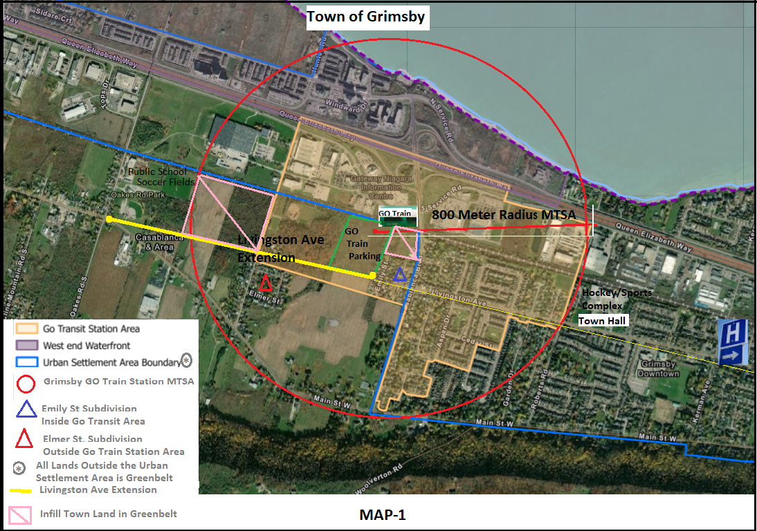

See **TABLE-1** on the next page for a description for prime Landmarks listed on **MAP-1** that are in the MTSA.

Make special note of the **Infill Town Land not in the Urban Settlement Area Boundary** outlined with Pink Boxes as those (and other) lands were **mistakenly included in the Greenbelt when originally mapped**[1]. Those identified lands are approximately 38-acres of key development land in vacant and fallow parcels that are in an infill area in the Town of Grimsby. They are in the Grimsby GO Train MTSA and are a strategic and viable transportation hub for growth[2].

In addition to the strategic Landmarks located within the MTSA there are other Town of Grimsby key landmarks that are proximate to the MTSA and support providing for an excellent Transit Oriented Development or TOD space. These are labeled on **MAP-1** and include:

* A Public School
* Baseball/Soccer Fields (park and leisure areas)
* Hockey/Sports Complex (Peach King Centre) and City Hall
* The new Grimsby Hospital - currently under a complete reconstruction is scheduled for completion in 2025.

|  |  |  |
| --- | --- | --- |
| **TABLE-1 – Items labeled in the MAP-1 Legend** | | |
| **Item** | **Landmarks within MTSA** | **Description** |
| **1** | 800 Mete Radius MTSA (**in red line**) | Defined Boundaries as est. by Province |
| **2** | GO Train Station Site (north-side of tracks) | Planned Higher Order Transit Station (2011) |
| **3** | GO Train Station Parking (south-side of tracks) | Metrolinx, Region of Niagara and Town of Grimsby Acquired GO Train Parking Lot (2015) |
| **4** |  | Future Regional Road - completing a major east-west corridor to downtown and the GO Train Station Parking Lot |
| **5** |  | A fully serviced Subdivision that is within the GO Transit Study Area identified in the secondary Plan. |
| **6** |  | A fully serviced Subdivision that is outside the GO Train Study Area but is not in the Town’s Urban Settlement Area because it is in Greenbelt. |
| **7** |  | Vacant fallow land-parcels within the MTSA that are not in the Town’s Urban Settlement Area because it is in Greenbelt. |

**Item 1** – The **A Place to Grow Growth Plan for the Greater Golden Horseshoe of August 2020** provides the definition:

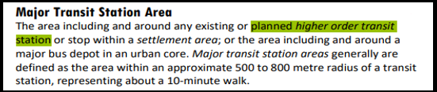

**Items 2 and 3** - GO Train Station Site and Parking on both the north and south sides of the Rail Tracks:

A description for this item is found on the Region of Niagara Web notice provided below. The original Grimsby GO Train Station site on the north side of the rail tracks was selected in 2011. A very large 14-acre parcel of land was subsequently acquired in 2015 for parking and growth options on the south side of the train tracks as a direct add-on to the original north-side site: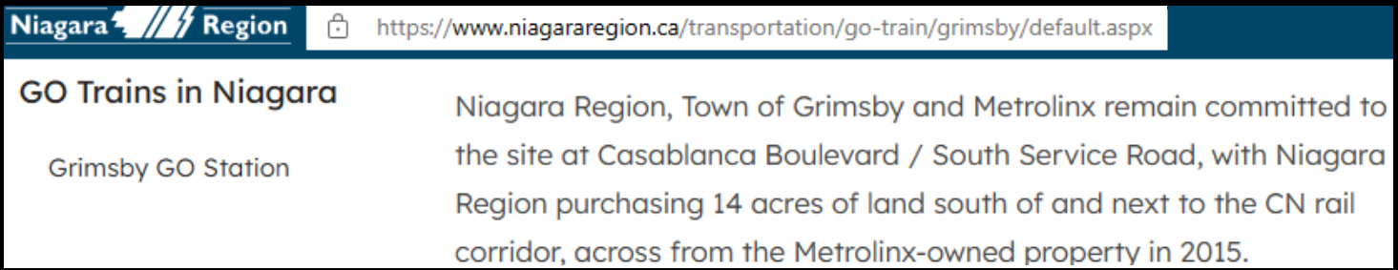

**Item 4** – The Livingston Avenue Extension. This is the **Future Regional Road** noted below in the legend of **Schedule J1 – Transportation Infrastructure** on the approved Region of Niagara Official Plan 2022. The future Livingston Avenue Extension has an approved EA and the construction start is TBD.

The Livingston Ave Extension or **Future Regional Road** is just over 1 km in length and was acquired by the Region of Niagara early in the 1970’s. It will finally complete a major east-west corridor to the downtown of Grimsby as well as provide direct access into the south-side parking lot of the *Planned Higher Order Transit Station* (as highlighted in **Item 1 – A Place to Grow** thatincludes this reference as a verbatim term in the definition for a MTSA).

**Note:** The Region and Town have **already built** underground infrastructure in the Livingston Ave Extension for Water, Natural Gas, Bell Lines and Sewers into the established Subdivisions where they are noted as serviced in **Map-1**.

The Region of Niagara has scheduled the Casablanca Blvd Reconstruction Project for a 2024 start; it will completely renew the QEW on-off ramps as well as the entire Casablanca Blvd including above and below ground infrastructures.

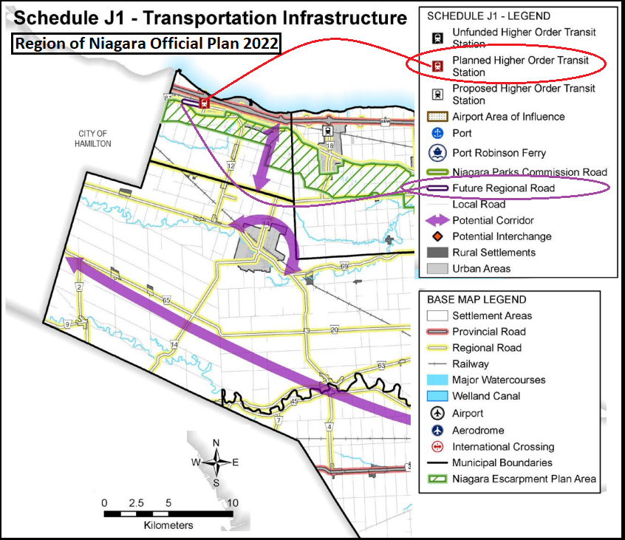

**Items 5, 6 and 7** – Are self-defined in **Table-1**.

On November 2, 2023 the Hon. Paul Calandra Minister of The MMAH wrote to the Town of Grimsby to provide feedback for changes the municipality would like to see made to the official plans by Dec 7. The town’s official response was to request an option to expand the urban boundary in west Grimsby to include the MTSA lands presently in the Greenbelt.

**Other Notes.**

For reference to related ERO *Individual* comments specific to Grimsby for feedback to the Province’s Greenbelt amendments over the past year see the Comment in **ERO 019-7739 Proposal to return lands to the Greenbelt - Greenbelt Statute Law Amendment Act, 2023.**

This provides further details with a presentation with very relevant feedback made to other ERO’s with our Comments that were provided to the province.

These are listed and include:

* **ERO 019-6216 -> Proposed Amendments to the Greenbelt Plan**

Comment Id's 66031, 68145 and 69291

* **ERO 019-6813 -> Review of proposed policies adapted from A Place to Grow and Provincial Policy Statement to form a new provincial planning policy instrument**

Comment Id 88023

**Exhibit-1**

Article providing a history on the mistake made by the in original mapping of the Greenbelt boundary in 2005.

The news article points out this area in west Grimsby that includes the MTSA was never intended to be contained in the Greenbelt boundary and was NOT amended to be removed from the Greenbelt boundary during the Greenbelt Review Panel in 2015 as was promised by the province.

An **official letter of objection** was filed by the then Town of Grimsby Mayor and Council to the Province in February 27, 2017 after the Provinces 2016 Co-Ordinated Land Use Planning Review Panel’s decision for Grimsby failed to make the appropriate and promised changes.

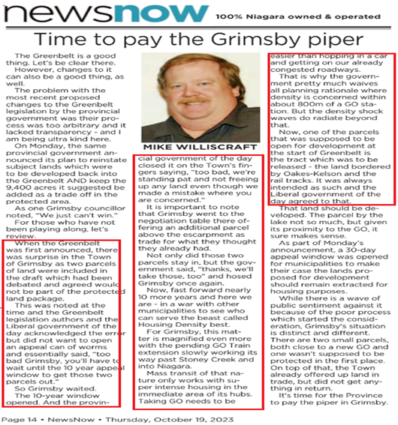

**Exhibit-2**

Shows that studies by profession agrologists provided scientific proof the lands within the Grimsby GO Train MTSA should not have been included in the Greenbelt boundary as the soil is not suitable for Specialty Crop in the Greenbelt as their ratings show:

* the area identified as shallow soils with limited specialty Crop Suitability as shown by ratings of Poor, Poor to Very Poor and Unsuitable
* Specialty crop production is not predominant[3].

|  |
| --- |
| The following is stated in the Agricultural Impact Assessment of March 25, 2022 provided by **DBH Soils Inc** for the nearby 502 Winston Rd development that was initially proposed for Greenbelt Redesignation by the Gov ON on November 2022:   * + *The soils in the Secondary Study Area* ***(includes the Subject Lands)*** *comprise a mix of specialty crop ratings with much of the area identified as shallow soils with limited specialty crop suitability as shown by ratings of Poor, Poor to Very Poor and Unsuitable.*   This matched the results on soil quality that were concluded in the **AgPlan Limited – Specialty Crop Greenbelt Study** report commissioned by the Town of Grimsby (Oct 28, 2016):   * + *Specialty crop production is not predominant,*   + *Soil capability and soil potential in Grimsby is not the best found in Niagara and in some areas is diminished due to non-agricultural development.*   *The Provincial Policy Statement (2014) is mute with respect to the application of tests needed to be met in order to be able to designate a specialty crop area and does not provide any guidance with respect to the relative importance (weighting) on characteristics. Additionally, there is no guidance with respect to a minimum size of area designated as specialty crop area* |

The studies further conclude lands within the Grimsby GO Train MTSA are:

1. fragmented
2. contain valuable prebuilt infrastructure
3. contains fully serviced subdivisions and is basically infill.

**Map-1** clearly shows that ALL land within the Grimsby GO Train Station MTSA abuts to what the Region of Niagara maps as ***Strategic Urban Area Designations -> Delineated Built-Up Area*** as well as being ***Strategic Growth Areas -> Protected Major Transit Station Area*** in **Schedule B – Regional Structure** in their Official Plan (2022).

A **mechanism** to permit strategic and viable lands to be removed from the Greenbelt and included in the Urban Settlement Area Boundary is necessary.

**Conclusion:** Lands in the Grimsby GO Train MTSA and not in the Town of Grimsby **Urban Settlement Area Boundary** should be considered for removal from the Greenbelt boundary.

1. See Newspaper Article in **Exhibit-1** below.
2. See reference to Professional Agrologist Studies completed for Grimsby in **Exhibit-2** below.
3. In fact, there is no Specialty Crops planted on any of the land contained within the MTSA. **Map-1** clearly shows that all land within the MTSA is a) fragmented, b) contains valuable prebuilt infrastructure and c) actually contains fully serviced subdivisions.