March 8, 2024

EA Modernization Project Team
Environmental Assessment Modernization Branch
135 St Clair Ave West, 4th Floor
Toronto, ON M4V 1P5
Re: New regulation to focus municipal environmental assessment requirements (ERO 019-7891 and ORR Proposal Number:23-MECP025)

To EA Modernization Project Team:

We thank Ministry of Environment, Conservation and Parks (MECP) for the opportunity to comment on the proposed changes to municipal environmental assessment (EA) requirements. It is our understanding the MECP is proposing to focus Environmental Assessment (EA) Act requirements for municipal infrastructure projects on more complex municipal water, sewage, and shoreline/in-water works projects. The proposal has two key components:

- The Project List that describes the municipal infrastructure project types subject to the process (to be designated as Part II.4 projects under the EA Act).
- The Municipal Project Assessment Process (MPAP) that sets out requirements for consultation, consideration of alternative designs, impact assessment studies, documentation and notification.

As well, the Municipal Class Environmental Assessment (MCEA) and Private Sector Developers Regulation (O. Reg. 345/93) are proposed to be revoked.

Peel Region appreciates the modernization of EA Act requirements for municipal infrastructure projects such as roads, water, and wastewater that currently follow the MCEA. Reducing duplication in EA requirements and eliminating the unnecessary regulatory burden on lower impact projects can improve the timing of critical housing enabling infrastructure. As stated in our May 2023 submission, that Peel Region supports reform the EA and MCEA processes, while at the same time ensuring any proposed changes to municipal EA requirements include environmental oversight and public consultation, as well as apply a climate change lens.

Peel Region staff’s general and specific comments for this proposal are outlined below.

GENERAL COMMENTS
Peel Region appreciates and welcomes the proposed new regulation and process regarding municipal EA requirements as it would support the delivery of critical public works infrastructure faster to help meet provincial housing targets and address pressure from the development community. While generally supportive, Peel Region staff have some general comments largely regarding the proposed Municipal Project Assessment Process (MPAP) not applying to certain projects, which have implications for environmental protection and oversight, climate change, and stakeholder engagement and consultations. For projects not subjected to the MPAP, Peel Region staff would still carry its due diligence on sound engineering, apply a climate lens (in alignment with its Master Climate Change Plan) and consult with residents.

a) Need for Environmental Protection and Oversight
While the proposed changes to the municipal EA process would streamline the process for the timely implementation of critical municipal housing enabling infrastructure, it is also important to maintain environmental oversight for some municipal projects that would not be subject to the proposed MPAP. Some municipal infrastructure projects that are currently under Schedule C of the MCEA (e.g., pumping stations, sewage treatment plant, municipal roads or new parking lots, bridges, all water crossings) are considered to be high impact projects and their exclusion from the streamlined project list under the new MPAP could pose a risk to the environment if impacts are not mitigated.

Peel Staff Recommendation
All high impact projects be assessed for adverse environmental impacts under the proposed MPAP process and how these impacts can be avoided.

b) Applying a Climate Change Lens for assessing Municipal Infrastructure projects
Schedules B and C of the current MCEA prescribes taking a climate change lens and considerations into account when completing EAs. These same requirements under the current MCEA should be part of the proposed MPAP as it could help to avoid several adverse and costly impacts and possible disruption to services.

c) Stakeholder Engagement and consultations
Adequate consultation and engagement of the public and stakeholders is vitally important to the municipal EA process. The current 2023 MCEA process gives the public the opportunity to get involved at every stage of the project. In the past such consultation and stakeholder engagement has helped to identify certain deficiencies with proposed solutions and led to alternative solutions that are more cost effective and minimize adverse environmental impacts.

Peel Region is committed to work with the agencies, residents, stakeholders, and the community as it plans, designs and builds infrastructure and values their input during the planning process before the implementation of infrastructure projects. While the Region can prepare much of the required EA work (technical studies) ahead of the notice of commencement, the 150-day maximum (including the 30 day pause) to complete the MPAP would not allow sufficient time to adequately consult, as required.

Peel Staff Recommendation
MECP considered extending the consultation or pause period by 60 days.

SPECIFIC COMMENTS

Streamlined Projects List
The MECP is proposing to include the current EA Act requirements for municipal infrastructure projects on more complex municipal water, sewage, and shoreline/in-water works projects and would exempt projects identified not on the streamlined project list from the process. Projects on the Streamlined list that would be subject to the MPAP includes drinking water facilities, water treatment facilities, sewage treatment facilities, sewage systems, stormwater management systems, Shoreline/In-water works.

While these projects remain subject to the EA Act, it is important to consider certain conditions that limit phased-in or a segmented format of construction work (i.e., the scale of the infrastructure project). For instance, expanding an existing sewage treatment plant by 25 per cent or more of the existing rated capacity as the threshold to meet the project list criteria could result in phased-in expansion projects (i.e., expansions below 25 per cent) that would not be subject to the MPAP. These series of phased-in expansions would disregard the cumulative impact on the environment.

Also, any of the project types on the Streamlined projects list could have climate change implications and therefore should be reviewed through a climate change lens. It is unclear from the proposed MPAP includes such a lens. If a climate change lens is not applied, this could lead to undue cost for the taxpayer as a result of costly infrastructure damage from climate events; disruption to services; and likely result in higher costs to properly design and implement a retrofit at a later time.

Peel Staff Recommendation
The new MPAP process include the application of a climate change lens.

Proposed Projects Not Subject to the MPAP
Peel Region staff suggest for municipal infrastructure projects not on the streamlined project list and not subject to the MPAP that certain technical studies are carried out before the project’s implementation.

Moreover, elevated water tanks and pumping stations are excluded from the streamlined project list, which could limit valuable public input on these types of projects. These projects require land and consultations allow stakeholders and the public to provide input on site selection. The lack of consultation could have negative impacts such as selecting the wrong site, delays, and the high cost of expropriation, potentially placing communities at risk if not completed properly. Including these projects on the list could ensure that projects are inclusive and transparent.

Proposed Municipal Project Assessment Process (MPAP)
Peel Region makes the following suggestions to enhance the MPAP:
- Provide clarification and guidance on requirements for ancillary components (e.g., ditches and water and wastewater (W&WW) infrastructure within the roads right of way) of projects on the project list and covered by MPAP as the proposal is unclear. on the requirements for ancillary components.
- Ensure that interested parties for MPAP are contacted and also include municipalities.
- Climate Change impacts should be part of the required studies conducted under the new MPAP process.

Private Developers are exempt from the New Municipal EA Regulation
O. Reg 345/93 covers Schedule C projects that have the potential for significant environmental impacts, like the construction of W&WW facilities or expansion. Peel Region staff have a number of comments regarding the MECP’s proposal to revoke Private Sector Developers Regulation (O. Reg. 345/93) and not subject private developers to the proposed MPAP:

- It is unclear what review environmental process would apply to private sector developers/proponents of infrastructure projects.
- As municipalities will ultimately take over the operation and maintenance of infrastructure built by private developers, the lack of environmental oversight on these projects could result in future risk and additional liability to the municipality. In other words, the municipality might have to deal with the consequences of poor environmental mitigation and impact assessment.
- Municipalities may be reluctant to pursue new approaches to development and building infrastructure that could see the private sector build more homes faster.
- It could lead to the potential erosion of the public’s confidence in private sector led projects.
- It brings uncertainty to the private sector’s environmental stewardship by removing the conditions for continued environmental oversight.

Specific Concerns about Consultation and Stakeholder Engagement
This proposal has the potential for less consultation for municipally led infrastructure projects, in particular those not on the project list. Therefore, MECP should examine the implications of less consultation and consider and clarify the following:

- A need for a plan to adequately inform the public and indigenous communities that under the proposed changes, proponents are not required to consult with them, which includes municipal master planning.

- Who (the MECP or project proponent) is responsible for informing the public, stakeholders and indigenous communities on the ramifications of the proposed municipal EA process changes?
- Additional resources would be needed to respond to the growing number of inquiries. The 2022 changes to the MCEA process created confusion with the indigenous community. Project proponents were required to explain these changes to this community as MECP did not adequately involve them community in these changes.

- Potentially deal with the public’s and elected official’s impression that a MPAP can be completed within 120 days following notice of commencement. If the proposed changes are made, more education would be required regarding the new process so that it is clear that most of the MPAP work would start before the notice of commencement is issued in order to fit all the required studies to properly complete the project.

- What happens if a municipality does not complete the MPAP work within the 120-day timeframe? What are the consequences? If they have to re-start the process, are there any consequences other than re-issuing the notice of commencement?

- MECP provide clear direction for indigenous consultation requirements and the duty to consult obligation for any municipal infrastructure projects not subject to the MPAP.

CONCLUSION
Peel Region supports efforts to reform and streamline the EA and MCEA processes that improve timelines for the completion of critical housing enabling infrastructure projects. However, it is also important that the proposed MPAP maintains adequate environmental protection and oversight, public consultation and application of a climate change lens for particular high impact projects not on the streamlined list. In our review of the proposal, there appears to be a lack of consultation and transparency with projects not subject to the MPAP. Moreover, there are many impactful municipal infrastructure projects excluded from the project list, which could have significant environmental and financial implications.

If you have any questions or require more information, please contact me at Kealy.dedman@peelregion.ca.

Kind Regards,
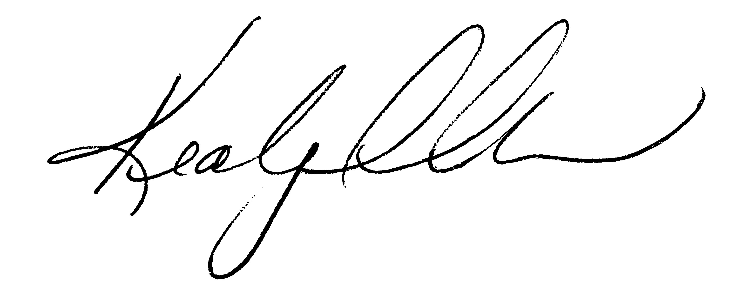

Kealy Dedman, Commissioner of Public Works

