To whom it may concern,

This letter is to express concern for the well-being and health of the local community and the potential adverse effects on the Sydenham watershed, should the proposal for the expansion and relocation of the small dormant landfill along with the development of a Regenerative Recycling Facility put forth to the Environmental Registry of Ontario by York1 be approved.

This letter aims to provide supplementary information and relevant concerns regarding the history of the site, the significance of the watershed, as well as the potential ecological damage that this expansion would impose on the Sydenham watershed.

## Site of Proposed Dump Expansion

York1 Environmental Waste Solutions Ltd plans to expand a defunct 2-acre waste disposal site on 29831 Irish School Road. Historically, this site had been established to dispose of ash from the town’s garbage incinerator, and according to land transfer records, it was sold by ‘Dresden Tile Yard’ to the Town of Dresden in 1979. Subsequently, on November 20, 1980, the town received a license to use the property for waste disposal insofar as 95% of waste product disposed of onsite was ash. It was also previously owned by an individual and was allowed to do some small-scale recycled wood operation. I saw this mentioned as up to 75 T/day being allowed but I have not scrutinized this.

Under York1’s current proposal, up to 7,000 tons of waste will be disposed of daily, running 24 hours per day, 7 days a week. According to York1’s proposal, up to 700 trucks can be expected to enter the site daily

Additionally, this site is less than 2 km from the town of Dresden. Historical evidence in Ontario has shown that the minimum distance within which adverse effects could be experienced while a landfill is operating is up to 3 km. There is cause for concern regarding the proximity of the proposed dump site to the municipality of Dresden on so many levels.

## The Sydenham Watershed

Please see the website link [www.sydenhamriver.on.ca](http://www.sydenhamriver.on.ca) from which the following facts have been produced here.

## The Sydenham watershed consists of two primary branches: the East and North Sydenham Rivers. The East Sydenham River is far more diverse in habitat availability and among its inhabitants are 34 species of mussels, acting as filter feeders and keeping these waters healthy, and 80 species of fish that depend on the waters of the Sydenham for feeding and reproduction. Of these, 15 species of mussels and 10 species of fish have been classified as Endangered, Threatened, or of Special Concern by the Committee on the Status of Endangered Wildlife in Canada (COSEWIC). There are also three snakes and five turtles that are Species At Risk (SAR).

Habitat in the North Sydenham River is less diverse and has poorer channel morphology. The East Sydenham River, however, supports much biodiversity and must be protected. In support of this acknowledgement, I present the following;

Again, form the website for the Sydenham Watershed [www.sydenhamriver.on.ca], please see the specifics regarding this information.

# **Species at Risk in the Sydenham**

The Sydenham River supports an amazing diversity of aquatic life, it is home to at least 34 mussel species and 80 fish species. More than 20 fish and mussels in the Sydenham are Species at Risk (SAR). The watershed also supports many other semi-aquatic SAR including amphibians, turtles, snakes, and dragonflies. Some of these species are found nowhere else in Canada or remain in only a few locations globally. The Sydenham watershed is of global conservation concern for the persistence of these species.

**From the**[**2018 Sydenham Action Plan**](https://www.sydenhamriver.on.ca/wp-content/uploads/2021/09/2018-Action-Plan-for-the-Sydenham-River.pdf)**:**

*Some of these species, such as Rayed Bean, occur in only one other location in Canada and persist in only a few locations in North America. The Salamander Mussel is found nowhere else in Canada and is considered globally vulnerable. The Northern Riffleshell population in the Sydenham River is one of only three remaining relatively healthy and reproducing populations globally. Consequently, the Sydenham River is of global significance to the conservation of these species.”*

**Learn more about the species at risk that are home to the Sydenham:**[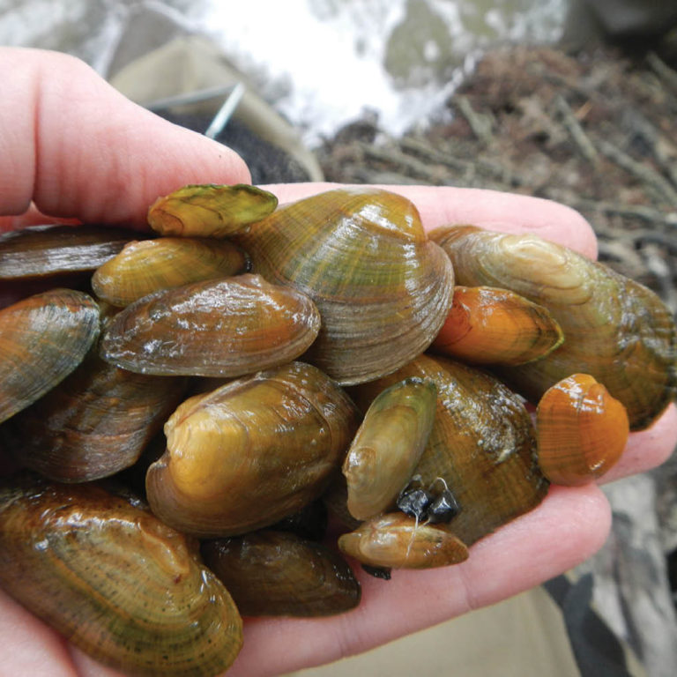](https://www.sydenhamriver.on.ca/sydenham-sar/mussels/)

#### [**Mussels at Risk**](https://www.sydenhamriver.on.ca/sydenham-sar/mussels/)

[Eastern Pondmussel](https://www.sydenhamriver.on.ca/sydenham-sar/mussels/eastern-pondmussel/)

[Fawnsfoot](https://www.sydenhamriver.on.ca/sydenham-sar/mussels/fawnsfoot/)

[Kidneyshell](https://www.sydenhamriver.on.ca/sydenham-sar/mussels/kidneyshell/)

[Lilliput](https://www.sydenhamriver.on.ca/sydenham-sar/mussels/lilliput/)

[Mapleleaf](https://www.sydenhamriver.on.ca/sydenham-sar/mussels/mapleleaf/)

[Northern Riffleshell](https://www.sydenhamriver.on.ca/sydenham-sar/mussels/northern-riffleshell/)

[Purple Wartyback](https://www.sydenhamriver.on.ca/sydenham-sar/mussels/purple-wartyback/)

[Rainbow](https://www.sydenhamriver.on.ca/sydenham-sar/mussels/rainbow/)

[Rayed Bean](https://www.sydenhamriver.on.ca/sydenham-sar/mussels/rayed-bean/)

[Round Hickorynut](https://www.sydenhamriver.on.ca/sydenham-sar/mussels/round-hickorynut/)

[Round Pigtoe](https://www.sydenhamriver.on.ca/sydenham-sar/mussels/round-pigtoe/)

[Salamander Mussel](https://www.sydenhamriver.on.ca/sydenham-sar/mussels/salamander-mussel/)

[Snuffbox](https://www.sydenhamriver.on.ca/sydenham-sar/mussels/snuffbox/)

[Threehorn Wartyback](https://www.sydenhamriver.on.ca/sydenham-sar/mussels/threehorn-wartyback/)

[Wavy-rayed Lampmussel](https://www.sydenhamriver.on.ca/sydenham-sar/mussels/wavy-rayed-lampmussel/)

[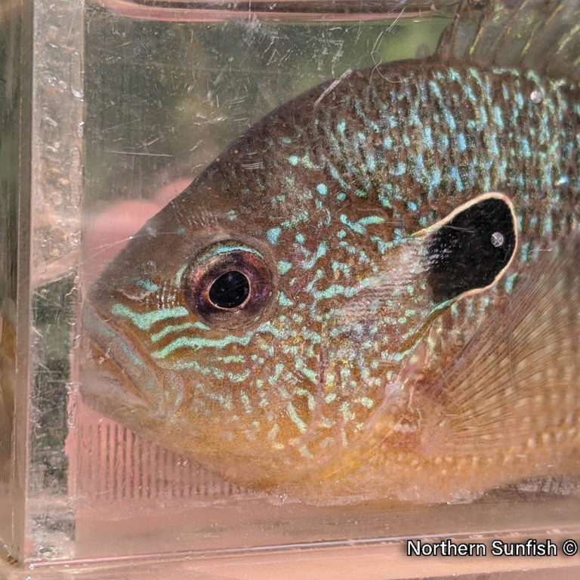](https://www.sydenhamriver.on.ca/sydenham-sar/fishes/)

#### [**Fishes at Risk**](https://www.sydenhamriver.on.ca/sydenham-sar/fishes/)

[Blackstripe Topminnow](https://www.sydenhamriver.on.ca/sydenham-sar/fishes/blackstripe-topminnow/)

[Eastern Sand Darter](https://www.sydenhamriver.on.ca/sydenham-sar/fishes/eastern-sand-darter/)

[Grass Pickerel](https://www.sydenhamriver.on.ca/sydenham-sar/fishes/grass-pickerel/)

[Northern Madtom](https://www.sydenhamriver.on.ca/sydenham-sar/fishes/northern-madtom/)

[Northern Sunfish](https://www.sydenhamriver.on.ca/sydenham-sar/fishes/northern-sunfish/)

[Pugnose Minnow](https://www.sydenhamriver.on.ca/sydenham-sar/fishes/pugnose-minnow/)

[Pugnose Shiner](https://www.sydenhamriver.on.ca/sydenham-sar/fishes/pugnose-shiner/)

[River Darter](https://www.sydenhamriver.on.ca/sydenham-sar/fishes/river-darter/)

[Silver Lamprey](https://www.sydenhamriver.on.ca/sydenham-sar/fishes/silver-lamprey/)

[Spotted Sucker](https://www.sydenhamriver.on.ca/sydenham-sar/fishes/spotted-sucker/)

[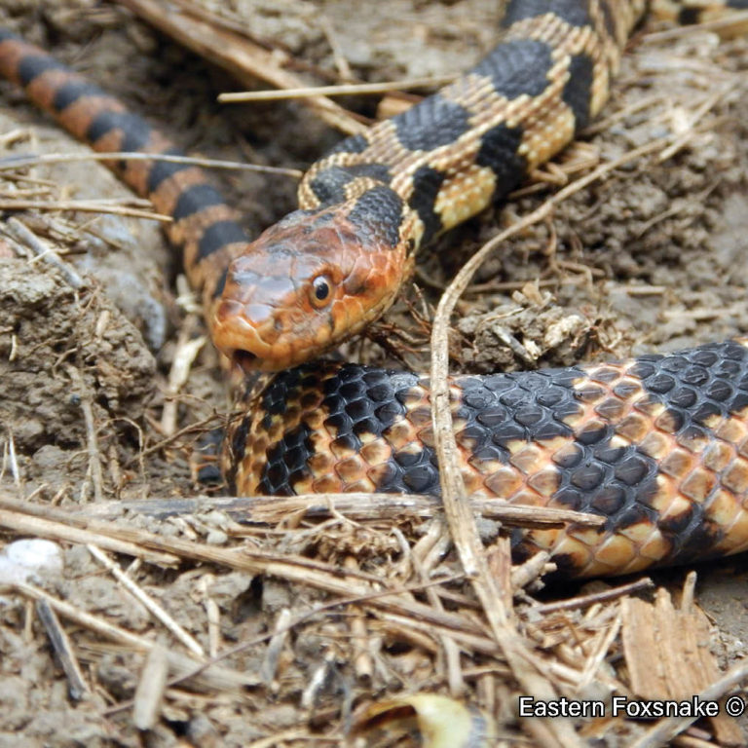](https://www.sydenhamriver.on.ca/sydenham-sar/snakes/)

#### [**Snakes at Risk**](https://www.sydenhamriver.on.ca/sydenham-sar/snakes/)

[Eastern Foxsnake](https://www.sydenhamriver.on.ca/sydenham-sar/snakes/eastern-foxsnake/)

[Eastern Hog-nosed Snake](https://www.sydenhamriver.on.ca/sydenham-sar/snakes/eastern-hog-nosed-snake/)

[Eastern Milksnake](https://www.sydenhamriver.on.ca/sydenham-sar/snakes/eastern-milksnake/)

[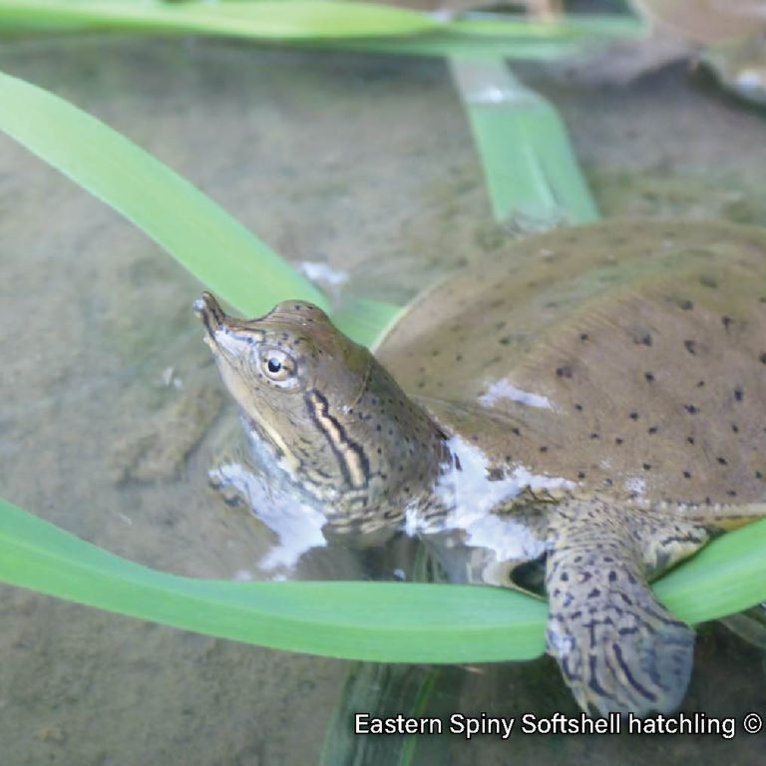](https://www.sydenhamriver.on.ca/sydenham-sar/turtles/)

#### [**Turtles at Risk**](https://www.sydenhamriver.on.ca/sydenham-sar/turtles/)

[Blanding’s Turtle](https://www.sydenhamriver.on.ca/sydenham-sar/turtles/blandings-turtle/)

[Midland Painted Turtle](https://www.sydenhamriver.on.ca/sydenham-sar/turtles/midland-painted-turtle/)

[Northern Map Turtle](https://www.sydenhamriver.on.ca/sydenham-sar/turtles/northern-map-turtle/)

[Snapping Turtle](https://www.sydenhamriver.on.ca/sydenham-sar/turtles/snapping-turtle/)

[Spiny Softshell](https://www.sydenhamriver.on.ca/sydenham-sar/turtles/spiny-softshell/)

#### **How are SAR protected?**

The federal Species at Risk Act (SARA) and the Ontario Endangered Species Act, 2007 (ESA) automatically protect species classified as extirpated, endangered or threatened as well as their habitat. Through the 1996 Accord for the Protection of Species at Risk, the federal, provincial, and territorial governments agreed to develop complementary legislation and programs to effectively protect SAR throughout Canada.

For species listed as threatened, endangered or extirpated, **it is illegal to**:

* kill, harm, harass, capture, or take an individual
* possess, collect, buy, sell or trade an individual
* **damage or destroy the habitat**

In light of this information alone it seems obvious the proposal by York1 cannot be allowed to go forward!

Of course there are other issues that would result from the dump site such as increased vehicular traffic, which local roads are not designed to handle, constant truck noise, site smashing and grinding noise, dust, odour, and other air emissions (think diesel).

But back to the Environment…

There is a feeder waterway, called Molly’s Creek which is adjacent to the proposed dump site (see Fig. 1). This spring-fed creek feeds directly into the East Sydenham River and is of utmost concern for the probable facilitation of pollution spread.

As presented on March 1st, 2024, by York1 at a town meeting where York1 had a hydrologist to show site plans regarding storm water management, it was stated by him that there would be holding ponds that would overflow right into Molly’s Creek during heavy rain events. The holding ponds are meant to handle leachates. Due to the multitude of highly concentrated water substances landfill leachate is one of the most difficult waste waters to handle or treat. Even designs meant to handle 100 year rain events, of which there have been several recent ones, and more are likely to keep coming due to climate change, would obviously allow contamination of the environmentally risk averse Sydenham River.

## Conclusion

Our whole community is voicing its concerns regarding the pollution that would occur, especially, but not limited to, ground and surface water contamination by leachate, surface runoff, and contaminant discharge.

And again I must mention some of the other issues of concern. NOISE, traffic, dust, pollution, and property devaluation for the whole area are only some of the detrimental issues. The list is long.

I therefore voice my concerns, in concert with the whole community of Dresden and surrounding area, regarding the proposed dump site expansion put forth by York1.

Thank you for your time and consideration.

## Supplementary Figures and Tables: Fig. 1.

## 

