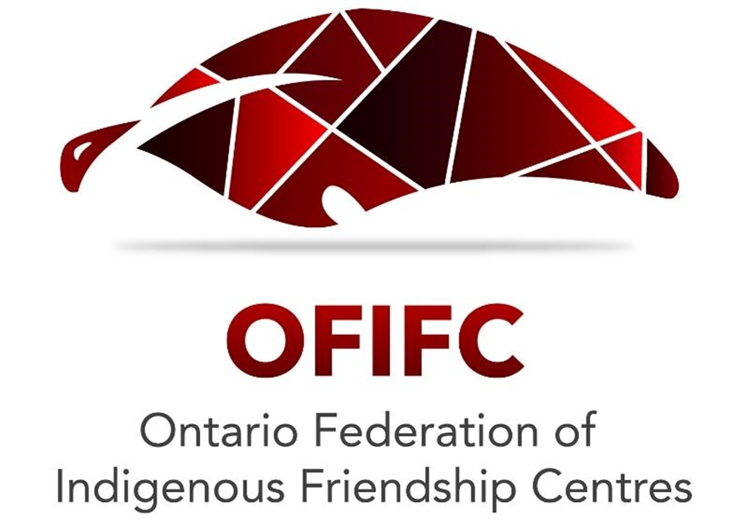

May 2024

Feedback on Southwestern Ontario Transportation Planning Study

Introduction
Over the past 60 years, Friendship Centres have been increasingly vocal about a central issue that affects their ability to serve urban Indigenous community members – access to affordable, adequate transportation.
When developing transportation policy and plans, it is important for the Ontario Ministry of Transportation (MTO) to understand the historical, social and economic context in which urban Indigenous communities are situated.

The legacy of colonialism continues to threaten the well-being of urban Indigenous communities. While the impact of residential schools, and Sixties Scoop, and other failed historical government policy continue to reverberate through our communities, modern-day government policy still carries colonial concepts and ways of interacting with community that continue to create negative outcomes for urban Indigenous communities.

Today, 88% of Indigenous people in Ontario live in cities, towns and rural areas. Urban Indigenous communities continue to face unacceptable service gaps across areas such as transportation, health, education, child care, and housing, and face daunting barriers that get in the way of achieving a quality of life that residents of Ontario should expect.

The Friendship Centre movement has grown significantly since the late 1950s when Indigenous community centres were first established. Today, the 31-member Friendship Centres in Ontario operate the largest urban Indigenous social infrastructure system in the province.
Friendship Centres are dynamic hubs of economic and social convergence that support urban Indigenous communities to thrive. Friendship Centres respond to the needs of tens of thousands of community members every day, and significantly contribute to local economies by employing hundreds of program workers and support staff in urban communities across Ontario.
Our centres actualize the inherent rights outlined in the United Nations Declaration on the Rights of Indigenous People (UNDRIP) by creating an avenue for urban Indigenous people to access their right to accessible and culturally appropriate programs and services.
Our centres provide access to wraparound programs and services across the life cycle including prenatal care, early on, child care, high school, food security, Indigenous justice, employment and training, housing, homelessness prevention, long-term care and more. Friendship Centres are also status blind, meaning any self-identifying Indigenous person can access Friendship Centre services.
Four Friendship Centres are located in southwestern Ontario:
- Sarnia-Lambton Native Friendship Centre (Sarnia)
- M’Wikwedong Native Cultural Resource Centre (Owen Sound)
- N’Amerind Friendship Centre (London)
- Can-am Indian Friendship Centre (Windsor)
The services that Friendship Centres provide are relied upon by the most vulnerable members of our communities, those most impacted by intergenerational trauma caused by colonization. Friendship Centre programs are frequently tailored to meet the needs of the elderly, disabled, and most marginalized individuals as well as those in crisis. These community members are oftentimes on fixed incomes and living in precarious situations. They lack access to personal vehicles, and are often living in places without safe, reliable, affordable and accessible public transportation.

Friendship Centres are acutely aware and knowledgeable about the local transportation barriers and gaps facing their communities because they step in to fill these gaps, out of necessity, and without adequate funding to do so.

Given that the vast majority of urban Indigenous people live in Ontario live in cities, towns and rural areas, it is critical for all levels of government to ensure that urban Indigenous organizations are included in funding and processes that inform policy and decision-making.

Feedback
After reviewing the proposal and supporting materials related to the Southwestern Ontario Transportation Planning Study, the OFIFC recommends that the overall study goals are amended to create a new goal related to implementing solutions to systemic transportation gaps and barriers in urban Indigenous communities.

As outlined in recent feedback to the Ministry of Transportation, the OFIFC recommends MTO establish an urban Indigenous transportation technical table comprised of the OFIFC and other provincial urban Indigenous organizations to inform regional planning and the provincial plan.

We recommend that several of the outcomes in the “Phase 3 Summary” are amended and become objectives of this new overall goal related to urban Indigenous communities.

As the materials state, outcomes in the “Phase 3 Summary” do not reflect government commitments and are for planning purposes only. We urge MTO to fulfil its reconciliatory responsibilities to urban Indigenous communities by committing to these outcomes and by making them objectives of the study. The current outcomes include:
- Provide equitable access to critical services and employment using public transit.
- Identify and implement transportation initiatives tailored to the needs of and opportunities related to Indigenous communities.
- Combat human trafficking through training to increase recognition and reporting, posting educational material with the Canadian Human Trafficking Hotline and working with key partners, including MTO agencies, to increase awareness of human trafficking.
- Assess and address transportation needs in equity-deserving communities (e.g., Indigenous and racialized communities, low income communities, rural communities, and persons with disabilities) through service guidelines, funding considerations, and other policy mechanisms.

Proposed Amendments and Considerations:
- Under #1 above, it is important to understand that providing access to critical services includes the culturally appropriate programming and social services of Friendship Centres which are critical to the wellbeing of urban Indigenous people and communities.
We strongly urge MTO to ensure that Friendship Centres are located on bus routes with reliable, affordable, safe and sufficiently frequent service. To ensure that individuals with mobility issues can access the Friendship Centre from the bus stop, there needs to be a bus stop directly outside of Friendship Centres.

We also urge the study planners to work with urban Indigenous organizations to ensure that bus routes operate from the Friendship Centre to other community-identified essential services such as affordable grocery stores and affordable housing that meets the needs of community.

The COVID-19 pandemic revealed the extent of the housing crisis which is contributing to rising rates of Indigenous homelessness. Insufficient, inadequate, and unaffordable housing disproportionately affects Indigenous people who are more likely to experience homelessness, racism in the rental market, and barriers to home ownership. Current waitlists for adequate affordable housing span years.

Transit-oriented development must be coupled with permanently affordable housing development. In instances where public transportation options improve, especially in small cities and towns, it drives up the cost of housing and makes it more difficult for those who are marginalized and close to poverty to access affordable housing. Much-needed investments in public transportation must be accompanied by significant investments in a range of affordable housing options including social housing.

A new approach to housing affordability should be bold, transformative for all, and guided by a strategic approach. The 2021 HUMA Committee Report on urban Indigenous housing found that Indigenous-led solutions to housing needs are the best answer to the housing crisis, but Indigenous housing providers are inadequately resourced to implement housing solutions.1 The National Inquiry into Missing and Murdered Indigenous Women and Girls identified the need for Indigenous-designed and developed housing that meets community needs.
- #2 and #4 can be merged . Funding and policy changes should include allocating sufficient (and non-application based) investments in the community transportation services of Friendship Centres. Due to systemic gaps and barriers, Friendship Centres provide intercommunity transportation as well as local transportation and medical transportation to many community members. However, demand for these services outweigh Friendship Centre resources and Friendship Centres are not renumerated in kind. Friendship Centres require funding to purchase vehicles, retrofit vehicles to be more accessible, hire dedicated drivers, and pay for vehicle maintenance.

We also recommend MTO implement sufficient para-transit services that address transportation needs for people requiring mobility and accessibility supports particularly in rural communities. Where these services exist, they can be almost impossible to secure and secured bookings for critical appointments are frequently cancelled due to high demand.

The OFIFC also wants to work with the Ministry of Health and Ministry of Transportation to inform systemic solutions to medical transportation gaps in urban Indigenous communities. Demand for medical transportation has sharply increased since the pandemic. Our Centres are increasingly subsidizing the cost of medical transportation due to pervasive barriers and gaps. This is an unsustainable situation that is unfairly draining Friendship Centres resources and placing the health and wellbeing of community members at risk.

- Under #3 above, the OFIFC recommends that study’s objectives clearly state that MTO will work with urban Indigenous organizations to ensure that transportation planning addresses violence against Indigenous women and girls and 2SLGBTQQIA+ individuals through measures that include aligning transportation design and investments with the Calls to Justice of the National Inquiry into Missing and Murdered Indigenous Women and Girls (NIMMIWG).

Local Friendship Centre Feedback

To inform the study, the OFIFC was able to collect new feedback from two of the four Friendship Centres in southwestern Ontario. The OFIFC is able to connect with all four Friendship Centres to continuously inform the study and facilitate implementation of Friendship Centre feedback. As mentioned early, the OFIFC recommends this is accomplished through the creation of an urban Indigenous transportation table.
Sarnia-Lambton Native Friendship Centre
At this Friendship Centre, members have great difficulty accessing the limited public transportation system. Buses are so unreliable that the vast majority of members don’t use public transit. It is also unaffordable. However, if service was more reliable, more people might invest in bus passes that reduce the cost. The Friendship Centre is also not included on a bus route, and there is no public transportation outside city limits which leaves many families without access to the Friendship Centre.
The Friendship Centre pays for taxi service for clients of its Life Long Care program because it is the only way for them to access the Friendship Centre. Taxi services are very expensive in Sarnia, even within city limits. For a one-way ride to the Friendship Centre, it costs an average of $20. Furthermore, the wheelchair accessible taxi service is in such high demand that it is practically impossible to book. Even when this service is secured ahead of time, the service frequently cancels and can’t be relied upon when clients have important medical appointments.
The Friendship Centre recently secured funding to purchase two vans, one of which will be wheelchair accessible. However, the Centre needs funding for a dedicated driver.
The Friendship Centre reports that regional and intercommunity transportation is also poor in the area. Only one train or bus operates each day to Toronto, London and Windsor. It departs early in the morning and returns at night.
TLack of transportation creates safety risks for Indigenous women, girls and 2SLGBTQQIA + individuals. Without access to transportation, it is difficult to flee violent situations and individuals are more likely to hitchhike and accept rides from dangerous peoplehe Canadian Centre to end Human Trafficking has identified Highway 401 as a corridor susceptible to human trafficking due to the populous areas it crosses. Sarnia is now considered a commercial sex market.
M’Wikwedong Native Cultural Resource Centre (Owen Sound)
There is a bus route to the Friendship Centre in Owen Sound but it is unreliable and operates every 40 minutes or longer. There is also no bus stop outside the Friendship Centre, which means seniors and those with mobility issues cannot get to the Friendship Centre from the bus stop. The bus route also does not run the whole length of the city, which hinders access to necessary services including the local No Frills.
Additionally, there is no public transportation after 6 p.m. which has prevented the Friendship Centre from offering evening programming related to substance use unless it arranges transportation for everyone.
The taxi shortage in Owen Sound also results in long wait times that result in member missing their programming. The Friendship centre covers this expense, which costs the Friendship Centre between $800-$2000 a month. There is also no regional transportation that serves people in an affordable, efficient way. Transit is unavailable for those outside the main core of the city and in the numerous smaller hamlets and neighbouring communities. Transit is also inaccessible for service users who require transportation to and from nearby reserves.
Lack of transportation creates safety risks for Indigenous women, girls and 2SLGBTQQIA + individuals. Without access to transportation, it is difficult to flee violent situations and individuals are more likely to hitchhike and accept rides from dangerous people. The Canadian Centre to end Human Trafficking has identified Highway 401 as a corridor susceptible to human trafficking because of the populous areas it crosses. Sown Sound is now considered a commercial sex market.
The Friendship Centre requires funding to purchase an accessible passenger van and to hire a dedicated driver.

