This is our comment for ***ERO 019-8462 - Review of proposed policies for a new provincial planning policy instrument*** that requests feedback to *the proposed policy concepts and proposed wording in the land use policy document*.

The ERO 019-8462 item outlines five focus areas for the proposed Provincial Planning Policy instrument as follows:

1. Generate increased housing supply
2. Make land available for development
3. Provide infrastructure to support development
4. Balance housing with resources
5. Implementation

Our feedback will isolate on the two (boxed below) highlighted items taken from point 5. Implementation.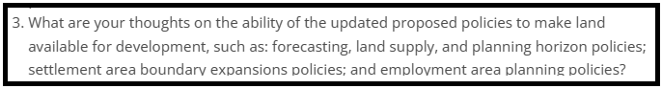

and

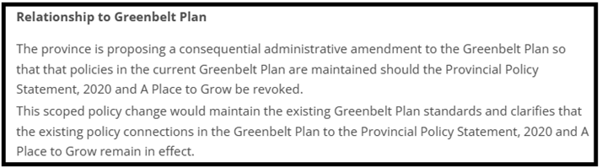

Since its inception in 2005, the Greenbelt Act has made accommodation to review and make changes to its mapping every 10 years. The last review was in 2015 (and after its completion) lands were both added to and removed from the Ontario Greenbelt. The next scheduled Greenbelt Plan review will be in 2025.

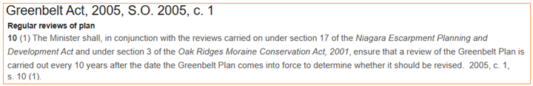

The Greenbelt Act states there is a requirement to “*ensure that a review of the Greenbelt Plan is carried out every 10 years after the Greenbelt Plan comes into force to determine whether it should be revised”*. This review provides an opportunity for municipalities to request Greenbelt Area boundary revisions by way of a Co-Ordinated Land Use Planning Review Panel. At this time, with housing shortages as well as climate concerns, there has been emphasis on making large investments in mass public transportation to allow for intensification of housing developments in built-up urban areas. The new proposed Provincial Planning Policy instrument must incorporate wording to allow revisions as permitted by the Greenbelt Act in its **Regular reviews of plan** section. Especially to allow for the expansion of municipal Urban Settlement Areas **(SINCE THE PLANNING ACT - BILL 185 - DOES NOT ALLOW URBAN EXPANSION INTO GREENBELT LANDS).**

**Specific to the thought on *“ability of the updated proposed policy to make land available for development”* presented in ERO 019-8462, we feel the new proposed policy falls short on providing a clear path to make Greenbelt Plan boundary revisions that would allow an Urban Settlement Area to expand into a Major Transit Station Area (MTSA).**

In this ERO item, the province requests feedback *“on the ability for the updated proposed policies to make land available for development, such as: forecasting, land supply, and planning horizon policies; settlement area boundary expansion policies; and employment area planning policies”*. Especially to provide for development in a MTSA.

We ask for the new Provincial Planning Policy instrument to incorporate specific wording to permit expansion of an Urban Settlement Area into a MTSA. An update must provide guidance for applying tests and weighting factors (as well as conditions) when designating lands that belong in the Greenbelt boundary. **Exhibit-2** below provides a summary on this topic which speaks to the case for the Town of Grimsby where infill urban lands were wrongfully designated under Specialty Crop in the Greenbelt Plan (2005). A parcel of land in the MTSA has been locked out of the Grimsby Urban Settlement Area by the Greenbelt boundary because there is no effective **policy** consideration to allow for change to the designation. The Town of Grimsby has repeatedly made requests to the province to correct this without success.

A mechanism OR process needs to be **legislated** in the Provincial Planning Policy instrument to allow for a re-evaluation of Greenbelt designated lands during the 10-year Greenbelt Review **OR** be implemented as a defined overriding policy to permit for an Urban Settlement Area expansion into the Greenbelt – on the condition where lands are:

* in a defined MTSA
* in an urban area with existing built-up infrastructure that is near a town centre and amenities
* included in the Greenbelt by mistake as noted in **Exhibit-1** or does NOT have the characteristics to be designated as Greenbelt lands based on selection criteria rules outlined in **Exhibit-2**.

The Town of Grimsby is a municipality in the Region of Niagara with a population of 30k+. **MAP-1** below provides an aerial view of the west end of the town and shows strategic landmarks as well as the MTSA in the red circle. Key notes:

* The area in the bottom and left-hand quadrant of the MTSA circle is outside of the Urban Settlement Area boundary (blue lined) as it has been locked out by the Greenbelt Plan mapping since it was adopted in 2005.
* There is a **Planned Higher Order Transit Station** - the Grimsby GO Train Station approved by Metrolinx (2016).

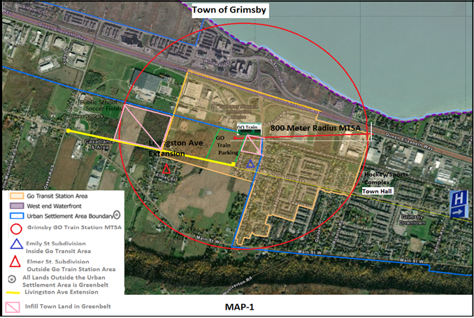

**TABLE-1** below itemizes Key Landmarks (contained in the MTSA) listed on **MAP-1:**

|  |  |  |
| --- | --- | --- |
| **TABLE-1 – Items labeled in the MAP-1 Legend** | | |
| **Item** | **Key Landmarks** | **Description** |
| **1** | 800 Mete Radius MTSA Circle (red circle) | Defined MTSA boundary established by Province |
| **2** | GO Train Station Site. | North side of tracks - Planned Higher Order Transit Station and parking lot (2011) - directly off QEW Casablanca Blvd interchange. |
| **3** | Additional GO Train Station Parking. | South side of tracks - Metrolinx, Region of Niagara and Town of Grimsby Acquired 14-acre GO Train Parking Lot (2015).  Access to GO Train Station to be upgraded with new on-off ramps to Casablanca Blvd interchange and service roads with a comprehensive reconstruction project scheduled for 2024. |
| **4** |  | EA Approved Future Regional Road about 1 km in length - completing a major east-west corridor to the GO Train Station Parking Lot. |
| **5** |  | A fully serviced Subdivision that is within the GO Transit Study Area defined in OPA-6 Secondary Plan but is not in the Town’s Urban Settlement Area because it is in Greenbelt. |
| **6** |  | A fully serviced Subdivision that is outside the GO Transit Study Area defined in OPA-6 Secondary Plan but is not in the Town’s Urban Settlement Area because it is in Greenbelt. |
| **7** |  | Vacant land-parcels within the MTSA that are not in the Town’s Urban Settlement Area because it is in Greenbelt. Has existing significant long-term investment in municipal infrastructure. |

Note that lands within the west-end of the MTSA have already been serviced by the region when **Item 4 – Livingston Ave Extension** was allocated during the 1970’s with underground infrastructure including Natural Gas, Bell, Water and Sewer lines. These were implemented to provide services to the existing subdivisions noted in **MAP-1** as **Item 5 - Emily St Subdivision Inside GO Transit Study Area** and **Item 6 - Elmer St Subdivision Outside GO Train Station Study Area** and also to prepare for future growth. The **GO Train Station Study Area** (shaded in yellow on **MAP-1**) is mapped in the Grimsby GO Transit Station Secondary Plan OPA-6. We find it unreasonable the outlined MTSA lands that include existing fully serviced subdivisions are mapped in Greenbelt.

Make special note of the 2 land parcels outlined in the pink boxes identified as **Item 7 - Infill Town Land in Greenbelt,** they have not been included in the Grimsby Urban Settlement Area Boundary shown on **MAP-1.** These prime TOC development parcels were mistakenly included in the Greenbelt boundary when it was originally mapped in 2005 and was not corrected as was promised by the province during the 10-Year Greenbelt Review in 2015. These are vacant and fallow lands, see details in the newspaper article in **Exhibit-1** below for a further description on this oversight.

To support their request for the removal of lands from the Greenbelt during the 10-Year Greenbelt Review in 2015, the Town of Grimsby commissioned a comprehensive agricultural land study that concluded the property within the MTSA “*can reasonably be removed from the specialty crop designation*”.

A summary of findings from the studies by professional agrologists is detailed in **Exhibit-2** below.

In addition to the strategic “Key Landmarks” listed in **TABLE-1** that are located directly within the MTSA; there are other landmarks nearby to the MTSA that are supportive of a TOC. They are labeled on **MAP-1** and include:

* A public school that abuts to the MTSA.
* A baseball and soccer field with parkland and leisure area that abut to the MTSA.
* A hockey and sports complex (Peach King Centre) contained on grounds that include Grimsby City Hall.
* The new $224 million Grimsby Hospital currently under reconstruction and scheduled for completion in 2026.

The Town of Grimsby has repeatedly made request to the province to permit expansion of their Urban Settlement Area to include lands in the Grimsby GO Train MTSA outlined in **MAP-1**.

To review the Greenbelt revision requests made by the Town of Grimsby (to the province) see:

* **Exhibit-3 (**by Mayor of Grimsby at the scheduled 10-Year Greenbelt Review in 2015).
* **Exhibit-4** (in response to the Hon. Paul Calandra Minister MMAH letter for December 2023).

The Greenbelt proves to be an obstacle for change since the specification criteria to designate Specialty Crop lands in the Provincial Policy Statement (2014 as well as 2202) is vague. The proposed new Provincial Planning Policy instrument fails to provide an update on guidance that would allow for a concise interpretation for the definition of Specialty Crop Area lands so they may be revised if justified. The Planning Act – Bill 185 – does not permit lands that are Greenbelt Area to be incorporated into an Urban Settlement Area expansion to allow for development and we feel this is an oversight.

**Exhibit-2** provides a summary of recommendations based on conclusions in the **AgPlan Limited – Grimsby Specialty Crop Greenbelt Study (2016).**  It speaks to definitions in the Provincial Policy Statement (2014 as well as 2020) that are vague, specifically for the designation of Greenbelt Specialty Crop Area lands. We make request of the province to include updates to the Provincial Planning Policy instrument that would allow for a fully defined and transparent method for designating lands within the Greenbelt (as outlined in the AgPlan Ltd Study). This would allow for consequential consideration during a Greenbelt Act **Regular reviews of plan** session that might allow for Specialty Crop designated lands in an MTSA to be revised so that it might be included in an expanded Urban Settlement Area.

Relevant information provided in previous ERO item Comments:

RESPONSE to ***ERO 019-7739 -> Proposal to return lands to the Greenbelt - Greenbelt Statute Law Amendment Act, 2023*** with Comment Id 94830. The Supporting Document in this ERO item comment provides a comprehensive history and background for MTSA lands in a slide presentation format. To review, open the comment and select the attached document Grimsby31AcrePMTSAGreenbeltRemovalERO019-7739Comment.pdf.

RESPONSE to ***ERO 019-6813 -> Review of proposed policies adapted from A Place to Grow and Provincial Policy Statement to form a new provincial planning policy instrument*** with Comment Id 88023

**Exhibit-1**

News article providing a history of a mistake made in the original mapping of the Greenbelt boundary in 2005.

The article points out the area in west Grimsby (that includes the MTSA) was never intended to be added into the Greenbelt boundary in 2005 and it was NOT corrected or removed from the Greenbelt by the Greenbelt Review Panel in 2015 (as was promised by the province at the time).

An **official letter of objection** was filed by the then Town of Grimsby Mayor and Council to the Province in February 27, 2017, after the Province’s 2016 Co-Ordinated Land Use Planning Review Panel’s decision for Grimsby failed to make the appropriate and promised changes requested by Grimsby. A summary of the letter is shown in **Exhibit-3** below.

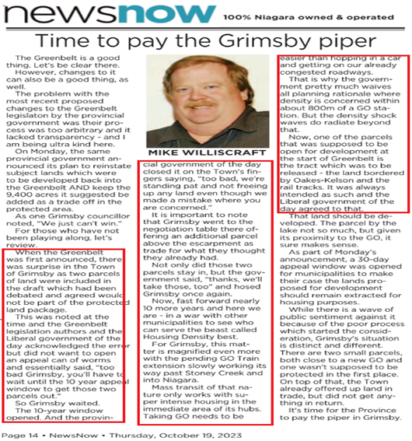

**Exhibit-2**

Studies were conducted by 2 prominent agrologist companies on separate occasions. Conclusions of the studies provided scientific evidence the lands within the Grimsby GO Train MTSA are not suitable to be designated as Specialty Crop.

1. **AgPlan Ltd. Study**

|  |
| --- |
| The Study Report's conclusion (by Michael K. Hoffman of AgPlan Limited) for the interpreted definition for **Specialty Crop Area** in theProvincial Policy Statement was as follows:  *The definition* (i.e., for a Specialty Crop Area) *can be interpreted to mean that there are seven tests to be applied when designating specialty crop areas:*   * 1. *Current production of fruits and vegetables (land-based and/or in greenhouses)*   *where,*   * 1. *greater than 50% of a given area is used for that production,*   2. *where soils are suitable (interpreted to mean have the potential for relatively high yields) for the production of those crops,*   3. *where climate conditions allow for fruit and vegetable production (and that climate is unusual in the context of the Province),*   4. *where the farm population has skills and experience in fruit and vegetable production, in addition to*   5. *where there is capital investment in infrastructure related to that specialty crop production and,*   6. *where there are facilities to produce, store or process specialty crops.*   *The PPS (2014)* ***is mute*** *with respect to how many of the seven tests need to be met in order to be able to designate a specialty crop area and does not provide any guidance with respect to the relative importance (weighting) of the seven characteristics. Additionally, the PPS (2014)* ***provides no guidance with respect to a minimum size of area designated as specialty crop area****.*  *7.0 CONCLUSIONS/OPINIONS*  *The findings of this study demonstrate that the lands proposed to be removed from the specialty crop area in Grimsby are relatively poor for the production of specialty crops.*  *Several of the tests for the designation of a specialty crop area are not met:*   * *specialty crop production is not predominant,* * *soil capability and soil potential in Grimsby is not the best found in Niagara and in some areas is diminished due to non-agricultural development,* * *fewer farms and farmers are producing fruits and vegetables within Grimsby and, as a result, there is diminishing infrastructure as well as fewer farmers skilled in the production of fruits and vegetables.*   *Given the characteristics of the lands in Grimsby proposed to be removed from the specialty crop area (areas identified within this report as one and two and located north of the Niagara Escarpment), I am of the opinion that the lands can reasonably be removed from that specialty crop area designation.* |

See the full copy of the **AgPlan Limited – Grimsby Specialty Crop Greenbelt Study** attached EXHIBIT-2a document in the Supporting Documents of this ERO item comment.

1. **DBH Soils Inc. Study**

|  |
| --- |
| The following is stated in the Agricultural Impact Assessment (AIA) of March 25, 2022 provided by **DBH Soils Inc** for the redesignation request of Greenbelt land at 502 Winston Rd.   * *The soils in the Secondary Study Area* ***(includes the Grimsby MTSA)*** *comprise a mix of specialty crop ratings with much of the area identified as shallow soils with limited specialty crop suitability as shown by ratings of Poor, Poor to Very Poor and Unsuitable.* |

See the full copy of the **DBH Soils Inc – AGRICULTURAL IMPACT ASSESSMENT (AIA) STUDY** attached EXHIBIT-2b document in the Supporting Documents of this ERO item comment.

The conclusions of the studies by AgPlan Ltd and DBH Soils Inc are further supported by evidence shown on **MAP-1** where lands within the Grimsby MTSA (in scope of a **Planned Higher Order Transit Station** - Grimsby GO Train) are:

* Without Specialty Crops.
* Made up of fragmented parcels of land.
* Infill for an established neighborhood with access to public utilities, transportation, and modern conveniences as evidenced by the inclusion of 2 fully serviced subdivisions in the 800-meter MTSA boundary.

**Exhibit-3**

On February 27, 2017 then Grimsby Mayor Bob Bentley submitted a letter of objection to the Greenbelt Site Specific Review Panel’s decision to deny the Town of Grimsby’s request to modify the Greenbelt boundary by swapping land to allow for urban expansion. The following is an excerpt from that letter:

*“In the absence of criteria being provided by the province to determine which lands are suitable for Specialty Crop / Tender Fruit and Good Grape Agriculture, the Town of Grimsby commissioned an independent and wholly unbiased study of agricultural viability in Grimsby's west end by a reputable and experienced agricultural consultant.*

*The study was completed by Michael Hoffman, of AgPlan Limited, an expert in the field of agricultural viability Analysis. Mr. Hoffman's study concurred with the assumptions of the Town. The AgPlan report was included with the Town's submission to the Province in October 2016 and was handed personally to the Ministry of Agriculture.*

*The Province had provided no evidence to contradict the conclusions contained in this Report, particularly in relation to the lands we have prioritized in this letter for redesignation. I am resubmitting this study with this letter for your perusal”.*

The full letter of complaint (dated February 27, 2017, by the Mayor of Grimsby to the Greenbelt Site Specific Review Panel) is attached EXHIBIT-3 document in the Supporting Documents of this ERO item comment.

At the end of The Town of Grimsby’s 2016 Co-Ordinated Land Use Planning Review process the panel delivered its decision:

* Did not remove any of the requested 250 ha of land tabled for consideration to be swapped out of Specialty Crop designation in west Grimsby.
* Did not return the any of the 923 ha of land offered by Grimsby in the land swap. These lands were newly brought into the Ontario Greenbelt Specialty Crop designation only after the 10-year review process was conducted for 2015 and despite the identified shortcomings identified in the PPS for designating Specialty Crop Lands.
* Did not make a response or changes after the Town of Grimsby Mayor’s mailed objection letter and resubmission of the study.

**Exhibit-4**

The Hon. Paul Calandra MMAH sent a letter dated November 2, 2023 to solicit a response **RE: Announcement Impacting Provincial Decisions on Municipal Official Plans/Official Plan Amendments** to a number of municipalities including Grimsby. The letter had a deadline for municipalities to respond by December 7, 2023.

On November 20, 2023, the Town of Grimsby met to document their official response PA-23-36. The following is the conclusion presented by the town to the province which advocates ***for a reasonable process to consider lands within the Greenbelt north of the Escarpment for potential expansion to accommodate residential and commercial / employment growth*** as noted below (the lands requested for potential expansion to accommodate growth includes lands in the MTSA):

*Conclusion (in the Town of Grimsby response to the MMAH):*

*The Town is once* ***again*** *asking the Province for consideration of the unique circumstances in Grimsby. While the 2022 removals of land from the Greenbelt was not anticipated, the Town cooperated with the Provincial process. At the direction of the Province, the process proceeded on an accelerated basis. The reversal in October of 2023 was without consultation with impacted municipalities. The Town has* ***long advocated*** *for a reasonable process to consider the lands within the Greenbelt north of the Escarpment for potential urban expansion to accommodate residential and commercial / employment growth.*

*The Town has proposed an exchange of lands, and undertaken an agricultural study that determined that the specialty crop designation could reasonably be removed. This most recent reversal would once again not reflect the needs of the Town over the long term. The Town requests compensation for the monies expended to follow the 2022 removal process, that the removed lands continue to be kept out of the Greenbelt, and that a process be developed that considers municipal requests for the reasonable expansion of the settlement area in the Greenbelt in consideration of Grimsby’s unique circumstances.*

The full response from the Town of Grimsby is attached EXHIBIT-4 document in the Supporting Documents of this ERO item comment.