COMMENT 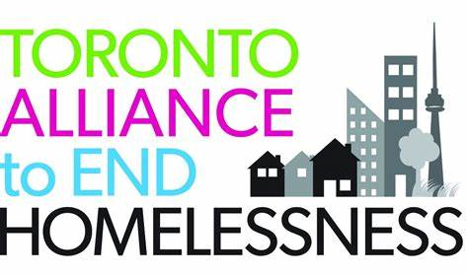

To: Municipal Finance Policy Branch, Attn: Ruchi Parkash.
Date: Friday, May 10, 2024.
Re: Proposed Planning Act, City of Toronto Act, 2006, and Municipal Act, 2001, Changes (Schedules 4, 9, and 12 of Bill 185 – the proposed Bill 185, Cutting Red Tape to Build More Homes Act, 2024). - Ministry of Municipal Affairs and Housing.
ERO: 019-8369.
________________________________________________________________________________________________________

The Toronto Alliance to End Homelessness (TAEH) is a community-based collective impact initiative committed to ending homelessness in Toronto. Our network includes not-for–profit organisations that support those living with homelessness and those who are housed and who must spend a disproportionate amount of income on housing., as well as affordable and supportive housing developers, property managers, and landlords.

As part of our mission, TAEH works directly with the City of Toronto in its mandates surrounding homelessness and maintaining and growing affordable housing stock in the city, including engagement on client support services and funding. This includes TAEH co-chairing the Toronto Housing and Homelessness Service Planning Forum with both the City of Toronto Shelter, Supports and Housing Administration and the Housing Secretariat.

Recommendations.

- TAEH supports the proposed change to remove a minimum parking requirement for developments within Protected Major Transit Station Areas and Major Transit Areas.

- TAEH supports extending this removal to all developments within Transit Oriented Communities.

- TAEH supports the Minister removing zoning barriers as set out in ERO 019-8366, and includes the following two recommendations also found in a Comment filed in the file:

  - TAEH recommends that the province permit municipalities to enact inclusionary zoning by-laws, at their discretion, over all or part of the municipality; or that the City of Toronto be permitted to do so, in keeping with the longtime request from the City of Toronto for such zoning controls.

  - In the alternative, TAEH recommends that the province permit inclusionary zoning on all lands designated in Toronto as Major Transit Station Areas/Protected Major Transit Station Areas/Transit Oriented Communities and their equivalents in other municipalities; or that the City of Toronto be permitted to do so.

- TAEH supports the proposed change to allow the “decommissioning” of approved projects that fail to begin construction in a reasonable time. We further recommend that the provincial government discuss the appropriate length of time before this takes place with municipalities on an individual basis as each municipality will have its own opinion on the ideal length of time that is deemed acceptable before construction must begin on projects.

- TAEH recommends that the proposed limits on third party appeals to the OLT not be established. Alternatively, TAEH proposes that such limits apply only to affordable, supportive, and public housing projects, since there is a heightened need for such projects to be developed in comparison to private market housing in the context of municipalities achieving their housing targets by 2031.

- TAEH recommends that the province, instead of limiting appeals to the OLT, overhaul the OLT procedures to weed out frivolous appeals at an early stage and streamline the appeal hearing process, including greater limits on the grounds upon which an appeal can be made.

Thank you,
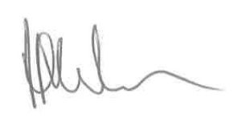
Peter G. Martin
Housing Solutions Manager
647-913-7305
peter@taeh.ca

