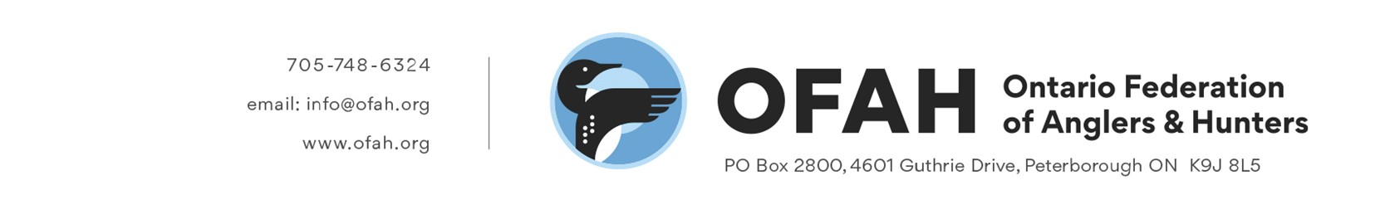
OFAH FILE: 794
August 28, 2024

MNR - PSD - Aviation, Forest Fire and Emergency Services
300 Water Street
Peterborough, ON
K9J 3C7

Email: WildlandFire@ontario.ca

Subject: ERO #019-8756 Modernizing wildland fire management in Ontario

The Ontario Federation of Anglers and Hunters (OFAH) is Ontario’s largest, non-profit, fish and wildlife conservation-based organization, representing 100,000 members, subscribers and supporters, and 700 member clubs. We have reviewed the “Modernizing wildland fire management in Ontario” posting and discussion paper and have answered the appropriate questions below.

“1. Do you support strengthening collective responsibility for wildland fire management in Ontario? What steps can be taken to immediately strengthen collective responsibility for wildland fire management?”

Yes, the OFAH supports strengthening collective responsibility for wildland fire management in Ontario. Redistributing responsibility should help address the increasing resource needs of wildland fire management, strengthen lines of communication, and, hopefully, increase accountability and subsequent cost recovery. As the climate crisis worsens, all measures to engage and involve the public in wildland fire risk reduction, and the development of a stewardship mindset for the natural environment, are also critically important.

We encourage the province to require industry and communities which exist in a wildland setting to be trained in terms of fire risk assessment and basic fire response.

Municipalities, in particular, have a role to play in fire management, and should be trained to apply the concepts of watershed protection as a fire reduction and mitigation strategy in their land-use planning. This means protecting wetlands (and their associated vegetation) on the landscape to be reservoirs of ground water and natural fire breaks.

2. N/A

3. N/A

“4. Industrial activity can cause wildland fires. Many types of industrial activities are already subject to various fire prevention rules and regulations. Do you have suggestions about how to improve the approach to preventing and preparing for wildland fires caused by industrial activity?”

In addition to above training needs for industry, we strongly advocate for development of a dedicated AFFES inspection unit. Considering the continued evolution of natural resource industry technology/methodology, a modern approach to compliance monitoring and promotion must include an effective inspection program.

ONTARIO FEDERATION OF ANGLERS AND HUNTERS
-2-

5. N/A

6. N/A

“7. What innovative approaches can we explore to collectively fund prevention and mitigation activities?”

The OFAH suggests the MNR consider an industry permitting process with variable fees made proportional to risk and consequences of a given project.

“8. How should MNR better prepare and respond to wildland fires?”

We strongly encourage the province to establish a risk-based model of wildland fire management which includes allowances for certain fires to play-out in a controlled manner. An affective and modern strategy should not stop at strengthening our ability to avoid or resist some of the negative social, economic and environmental consequences of wildland fires, but must also harness the positive force of fire. As per Tymstra et al.’s 2020 paper on wildfire management in Canada, “Strategically allowing more managed wildfire on the landscape using a risk-based approach contributes to disaster risk reduction through negative feedback.” while at the same time ensuring ecological processes that rely on fire are allowed to unfold. Controlled burning cannot fulfill this need alone. As a conservation-based organization, the OFAH would like to see more consideration for the critical role that wildland fires play in naturally ecology in Ontario’s management strategy, particularly for the boreal-shield ecozone.

We also encourage the MNR to establish a staff unit within the Ministry with the primary focus of forest-fire investigation. Relying on fire suppression teams to double as investigators is unlikely to produce an appropriate level of accountability and cost-recovery, making a dedicated unit with training on identification, record keeping, and analysis of the fragile evidence of fire necessary.

9. N/A

10. N/A

“11. Are these proposals the appropriate enforcement and compliance measures to support compliance?”
The FFPA is badly out-of-date in terms of inspection and enforcement authorities; the most modern statute that the MNR has available is currently the Invasive Species Act (ISA). It would be a good strategy to use the ISA as a model to develop a more comprehensive suite of inspection and enforcement tools for the FFPA. However, one shortfall of the ISA approach to authorities is in its placing section 16 (surveys) under the heading of inspections. Survey work of this type has context in fire risk mitigation activities but is not related to regulatory inspections and should therefore stand alone in the legislation.

In addition to the above recommendations, we encourage the Ministry to consider how they might grant authority for the crossing of private lands to carry out FFPA duties and actions on adjacent properties.

ONTARIO FEDERATION OF ANGLERS AND HUNTERS
-3-

“12. What additional measures or authorities should be considered to effectively encourage compliance with the Act or the regulations?”

A modern fire management regime must contain a variety of compliance actions equal to the variability in risk. As previously stated, the AFFES is lacking industry training requirements, improved self-monitoring, and regulatory inspections, and these should be prioritized.

“13. What further consequences should be contemplated for individuals, organizations and companies that fail to comply with the Act or the regulations?”

We recognize that AMPs are a potentially helpful tool in the toolbox of compliance incentivization and enforcement. However, we have several concerns about their use in the case of the FFPA:
- AMPs may confuse the public, due to the degree to which they vary from the penal system of ticketing/court attendance.
- In the past, AMPs have not considered the application of due diligence (i.e. EVAMPA). We feel this is an important consideration within the regulatory process.
- AMPs require the creation of a new bureaucracy to administer and oversee the program (including appeal tribunals). This would include a separate team of people responsible for issuing the processes and collecting fine moneys – this should not be yet another expectation of Enforcement Branch staff.
- AMPs may lack transparency, as the bureaucracy establishes the fines (including the collection of moneys), administers the program and acts as the tribunal for appeals.
- The current penal system allows for a graduated approach to compliance promotion, including issuing warnings, issuing tickets, making seizures, and having the accused attend court. We are concerned that the AMP approach does not add to the compliance promotion range of options in a meaningful way that would justify its additional burden.
- The claim that the AMP process reduces the burden on courts may be overstated, since most FFPA violations are commenced by “ticket” and most tickets are paid out of court. Therefore, there is very little burden on courts under the current penal process.

We appreciate the opportunity to comment on this matter and look forward to seeing the improvements to Ontario’s wildland fire management put into practice.

Yours in Conservation,
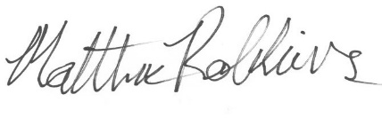
Matthew Robbins
Fish & Wildlife Biologist

cc: OFAH Board of Directors
OFAH Land Use/Access/Trails Advisory Committee
Angelo Lombardo, OFAH Executive Director
Matt DeMille, OFAH Executive Director (Incoming)
Mark Ryckman, OFAH Manager, Policy
Policy & Programs Staff

