Bill 212: Reducing Gridlock, Saving You Time Act, 2024 - Framework for bike lanes that require removal of a traffic lane

Environmental Registry of Ontario – ERO Number 019-9266

**City of Ottawa Comments**

**Introduction**

The City of Ottawa appreciates the opportunity to comment on Bill 212. This Bill has the potential to impact the City’s transportation goals and objectives, and as such, this submission offers suggestions on how the legislation and associated regulations may be developed in order to address the Ministry’s concerns yet allow the City to build an integrated transportation network serving all residents.

The City’s new Transportation Master Plan sets out general policies for all transportation modes and identifies a list of key standalone cycling projects to be implemented over the next 20 years. Residents from all areas of the city, representing a diverse range of perspectives and demographic groups, participated in the engagement process for the Plan, with over 4000 markers added to the interactive map identifying gaps in the active transportation network.

Cycling has seen a significant increase in recent years, with cycling mode share more than doubling between 2011 and 2022, consistent with long term trends noted in the City’s Transportation Master Plan (see chart below). This is evidence that the City’s investment in cycling infrastructure has attracted new riders.

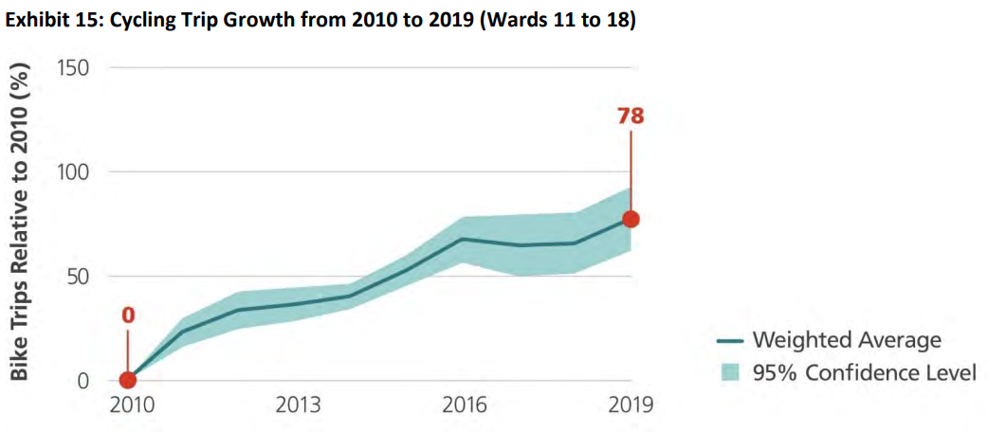

**Figure 1 Growth in Cycling Trips from 2010 to 2019 in Wards 11 to 18**

Cycling in Ottawa is not just a fair-weather activity. Cycling in January and February is growing about three times faster than cycling in general. The City has also found that about 11% of cyclists ride in both summer and winter, with many cyclists shifting to transit in the winter months. In all seasons, cycling is an important link to transit, supporting our shared investment in rapid transit. In fact, in both 2011 and 2022, fewer than half of trips into the downtown core were by car, showing how an integrated transportation system can address the needs of all residents.

The City has multiple bike counters at key locations and these counters provide count data throughout the day, during all seasons. The City would be happy to share results from these counters with the Ministry.

**Impacts to the City’s Cycling Plans**

The proposed Bill 212 is expected to have a significant impact on the planning, design, and implementation of the City’s cycling network.

The City conducts a robust review of all transportation projects to understand and mitigate the impacts to other travel modes. Cycling projects are no exception; extensive internal and external consultation is undertaken to ensure that all modes of travel – including driving, transit, trucks, and emergency vehicles – have an acceptable level of mobility. Cycling projects are only advanced where the analysis has demonstrated that the impacts are manageable, and traffic will continue to flow. Occasionally, projects may involve more significant trade-offs, and these projects require Council approval.

The City’s analysis is not limited to traffic impacts; safety is also an important consideration. Collision data and current design guidelines are all considered when planning cycling projects.

As noted above, the City already collects data and analyzes cycling projects to inform local decision-making, so this requirement is not new. However, sharing this information with the Ministry and awaiting a decision will extend the timelines for project implementation, which may impact project cost. Each traffic study is a detailed technical document with multiple appendices, typically ranging from 100-300 pages. Depending on the number of projects that would require Ministry approval each year, this could represent a significant strain on municipal and Ministry resources.

While the City appreciates the Province’s priority to maintain traffic flow, the City is also concerned that important cycling projects could be jeopardized by this legislation where the traffic impacts have been shown to be minor or acceptable. It is significantly more costly to implement cycling facilities within the boulevard (i.e., behind curbs) compared with repurposing existing underutilized road space. There are also potentially negative impacts to the rest of the road right-of-way if cycling facilities are not able to use existing road space and must be placed within the boulevard. This includes possible impacts to pedestrian facilities, street trees, public realm elements, and utilities. Adding another element that must compete for finite space may increase pressure for right-of-way widening, which will have the effect of significantly increasing project costs and may conflict with policies to make more efficient use of land to support development.

In summary, it is anticipated that the City’s cycling projects could be affected in several possible ways, including extending project timelines, increasing project costs, and eliminating some projects altogether. Should these effects materialize, this will impact the City’s ability to implement an integrated and connected transportation network, potentially reducing cyclist safety, increasing congestion (as more people continue to drive) and compromising efforts to create healthy communities that attract intensification and development.

In light of the above, we have several suggestions to make the process more effective and streamlined if the legislation moves forward.

**Suggested Exemptions**

* **Collectors and local roads**: Traffic impacts on collector and local roads tend to be minor and localized since traffic volumes are typically much lower. Collector and local roads are intended to provide access to adjacent properties and any impacts to these facilities are limited to the local community. In contrast, arterials are designed to move traffic throughout the city and have a much broader impact to the regional mobility network. Exempting local and collector roads would give municipalities opportunities to implement a comprehensive and connected cycling network using less important roadways.
* **Roads with traffic volumes below a given threshold**: In certain areas, the City of Ottawa has arterial roads with excess capacity. A simple but effective way to screen projects for traffic impacts would be to set volume thresholds for different classes of roads. For example, on suburban roads, the lane capacity is typically in the order of 1000 vehicles per hour. If the existing number of vehicles per lane is less than this threshold under the proposed design, the project would be exempt from requiring Ministry approval. Lower thresholds could be applied on commercial mainstreets.
* **Projects with no mid-block lane reductions**: In the media surrounding Bill 212, the focus has been on cycling projects that have resulted in lane reductions over an extended length (i.e. road diets). However, many cycling projects have no impact on the number of through lanes on the road, but may impact one or more auxiliary turning lanes at a particular intersection. It is our interpretation that these projects would also require Ministry approval despite the relatively minor impacts to traffic flow, even though that may not have been the intent.
* **Projects that are already in Preliminary or Detailed Design**: The City of Ottawa has a number of projects that are currently in the Preliminary or Detailed Design stage. The requirement for additional provincial approvals will delay these projects – many of which include other key elements such as road resurfacing or renewal of underground infrastructure. An extended transition phase would allow these important infrastructure projects to proceed.
* **Projects that are subject to an Environmental Assessment process** (e.g., a transit priority project that also includes the addition of cycling lanes): These projects already include a comprehensive assessment of impacts – including traffic impacts – and are also subject to extensive public consultation and review by provincial ministries. These projects should therefore be exempt from duplication of review.
* **Pilot projects of less than 2 years of duration**: These projects have a finite time period and using the pilot project approach allows the City to identify modifications to the design to address impacts. It also provides an opportunity to assess the results of the traffic analysis. Permanent implementation of the project (beyond the 2 year pilot) would continue to require Ministry approval, with the added benefit that the decision would be based on actual observed results.
* **Projects where a lane of traffic is removed, but the primary purpose for the lane conversion is not for cycling**, even if cyclists are allowed to use the lane. This situation can arise, for example, with the introduction of transit priority measures. Similarly, projects should be exempt where motor vehicle travel lanes are removed primarily to address a safety issue or for traffic calming, with bike lanes being a secondary consideration. Specifically, projects that modify a roadway to address a history of collisions involving people cycling or walking, or where observed vehicle speeds exceed the speed limit by 20% at the 85th percentile.
* **Projects with minor traffic impacts**: This exemption should apply where additional delay to motor vehicle traffic as a result of the lane removal is less than two minutes from the existing condition during peak periods for the affected traffic. This exemption should also apply where mitigation measures (e.g., through addition of new auxiliary lanes or signal optimization) reduces the impact such that the resulting impact to motor vehicle traffic is less than two minutes of delay from the existing condition.
* **Where bike lanes are identified in a municipal Transportation Plan and where there is no feasible alternative within 500 metres**: Diverting cyclists more than 500 m is a significant barrier to cycling comfort and should be avoided.

**Suggested Clarifications**

* It is our understanding that this legislation applies where the design of the bicycle lane “would reduce the number of marked lanes available for travel by motor vehicle traffic”. As a result, it is our interpretation that bus-only lanes are excluded, and would appreciate if this could be clarified in the Regulations. In rare cases, the City of Ottawa has bus-only lanes that are no longer needed (for example, due to the construction of parallel LRT facilities). Such lanes provide an ideal opportunity for improving cycling infrastructure with no impact to motor vehicle traffic.

**Process Suggestions**

* The Regulations should clearly define the timelines for Ministerial review and decision-making to reduce the impact of delays on municipal projects (suggested timeline: 60 days). If a decision is not rendered within the specified timeline, the project would be deemed to be approved. Since cycling projects are often bundled with other projects (such as road resurfacing or renewal), approval delays will also impact the schedule for these other critical projects which benefit drivers.
* The Regulations should clearly specify the review criteria, which should take into consideration impacts on all modes and should consider impacts on safety and also consider the overall impacts on the transportation network if the bike lanes were not implemented.
* The Regulations should clarify at what stage of design Ministry approval is required. It is suggested that Ministry approval be required at or prior to the Functional Design stage, similar to the Environmental Assessment process. Later stages of design are concerned more with technical matters like drainage and grading, signal pole placement, and signage. The City would like certainty that a particular project is approved prior to dedicating resources to future phases of design. Once approval is granted, there should be no expiry date since some projects – particularly those that are bundled with other initiatives – may take many years to proceed to implementation.
* The Regulations should set the parameters for the type of data the Ministry will consider when evaluating cycling facilities. For example, cycling data should be peak hour, peak season to be consistent with how we evaluate other transportation infrastructure.
* For projects that are identified in a Council-approved Master Plan, and where Ministry approval for the project is withheld, the Province should provide funding for an alternative design / route and the cost difference for its implementation. The City’s Transportation Master Plan cycling projects were based on high-level design assumptions that would fit within the City’s long-range financial plan. These projects are critical for supporting development and intensification. Should costs increase as a result of this legislation, financial support from the Province is requested to ensure that the identified projects (or their alternatives) can be implemented as planned.
* The project evaluation process should consider equity. In equity-deserving areas, residents are less likely to have access to a motor vehicle and improving transportation options is critical to increasing residents’ ability to access jobs and services.

**Review of Existing Bicycle Lanes**

* Projects more than five (5) years old should be exempt. A bike lane that has existed for 5 years or more has been integrated into the overall transportation network, with people relying on it for their daily transportation needs.
* The City of Ottawa does not support the removal of its existing cycling lanes. If lanes are removed, the Province should be responsible for all costs.

**Associated Cycling Improvements**

If the Province intends for collector and local roads to be the preferred location for cycling facilities, additional measures, and accompanying changes to the Highway Traffic Act, should be reviewed and made available for municipalities to consider to make it safer and more comfortable for people to cycle on these roads. This includes:

* Permit the use of the “Idaho stop” through a municipal by-law, where cyclists do not need to come to a complete stop at stop signs. Many local roads have multiple stop signs. However, when cyclists stop completely, it has a significant impact to their speed of travel and comfort, as they incur significant energy getting back up to speed after coming to a complete stop.
* Where pedestrians are given an advanced walk signal (leading pedestrian interval), permit cyclists to proceed at the same time as pedestrians. This will provide additional safety and comfort for cyclists in a cost-effective manner.
* Enabling the use of Bicycle Crossovers or BXOs, which are similar to Pedestrian Crossovers in that they require motor vehicles to yield to a cyclist crossing mid-block.