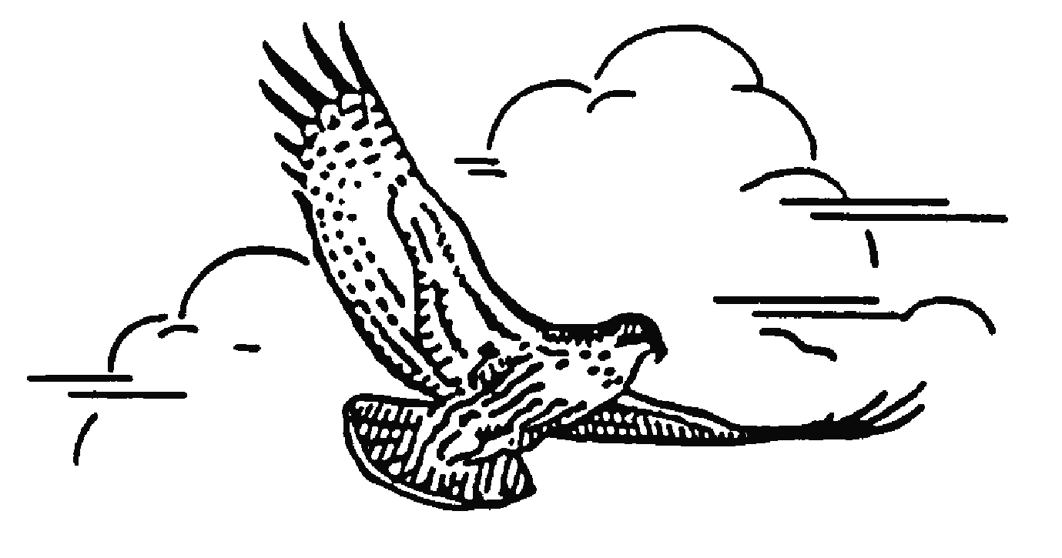
Toronto Ornithological C Toronto Ornithological Club
6243-2100 Bloor St W
Toronto, Ontario M6S 5A5

May 14, 2025
The Honourable Todd McCarthy
Minister of the Environment, Conservation and Parks
5th Floor, 777 Bay Street Toronto ON M7A 2J3
Re: ERO 025-0380 - Proposed interim changes to the Endangered Species Act, 2007 and a proposal for the Species Conservation Act, 2025
Dear Minister McCarthy,
I am writing to you on behalf of the Toronto Ornithological Club. We are a Toronto based club, but we are a large part of Ontario’s birding community and our activities extend well beyond the borders of our city. Through our activities and community science programs, we collect data about bird Spopulations across the province which are important indicators of the health of Ontario’s biodiversity and environment. Our birds are the proverbial canaries in a coal mine.
Toronto is also part of Carolinian Canada, stretching from our city to Windsor at the extreme southwest corner of the province. Although this region of Ontario represents only 0.25% of Canada’s land mass, its biodiversity is one of the richest in Canada. It is also home to one third of Canada’s rare and endangered species and there are 150 species at risk that include many cherished bird species. This biodiversity is miraculous when one considers 25% of Canada’s population lives in this region, the land is highly developed and natural habitat is extremely fragmented. Ontario is not only home to birds that breed in our province, two North American migratory pathways meet in Ontario, bringing large numbers of birds to feed on their journeys to their northern breeding grounds and their return to their wintering grounds.
Under Bill 5: Protect Ontario by Unleashing our Economy Act, 2025, the Endangered Species Act will be replaced with the Species Conservation Act which will allow scientifically based decisions on species at risk to be overridden by the provincial government. Politics will now become part of the decision-making process. There are also many loopholes that will allow development to proceed without considering its impact on nationally and municipally protected wildlife. No doubt, other ERO submissions will provide many other detailed explanations on how Bill 5 will chip away at legislation that were created over decades to protect endangered species in Ontario
In the big picture, this legislation in its current form will steal from a biodiverse inheritance for future generations of Canadians. It will rob our children and grandchildren of the joys of experiencing the biodiversity of the present, which has already been in decline for decades. The desire to expedite development to protect Ontarians from tariff challenges is appealing, but over time, tariffs come and go. A species that becomes extinct is gone forever. Ontario’s biodiversity has been in the making for hundreds of thousands of years. Please do not sacrifice it for a short-term election cycle.
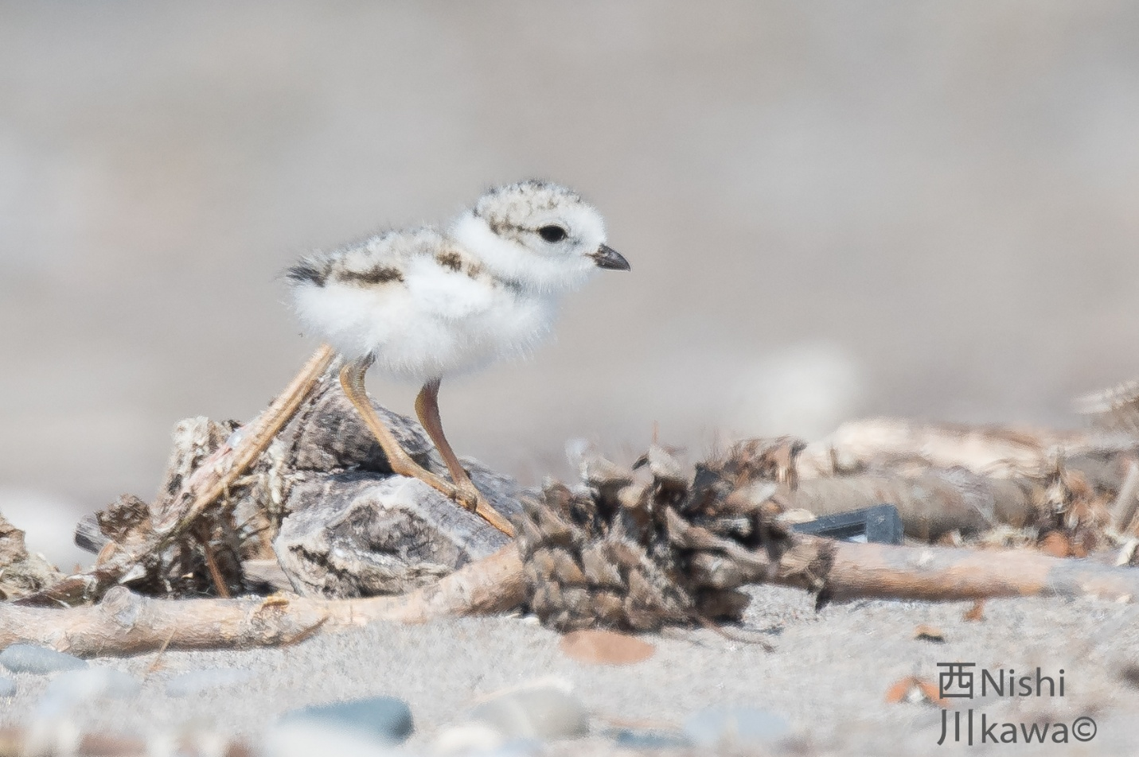
One of two endangered Piping Plover chicks successfully fledged on Toronto Island in 2022. There were only 5 Piping Plover nests in all of Ontario that year.

