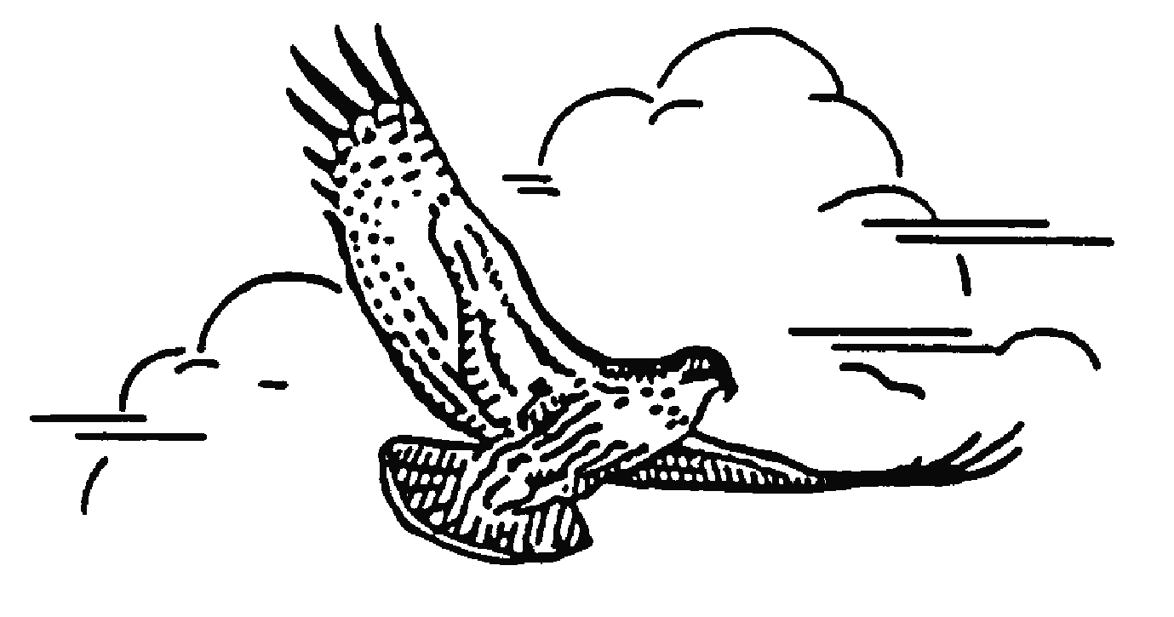
Toronto Ornithological C Toronto Ornithological Club
6243-2100 Bloor St W
Toronto, Ontario M6S 5A5

August 11, 2025
The Honourable Todd McCarthy
Minister of the Environment, Conservation and Parks
5th Floor, 777 Bay Street Toronto ON M7A 2J3
Re: ERO 025-0694 - Proposed legislative amendments to the Provincial Parks and Conservation Reserves Act, 2006, and Historical Parks Act to support the Town of Wasaga Beach’s Tourism Enhancement Proposal

Dear Minister McCarthy,
I am writing to you on behalf of the Toronto Ornithological Club. We are a Toronto based club, but we are a large part of Ontario’s birding community and like birds, our reach extends well beyond the borders of our city. Through our activities and community science programs, we collect data about bird populations across the province which are important indicators of the health of Ontario’s biodiversity and environment. Our birds are the proverbial canaries in a coal mine.
One might ask why a Toronto based birding group is so concerned about municipal activities in The Town of Wasaga Beach. From a birds-eye-view of our province (literally), birds do not see political lines nor jurisdictional borders, they see habitat; where can they feed and where they can breed. The Great Lakes population of Piping Plovers are endangered according to the federal Species at Risk Act and the provincial Endangered Species Act. Piping Plover disappeared from Ontario in the 1970s due to loss of habitat from development and human recreational activities. However, after a 30-year absence, they returned to our province thanks to managed remnant populations on the American side of the Great Lakes. These plovers have struggled to make a recovery in Ontario. In 2024 the province hosted only 6 nests with 7 fledged young. Wasaga Beach 1 continues to be the most important breeding site for Piping Plover in Ontario. Toronto has been fortunate to host nesting pairs of Piping Plover. After an 84 year absence, a pair showed up in 2018 on Toronto Island. The nests occurred in an Environmentally Significant Area that was incorporated into the Toronto Island Master Plan, recently approved by City Council. It is our hope that the province and the Town of Wasaga Beach will recognize their responsibility to maintain and improve the chances of survival for endangered Piping Plovers in Ontario by keeping the beaches of Wasaga Beach Provincial Park preserved and protected from development. The importance of Wasaga Beach in not limited to bird life. The dune habitat of Beach 1 has a unique biodiversity that is rare enough in Ontario to have been provincially designated an Area of Natural Scientific Interest. The province, the Town of Wasaga Beach and all Ontarians have a responsibility to protect its biodiversity. It is a gift from nature and an inheritance that must be carefully tended to for future generations to enjoy.
John Nishikawa, Director of Conservation,
Toronto Ornithological Club
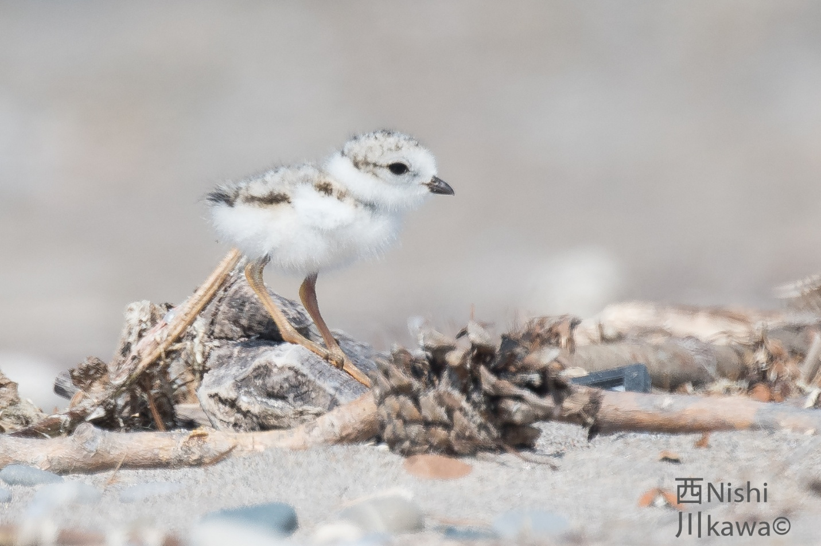
One of two endangered Piping Plover chicks successfully fledged on Toronto Island in 2022.

