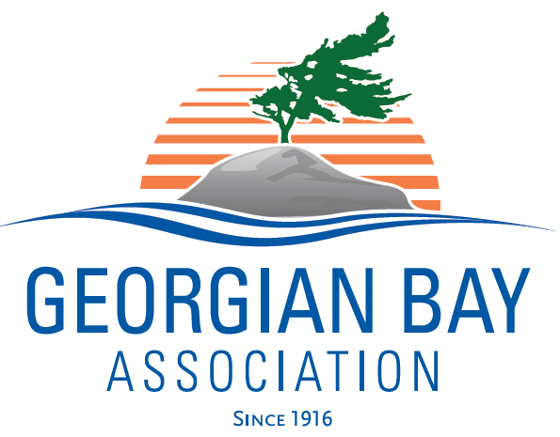
138 Hopedale Avenue, Toronto, Ontario M4K 3M7
executivedirector@georgianbay.ca
http://www.georgianbay.ca/.ca

August 11, 2025. Via email
Hon. Tod. McCarthy
Minister of Environment, Conservation and Parks

Re: Proposed legislative amendments to the Provincial Parks and Conservation Reserves Act, 2006, and Historical Parks Act

Dear Minister McCarthy,
In response to the call for input on proposed amendments to the Provincial Parks and Conservation Reserves Act, 2006, (PPCRA) and changes to the Historical Parks Act (HPA), the Georgian Bay Association is glad to see that your ministry making such an effort to support local economies in an uncertain time and making it easier for Ontarians to enjoy staycations.
At the same time, we are concerned about the precedent that these amendments will set. We definitely do not want it to be easy to remove park land from protection. There are classes of land use that must be strongly protected as their overall value far exceeds the dollar amounts of seasonal tourism. Healthy wetlands, intact wildlife habitats for larger animals, and sacred First Nations sites are all beneficial to Ontarians and integral to our culture for the long run.
To that end, we would like to propose an additional amendment: to amend the Provincial Parks and Provincial Conservation Areas Act to extend Section 15’s prohibition on exploration and mining to include Conservation Authority and charitably registered land trust lands.
In this way, your government can help Ontarians enjoy their natural spaces and stand up for the long-term value of preserving our most beautiful and sensitive places for the long term. This nuanced approach is espectially important in the Georgian Bay watershed, where the healthy ecosystems of a world-class, UNESCO-designated biosphere are actively supporting a growing economy with valuable tourism, recreation, and fishery industries.
Yours sincerely,
Meredith Denning
Executive Director, Georgian Bay Association

About the Georgian Bay Association
The Georgian Bay Association (GBA) speaks for 18 community associations along the east and
north shores of Georgian Bay, representing approximately 3,000 families. Our mandate is to
work with our water-based communities and other stakeholders to ensure the careful
stewardship of the greater Georgian Bay environment. We reach an estimated 30,000 residents
every year and we have been advocating on behalf of our members for over a century.

